

Grade: 7 & 8

Module: Python

Lesson: 01

Topic: Introduction to Python

**CLASS CONTENT:**

**OVERVIEW:**

**Learning Outcomes**

* Learn about history of Python, features, and applications of Python
* Explore the Python online IDE – Google Collab
* Explore and work with various Python data types.
* Understand how to declare and manage variables.
* Learn to perform type conversion between different data formats.
* Gain skills in using input and output functions for program interaction.

**KEY CONCEPTS:**

Known for its simplicity and versatility, Python is one of the most popular programming languages globally!

**Common Features of Python:**

* It is an interpreted and platform independent language interpreted.
* It is platform independent, open source and robust.
* Its syntaxes are simple and concise.
* It can be embedded inside web application, GUI based applications, software applications, et cetera.
* It has rich libraries of inbuilt functions to perform mathematical, logarithmic operations, data science apps, machine learning and ai applications, and operating system libraries as well.

**Applications of Python:**

* Web development
* Software applications
* GUI applications big data handling,
* Machine Learning
* Artificial Intelligence

**Variables in Python:**

* Variables are placeholders in programming, which can hold/store different types of values, such as numeric, text, floating-point (decimal), and complex numbers.
* We can even manipulate the values of a variable- score can be increased or decreased.
* The type of data stored in a variable is known as the data-type. Python supports data-types like integer, float, string, complex, boolean, and many other data-types.

**Google Collab** (short for *Collaboratory*) is a free, cloud-based platform provided by Google that allows users to write, run, and share Python code through Jupyter Notebook-like interfaces.

**MAIN ACTIVITY:**

**Power wattage Calculation:**

Let us say you have a 300-watt solar panel that receives an average of 5 hours of direct sunlight per day. To calculate the daily output in W, we would use the following formula:

Daily Output (W) = Wattage (W) x Hours of Sunlight x Efficiency

(Where wattage is the watt production capacity of one solar panel).

In this case, it would be:

Daily Output (kWh) = 300 W x 5 hours x 0.2 (assuming a 20% efficiency) = 300 w

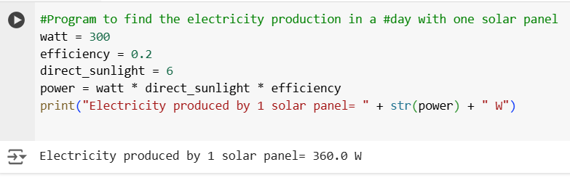

**HOMEWORK**

Peter lives in Grand Forks, North Dakota (very cold place), whereas, Vineeta lives in Miami (very hot place). Find the power production according to different seasons by number of solar panels in Miami and Grand Forks.

**Hints:**

For summer, direct sunlight is for 5-6 hours

Daily Output (kWh) = 300 W x 5 hours x 0.2 x No. of panels

* For winter, direct sunlight is for 2-3 hours

Daily Output (kWh) = 300 W x 2 hours x 0.2 x No. of panels

**KEY TAKEAWAYS**

* Data types in Python
* Concept of Variables
* Type Conversion
* Input Output in Python
* Daily Power Wattage Calculation
* Power Wattage Calculation for Different Seasons