

**PREVIOUS HOMEWORK SOLUTION:**

Grade: 7 & 8

Module: Python

Lesson: 09

Topic: GUI Programming

Write a Python program for plotting a pie chart and histogram based on the marks scored by 5 students. Data for reference:

students = ["Alice", "Bob", "Charlie", "David", "Eve"]

marks = [88, 92, 75, 85, 95]

* A pie chart to show the proportion of each student’s marks in comparison to the total.
* A histogram to show the distribution of marks across students.

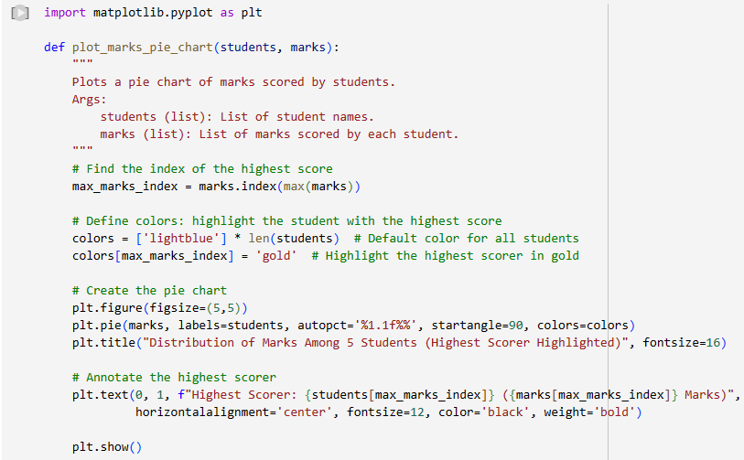

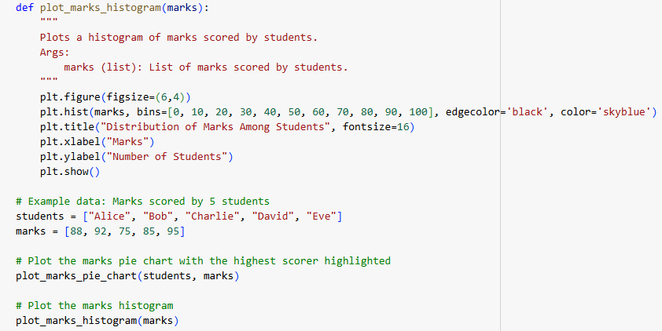

**CLASS CONTENT:**

**OVERVIEW:**

**Learning Outcomes**

* Perform installation of Python and Visual Studio Code.
* Learn to navigate through the IDE
* Understand GUI Basics using Tkinter
* Understand how to handle button clicks and link user actions to specific functions in the app
* Design a Basic GUI Layout
* Learn to run the Tkinter app and troubleshoot basic errors.

**KEY CONCEPTS:**

**Install Python**

**For macOS:**

1. Open [Python's official website](https://www.python.org/downloads/).
2. Download the macOS installer (universal or Intel/ARM based on your system).
3. Run the installer, check "Add Python to PATH" (if available).
4. Verify the installation:
5. Open Terminal and type: *python3 --version*

**For Windows:**

1. Go to [Python's official website](https://www.python.org/downloads/).
2. Download the Windows executable installer.
3. Run the installer:
4. Check "Add Python to PATH" before proceeding.
5. Verify the installation:
6. Open Command Prompt and type: python --version

**For Linux:**

1. Open Terminal and use the package manager for your Linux distro:

For Ubuntu/Debian:

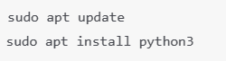

1. Verify the installation:



**Install Visual Studio Code (VS Code)**

**For macOS:**

1. Download the VS Code .dmg file from the [official VS Code website](https://code.visualstudio.com/).
2. Drag the downloaded .dmg file to the Applications folder.
3. Open VS Code and install the Python extension from the Extensions tab.

**For Windows:**

1. Download the VS Code installer .exe file from [VS Code's official site](https://code.visualstudio.com/).
2. Run the installer:
3. During installation, check the box "Add to PATH".
4. Open VS Code and install the Python extension from the Extensions tab.

**For Linux:**

* 1. Open Terminal and install VS Code:

For Ubuntu/Debian:

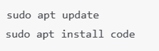

Important:

* Ensure you check **"Add to PATH"** during installation of Python and VS Code.
* The **Python extension** in VS Code is crucial for coding with Python.
* On macOS and Linux, Python might already be pre-installed; always verify with python3 --version.

**Tkinter:**

* Tkinter is the standard GUI (Graphical User Interface) library included with Python.
* It provides tools to create graphical desktop applications with buttons, labels, text boxes, menus, and more.
* Tkinter is widely used for beginners and simple GUI projects because it is easy to use and does not require additional installations (it comes bundled with Python).

**MAIN ACTIVITY:**

**Task:**

Create a personalized greeting application using GUI widgets.

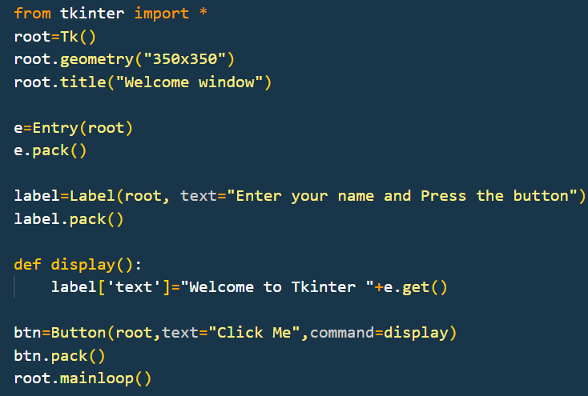

**HOMEWORK**

Create a Python GUI based program to add two numbers and display their result.

**Hints:**

* 1. Create 2 entry fields for two numbers
  2. Create a label to display the result
  3. Create a button to bind with the function of addition of two numbers.

**KEY TAKEAWAYS**

* Python is easy to install and comes with Tkinter by default.
* Visual Studio Code with Python extension is an offline IDE for development.
* Tkinter is beginner-friendly for creating GUI applications.
* The main components of a Tkinter app are **root window, labels, entries, and buttons**.