

**PREVIOUS HOMEWORK SOLUTION:**

Grade: 7 & 8

Module: Python

Lesson: 10

Topic: Lists

Create a Python GUI based program to add two numbers and display their result

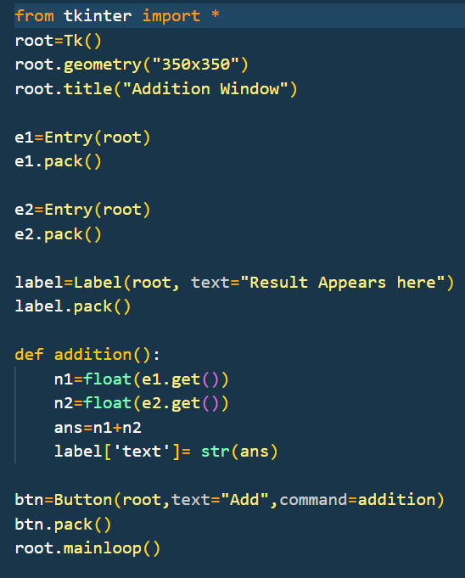

**CLASS CONTENT:**

**OVERVIEW:**

**Learning Outcomes**

* Understand the concept of geographical coordinates (latitude and longitude).
* Gain hands-on experience with the **ephem** library to calculate celestial events.
* Learn to use Python libraries and functions to solve real-world problems.
* Enhance research skills by finding geographical coordinates for their hometown

**KEY CONCEPTS:**

**List**

A list in Python is a built-in data structure that allows you to store a collection of items in a single variable. It is ordered, mutable, and can hold elements of different data types (e.g., integers, strings, or even other lists). Lists are enclosed in square brackets [].

**List Operations (in short)**

1. **Basic Operations:**

* Create a list: my_list = [1, 2, 3]
* Access elements: my_list[0] (first element)
* Modify elements: my_list[1] = 20

1. **Common Methods:**

* Add elements: append(), extend()
* Remove elements: pop(), remove()
* Sort a list: sort(), reverse()
* Count elements**: len(), count()**

1. **Slicing:** Extract parts of a list using my_list[start:end:step].

**List Properties**

* Order Matters: Lists maintain the order of elements.
* Mutability: You can change, add, or remove elements after a list is created.
* Dynamic: Lists can grow or shrink in size as needed.
* Heterogeneous Elements: A list can store items of various types, e.g., [1, "text", [2, 3]].

**Ephem Library**

* Ephem is a Python library used for performing astronomical computations.
* It provides tools to calculate the positions of celestial objects like planets, stars, and the Sun, as well as phenomena like sunrise, sunset, and moon phases.
* It is widely used in applications related to astronomy, astrology, and scientific observations.

**MAIN ACTIVITY:**

To build a Python program that calculates the next sunrise and sunset times for these five cities using their geographical coordinates.

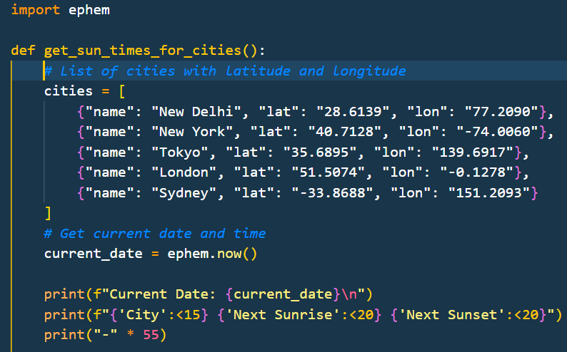

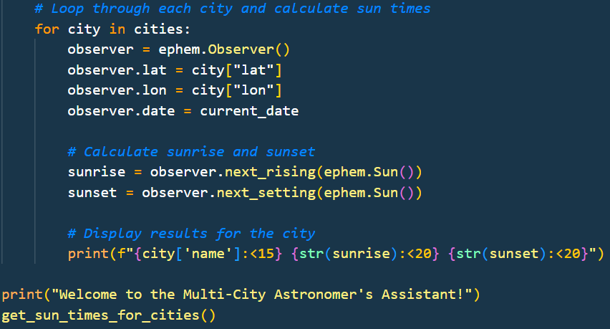

**HOMEWORK**

**Task:**

* Imagine you are building a tool for travelers who love to chase sunrises and sunsets across different cities.
* Your task is to create a program that calculates the next sunrise and sunset times for a list of cities based on their geographic locations.
* To make it easier for travelers to plan their journeys, add the ability to sort the cities based on either their next sunrise or next sunset times.

**Hints:**

* Use the ephem library to calculate sunrise and sunset times based on latitude and longitude.
* Store city details (name, latitude, longitude) in a list of dictionaries.
* Use the sorted() function with key=lambda to sort cities by sunrise or sunset times.
* Allow the user to choose sorting by sunrise or sunset for easy planning.
* Display thesorted results in a simple and readable format.

**KEY TAKEAWAYS**

* Lists are versatile and allow dynamic manipulation of data.
* Lists support various operations like adding, removing, and sorting.
* Ephem is a specialized library for astronomical calculations and is easy to integrate into Python programs.
* Ephem can calculate sunrise and sunset times based on a city's geographic coordinates (latitude and longitude).