ALLFARM NZ  2 DAY CONFERENCE  Wednesday 6th & Thursday 7th July 2011 | 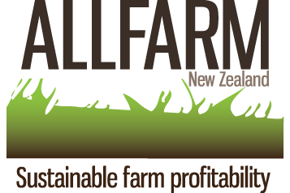

TOPICS
Wednesday Morning

- Nutrition for high producers (Carolina Diaz, AllfarmNZ)

- Feed efficiency conversion and management of cows in intensive systems (Adolfo Alvarez. AllfarmNZ)

- Cow Health in intensive systems
- Lameness (Fred Hoekstra, VeeHof Dairy Services Ltd)
- Mastitis (Dr. Kiro Petrovski, Massey University)
- Reproduction (Dr. Tim Parkinson, Massey University)

Wednesday afternoon

- Herd Home Farm visit

Wednesday Night
6pm Buffet Dinner & Entertainment

Thursday Morning

- Return on investment
  - herd homes (Tom Pow, Herd Homes CEO)
  - individual identification systems (Speaker to be confirmed)

- Fertiliser output -from manure to paddocks (Andres Reidel, AllfarmNZ)

- Biological v/s Traditional fertiliser
(Jim McMillan, CEO Outgro)
(Dr. Ants Roberts, Traditional fertiliser speaker)

Thursday Afternoon

- Mineral requirements for high producers (speakers to be confirmed)
- Organic v/s inorganic
- Stage of lactation
- Production requirements
- Complementing grass, soil minerals

- Farmers presentation (around 600kgMS/cow, stocking rate >4, high profits)
- Feedpad utilization (David and Raewyn Bennett, Waikato)
- Inshed feeding system (Kevin and Linda Davidson, Hawkes Bay)
- Herd home system (farmer still to be confirmed)

