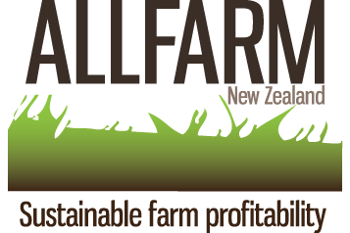

ALLFARM NZ 1st ANNUAL CONFERENCE

ALLFARM NZ profit and productivity consultants conference will enrich your knowledge with key topics discuss by the best international experts in the field.

TOPICS
- Lameness (impact on profitability & production)
- Mastitis (prevention & treatment)
- Reproduction (nutrition & veterinary approach)
- Calf rearing (rearing for the future)
- Farm Profitability (budgeting for production)
- Minerals and the seasonal requirements (organic vs inorganic)
- Fertiliser (from soil to milk)
- Nutrition status at calving and managing the colostrum cow

SPEAKERS: Kiro Petrovski; Richard Laven;
Jean Margerison; Adolfo Alvarez;
Andrew Robarts; Andres Reidel;
Carolina Diaz Lira

COST: $250 earlybird registration by 15 June.
$300 later registration.
Lunch included both days

TIME: 9.00am to 4.00pm

VENUE: PALMERSTON NORTH Kingsgate Hotel 110 Fitzherbert Ave.


SPONSORED BY

DATE: 1st and 2nd July 2010

REGISTER TODAY! Online: www.allfarmnz.co.nz or Ph: 06 3533302

