pH Indicative Strip Chart and Strips

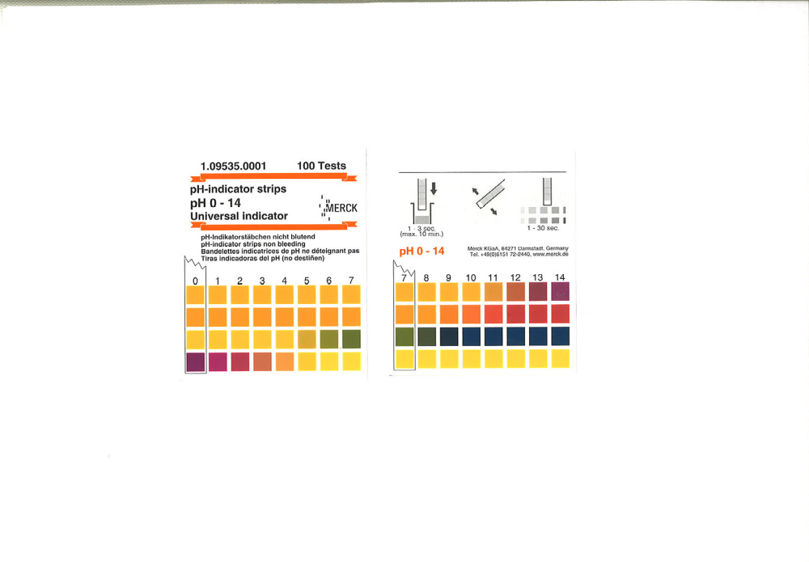

pHStrip boxes are available from our office. Please contact us either at info@allfarmnz.co.nz or 06 3533302 for purchase and delivery.

Complimentary Strips from the team at Allfarm NZ

