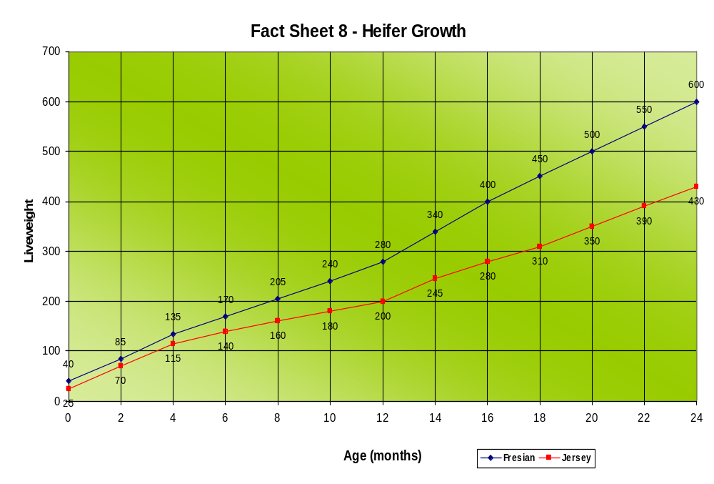
WEANING:
Friesian calves:
110 kg weight
95 cm height
(The Height of a 44 gallon drum!)

Jersey calves:
85 kg weight
85 cm height
MATING:
Friesian heifers:
350 kg weight
130 cm height
Jersey heifers:
285 kg weight
118 cm height
CRITICAL TIME No. 1: Weaning to Puberty
CRITICAL TIME NO. 2:
6 months pre-calving
Source:
Dr Leslie Sandles

