 | Faculty of Natural and Applied Sciences  Computer Science Department
CSC 323: Object-Oriented Design
Project – Report
Submitted by:
Student ID | Name | Major

Project Description (around 500 words)
DCLbot is a Windows Forms chat application written in C# on .NET 8. It is the deliberately barebones miniature of our production chatbot "doomalay", a large multi-component assistant (Go engine, Python brain, web app), rebuilt here with only the essential conversation core so that every line of code can be studied, tested and defended at the scale of a course project. The user types a message, the message joins an in-memory conversation history, and an AI provider returns an answer that is appended to the transcript: a classic back-and-forth chat with full memory of the dialogue.
The application talks to exactly one provider (OpenRouter) with exactly one pinned model (recursive/flint-v1.0:free), and it has no tools, no streaming and no extensions: the smallest honest version of our real product. A second provider, Echo, never touches the network: it answers with local canned replies so the application remains fully demonstrable without internet access or when the free model pool is rate-limited. Switching between the two providers at runtime through a combo box is deliberate: it is the living proof that both implementations are substitutable for the same abstraction.
Architecturally the solution is layered in five namespaces. Core holds the domain: ChatRole (an enum), ChatMessage, the Conversation collection with automatic history trimming, ApiSettings and the ChatReply result. Providers holds the abstraction IChatProvider, the information-only interface IProviderInfo, the abstract class ChatProviderBase that implements a template Send() method (guard, readiness check, timing, error translation), and the two concrete providers; OpenRouterProvider additionally adapts OpenRouter's REST/JSON wire contract (four DTO classes in Providers.Dto) into clean domain objects, and even ports a "provider quirk" idea from the parent project: reasoning-style models sometimes answer with empty content while the actual text sits in a reasoning field, and the adapter degrades gracefully in that case. Services holds ChatService, a Singleton facade that owns the conversation and the active provider, exposes four methods to the outside world, and loads the API key from the environment so no secret ever reaches source control. UI holds frmChat, a thin form that only paints state and captures input, plus Program as the entry point.
In total the design contains twenty-one types related in a coherent, meaningful structure, not demos bolted together. The five SOLID principles are exercised where they naturally belong: single responsibility across the layers, open-closed provider extension through the factory, Liskov substitution proven by the interchangeable providers (and by test stubs), interface segregation through the split send/info interfaces, and dependency inversion with the high-level modules depending only on abstractions. Three GoF patterns from the course catalogue are realized for real features: Strategy (interchangeable providers), Adapter (REST/JSON world to domain interface) and Singleton (the single chat brain). A zero-dependency smoke suite of seventy-two offline checks (core classes, provider behaviour, the exact JSON wire shape and every error path) plus five live API tests protects the behavior, and the same suite runs on every push in GitHub Actions.

Class Diagram (UML)
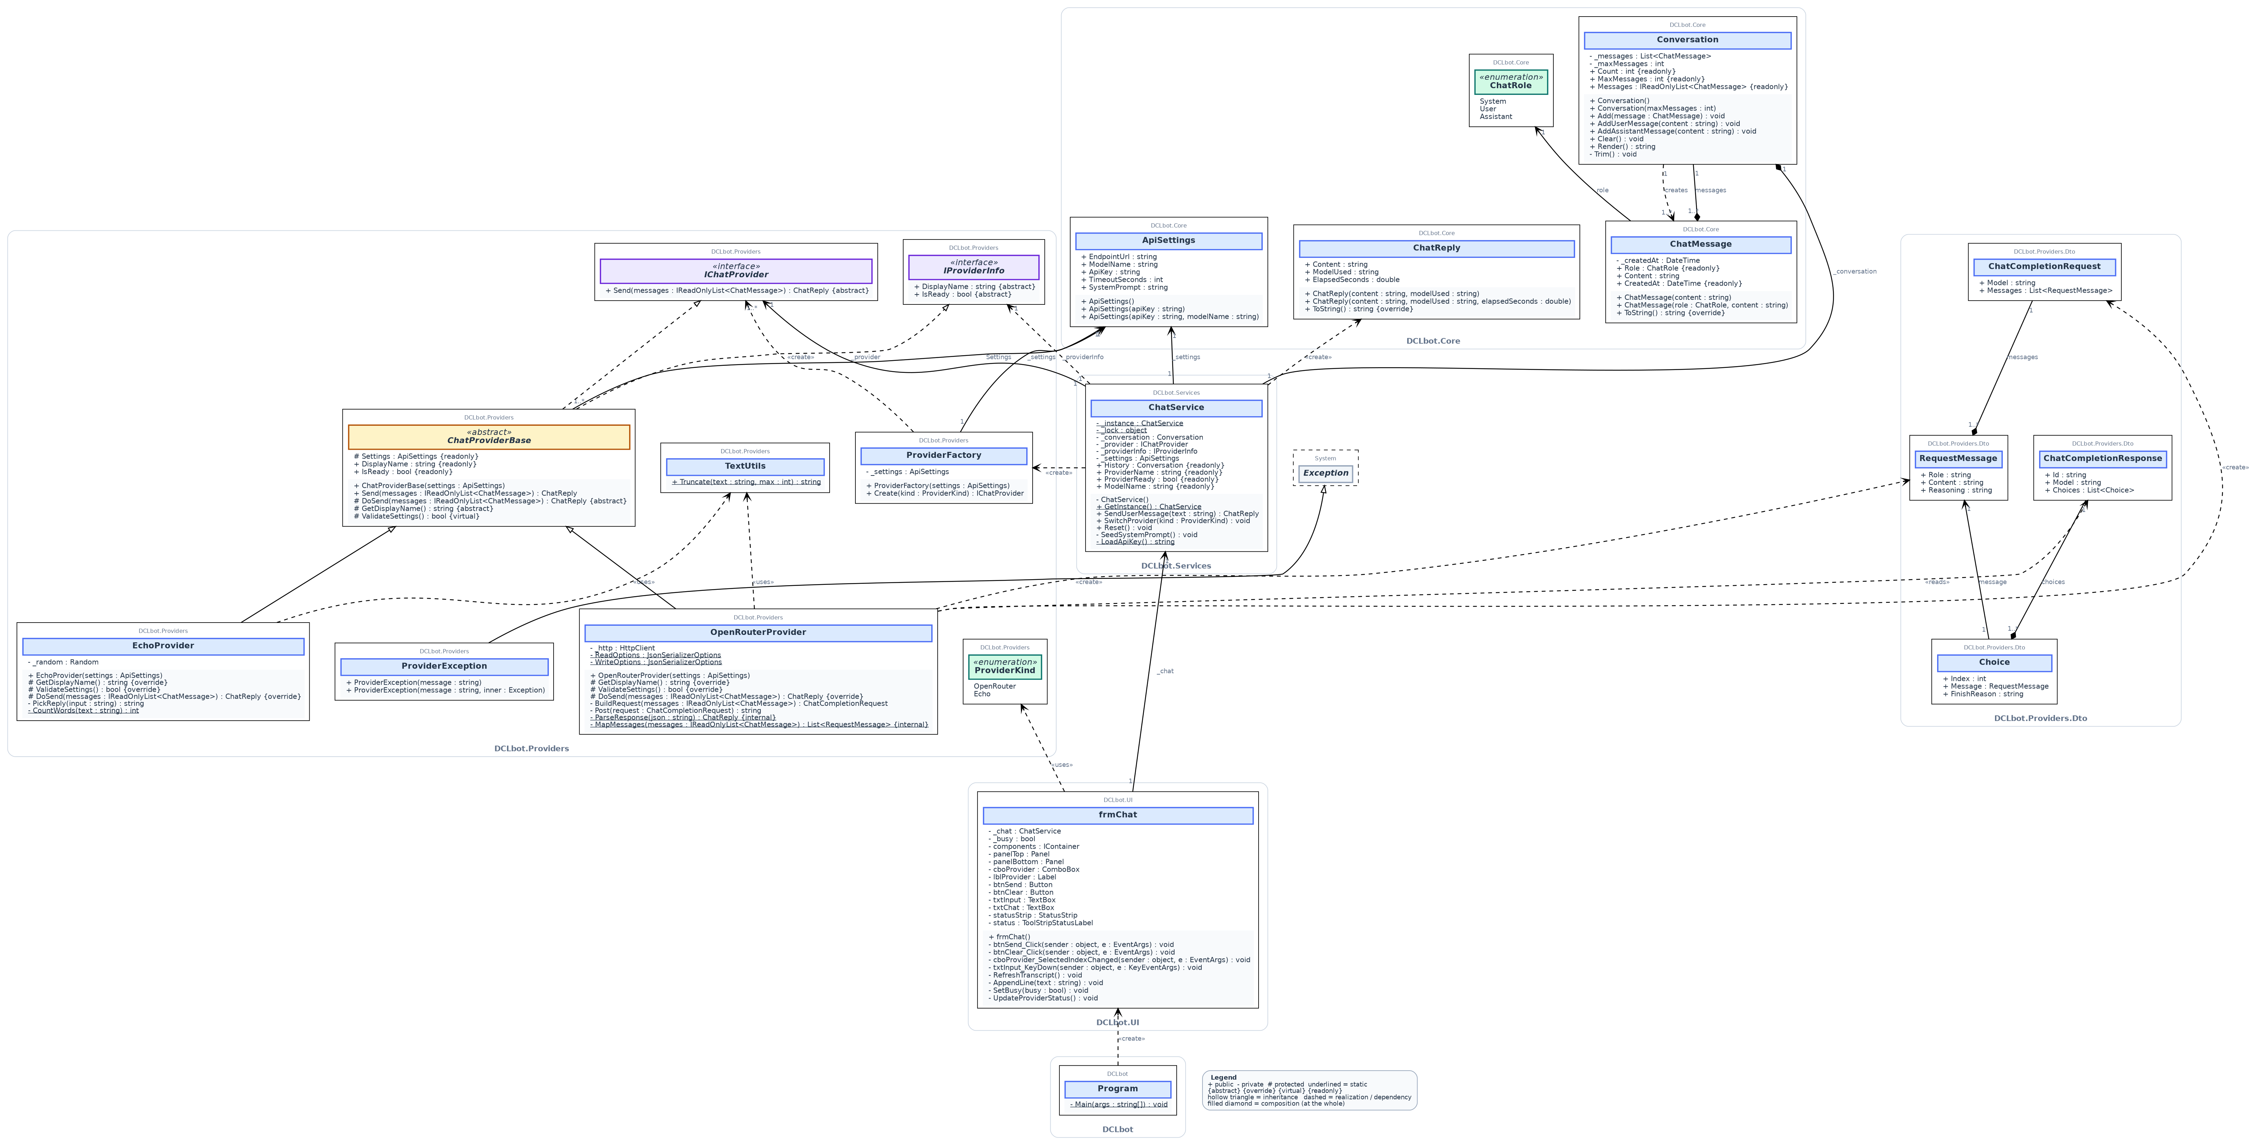
Figure 1. DCLbot class diagram: 21 types in five namespaces, generated by Graphviz from the checked-in source docs/diagram/class_diagram.dot - one explicit line per class and per relationship, layout computed by the tool, so every arrow lands on both endpoints. Edges read as sentences (uses / runs / holds / creates / sends / builds / guards...); hollow triangle = inheritance (the two providers fork under ChatProviderBase, which realizes the two interfaces above it); dashed = dependency; + public, - private, # protected, underlined = static. Visual Studio twin: src/DCLbot/DCLbot.cd.

Source Code (C#)
public class ChatMessage
{
private DateTime _createdAt;
public ChatRole Role { get; private set; }
public string Content { get; set; }
public DateTime CreatedAt { get { return _createdAt; } } // read-only property

public ChatMessage(string content) : this(ChatRole.User, content) { }

public ChatMessage(ChatRole role, string content) // overloaded constructor
{
Role = role;
Content = content;
_createdAt = DateTime.Now;
}

public override string ToString() // overriding
{
return string.Format("[{0}] {1}", Role, Content);
}
}

public class ChatReply // one answer from a provider
{
public string Content { get; set; } // the answer text
public string ModelUsed { get; set; } // which model answered
public double ElapsedSeconds { get; set; } // how long it took

public ChatReply(string content, string modelUsed)
{
Content = content;
ModelUsed = modelUsed;
ElapsedSeconds = 0;
}

public ChatReply(string content, string modelUsed, double elapsedSeconds)
: this(content, modelUsed) // constructor chaining
{
ElapsedSeconds = elapsedSeconds;
}

public override string ToString() // overriding
{
return string.Format("{0} ({1}, {2}s)", Content, ModelUsed, ElapsedSeconds);
}
}

public class ApiSettings
{
public string EndpointUrl { get; set; }
public string ModelName { get; set; }
public string ApiKey { get; set; } // read from the environment
public int TimeoutSeconds { get; set; }
public string SystemPrompt { get; set; }

public ApiSettings() // chained defaults
{
EndpointUrl = "https://openrouter.ai/api/v1/chat/completions";
ModelName = "recursive/flint-v1.0:free"; // the one pinned model
TimeoutSeconds = 90;
ApiKey = ""; // keys never live in the code
SystemPrompt = "You are DCLbot, a concise and helpful assistant.";
}
public ApiSettings(string apiKey) : this() // blank means "keep the default"
{
if (!string.IsNullOrWhiteSpace(apiKey)) { ApiKey = apiKey; }
}
public ApiSettings(string apiKey, string modelName) : this(apiKey)
{
if (!string.IsNullOrWhiteSpace(modelName)) { ModelName = modelName; }
}
}

public class Conversation // the collection type
{
private List<ChatMessage> _messages = new List<ChatMessage>();
private int _maxMessages;

public Conversation() : this(40) { } // constructor chaining
public Conversation(int maxMessages) { _maxMessages = maxMessages; }
public IReadOnlyList<ChatMessage> Messages { get { return _messages; } }

public void Add(ChatMessage message) { _messages.Add(message); Trim(); }

public string Render() // foreach + StringBuilder
{
StringBuilder sb = new StringBuilder();
foreach (ChatMessage message in _messages)
{
sb.AppendLine(message.ToString());
}
return sb.ToString();
}

private void Trim() // bounded memory
{
while (_messages.Count > _maxMessages) { _messages.RemoveAt(0); }
}
}
Figure 2. Core domain: ChatMessage (constructor overloading, ToString override, read-only CreatedAt), ChatReply (the answer, which model produced it and how long it took), ApiSettings (three chained constructors; the key comes from the environment, never from the code) and Conversation (List<ChatMessage> with automatic trimming and a foreach + StringBuilder renderer).

public interface IChatProvider // the ONE required ability
{
ChatReply Send(IReadOnlyList<ChatMessage> messages);
}

public interface IProviderInfo // status information only
{
string DisplayName { get; }
bool IsReady { get; }
}

public abstract class ChatProviderBase : IChatProvider, IProviderInfo
{
protected ApiSettings Settings { get; } // shared with the subclasses
public string DisplayName { get { return GetDisplayName(); } }
public bool IsReady { get { return ValidateSettings(); } }

protected ChatProviderBase(ApiSettings settings) { Settings = settings; }

public ChatReply Send(IReadOnlyList<ChatMessage> messages) // checks, timing, error handling
{
if (messages == null || messages.Count == 0)
{
throw new ProviderException("No messages to send.");
}
if (!IsReady)
{
throw new ProviderException(DisplayName + " is not ready: missing configuration.");
}
Stopwatch clock = Stopwatch.StartNew();
try
{
ChatReply reply = DoSend(messages); // the subclass does the real work
clock.Stop();
reply.ElapsedSeconds = Math.Round(clock.Elapsed.TotalSeconds, 2);
return reply;
}
catch (ProviderException) { throw; } // domain errors pass through
catch (Exception ex) // everything else is translated
{
throw new ProviderException(DisplayName + " failed: " + ex.Message, ex);
}
}

protected abstract ChatReply DoSend(IReadOnlyList<ChatMessage> messages);
protected abstract string GetDisplayName();
protected virtual bool ValidateSettings() { return true; } // optional to override
}
Figure 3. The provider abstractions: two deliberately small interfaces (Interface Segregation) and the abstract base class whose template Send() method fixes the skeleton (guard, readiness, timing, error wrapping) while subclasses fill the blanks.

public class OpenRouterProvider : ChatProviderBase
{
private HttpClient _http = new HttpClient();

public OpenRouterProvider(ApiSettings settings) : base(settings)
{
_http.Timeout = TimeSpan.FromSeconds(Math.Max(5, settings.TimeoutSeconds));
}

protected override string GetDisplayName() { return "OpenRouter"; }

protected override bool ValidateSettings() // ready only with a key
{
return !string.IsNullOrWhiteSpace(Settings.ApiKey); // ready only with a key
}

protected override ChatReply DoSend(IReadOnlyList<ChatMessage> messages)
{
ChatCompletionRequest request = BuildRequest(messages);
string payload = Post(request);
return ParseResponse(payload);
}

internal static List<RequestMessage> MapMessages(IReadOnlyList<ChatMessage> messages)
{
List<RequestMessage> mapped = new List<RequestMessage>();
foreach (ChatMessage message in messages) // domain -> wire
{
string role;
switch (message.Role)
{
case ChatRole.System: role = "system"; break;
case ChatRole.Assistant: role = "assistant"; break;
default: role = "user"; break;
}
mapped.Add(new RequestMessage { Role = role, Content = message.Content });
}
return mapped;
}

private string Post(ChatCompletionRequest request) // the HTTP call
{
string body = JsonSerializer.Serialize(request, WriteOptions);
using (HttpRequestMessage http = new HttpRequestMessage(HttpMethod.Post,
Settings.EndpointUrl))
{
http.Content = new StringContent(body, Encoding.UTF8, "application/json");
http.Headers.Authorization = new AuthenticationHeaderValue("Bearer",
Settings.ApiKey);
using (HttpResponseMessage response = _http.SendAsync(http)
.GetAwaiter().GetResult())
{
string payload = response.Content.ReadAsStringAsync()
.GetAwaiter().GetResult();
if ((int)response.StatusCode == 401) { throw new ProviderException(
"OpenRouter rejected the API key (401). Check OPENROUTER_API_KEY."); }
if ((int)response.StatusCode == 429) { throw new ProviderException(
"OpenRouter rate limit reached (429). Retry shortly or use Echo."); }
if (!response.IsSuccessStatusCode) { throw new ProviderException(
"OpenRouter HTTP " + (int)response.StatusCode + ": "
+ TextUtils.Truncate(payload, 300)); }
return payload;
}
}
}

internal static ChatReply ParseResponse(string json) // wire -> domain
{
ChatCompletionResponse parsed;
try { parsed = JsonSerializer.Deserialize<ChatCompletionResponse>(json, ReadOptions); }
catch (JsonException ex)
{
throw new ProviderException("OpenRouter returned unreadable JSON: " + ex.Message, ex);
}
if (parsed == null || parsed.Choices == null || parsed.Choices.Count == 0)
{
throw new ProviderException("OpenRouter response contained no choices.");
}
Choice best = parsed.Choices[0];
string content = (best.Message == null) ? null : best.Message.Content;
if (string.IsNullOrWhiteSpace(content)) // the provider quirk:
{ // reasoning models may spend the whole budget
string reasoning = (best.Message == null) ? null : best.Message.Reasoning;
if (!string.IsNullOrWhiteSpace(reasoning))
{
return new ChatReply("[thinking] " + TextUtils.Truncate(reasoning, 240),
parsed.Model ?? "openrouter");
}
throw new ProviderException("OpenRouter returned an empty answer.");
}
return new ChatReply(content, parsed.Model ?? "openrouter");
}
}
Figure 4. The Adapter: OpenRouterProvider translates between the domain world and OpenRouter's REST/JSON contract (DTOs in Providers.Dto), maps 401/402/429 to clean domain errors, and handles the reasoning-model quirk (empty content, answer in the reasoning field).

public class ChatService // SINGLETON + FACADE
{
private static ChatService _instance;
private static readonly object _lock = new object();

private Conversation _conversation;
private IChatProvider _provider; // depends on the abstraction
private IProviderInfo _providerInfo;
private ApiSettings _settings;

private ChatService() // private: only GetInstance builds
{
_settings = new ApiSettings(LoadApiKey()); // key from the environment
_conversation = new Conversation();
SwitchProvider(ProviderKind.OpenRouter);
SeedSystemPrompt();
}

public static ChatService GetInstance() // thread-safe lazy creation
{
lock (_lock)
{
if (_instance == null) { _instance = new ChatService(); }
return _instance;
}
}

public Conversation History { get { return _conversation; } }
public string ProviderName { get { return _providerInfo.DisplayName; } }
public bool ProviderReady { get { return _providerInfo.IsReady; } }
public string ModelName { get { return _settings.ModelName; } }

public ChatReply SendUserMessage(string text) // one full turn with memory
{
if (string.IsNullOrWhiteSpace(text))
{
throw new ProviderException("Type a message before sending.");
}
_conversation.AddUserMessage(text);
ChatReply reply = _provider.Send(_conversation.Messages); // WHOLE history rides along
_conversation.AddAssistantMessage(reply.Content);
return reply;
}

public void SwitchProvider(ProviderKind kind) // swap the provider on request
{
IChatProvider created = new ProviderFactory(_settings).Create(kind);
_provider = created;
_providerInfo = created as IProviderInfo; // status info for the bar
}

public void Reset()
{
_conversation.Clear();
SeedSystemPrompt();
}

private static string LoadApiKey() // keys never enter source control
{
string key = Environment.GetEnvironmentVariable("OPENROUTER_API_KEY");
return (key == null) ? "" : key;
}
}
Figure 5. The Singleton facade: ChatService is the only type the UI knows. A private constructor, a static _instance and a thread-safe GetInstance() guarantee exactly one chat brain; SwitchProvider() swaps strategies at runtime behind IChatProvider.

public partial class frmChat : Form
{
private ChatService _chat;
private bool _busy;

public frmChat()
{
InitializeComponent();
_chat = ChatService.GetInstance();
foreach (ProviderKind kind in Enum.GetValues(typeof(ProviderKind)))
{
cboProvider.Items.Add(kind); // combo filled from the enum
}
cboProvider.SelectedIndex = 0;
RefreshTranscript();
UpdateProviderStatus();
}

private async void btnSend_Click(object sender, EventArgs e)
{
string text = txtInput.Text.Trim();
if (text.Length == 0 || _busy) { return; } // guards: no empty/double sends

SetBusy(true); // lock the input while waiting
txtInput.Clear();
AppendLine("You: " + text);
AppendLine(_chat.ProviderName + " is thinking...");

string failure = null;
try
{
ChatReply reply = await Task.Run(() => _chat.SendUserMessage(text));
AppendLine("Bot: " + reply.Content); // UI stays alive off-thread
}
catch (ProviderException ex) { failure = ex.Message; } // clean domain errors
catch (Exception ex) { failure = "Unexpected problem: " + ex.Message; }
finally
{
SetBusy(false);
RefreshTranscript(); // re-renders the real history
if (failure != null) { AppendLine("[error] " + failure); }
txtInput.Focus();
}
}

private void UpdateProviderStatus()
{
if (_chat.ProviderReady)
{
status.Text = string.Format("Ready - {0} | model: {1}",
_chat.ProviderName, _chat.ModelName);
return;
}
// explain what is missing instead of switching back to Echo
status.Text = _chat.ProviderName
+ " has no API key. Set OPENROUTER_API_KEY (env var), or pick Echo for offline mode.";
}
}
Figure 6. The thin UI: frmChat owns zero business logic - it paints state, captures input, delegates every decision to the ChatService singleton, and explains in the status bar what is missing when a provider is not ready.

Descriptions of how and where you have used key concepts
Concept | Description (around 30 words each)  refer to the class diagram and source code figures as you see fit
Abstraction (abstract classes and/or interfaces) | IChatProvider and IProviderInfo are pure contracts; ChatProviderBase is an abstract class implementing the shared Send() template while leaving DoSend() and GetDisplayName() abstract.
Concrete classes | ChatMessage, Conversation, EchoProvider, OpenRouterProvider, ChatService and frmChat are instantiable classes with real state and behavior that together form the running chatbot.
Namespaces | Code is organized into DCLbot.Core, .Providers, .Providers.Dto, .Services and .UI, mirroring the architecture and separating domain, vendors, orchestration and UI.
Methods | Conversation.Render() builds the transcript, OpenRouterProvider.Post() performs the HTTP call, ChatService.SendUserMessage() orchestrates a full turn with memory.
Properties | ChatMessage.Role/Content/CreatedAt, ApiSettings.ModelName and ChatProviderBase.DisplayName/IsReady use accessors; CreatedAt is read-only over a private DateTime field.
Overriding of methods and/or properties | EchoProvider and OpenRouterProvider override abstract DoSend()/GetDisplayName() and virtual ValidateSettings(); ChatMessage and ChatReply override Object.ToString() for the transcript.
Constructor overloading | ChatMessage has (string) and (ChatRole, string) constructors; ApiSettings chains three constructors with this() over the key string; ProviderException mirrors Exception's two-ctor pattern.
Enumeration (Enum) | ChatRole (System/User/Assistant) drives the wire mapping; ProviderKind (OpenRouter/Echo) fills the provider combo box at runtime through Enum.GetValues.
Collections (e.g., Lists) | Conversation holds a List<ChatMessage> with automatic trimming; the DTOs carry List<RequestMessage> and List<Choice>; MapMessages() returns a List of wire messages.
Loops (e.g., foreach) | foreach iterates messages in Conversation.Render(), maps ChatMessages to wire DTOs in MapMessages(), fills the combo box in frmChat and counts words in EchoProvider.

SOLID Principle | Description of where the principle is realized and for what purpose (around 50 Words)
1) Single Responsibility | Each type has one reason to change: frmChat only paints and captures input, ChatService only orchestrates turns, OpenRouterProvider only speaks HTTP/JSON, Conversation only manages history; UI, orchestration and API changes never collide.
2) Open-Closed | Adding a provider (e.g., Mistral) means one new ChatProviderBase subclass and one factory case; ChatService, frmChat and all other classes stay untouched - the system grows by extension, not modification.
3) Liskov Substitution | EchoProvider and OpenRouterProvider are fully substitutable behind IChatProvider: the form, service and smoke tests send through one abstraction without knowing which concrete provider answers; the runtime combo box demonstrates substitution live.
4) Interface Segregation | Clients see only what they use: ChatService depends on the minimal IChatProvider (Send), while the status bar consumes the separate IProviderInfo (DisplayName/IsReady); no consumer drags members it never calls.
5) Dependency Inversion | High-level modules (ChatService, frmChat) depend on the abstractions IChatProvider/IProviderInfo, never on concrete providers; ProviderFactory injects the concrete at a single composition point.

GOF Design Pattern | Description of where the pattern is realized and for what purpose (around 50 Words)
1) Strategy | IChatProvider encapsulates the "how to answer" algorithm; OpenRouterProvider (live API) and EchoProvider (offline canned replies) are interchangeable strategies that ChatService can hot-swap at runtime.
2) Adapter | OpenRouterProvider converts OpenRouter's REST/JSON world (ChatCompletionRequest/Response DTOs, headers, status codes, quirks) into our domain interface IChatProvider over clean ChatMessage/ChatReply objects.
3) Singleton | ChatService uses a private constructor, static _instance and thread-safe GetInstance() so exactly one chat brain exists per application; the form reaches it through one global access point.

User Interface (Windows Forms)
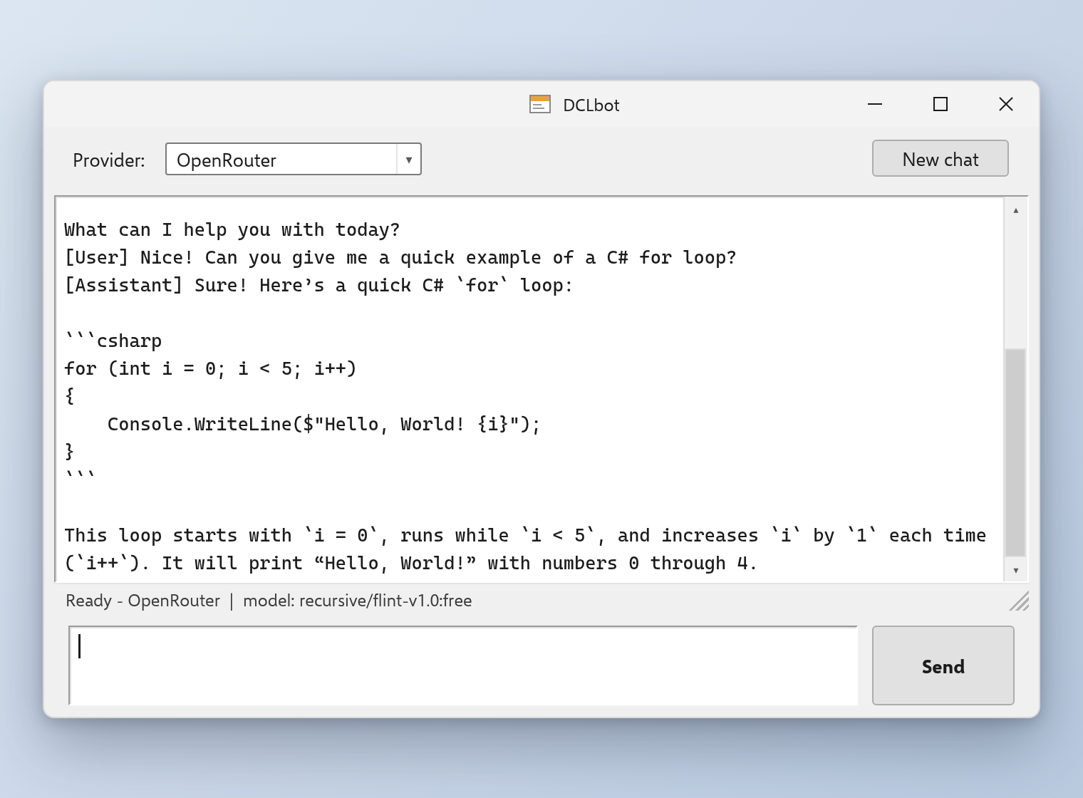
Figure 7. DCLbot main window: a live OpenRouter conversation. The status bar shows the active provider and the pinned model; the transcript keeps the whole history (system prompt, user and assistant turns), and the provider combo box keeps whatever the user picks.
Brief Description of UI (around 50 words)
The single form hosts a provider combo box (OpenRouter / Echo), a read-only transcript, a multiline input with Send (or Enter) and a New chat button; a status strip reports the active provider and the pinned model. Without an API key the status bar explains how to set the OPENROUTER_API_KEY environment variable, and the offline Echo provider keeps the demo alive - whatever the user picks in the combo box stays picked.

