**Introduction**

In this part, we mainly study the housing sales in Beijing. We have made statistics on the housing sales in Beijing from January 2019 to December 2020, and visualized these contents to directly reflect the changes of housing sales. At the same time, we can also combine the factors of geographical location to analyze the reasons for the differences in housing sales.

**Data**

The data we used in the experiment came from the Netease Real Estate Center（<https://data.house.163.com/bj/housing/index.html>）.We collected data from the website and cleaned up the data to get the change of housing sales in 16 urban areas of Beijing in 24 months.

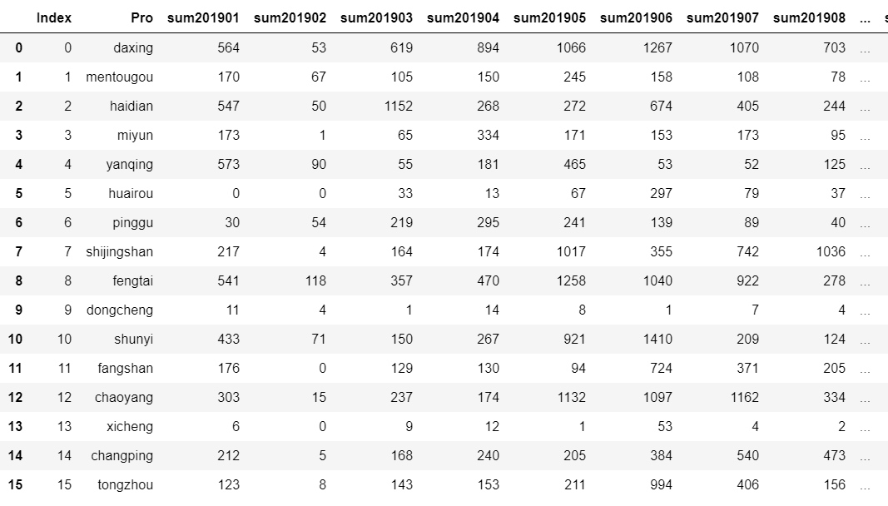

**Result**

After we visualize the data, the page we make is shown in the following figure.

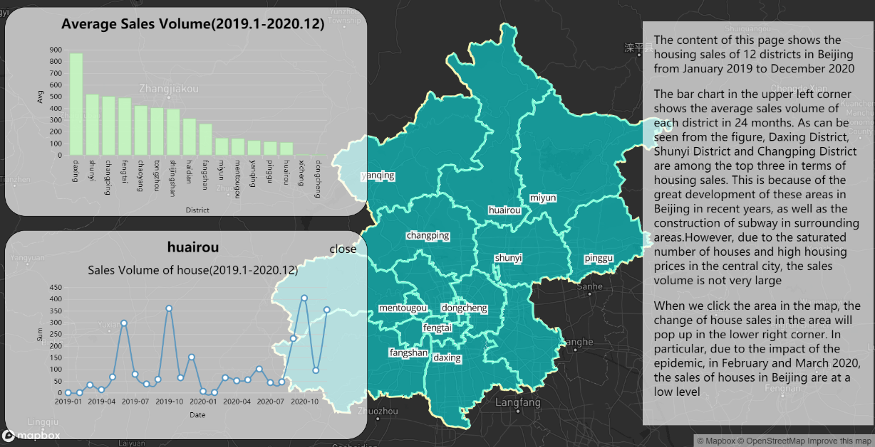

We divided the whole page into four parts. First of all, in the base map, we choose the administrative district distribution map of Beijing, and the blue area in the map is our research area. In the upper left corner of the page is a bar chart of the average house sales in each urban area in 24 months. When we click on different districts in the base map, the lower left corner of the page will show the change of the house sales in this district within 24 months. On the right side of the page is a text description.

**Analysis**

The figure below shows the average housing sales of 16 urban areas in 24 months.

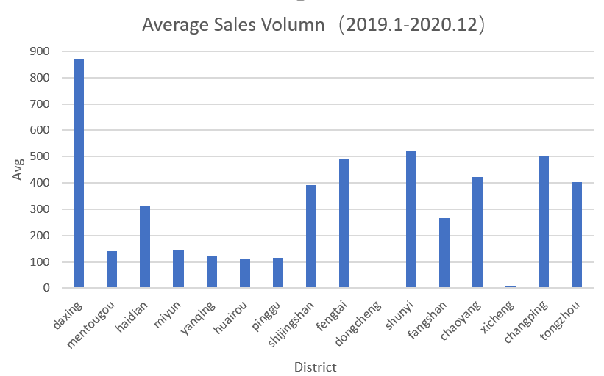

It can be seen from the figure that the housing sales of Daxing District, Shunyi District and Changping District are higher in 2019 and 2020. Among them, Daxing District Housing sales accounted for about 20% of the total sales. However, we can see from the map that the areas with high housing sales are not located in the center of the city. On the contrary, the East and west districts in the city center sell less houses. After our analysis, the reasons can be divided into the following aspects. First, although Dongcheng District and Xicheng District, located in the center of Beijing, have superior geographical location, it is precisely for this reason that housing prices are too high for ordinary people to pay high fees. In addition, in recent years, the central city of Beijing has implemented strict restrictions on house purchase, and the number of houses is saturated, so the sales volume is not high.Second, with the rapid development of transportation in Beijing in recent years, especially the construction of subway and expressway, the surrounding areas of the central urban area are gradually booming. Relatively speaking, Daxing District, Shunyi District and other places have medium housing prices, and the geographical location is not particularly remote. Therefore, the houses here are more cost-effective. Third, Beijing Daxing International Airport will be officially put into operation in September 2019. This is the largest airport in the world. The use of Daxing International Airport has also led to the development of surrounding infrastructure. Therefore, in recent years, the sales volume of houses in Daxing District is far ahead.

What we designed in the page is to show the change of housing sales in each district within 24 months. For the convenience of analysis, we show the change of housing sales in Beijing in 24 months in the figure below.

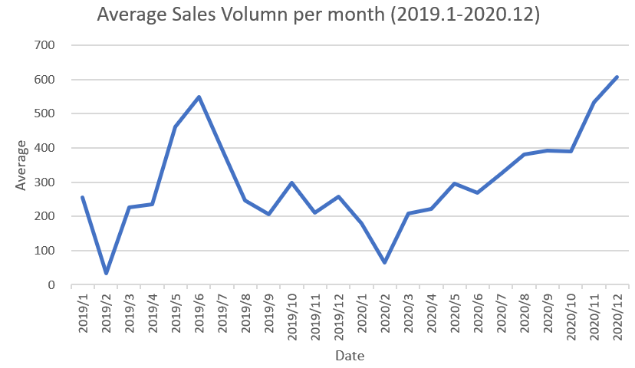

From the above figure, we can basically divide the housing sales in Beijing into different time periods according to the time. The peak season is from April to August, and the off-season is from January to February. For the rest of the time, Beijing's housing sales remained between 200-300 units per month. This is because Beijing is a city with a large floating population, and China's Spring Festival is mainly concentrated in January and February. Therefore, during this period, the sales of houses are not high. After the Spring Festival, the property market is warming up. However, 2020 is a special year. At the beginning of 2020, China will be attacked by Covid-19. In order to control the spread of the epidemic, the government implemented home isolation measures, so all industries were relatively depressed at the beginning of the year. After March 2020, the epidemic situation is gradually under control, and the state has implemented a series of measures to stimulate economic development, including preferential policies in the housing market. Therefore, we can see from the figure that the housing sales in Beijing have been rising in 2020, which also shows that the economy is gradually developing in a good state.

**Conclusion**

From the above analysis, we can see that housing sales and house prices are actually two factors restricting each other. On the one hand, when the house price is too high, people's purchasing power is insufficient, which will lead to the decline of housing sales. On the other hand, housing sales will directly affect the trend of the property market, affecting the local house prices. In addition, housing sales will also be affected by many external factors, but in the final analysis, these factors also affect the housing price first, and then affect the sales.

To be exact, the relationship between housing sales and prices is very complex, and the space of this study is limited, so we only analyze the possible laws. The focus of this experiment is to discuss the impact of some basic factors on house prices, and then we will analyze them in detail.