**Jiminy Cricket**



Charles Madere, Geonathan Sena, Jarrad Pinestraw, and Joseph Gautier

Advisor: Dr. Kuo-pao Yang

Abstract- We Paint is a 100% web browser paint application that allows two Facebook friends to socialize and enjoy their very own private paint room. It also allows the users to download their paintings and chat with the Facebook friend that they are currently painting with.

Keywords – Paint, Canvas, HTML5, Chat, Color, PHP, JavaScript, CSS, MySQL

**Introduction**

Team Jiminy Cricket is a new software development group that consist of; Charles Madere (The Group Leader), Geonathan Sena, Jarrad Pinestraw, and Joseph Gautier. The self-titled project, “We Paint”, is a project that leans heavily towards the web based aspect of developing. By using the browser as a paint program combined with Facebook and its own built in chat all without using flash they hope to create something that not many have been able to do or even thought of doing. This technical report goes into the details of the “We Paint” project, its reason for coming to existence, its implementation, the approach taken to get it there, and finally the conclusion to this project.

**The Problem**

There aren’t too many web painting programs that allow friends to socialize and have fun while sharing a canvas to paint on. There also aren’t many that are powered by HTML5 and use the Facebook API to help keep friends connected in a unique way.

**Software Approach and Implementation**

“We Paint” was developed using HTML5 as a true platform basis and the group used the Facebook API to blend in their Facebook features. They also used a lot of PHP, JavaScript, and a small amount of CSS. The site is being hosted on Southeastern’s Netsal server, and is able to run on any browser that supports HTML5.

**Conclusion**

Although everything works as it’s supposed to Team Jiminy Cricket is still searching for and implementing new things in order to make this site the best HTML5 non-flash painting site on the net as any true innovator would.

**References**

Umm can you guys fill this in im not sure of all the refs we used

**Team Biography**

Charles Madere is

Geonathan Sena is

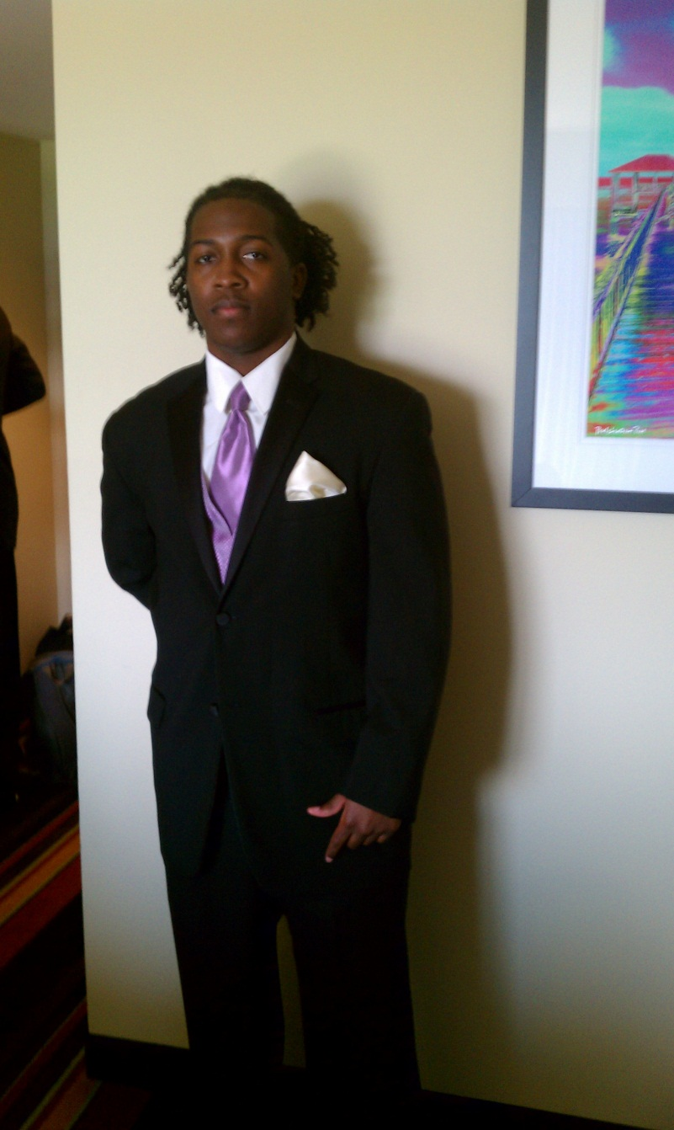Jarrad Pinestraw is a junior at Southeastern. He started his freshman year as undecided, but by his sophomore year he found his curiosity for technology growing in a world now surrounded by many technological advancements that just continues to take over our world. He then set his college career on what he calls the future of mankind, computer science. He chose the information technology concentration and thinks this is the best decision he could have made as a career. He strives to do his best.

Joseph Gautier is