**DEEP CONVOLUTION NEURAL NETWORK FOR BIG DATA MEDICAL IMAGE CLASSIFICATION**

**Objective:** The objective of this project is about classifying the various medical images for various body organs. This method of image classiﬁcation is beneﬁcial to predict the appropriate class or category of unknown images. As, Digital images play a vigorous role in predicting the patient disease intensity and there are vast applications of medical images in diagnosis and investigation.

**Abstract:** Deep learning is one of the most unexpected machine learning techniques which is being used in many applications like image classiﬁcation, image analysis, clinical archives and object recognition. With an extensive utilization of digital images as information in the hospitals, the archives of medical images are growing exponentially. Digital images play a vigorous role in predicting the patient disease intensity and there are vast applications of medical images in diagnosis and investigation. Due to recent developments in imaging technology, classifying medical images in an automatic way is an open research problem for researchers of computer vision. For classifying the medical images according to their relevant classes a most suitable classiﬁer is most important. Where we are proposing our model where the algorithm is trained for classifying medical images by deep learning technique. A pre-trained deep convolution neural network (GoogleNet) is used that which can classifies the various medical images for various body organs. This method of image classiﬁcation is beneﬁcial to predict the appropriate class or category of unknown images. The results of the experiment exhibit that our method is best suited to classify various medical images.

**Keywords:** Medical image classiﬁcation, pre-trained DCNN, convolution neural network, deep learning

**Existing System:** This model emphasizes an existing method that which is designed using the machine learning architecture which is used to classify the various medical images. With an extensive utilization of digital images as information in the hospitals, the archives of medical images are growing exponentially. Digital images play a vigorous role in predicting the patient disease intensity and there are vast applications of medical images in diagnosis and investigation. To make this in the easier way Support Vector Machine (SVM) is used that which can classifies the various medical images for various body organs. The block diagram of the existing method is shown in the below figure.

**Disadvantages of Existing System:**

* Low efficiency.
* Time consuming.
* High complexities.
* No accurate classification

**Proposed System:**

The proposed model emphasizes a deep network architecture which is used to classify the various medical images. With an extensive utilization of digital images as information in the hospitals, the archives of medical images are growing exponentially. Digital images play a vigorous role in predicting the patient disease intensity and there are vast applications of medical images in diagnosis and investigation. Hence, we are proposing our model where the algorithm is trained for classifying medical images by deep learning technique. A pre-trained deep convolution neural network (GoogleNet) is used that which can classifies the various medical images for various body organs. The block diagram of the proposed model is shown in the below figure.

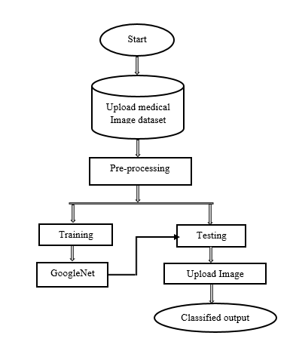

**Fig . Block diagram of proposed method**

**Advantages:**

* High efficiency.
* Time Saving.
* Inexpensive.
* Low complexities.

**Applications:**

* Useful for the hospitals to detect brain strokes using this application.

**Software & Hardware Requirements:**

# **H/W Configuration:**

# Processor : I3/Intel Processor

* Hard Disk : 160GB
* RAM : 8Gb

**S/W Configuration:**

* Operating System : Windows 7/8/10 .
* Server side Script : HTML, CSS & JS.
* IDE : Pycharm.
* Libraries Used : Numpy, IO, OS, Flask, keras.
* Technology : Python 3.6+.

**LEARNING OUTCOMES:**

* Practical exposure to
  + - * Hardware and software tools
      * Solution providing for real time problems
      * Working with team/individual
      * Work on creative ideas
* Testing techniques
* Error correction mechanisms
* What type of technology versions is used?
* Working of Tensor Flow
* Implementation of Deep Learning techniques
* Working of CNN algorithm
* Working of GoogleNet algorithm
* Building of model creations
* Scope of project
* Applications of the project
* About Python language
* About Deep Learning Frameworks
* Use of Data Science