TESTING

SYSTEM

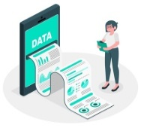

DIFFERENT ORGAN IMAGES

PHOTO

UPLOADED IMAGES

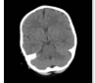

RIGESTER

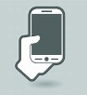



TAKE IMAGE

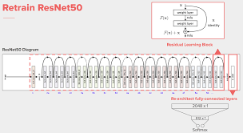

UPLOAD FILES

TAKE IMAGE

GOOGLENET

FILES



LOGIN

REGISTERED USERS DATA

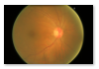

USER

Eye



Brain

DATA BASE