DHT22 - Temperature and Humidity Sensor

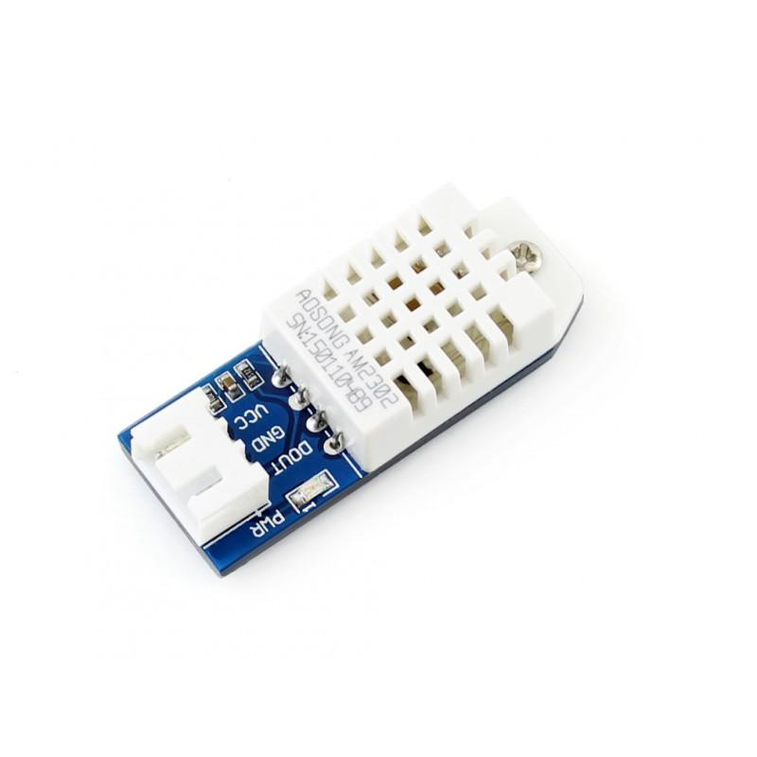

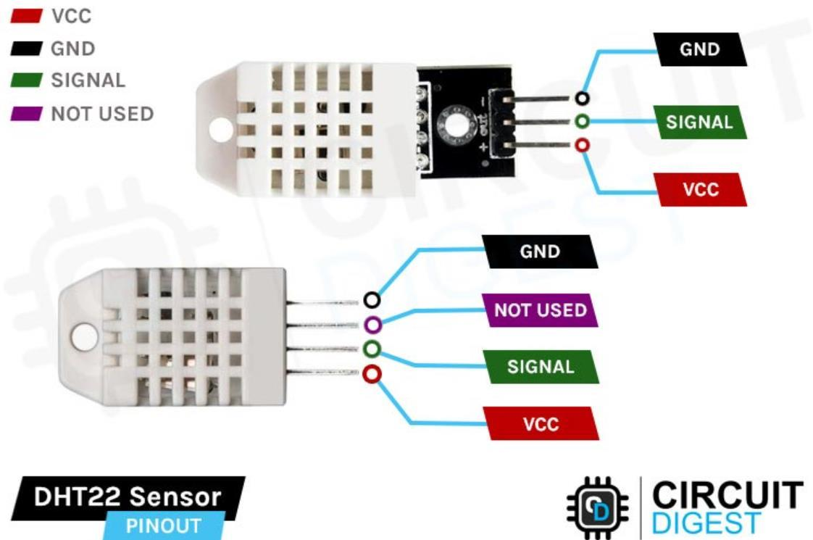

Description

The DHT22 Temperature and Humidity Sensor is an electronic module used to measure the temperature and humidity in the environment. It contains a capacitive humidity sensor and a thermistor that convert environmental data into digital signals. The sensor provides accurate and stable readings that can be processed by microcontrollers such as Arduino, ESP32, and Raspberry Pi.

Applications

- Weather monitoring systems
- Smart home automation
- Greenhouse monitoring
- Air conditioning systems
- Humidity control systems
- IoT environmental monitoring projects
- Temperature logging devices
- Robotics projects
Function
- Measures ambient temperature and humidity.
- Converts environmental data into digital signals.
- Provides high accuracy and stable readings.
- Communicates using a single digital signal pin.
- Can monitor environmental conditions in real-time.

