TFSWIWatcher

About

TFSWIWatcher is a service allowing you to register for watching workitems in Team Foundation Server. The service can be configured to use different logic to retrieve accounts to be notified and to deliver messages to the accounts to be notified.

In the standard configuration TFSWIWatcher will be notified if a workitem has changed. The ObserverAccountProvider will retrieve the value of the field "DNE.Observers" from the current workitem to get the account names to be notified.

Each account name has to be on a single line:

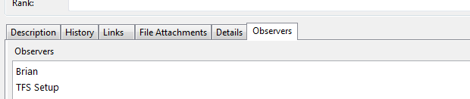

TFSWIWatcher will then determine the email addresses of the provided account names and will send an email using the provided WorkItemChangedEvent.xsl and the email-settings defined in TFSWIWatcher.Service.exe.config.

By default TFSWIWatcher will log status information to a file called "log.txt" in the application directory. The logfile is configured for not getting bigger than 1 MB in size.

Requirements

* [.Net 3.5 SP 1](http://www.microsoft.com/downloads/details.aspx?familyid=ab99342f-5d1a-413d-8319-81da479ab0d7&displaylang=en)
* [Visual Studio Team System 2008 Team Foundation Server Power Tools](http://msdn.microsoft.com/en-us/tfs2008/bb980963.aspx)

Installation with default settings

**.Net Framework 3.5 SP 1 Installation**

If you've not already installed .Net Framework 3.5 please download and install it using the link under >> Requirements <<.

**Team Foundation Power Tools Installation**

If you've not already installed TFPT please download and install it using the link under >> Requirements <<. You will need TFPT to complete the next step.

**Adding the Observer-Tab for Workitems**

After installing TFPT there will be a new Menu under Tools called "Process Editor":

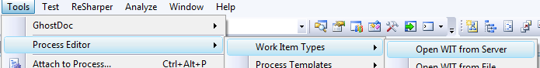

Please navigate to the selection in the above screenshot.

In the next dialog choose one of the provided workitem types (you will need to reapeat the following steps for all other types):

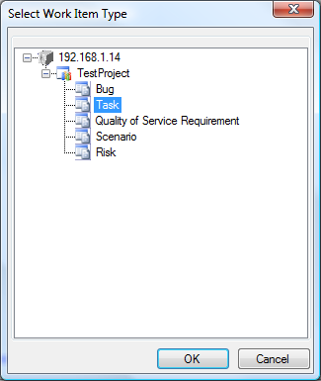

In the next dialog click "New" and fill the poup with the Information from the screenshot and press "ok":

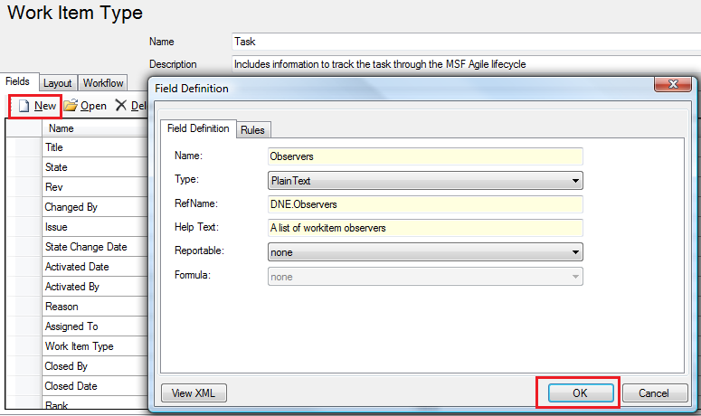

In the Layout tab add a new "Tab Page" to "TabGroup":

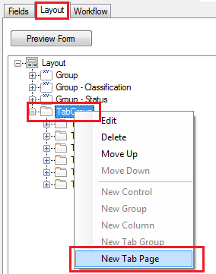

Call it "Observers":

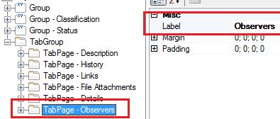

Add a "New Control" to the newly created Tab Page:

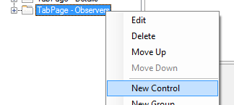

Configure the Control exactly as in the following screenshot:

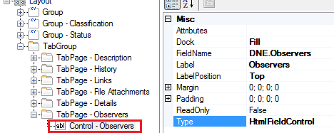

Save the result and after opening a workitem you'll have a new Tab "Observers":

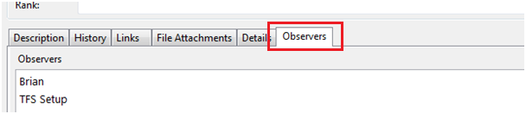

**Settings in TFSWIWatcher.Service.exe.config**

There are 2 important sections "appSettings" and "system.net". Please change the Teamserver in appSettings and if the provided port conflicts with another app on the server running TFSWIWatcher please also change the port:

<appSettings>

<add key="TeamServer" value="http://yourteamserver:8080"/>

<add key="LocalServicePort" value="50782"/>

</appSettings>

After this please configure your mail settings in the following section:

<system.net>

<mailSettings>

<smtp deliveryMethod="Network" from="TFSWIWatcher@YourDomain">

<network host="YourMailServer" port="25" />

</smtp>

</mailSettings>

</system.net>

**Installing the service**

Just run the "install.bat" script to install the service. You will be prompted for credentials the service should run with. Please specify an account having enough rights for the Team Foundation Server.

**Start-Options for the Service**

After installing the service, the service can be found in the service control panel as "TFSWIWatcherService". Configure the service like in the following screenshot:

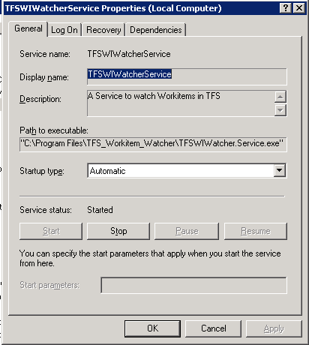

Further Configuration

A lot of stuff can be configured. Detailed information about the configurations will be provided in later versions of this document. Stay tuned!