TMSPS Developer Documentation

# Requirements

* good .Net knowledge
* good knowledge in C#
* german or english language knowledge
* latest version of trackmania server
* [Visual Studio 2008](http://download.microsoft.com/download/A/5/4/A54BADB6-9C3F-478D-8657-93B3FC9FE62D/vcssetup.exe)

# Where to start?

The project is hosted on CodePlex here: <http://tmsps.codeplex.com/>

The Solution to open is located here: $/Trunk/TMSPS.sln

# Opening the Solution

When you've got the source and opened TMSPS.sln in Visual Studio 2008, you'll get a dialog asking you how to load the projects in this solution. this is because the project **TMSPS.Daemon** has a modified project file causing an automatic deployment after compilation. Please choose "**Load project normally**" and **uncheck the checkbox** at the bottom of the dialog.

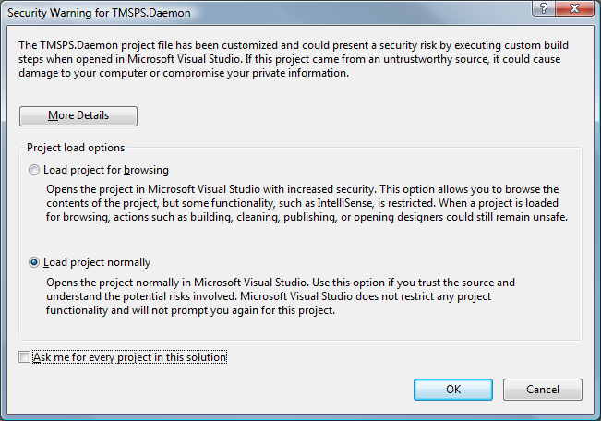

# Compiling the Solution

When you try to compile the solution right after opening it, you receive the following 2 errors:

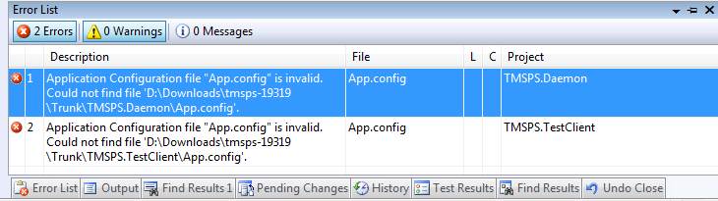

This is because all configuration files like app.config and other developer specific files are only marked to be part of the project but are not contained within the project. This is because each developer will have different settings in these files and if the files would be under source control, every developer would need to have the files checked out to edit them. So what should you do with the errors? **A yellow exclamation mark in the solution explorer states a missing file:**

|  |  |
| --- | --- |
| There is a file with the postfix "**_template**" for every missing file. Your job is it to create the missing file using the content of the file having the postfix "**_template**". For example App.config is missing as you can see. Just make a copy of App_template.config and rename it to App.config in both projects. |  |

There are a few more missing files in the root of the project **TMSPS.Daemon** as well as in all the subfolders of the Plugin folder. Repeat the above procedure for all the files marked with a **yellow exclamation mark** you find within the project **TMSPS.Daemon**. When you're finished with the procedure the solution should compile just fine.

# Starting with the TestClient

The TestClient is supposed to be the playground for developers where they can test the TMSPS API easily. To get the TestClient running you need to configure the following 3 lines within the **app.config**:

<appSettings>

<!-- The IP address of your TM-Server -->

<add key="ServerAddress" value="192.168.1.3"/>

<!-- The xmlrpc_port set in dedicated.config of the TM-Server -->

<add key="ServerXMLPort" value="4505"/>

<!-- The passsword of the superadmin user set in dedicated.config of the TM-Server -->

<add key="SuperAdminPassword" value="supersecure"/>

</appSettings>

You can now start the TestClient and try to connect and activate callbacks. You'll see the responses of the commands in the Log-Tab. When you've activated Callbacks you'll see messages in the log when someone is chatting or the map is changing an so on.

For testing the API of TMSPS you can just add new menu entries trying to call a few Methods you can find here: "**Client.Methods.XXX**". Have fun exploring the TMSPS universe!

More to come later!!!