Trackmania Service Wrapper

## Requirements

- .Net Framework 3.5 (available [here](http://www.microsoft.com/downloads/details.aspx?FamilyID=333325fd-ae52-4e35-b531-508d977d32a6&displaylang=de))

## Delivered Files

* install.bat
* uninstall.bat
* TMSPS.TrackmaniaServiceWrapper.exe
* TMSPS.TrackmaniaServiceWrapper.exe.config

## Configuration & Testing

Open the file **» TMSPS.TrackmaniaServiceWrapper.exe.config «** in your favorite editor, for example notepad. It should look like this:

|  |
| --- |
| <?xml version="1.0" encoding="utf-8" ?>  <configuration>  <appSettings>  <add key="StartupFile" value=""/>  <add key="WorkingDirectory" value=""/>  <add key="StartupParameters" value="/internet /dedicated_cfg=dedicated.config /game_settings=tracklist.txt /noautoquit"/>  <add key="HideProcess" value="true"/>  </appSettings>  </configuration> |

You should modify this config to represent your local settings. For example, if your server is located at **» C:\TM-Server «** the config would be:

|  |
| --- |
| <?xml version="1.0" encoding="utf-8" ?>  <configuration>  <appSettings>  <add key="StartupFile" value="**C:\TM-Server**\TrackmaniaServer.exe"/>  <add key="WorkingDirectory" value="**C:\TM-Server**\"/>  <add key="StartupParameters" value="/internet /dedicated_cfg=dedicated.config /game_settings=tracklist.txt /noautoquit"/>  <add key="HideProcess" value="true"/>  </appSettings>  </configuration> |

You can test whether your config is correct by setting **» HideProcess «** to **» false «**. This way the trackmania server window is not hidden at startup. Than just start the wrapper by double clicking the file **» TMSPS.TrackmaniaServiceWrapper.exe «**. Your result should be equal to the following screenshot:

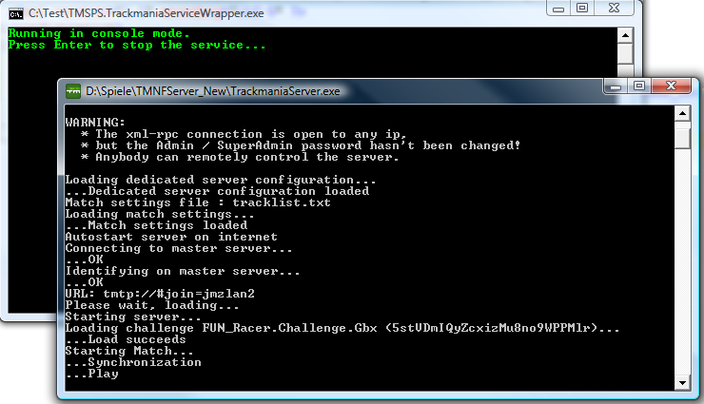

You can test to close only the trackmania server window. It should immediately restart. Your configuration is done, close both windows now and dont forgett to reset **» HideProcess «** to **» true «** in the config file. Continue reading at the installation section now.

## Installation

To install the service simply run the **» install.bat «** batch file. If you're running multiple trackmania server instances on the same computer you can open the **» install.bat «** batch file and modify the highlighted part for each installation:

%windir%\Microsoft.NET\Framework\v2.0.50727\InstallUtil.exe TMSPS.TrackmaniaServiceWrapper.exe --ServiceName="**Trackmania Server Service Wrapper**"

pause

After running **» install.bat «** you'll be prompted with the following dialog:

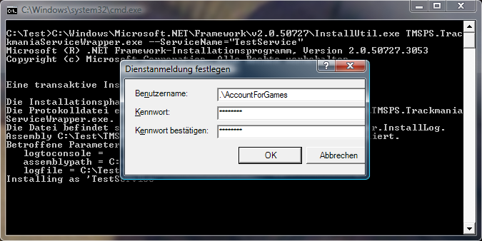

Enter the account, the service should run with, in the first textbox and enter the password for this account in the second and third textbox. Than press ok. The installation is finished.

When you open up the services interface of windows you'll find the service with a startup type of "manual":

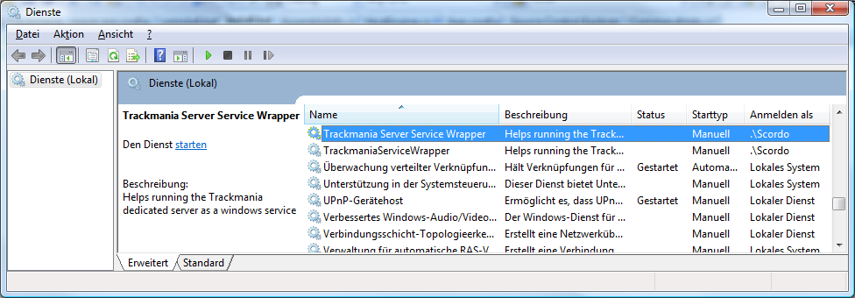

Double-click it and change the startup type to automatic if you want:

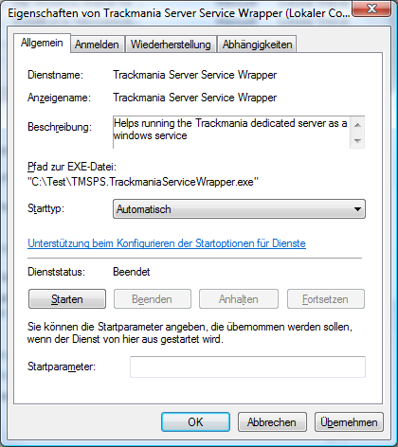

A good practice is to set the recovery scheme, to restart the service on failure:

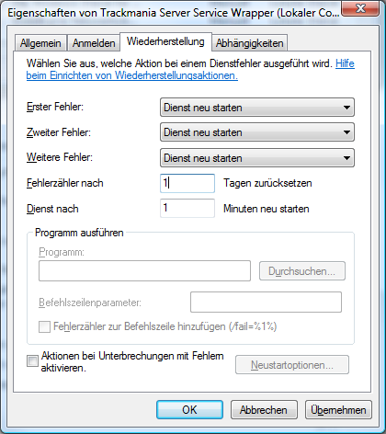

That's all, just start the service now and try to connect to your trackmania server.

## Uninstall

To uninstall the service simply run the **» uninstall.bat «** batch file. If you're running multiple trackmania server instances on the same computer you can open the **» uninstall.bat «** batch file and modify the highlighted part for each installation:

%windir%\Microsoft.NET\Framework\v2.0.50727\InstallUtil.exe TMSPS.TrackmaniaServiceWrapper.exe -u --ServiceName="**Trackmania Server Service Wrapper**"

pause

## Homepage

The home of this project is here: <http://tmsps.codeplex.com>