FutureWorld Robotics
The First Interactive AI Robotics Center
Business Plan — Governmental (GASB) Edition
Sorphoan (Jack) Ear, Founder · FutureWorld Robotics · June 2026 · Financials on a GASB enterprise-fund basis
▢ IMAGE PLACEHOLDER
Exterior / entrance at dusk — generate from Image Prompts #21

Confidential — for discussion purposes

Contents
1. Executive Summary
2. Company Overview & Vision
3. The Product & Experience
4. Market Opportunity
5. Competitive Analysis & Positioning
6. Business Model & Revenue Streams
7. Marketing & Go-to-Market
8. Operations & Facility
9. Implementation Timeline
10. Management Team & Organization
11. Risk Analysis & Contingency
12. Legal & Entity Structure
13. Financial Plan
14. Funding Ask & Use of Funds
15. Appendices

1. Executive Summary
FutureWorld Robotics will be the first interactive AI robotics center in the United States — a premium attraction where guests meet lifelike, conversational humanoid robots, including celebrity androids, and journey from the dawn of robotics to the age of AI. Unlike a static wax museum, every figure talks and interacts, and an ever-changing, vendor-funded content engine gives guests a reason to return.
The center opens on a fast-track schedule: a soft opening targeted for Christmas 2026 and a full-scale grand opening in Q1 2027, in a leased, phased 36,000 sq ft facility (24,000 sq ft built first). Seventeen revenue streams — led by admission, on-site spend, and memberships, and complemented by education, exhibitor showcases, sponsorships, and CES-style events — drive projected operating revenue of $35.5M in the first year, rising to $50.8M by year five. As a tax-exempt governmental enterprise fund, the center reports a change in net position rather than net income; income before capital contributions grows from $10.8M to $19.9M, and total net position rises to $95.0M by year five.
The center is capitalized with $22 million — a $16M capital contribution and $6M of tax-exempt revenue bonds — to fund the build-out, robot fleet, systems, and launch. Sourcing is anchored by established China manufacturing partners, enabling rapid, cost-effective fleet delivery, with U.S. manufacturing added over time. The venture is led by founder Sorphoan (Jack) Ear and co-founder Omar Sadek, a robotics-industry CEO.
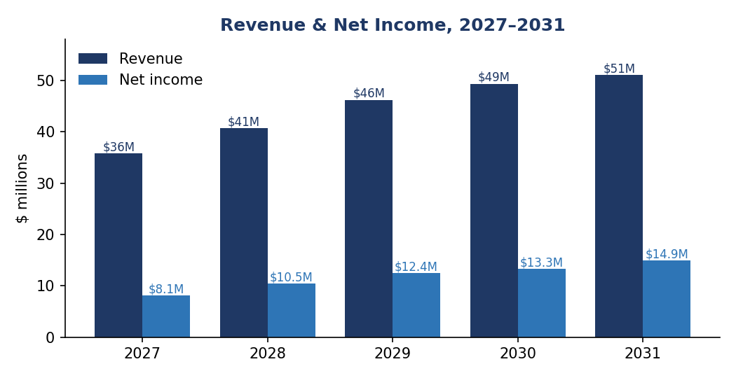
Projected operating revenue and change in net position, 2027–2031

2. Company Overview & Vision
FutureWorld Robotics is a premium experiential attraction dedicated entirely to robotics — past, present, and future. Its mission is to make advanced robotics and AI tangible, inspiring, and accessible: to let the public meet, talk to, and learn from lifelike machines, and to inspire the next generation of robotics engineers.
The experience stages a journey from the earliest mechanical automatons and industrial robots through to today's lifelike AI humanoids — a living museum of robotics that doubles as an education center and a stage for the newest inventions. The vision is to establish the category-defining “AI robotics center” brand and expand it over time through new locations, traveling exhibits, and format licensing.

3. The Product & Experience
The heart of FutureWorld Robotics is its fleet of lifelike, conversational robots. A marquee Celebrity Android Hall features humanoid androids of iconic figures that can talk and interact in character; surrounding galleries trace the history of robotics into the AI era, with interactive demonstrations, performer robots, and quadruped robo-animals throughout.
The core differentiator is the content engine. The floor is ever-changing and partly vendor-funded: robotics and technology brands place and refresh exhibits, so the experience evolves continuously — driving repeat visits and recurring, partner-funded content that a fixed attraction cannot match.
▢ IMAGE PLACEHOLDER
Celebrity Android Hall — hero image — generate from Image Prompts #18

▢ IMAGE PLACEHOLDER
Main experience floor — generate from Image Prompts #20

4. Market Opportunity
The United States leads the world in attraction attendance and discretionary entertainment spend, and public fascination with AI and humanoid robots is at an all-time high. FutureWorld Robotics targets a leading destination market; three candidates were analyzed — Los Angeles (~50M annual visitors), Las Vegas (~38.6M, the proven home of premium experiential attractions and CES), and Orlando (~76.7M, the most-visited U.S. destination).
Market size is not the binding constraint in any candidate city: the plan requires capturing well under 1% of annual visitors and only a low single-digit share of the attraction-going segment.
Sizing (illustrative) | Los Angeles | Las Vegas | Orlando
TAM — annual visitors | 50.0M | 38.6M | 76.7M
SAM — paid-attraction visitors (15%) | 7.5M | 5.8M | 11.5M
SOM — Year-5 capture (270k) | 3.6% | 4.7% | 2.3%
TAM/SAM/SOM = Total / Serviceable Available / Serviceable Obtainable Market. The full three-city comparison is in the appendix.

5. Competitive Analysis & Positioning
Comparable attractions validate demand: every candidate city already hosts a Madame Tussauds, and premium experiential venues such as Sphere and AREA15 prove that audiences pay top prices for a genuine “wow.” FutureWorld Robotics' wedge is clear and ownable — lifelike robots guests can talk to, not static wax — supported by the rotating content engine.
Pricing follows a deliberate skim curve: a premium launch ticket easing over five years as the market broadens, benchmarked against leading U.S. attractions. The detailed pricing benchmark is in the appendix.

6. Business Model & Revenue Streams
FutureWorld Robotics earns across seventeen streams, which diversifies risk and lifts revenue per visit. The model is consumer-led — admission, on-site spend, and memberships — complemented by higher-margin, faster-growing business lines.
- Core gate: general & signature admission; memberships & season passes.
- On-site: photo experiences; retail; robotic café; robotic restaurant; robot vending.
- Education: courses & field trips; summer & holiday camps; birthday parties.
- Business & strategic: exhibitor/showcase booths; sponsorship & naming rights; corporate events & private hire; CES-style conference & event hosting; robot-for-hire/mobile shows; grants; traveling-exhibit licensing.
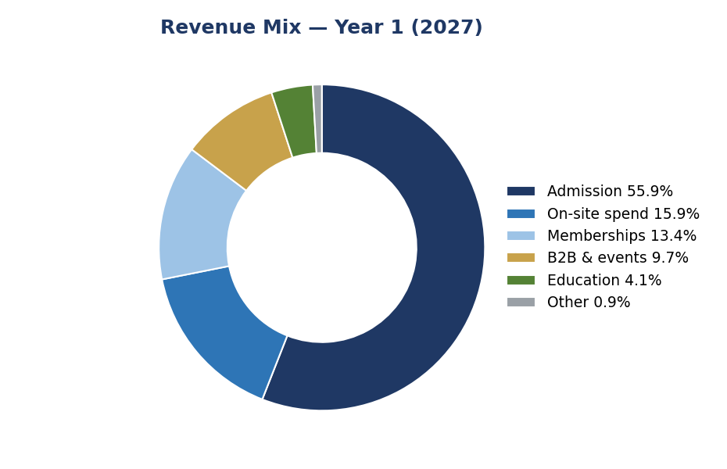
Revenue mix, Year 1 (2027)

7. Marketing & Go-to-Market
The go-to-market plan is weighted to where revenue comes from. Consumer demand (gate, on-site, memberships, education) accounts for roughly 89% of Year-1 revenue and is the primary focus; business lines (exhibitors, sponsors, corporate and conference) are a focused, growing secondary track.
- Tourists: online travel agencies and resellers, hotel and concierge partnerships, and tourism-board co-marketing.
- Local families & members: digital and social, a founding-membership drive, and community ties.
- Schools & education: direct district outreach and field-trip programs.
- Business: direct sales to robotics and technology brands for booths, sponsorships, and events.
The Year-1 marketing budget of $2.5M implies roughly $15 per visit (about 7% of revenue per visit) — an efficient ratio for a premium attraction. The full plan and KPIs are in the appendix.

8. Operations & Facility
FutureWorld Robotics leases a 36,000 sq ft envelope and builds and opens 24,000 sq ft first, expanding behind a rolling partition over years two to five. Leasing and retrofitting an existing shell — built plain, themed as robots arrive — keeps capital lean and the schedule fast. Robots are sourced primarily through established China manufacturing partners for speed and cost, with U.S. manufacturing added over time.
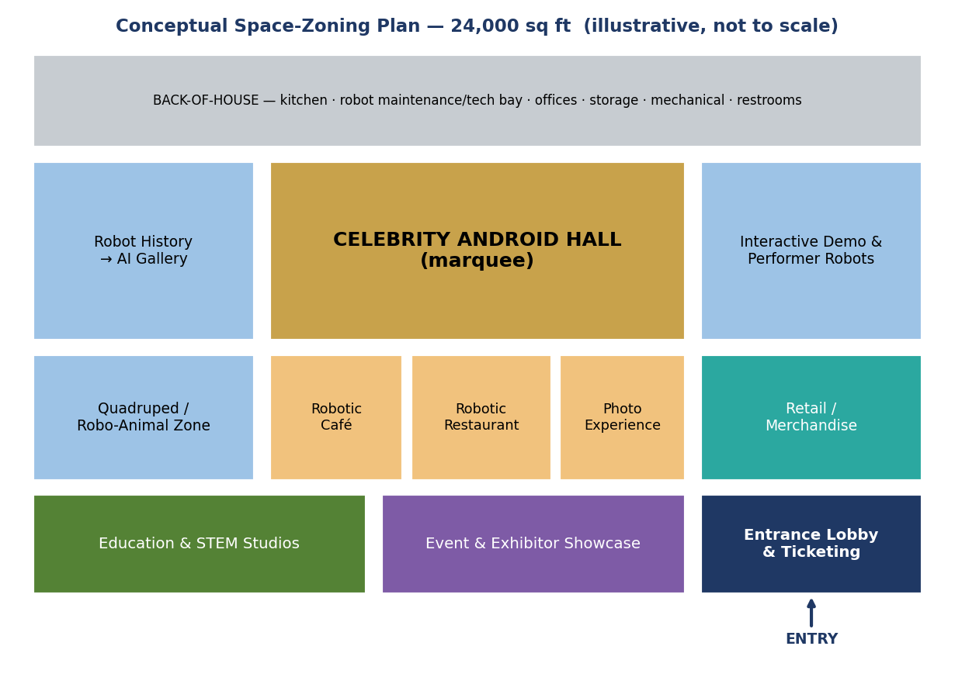
Conceptual space-zoning of the 24,000 sq ft Year-1 floor (illustrative, not to scale)
Cost figures are illustrative planning estimates. Actual build-out and construction costs vary with location, market conditions, materials, and finish quality, and should be confirmed with contractor bids before financing.

9. Implementation Timeline
The plan runs every workstream in parallel from financing close to reach a Christmas 2026 soft opening and a Q1 2027 grand opening — aligned with the financial model's 2027 launch year.
Milestone | Target
Financing close & entity formed | July 2026
Lease, robot orders, licensing begin | July 2026
Construction / fit-out start | August 2026
Robot fleet delivered & integrated | Nov–Dec 2026
Soft opening | Christmas 2026
Grand opening (full-scale) | Q1 2027

10. Management Team & Organization
Name | Role | Background
Sorphoan (Jack) Ear | Founder | DBA, MBA, BBA (Accounting). 25+ years of finance and operations leadership across USAID, construction, and professional services; managed $4B+ in U.S. government funds (USAID Distinguished Honor Award, 2016); led ERP implementations and a $300M+ construction program; founder of NP CFO Advisory LLC.
Omar Sadek | Co-founder | a robotics-industry CEO with robotics and AI expertise; U.S. Navy veteran with 30 years in defense and business leadership. Contributes robotics expertise and the manufacturing/supplier network.
The plan funds a senior operating layer, led by an experienced attraction General Manager, alongside heads of robotics, creative/show, marketing, and education, with a board and advisory board added as the round closes.

11. Risk Analysis & Contingency
The principal risks and mitigations are summarized below; a full scored register is in the appendix.
- Attendance & willingness-to-pay: 17 streams reduce gate dependence; validated by market sizing and a planned pricing survey.
- Robot delivery & reliability: established China supply chain, deep roster, dedicated technicians, and a maintenance budget.
- Likeness rights: license controlled estates and fill the floor with public-domain figures.
- Geopolitical/China & operating leverage: supplier diversification, a defense firewall, and a flexible cost base.

A/B/C contingency (flex-cost) plan
The cost base flexes to demand. All three scenarios remain surplus-positive (positive operating income and change in net position), including a 60%-attendance downside.
Scenario | Attendance | Revenue Yr1→Yr5 | Operating income Yr1→Yr5
A — Full scale | 165k→270k | $35.8M→$51.1M | $11.0M→$20.1M
B — Base (~80%) | 132k→216k | $29.4M→$42.4M | $6.3M→$15.2M
C — Lean (~60%) | 99k→162k | $23.0M→$33.8M | $3.9M→$12.1M

12. Legal & Entity Structure
Under the governmental scenario, FutureWorld Robotics is operated as a tax-exempt public enterprise fund — for example, an enterprise of, or affiliated with, a public university or public authority — capitalized through a capital contribution and tax-exempt revenue bonds rather than private equity, and paired with an affiliated nonprofit education foundation eligible for grants and donations. Robots are sourced from China through arm’s-length supplier agreements rather than equity, avoiding foreign-investment (CFIUS) review.
A strict legal and supply-chain firewall separates FutureWorld Robotics from the co-founder's defense-robotics business, with suppliers screened against U.S. restricted-party and DoD lists, and Section 301 tariffs budgeted. Likeness licensing for celebrity androids is handled through the controlled estates. Final structure will be confirmed with qualified counsel. The detailed framework is in the appendix.

13. Financial Plan
The five-year model is built bottom-up — revenue by stream, bottom-up staffing and operating costs, capital expenditure, depreciation, and interest. As a tax-exempt governmental enterprise fund, the center reports no income tax. The change in net position is positive every year, and operating margins rise from the low 30s toward roughly 40% (depreciation is included in operating expenses under GASB).
$ millions | 2027 | 2028 | 2029 | 2030 | 2031
Operating revenue | 35.5 | 40.4 | 45.9 | 49.0 | 50.8
Operating income | 11.0 | 14.1 | 16.8 | 17.9 | 20.1
Change in net position | 26.8 | 13.9 | 16.6 | 17.8 | 19.9
Operating margin | 31% | 35% | 37% | 37% | 40%
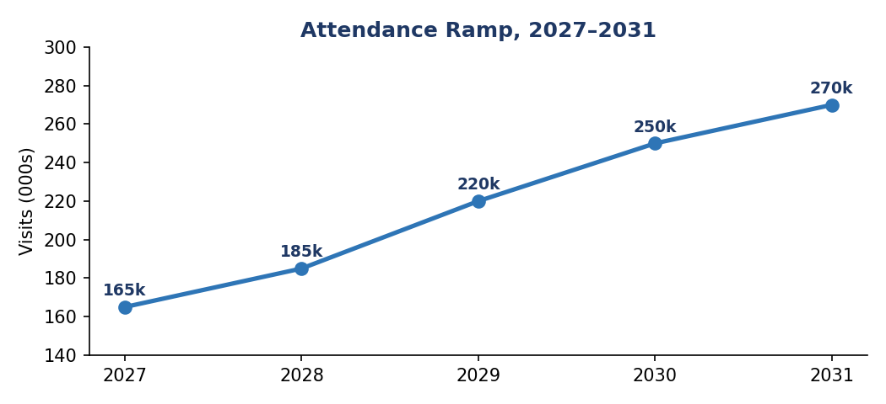
Attendance ramp underpinning the revenue plan
Key assumptions include a 5-year price-skim curve, an attendance ramp from 165k to 270k, $45/sq ft rent, and an 18% robot-maintenance rate. The full model is provided as a separate workbook.
Cost figures are illustrative planning estimates. Actual build-out and construction costs vary with location, market conditions, materials, and finish quality, and should be confirmed with contractor bids before financing.

14. Funding Ask & Use of Funds
FutureWorld Robotics is capitalized with $22 million (range $21–23M): a $16M capital contribution and $6M of tax-exempt revenue bonds (interest-only). The capital funds the venture from financing close to a cash-generating operation, with a positive change in net position from the first full year and roughly $98M of cumulative net cash from operating activities over five years.
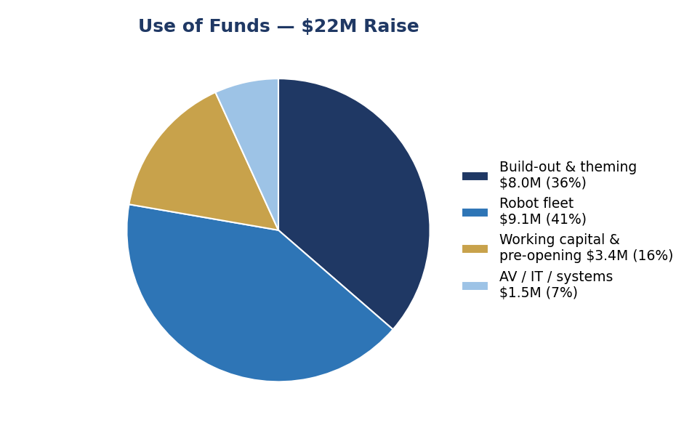
Use of the $22M raise
As a governmental enterprise fund, the center has no private ownership or equity exit; capital is contributed rather than invested for a financial return. Operating surpluses (change in net position) are retained and reinvested in the mission and used to service the revenue bonds, building unrestricted net position over time. Format licensing and traveling exhibits add self-generated revenue, and any future expansion would be financed through additional capital contributions or tax-exempt debt rather than equity.

15. Appendices
The following supporting documents accompany this plan:
- Financial Model — GASB v2 (workbook) — Statement of Net Position; Statement of Revenues, Expenses & Changes in Net Position; direct-method Statement of Cash Flows; MD&A; and notes.
- Market & Location Analysis — three-city comparison and TAM/SAM/SOM.
- Pricing Benchmark — comparable-venue pricing and positioning.
- Revenue Model — detailed per-stream projections.
- Go-to-Market Plan — channels, budget allocation, and KPIs.
- Risk & Contingency Plan — full scored register and A/B/C model.
- Management Team, Implementation Timeline, Licensing Strategy, and Entity & Legal Framework.

