**Project Flow**

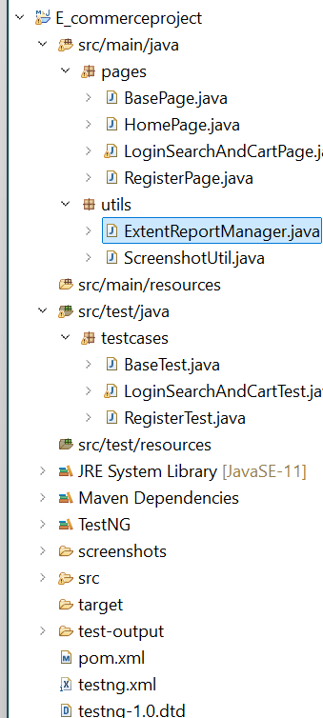

1. BasePage.java - It Contains Test code ,click information which is required in all the derived class behave like a super class.
2. Home page :- It Contains registration, Login and Cart. Its act like to navigator.
3. Login Search and Cart page :- basically login the page along with confirmation,add to cart elements,Navigate to cart,Place order,confirm purchase,loginuser,add to cart and Screenshort.
4. Register Page:- this is user registration page having crendentials
5. Extends Report :- this help of this we can generate Extend Report
6. Base Test :- call home page,register page and login Search and cart

**Note:- To Execute the test kindly click on testng.xml first run the *testcases.RegisterTest then* *testcases.LoginSearchAndCartTest"***