**CMSC203 Assignment 0**

Class: CMSC203 CRN XXXX

 Program: Assignment 0

Instructor: Professor Grinberg

 Summary of Description: (Give a brief description for each Program) A program that requires you to use functions to calculate the volume of a box and the volume of a Sphere.

 Due Date: 2/02/2022

 Integrity Pledge: I pledge that I have completed the programming assignment independently.

 I have not copied the code from a student or any source.

**Complete the following five parts of Assignment 0. Name your file as FirstInitialLastName_Assignment0.docx**

**Part1: Setup GitHub:** Provide the screen shots of your GitHub account with Assignment 0 file is uploaded on GitHub:

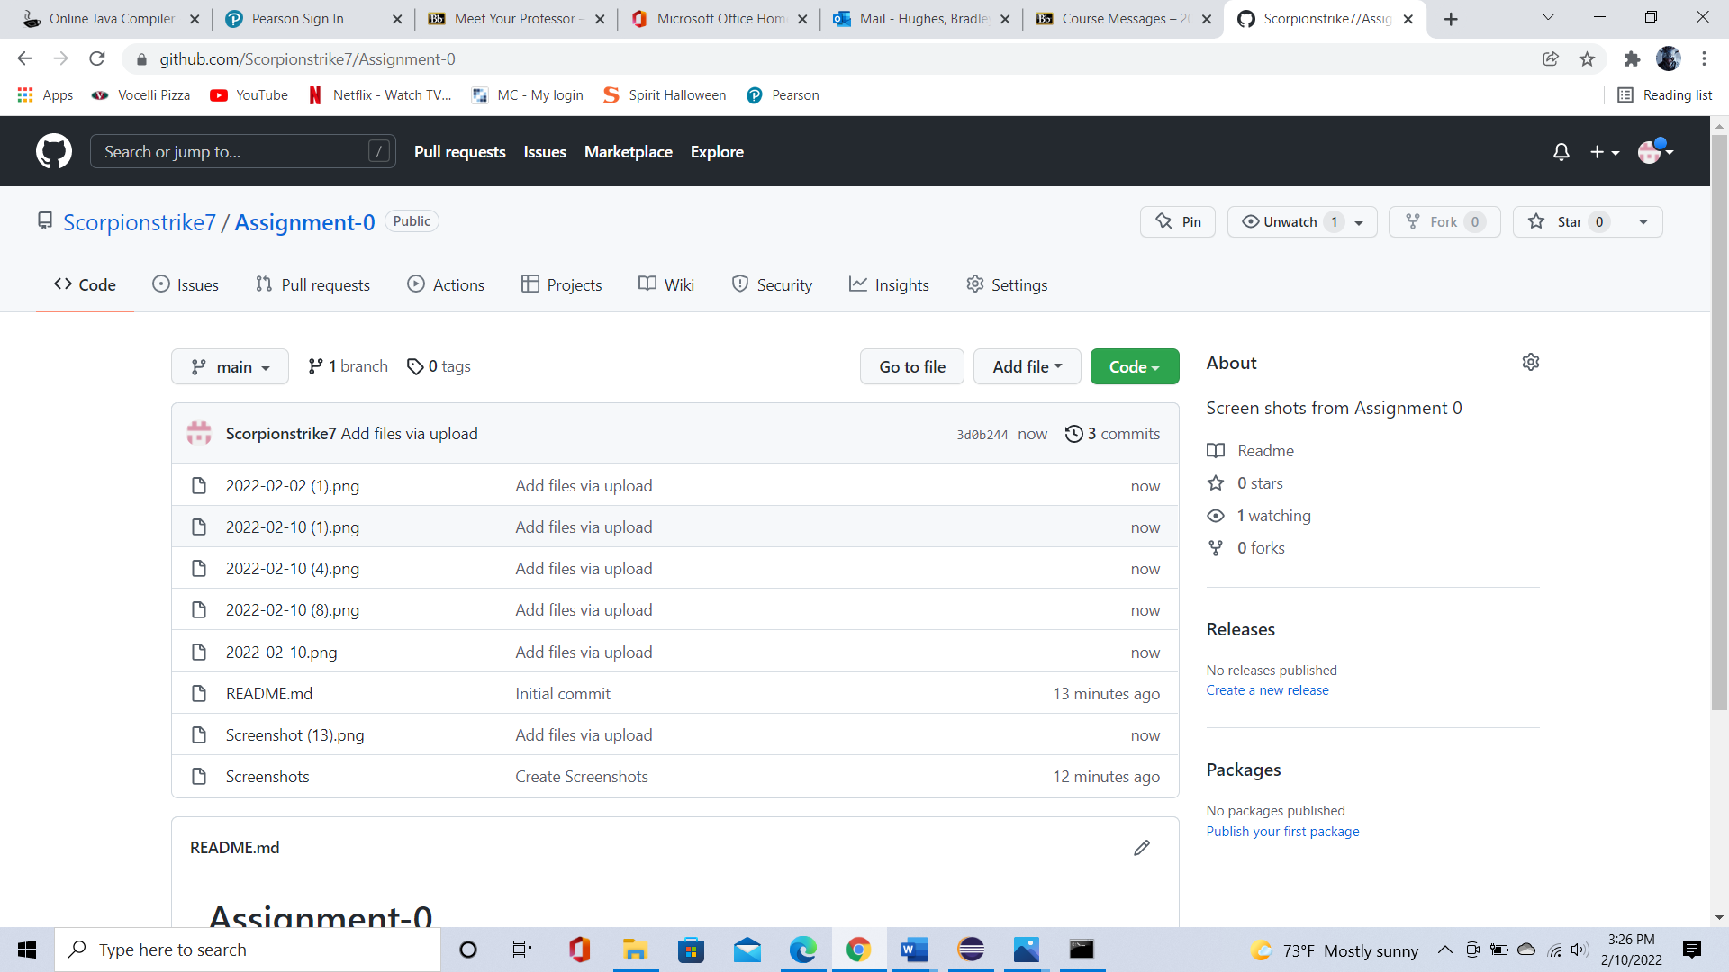

**Part 2 -Install JDK, Test java Application from Command Line**

Provide the screen shots from Step 1 and 2 here:

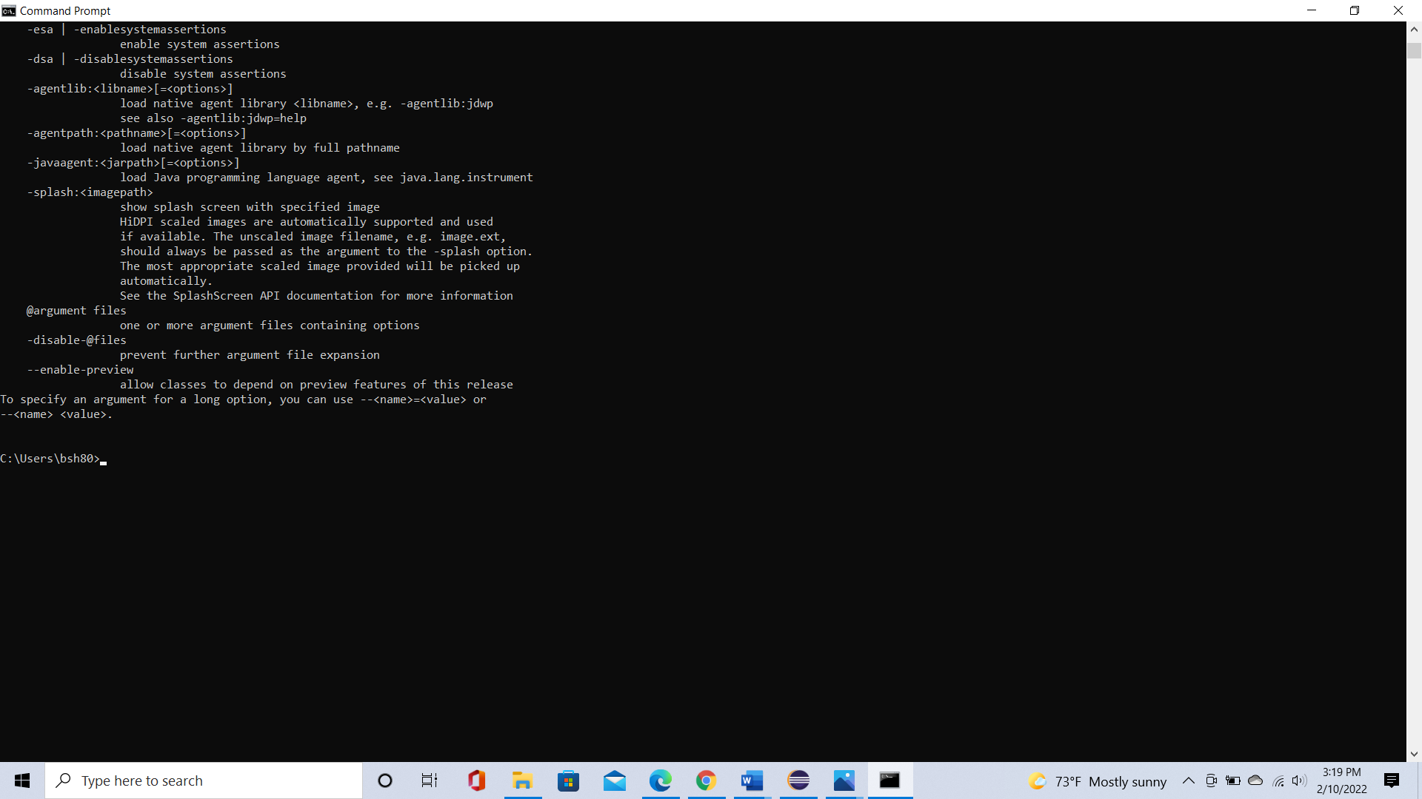

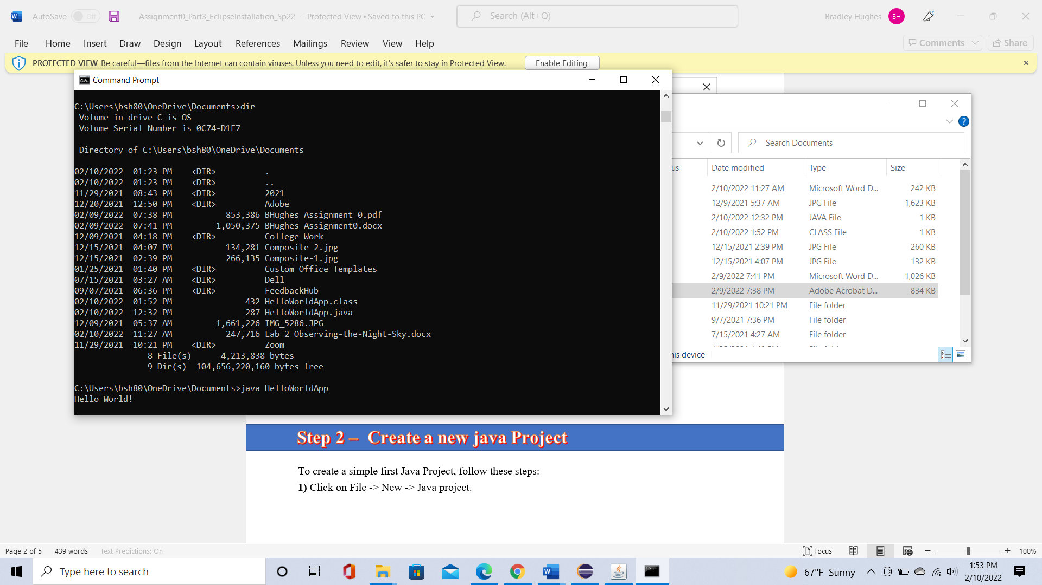

**Part 3 - Install Eclipse, Test Eclipse Java Application**

Provide the screen shots from Step 1 and 2 here:

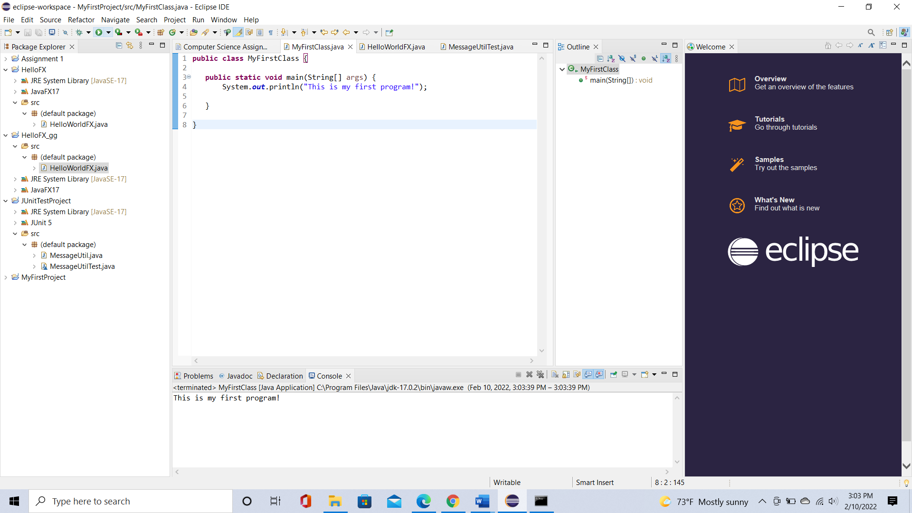

**Part 4 - Install, Setup, Test Junit Program.**

Provide the screen shots showing:

* 1. Eclipse with working JUnit Test example
  2. Project screenshot
  3. Running example screenshot

**Part 5 - Install, Setup, and Test JavaFX Application.**

Provide the screen shots showing:

1. JavaFX Project screenshot
2. Running example screenshot
3. Java Source Code File

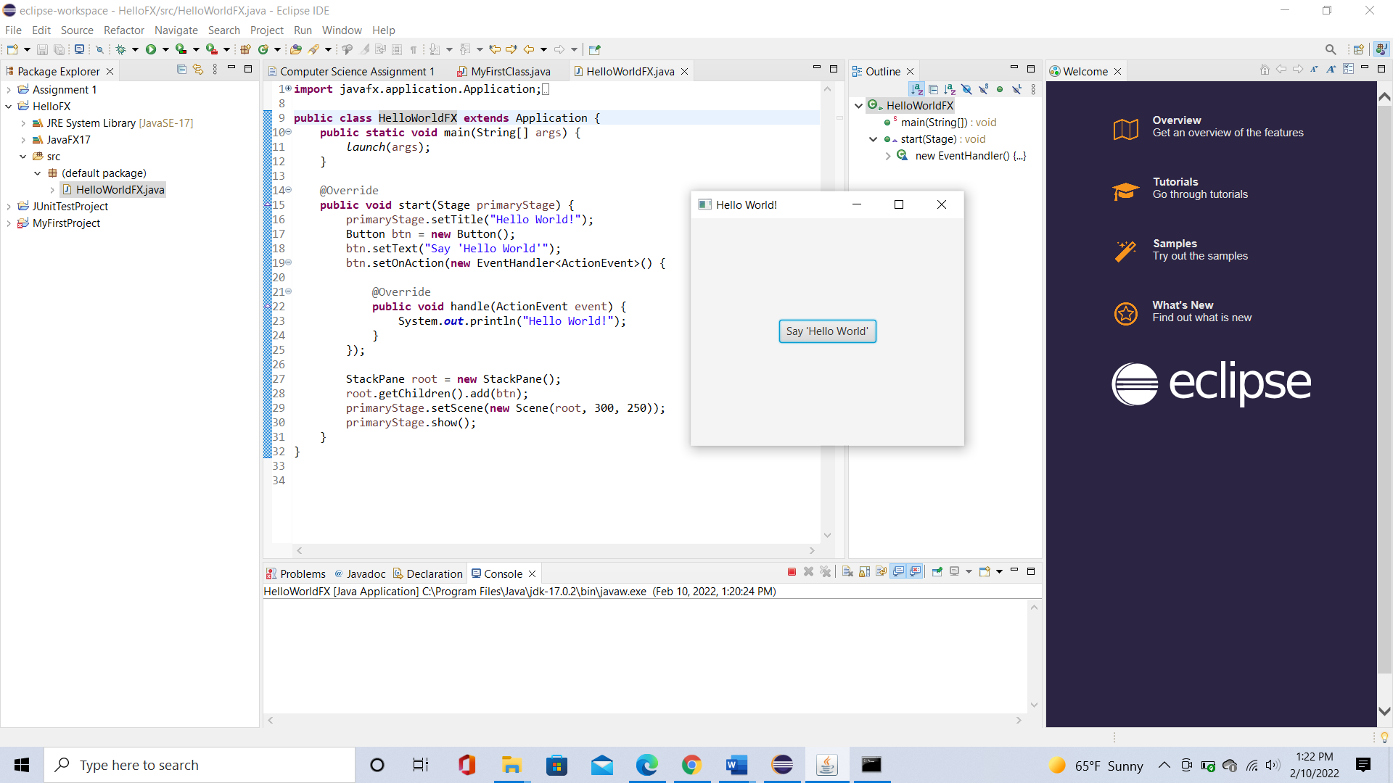

**Lessons Learned** <Provide answers to the questions listed below>**:**

Write about your Learning Experience, highlighting your lessons learned and learning experience from working on this assignment.

What have you learned? I learned how complex it can be to figure out how to install applications and running java code.

What did you struggle with? I struggled with installing and setting up parts 2 and 5.

What parts of this assignment were you successful with, and what parts (if any) were you not successful with? I was mainly successful with parts 1 and 5.

Provide any additional resources/links/videos you used to while working on this assignment.

**Check List:** <Provide answers to the column Y/N or N/A >**:**

|  |  |  |  |
| --- | --- | --- | --- |
| **#** |  | **Y/N** | **Comments** |
|  | **Assignment files:** |  |  |
|  | * FirstInitialLastName_Assignment0.docx/pdf | **Yes** | **File named as requested** |
|  | * Source java files | **Yes** |  |
|  | **Program compiles** | **Yes** | **I realized that I’m not supposed to type java code in Command Prompt and use notepad to access java files.** |
|  | **Program runs with desired outputs related to a Test Plan** | **Yes** | **After some revision, I found what I did wrong in installing JavaFX** |
|  | **Documentation file: Screenshots of** |  |  |
|  | * Part1: Setup GitHub | **Yes** | **Account setup** |
|  | * Part 2 -Install JDK, Test java Application from Command Line | **Yes** | **I did step 1 and was able to complete step 2 with help student service.** |
|  | * Part 3 - Install Eclipse, Test Eclipse Java Application | **Yes** | **Eclipse IDE Installed.** |
|  | * Part 4 - Install, Setup, Test Junit Program | **Yes** | **Junit Program installed.** |
|  | * Part 5 - Install, Setup, and Test JavaFX Application. | **Yes** | **After some assistance, I found the correct folder and the jar files.** |
|  | * Lessons Learned | **Yes** | **Completed** |
|  | * Checklist is completed and included in the Documentation | **Yes** | **Completed** |