**CMSC203 Assignment 1 Implementation**

Class: CMSC203 CRN XXXX

Program: Assignment #1

Instructor: Professor Grinberg

Summary of Description: Build an application that will step through some possible problems to restore internet connectivity. Assume that your computer uses wi-fi to connect to a router which connects to an Internet Service Provider (ISP) which connects to the Internet.

Due Date: 02/14/2022

Integrity Pledge: I pledge that I have completed the programming assignment independently.

I have not copied the code from a student or any source.

**Part1: Pseudo Code:** Here is a pseudo code for Assignment 1 program:

**Program start**

**DISPLAY "If you have a problem with your internet connectivity, this Wi-Fi Diagnosis might work”**

**DISPLAY "First step: reboot your computer."**

**DISPLAY "Are you able to connect to the internet? (yes or no)"**

**SET inputReboot1**

**GET inputReboot1**

**WHILE inputReboot1 does not equals "yes" and does not equal "no"**

**DISPLAY “Please enter yes or no"**

**GET inputReboot1**

**IF inputReboot1 equals “no" THEN**

**DISPLAY "Second step: reboot your router"**

**DISPLAY "Now are you able to connect with the internet? (yes or no)"**

**SET inputRouter2**

**GET inputRouter2**

**WHILE inputRouter2 does not equal "yes” and does not equals "no"**

**DISPLAY "Please enter yes or no"**

**GET inputRouter2**

**IF inputRouter2 equals "no" THEN**

**DISPLAY "Third step: make sure the cables to your router are plugged in firmly and your router is getting power"**

**DISPLAY "Now are you able to connect with the internet? (yes or no)"**

**SET inputCables3**

**GET inputCables3**

**WHILE inputCables3 does not equal "yes” and does not equal "no"**

**DISPLAY "Please enter yes or no"**

**GET inputCables3**

**IF inputCables3 equals "no" THEN**

**DISPLAY "Fourth step: move your computer closer to your router"**

**DISPLAY "Now are you able to connect with the internet? (yes or no)"**

**SET inputComputer4**

**GET inputComputer4**

**WHILE inputComputer4 does not equal "yes” and does not equal "no"**

**DISPLAY "Please enter yes or no"**

**GET inputComputer4**

**IF inputComputer4 equals "no" THEN**

**DISPLAY "Fifth step: contact your ISP"**

**DISPLAY "Make sure your ISP is hooked up to your router."**

**ELSE**

**DISPLAY "Moving your computer closer seemed to work"**

**ELSE**

**DISPLAY "Checking the routers cables seemed to work"**

**ELSE**

**DISPLAY "Rebooting your router seemed to work"**

**ELSE**

**DISPLAY "Rebooting your computer seemed to work”**

**Part2: Comprehensive Test Plan**

A good test plan should be comprehensive. This means you should have a few test cases that test when the input is in and out of range, division by 0, incorrect Data type, etc (Provide valid and invalid input)

|  |  |  |  |  |
| --- | --- | --- | --- | --- |
| Cases | Input | Expected Output | Actual Output | Did Test Pass? |
| Case 1 | no | “Second step: reboot your router”  “Now are you able to connect with the internet? (yes or no)” | “Second step: reboot your router”  “Now are you able to connect with the internet? (yes or no)” | Yes |
| Case 2 | yes | “Rebooting your computer seemed to work” | “Rebooting your computer seemed to work” | Yes |
| Case 3 | 76 | “Please enter yes or no” | “Please enter yes or no” | Yes |
| Case 4 | D | “Please enter yes or no” | “Please enter yes or no” | Yes |

**Part3: Screenshots related to the Test Plan:**

**Case 1**

**Case 2**

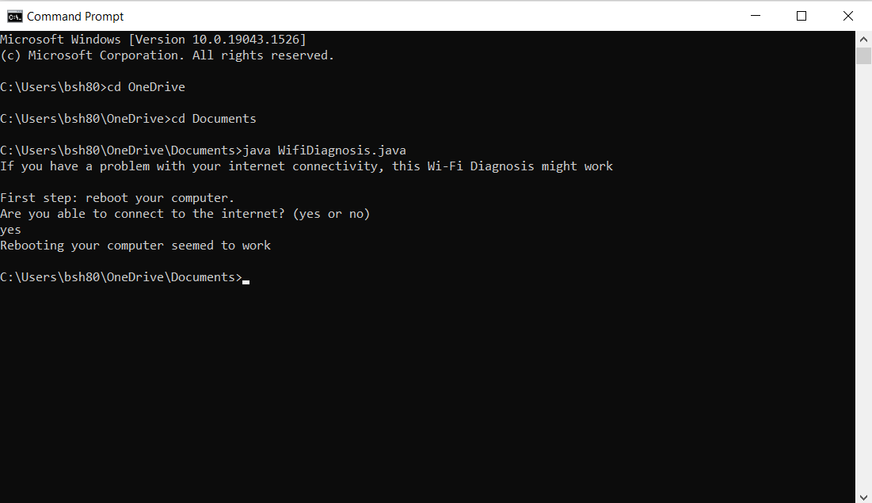

**Case 3**

**Case 4**

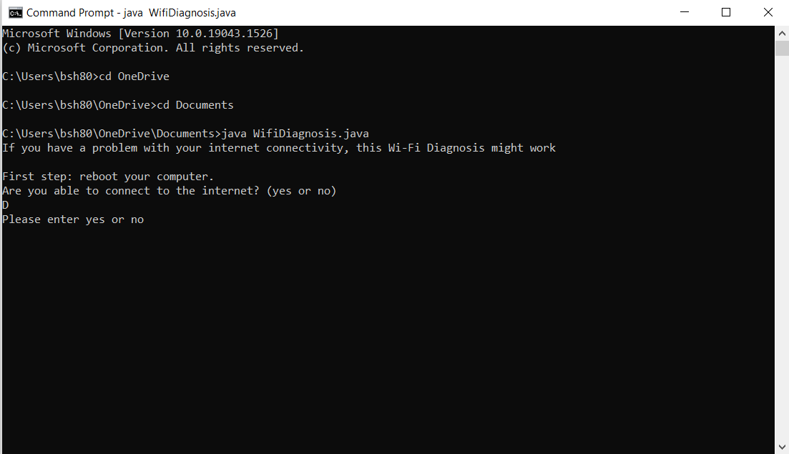

**Lessons Learned** <Provide answers to the questions listed below>**:**

Write about your Learning Experience, highlighting your lessons learned and learning experience from working on this project.

I started by making a java code that had if statements that would go into the next step when the input is no. There were also else statements for when the input is yes and while loops for when the input was anything but yes or no. The program didn’t work well due to the while statements, but I changed the condition from or to and. This revealed another flaw in the program. Regardless of any given input, the program went directly to the last else statement. I managed to fix the if statements by changing variable == “no” to variable.equals(“no”). This solved every problem, and the program was complete.

What have you learned? I learned how to properly use Sting variables and while loops.

What did you struggle with? I struggled with figuring out the if statements and while loops, but I figured out what I needed to fix with them.

What would you do differently on your next project? I would keep in mind how different variable types are used in java.

What parts of this assignment were you successful with, and what parts (if any) were you not successful with?

I was the most successful with setting up the if-else statements and indentations.

Provide any additional resources/links/videos you used to while working on this assignment/project.

**Check List:** <Provide answers to the column Y/N or N/A >**:**

|  |  |  |  |
| --- | --- | --- | --- |
| **#** |  | **Y/N** | **Comments** |
|  | **Assignment files:** |  |  |
|  | * FirstInitialLastName_ Assignment#_Moss.zip | **Yes** | **Zip folders complete** |
|  | * FirstInitialLastName_Assignment#.docx/.pdf | **Yes** | **Document and folder completed** |
|  | * Source java files | **Yes** | **Java file in both zip folders** |
|  | **Program compiles** | **Yes** | **The program compiles well.** |
|  | **Program runs with desired outputs related to a Test Plan** | **Yes** | **Program runs in command prompt and Eclipse.** |
|  | **Documentation file:** |  |  |
|  | * Comprehensive Test Plan | **Yes** | **Part 2 completed in document. Only used one input for each test case.** |
|  | * Screenshots related to the Test Plan | **Yes** | **Part 3 of document completed** |
|  | * Screenshots of your GitHub account with submitted Assignment# (if required) | **Yes** | **GitHub screenshot in zip folder** |
|  | * UML Diagram (if required) | **N/A** | **Not required** |
|  | * Algorithms/Pseudocode (if required) | **Yes** | **Part 1 of document completed** |
|  | * Flowchart (if required) | **N/A** | **Not required** |
|  | * Lessons Learned | **Yes** | **Part 4 of document completed** |
|  | * Checklist is completed and included in the Documentation | **Yes** | **Part 5 of document completed** |