**CMSC203 Lab 1 Template**

Class: CMSC203 CRN XXXX

 Program: Lab 1

Instructor: Professor Grinberg

 Summary of Description: (Give a brief description for each Program)

 Due Date: M2/22/2022

 Integrity Pledge: I pledge that I have completed the programming assignment independently.

 I have not copied the code from a student or any source.

**Complete the following three parts of Lab 1. Name your file as FirstInitialLastName_Lab1.docx**

**Task 1 – Writing a Driver Class**

**

**Task 2 – Writing Loop**

Provide the screen shots from Task 2 here:

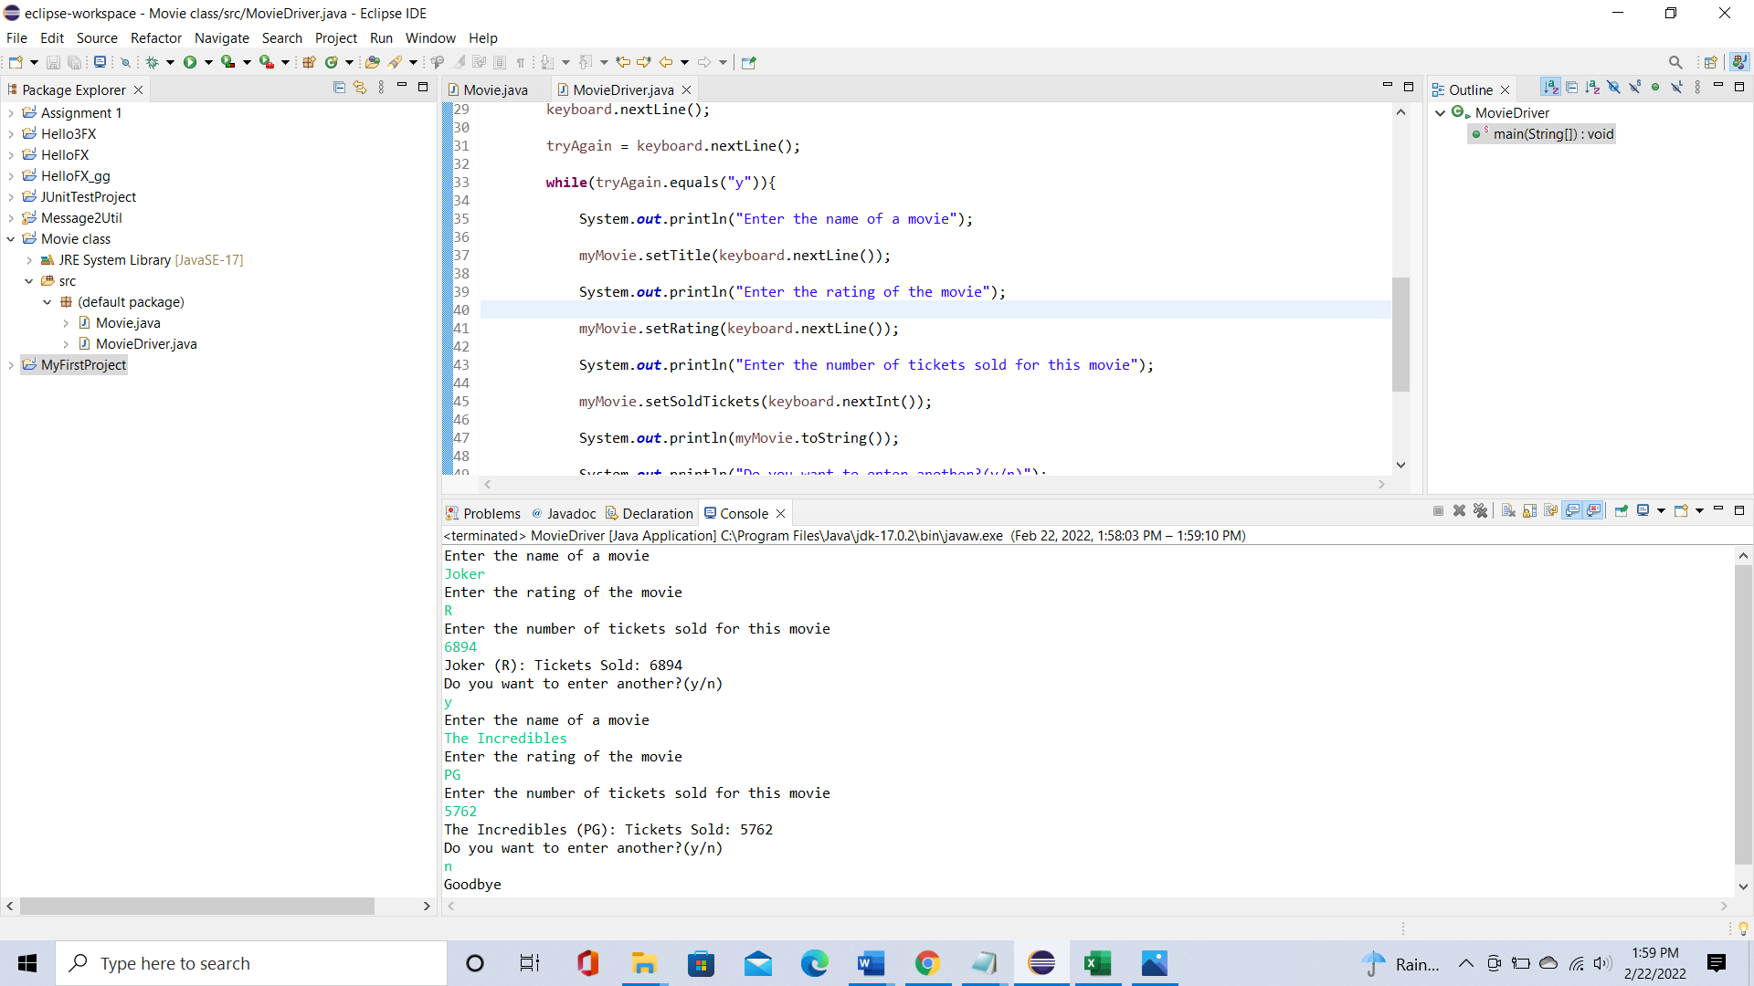

**Task 3 - – Upload your java files to GitHub**

Provide the screen shots of your GitHub account with Lab1 file is uploaded on GitHub

Attached:

* MovieDriver.java from Task #1 and Movie.java (**NOT the .class files**; submit the .java files). Submit both files, even though you have not changed Movie.java.
* MovieDriver.java from Task #2 and Movie.java (**NOT the .class files**; submit the .java files). Submit both files, even though you have not changed Movie.java.

**Lessons Learned** <Provide answers to the questions listed below>**:**

Write about your Learning Experience, highlighting your lessons learned and learning experience from working on this assignment.

I started by making three calls to the setTitle, setRating, and setSoldTickets methods of the Movie java file. At first, I included private variables and public methods, which caused many errors, but I fixed that problem by getting rid of the unnecessary modifiers. I also made a mistake by creating a keyboard call that didn’t and was having difficulty printing out the toString method. I fixed these by using a keyboard.nextInt instead of keyboard.nextLine and putting a call to toString inside of a print text code. Then for task 2, I had a problem with the while loop I set up. I fixed the loop so that it worked for the string variable I declared, but it still didn’t work. I set up a display code at the end of the code and it was revealed that the program completely ignored the while loop. To fix this, I put an input keyboard code statement on its own before setting the string variable to the user’s input. This worked for if the user chose to input “y” and I completed the program by putting an if statement for when the user inputs “n” that would say goodbye and closed the keyboard.

What have you learned? I learned the proper way to call class methods.

What did you struggle with? I struggled with displaying the last class method.

What parts of this assignment were you successful with, and what parts (if any) were you not successful with? I was most successful with calling the methods.

Provide any additional resources/links/videos you used to while working on this Lab.

**https://docs.oracle.com/javase/7/docs/api/java/util/Scanner.html**

**Check List:** <Provide answers to the column Y/N or N/A >**:**

|  |  |  |  |
| --- | --- | --- | --- |
| **#** |  | **Y/N** | **Comments** |
|  | **Assignment files:** |  |  |
|  | * FirstInitialLastName_lab1.docx/pdf | **Yes** |  |
|  | * Source java files | **Yes** | **Copied and pasted the code of both tasks onto Notepad java files** |
|  | **Program compiles** | **Yes** | **Compiles well on Eclipse** |
|  | **Program runs with desired outputs related to a Test Plan** | **Yes** | **Runs well on Eclipse** |
|  | **Documentation file: Screenshots of** |  |  |
|  | * Task 1 | **Yes** |  |
|  | * Task 2 | **Yes** | **I took one of the added code and another of the output code** |
|  | * Task 3 - | **Yes** |  |
|  | * Lessons Learned | **Yes** |  |
|  | * Checklist is completed and included in the Documentation | **Yes** |  |