**Creating Python Scripts**

Name: Priya Tomar

Date: 09/04/2024

Course: IT FDN 110 B Su 24: Foundations of Programming: Python

**Introduction**

This document outlines the steps taken to create a Python script for managing student course registrations, as required in Assignment06. The program incorporates constants, variables, functions, and classes while adhering to the separation of concerns pattern. This assignment demonstrates how to collect, display, and store student data in a JSON file, ensuring error handling and structured program flow.

**Topic Covered:**

**Steps Taken to Perform the Assignment**

**Step 1:** Understanding the Requirements

I started by thoroughly reading the assignment instructions, which provided a detailed list of functionalities. The program needed to allow students to register for courses, display the data, save it to a file, and handle multiple registrations. I also ensured structured error handling for file operations and user input.

**Step 2:** Setting Up the Script

I created the Python file Assignment06.py and included a header with the title, description, and a changelog to track updates to the script.

**Figure 1:** Header

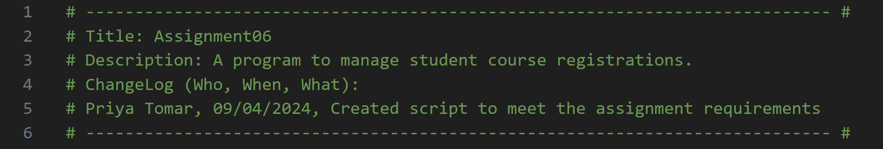

**Step 3:** Setting up constants and variables

I defined constants and variables used throughout the program:

**Figure 2:** Constants and variables

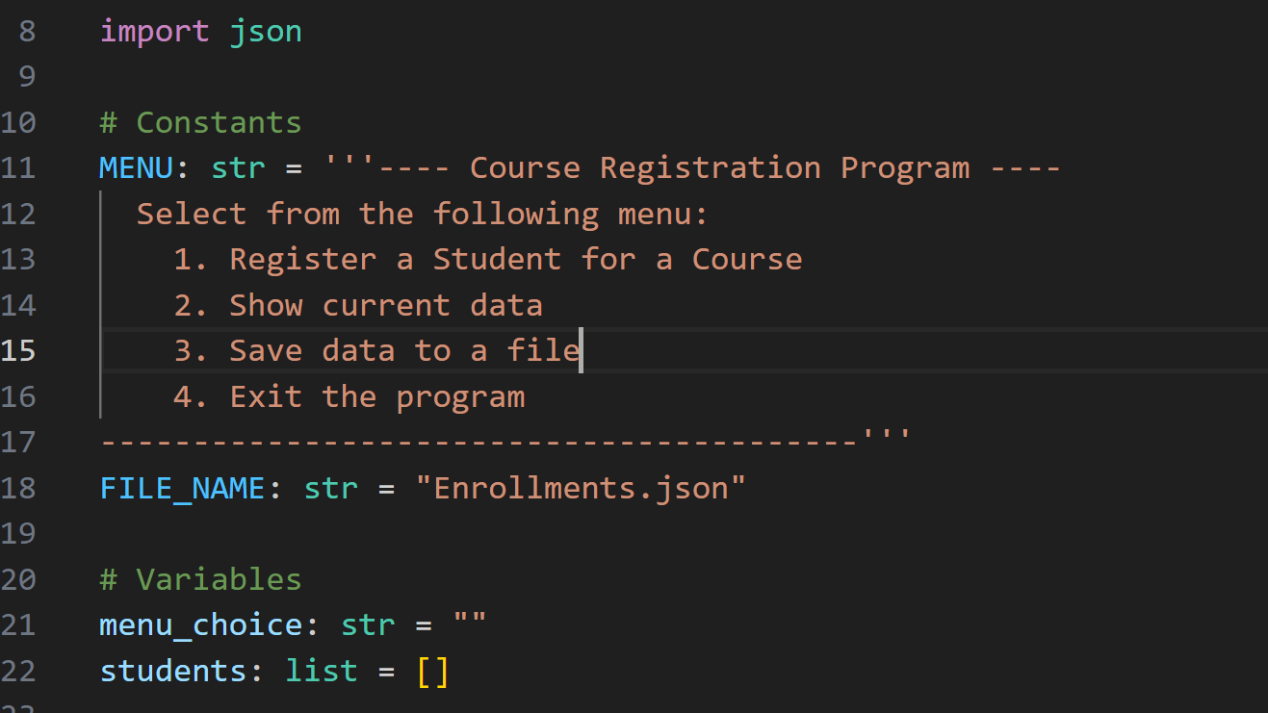

**Step 4:** Creating Classes and Functions

**Figure 3:**

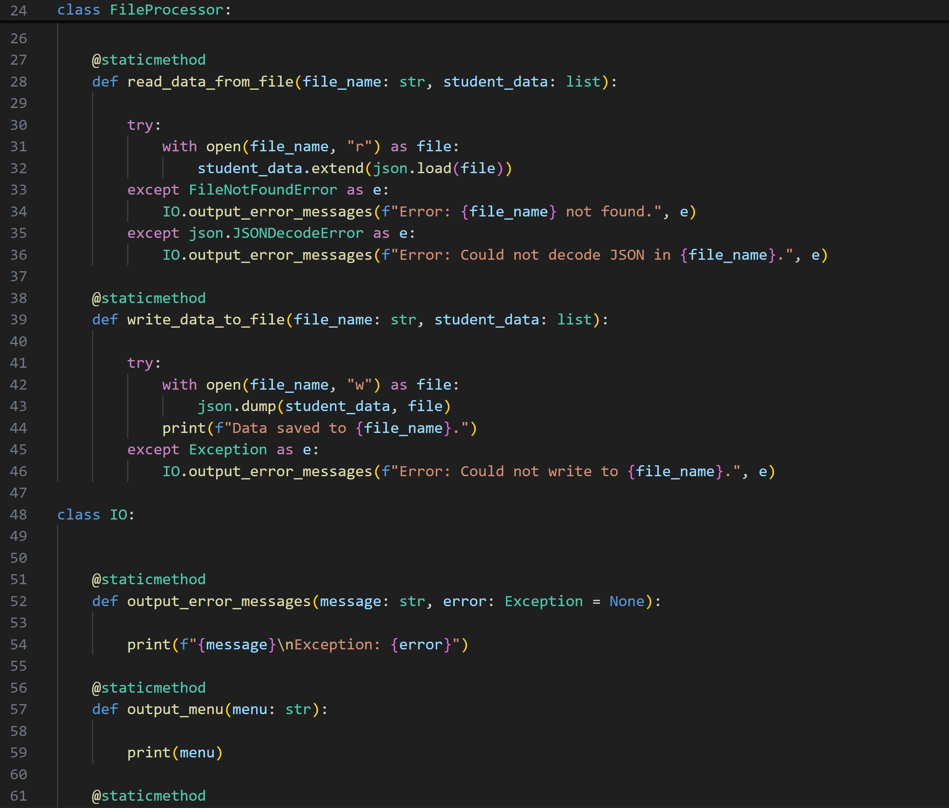

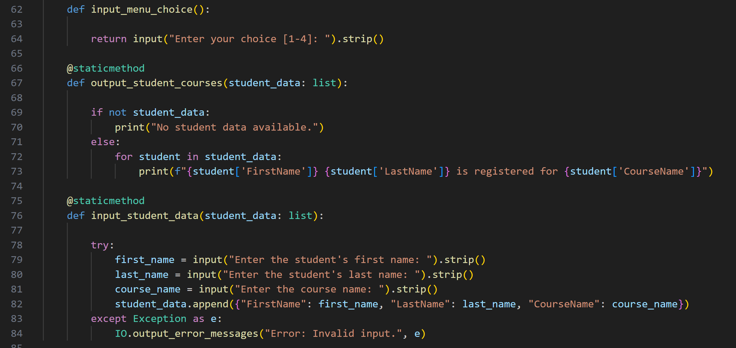

**Step 5:** Building the main program loop:

Using a while loop, I created a menu-driven interface where users could:

* Register students
* View current registrations
* Save data to the JSON file
* Exit the program

**Figure 4:** Main program loop

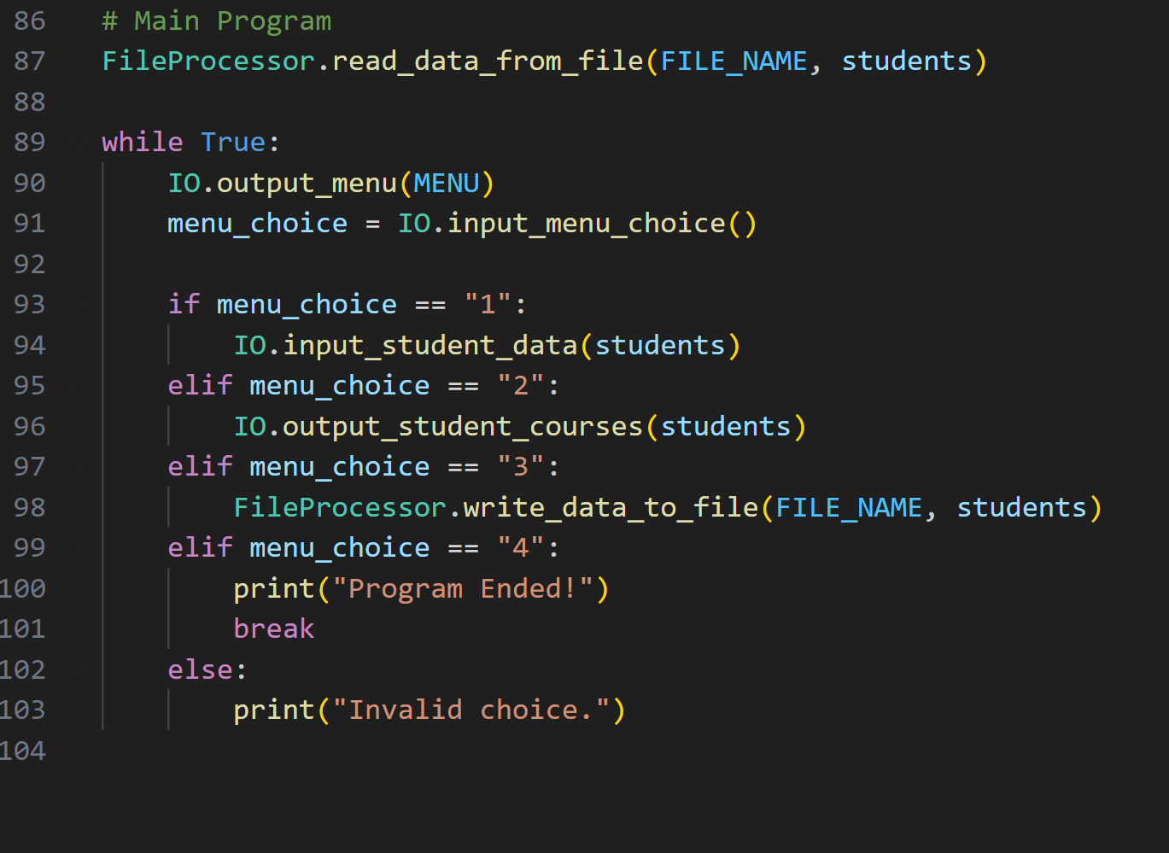

**Step 5:** Testing the program

I ran the program multiple times in both PyCharm and the terminal to verify its functionality:

Entering and displaying student data worked correctly.

Data was successfully written to and loaded from the JSON file.

Error handling properly managed invalid user input and file-related errors.

**Output:**

The script successfully captured student registration information, displayed it, and saved it to a JSON file. Below is an example of a student registration:

**Figure 6:** Output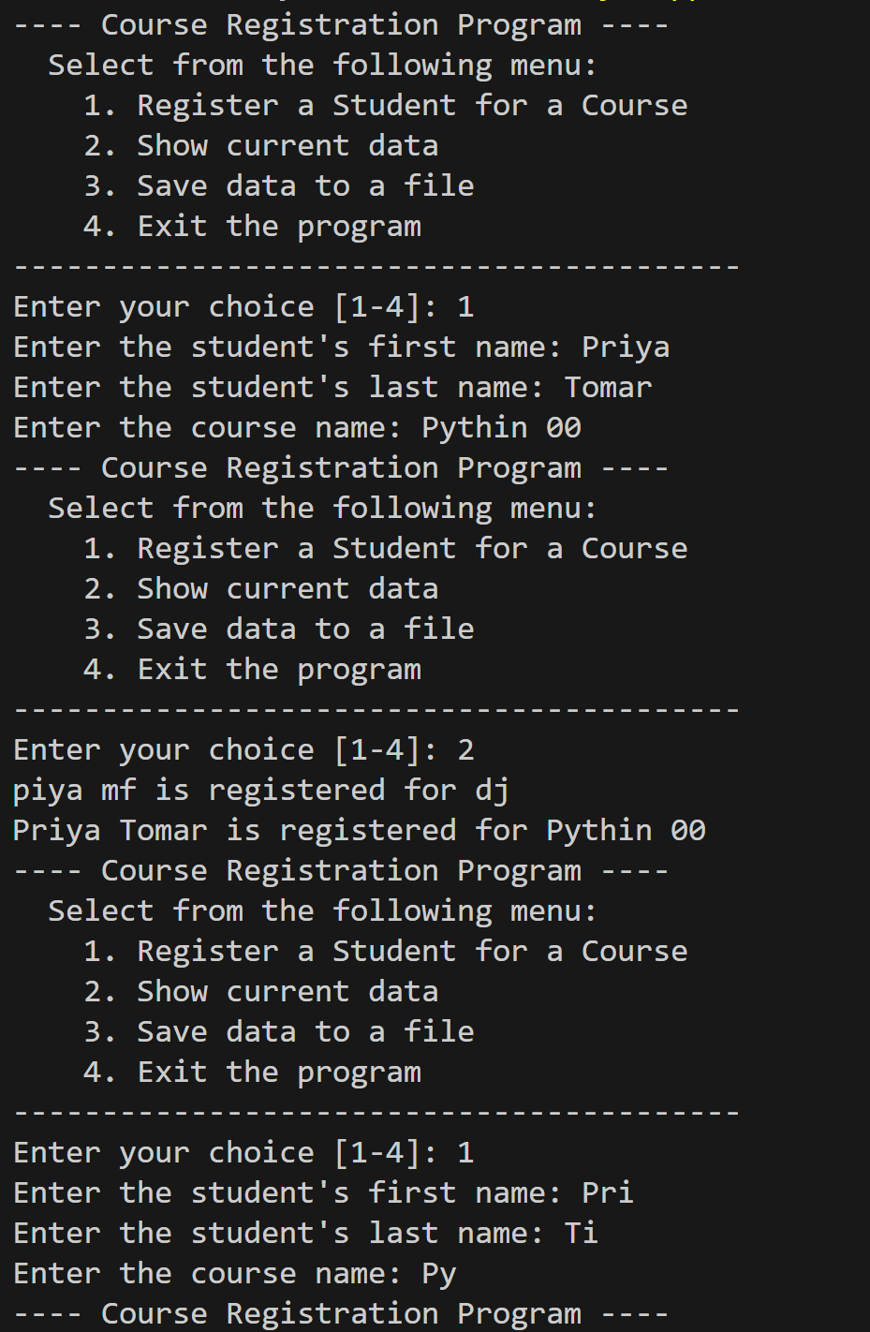

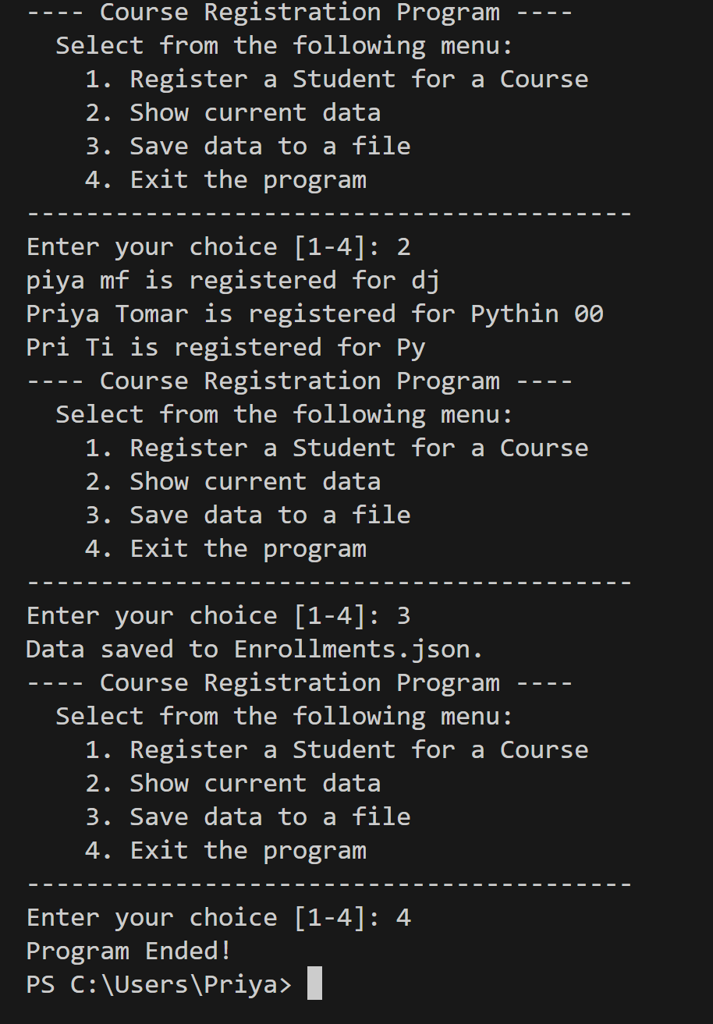

**Summary**

This assignment was a practical exercise in utilizing Python’s core functionalities such as file handling, classes, and error management. By applying the separation of concerns pattern, I was able to organize the program into clear, distinct modules, enhancing code maintainability and readability. The structured approach reinforced my understanding of object-oriented programming, and working with JSON files provided insights into managing external data storage.