Difference between DBMS and RDBMS
Although DBMS and RDBMS both are used to store information in physical database but there are some remarkable differences between them.
The main differences between DBMS and RDBMS are given below:
No. | DBMS | RDBMS
1) | DBMS applications store data as file. | RDBMS applications store data in a tabular form.
2) | In DBMS, data is generally stored in either a hierarchical form or a navigational form. | In RDBMS, the tables have an identifier called primary key and the data values are stored in the form of tables.
3) | Normalization is not present in DBMS. | Normalization is present in RDBMS.
4) | DBMS does not apply any security with regards to data manipulation. | RDBMS defines the integrity constraint for the purpose of ACID (Atomocity, Consistency, Isolation and Durability) property.
5) | DBMS uses file system to store data, so there will be no relation between the tables. | in RDBMS, data values are stored in the form of tables, so a relationship between these data values will be stored in the form of a table as well.
6) | DBMS has to provide some uniform methods to access the stored information. | RDBMS system supports a tabular structure of the data and a relationship between them to access the stored information.
7) | DBMS does not support distributed database. | RDBMS supports distributed database.
8) | DBMS is meant to be for small organization and deal with small data. it supports single user. | RDBMS is designed to handle large amount of data. it supports multiple users.
9) | Examples of DBMS are file systems, xml etc. | Example of RDBMS are mysql, postgre, sql server, oracle etc.
After observing the differences between DBMS and RDBMS, you can say that RDBMS is an extension of DBMS. There are many software products in the market today who are compatible for both DBMS and RDBMS. Means today a RDBMS application is DBMS application and vice-versa.
Dr Edgar F. Codd Rules
Dr Edgar F. Codd, after his extensive research on the Relational Model of database systems, came up with twelve rules of his own, which according to him, a database must obey in order to be regarded as a true relational database.
These rules can be applied on any database system that manages stored data using only its relational capabilities. This is a foundation rule, which acts as a base for all the other rules.

Rule 1: Information Rule
The data stored in a database, may it be user data or metadata, must be a value of some table cell. Everything in a database must be stored in a table format.

Rule 2: Guaranteed Access Rule
Every single data element (value) is guaranteed to be accessible logically with a combination of table-name, primary-key (row value), and attribute-name (column value). No other means, such as pointers, can be used to access data.

Rule 3: Systematic Treatment of NULL Values
The NULL values in a database must be given a systematic and uniform treatment. This is a very important rule because a NULL can be interpreted as one the following − data is missing, data is not known, or data is not applicable.

Rule 4: Active Online Catalog
The structure description of the entire database must be stored in an online catalog, known as data dictionary, which can be accessed by authorized users. Users can use the same query language to access the catalog which they use to access the database itself.

Rule 5: Comprehensive Data Sub-Language Rule
A database can only be accessed using a language having linear syntax that supports data definition, data manipulation, and transaction management operations. This language can be used directly or by means of some application. If the database allows access to data without any help of this language, then it is considered as a violation.

Rule 6: View Updating Rule
All the views of a database, which can theoretically be updated, must also be updatable by the system.

Rule 7: High-Level Insert, Update, and Delete Rule
A database must support high-level insertion, updation, and deletion. This must not be limited to a single row, that is, it must also support union, intersection and minus operations to yield sets of data records.

Rule 8: Physical Data Independence
The data stored in a database must be independent of the applications that access the database. Any change in the physical structure of a database must not have any impact on how the data is being accessed by external applications.

Rule 9: Logical Data Independence
The logical data in a database must be independent of its user’s view (application). Any change in logical data must not affect the applications using it. For example, if two tables are merged or one is split into two different tables, there should be no impact or change on the user application. This is one of the most difficult rule to apply.

Rule 10: Integrity Independence
A database must be independent of the application that uses it. All its integrity constraints can be independently modified without the need of any change in the application. This rule makes a database independent of the front-end application and its interface.

Rule 11: Distribution Independence
The end-user must not be able to see that the data is distributed over various locations. Users should always get the impression that the data is located at one site only. This rule has been regarded as the foundation of distributed database systems.

Rule 12: Non-Subversion Rule
If a system has an interface that provides access to low-level records, then the interface must not be able to subvert the system and bypass security and integrity constraints.

Normalization in Database (With Example)
Database normalization is the process of making the data in a database available in the most organized way possible. It is one of the first concepts you will learn when studying database management, as you might in a course like SQL Database For Beginners.
When you’re normalizing a database, there are two things you need to consider: whether the information in the database has internal redundancies, and whether the dependencies across the different tables in the database are logically organized.
The term normalization comes from the concept of normal forms, which describe just how organized the information is in the database. But normal forms were developed around the concept of a table-based relational database, which you need to learn about in order to understand database normalization. You might want to take a course like this one in RDBMS Concepts to get started. Normal forms are designed to enable the most straightforward approaches is for searching across information when it is structured in this manner.
As an example, let’s imagine we’re creating a database of the children in a class, and the pets they have. When starting to build this database, the first approach might be to create a simple table with all of the information in one place, and one row for each student.
TABLE: STUDENTS

| Name | Age | Pet | Pet Name |
----------------------------------------------
| Heather | 10 | Dog | Rex |
----------------------------------------------
| Rachel | 10 | Cat | Fluff |
----------------------------------------------
| Jimmy | 11 | Dog | Kimba |
----------------------------------------------
| Lola | 1o | Cat | Thomas |
----------------------------------------------
This works until you realize that Heather might have two pets, a dog and a cat. How would you represent that in this table? In order to do that, we need to introduce first normal form.

First Normal Form
To achieve first normal form for a database, you need to make sure that no table contains multiple columns that you could use to get the same information. Each table should be organized into rows, and each row should have a primary key that distinguishes it as unique. The primary key is usually a single column, but sometimes more than one column can be combined to create a single primary key.
Using the rules of first normal form, there may be redundant information across multiple rows, but each row will be unique.
TABLE: STUDENTS

| Name | Age | Pet | Pet Name |
----------------------------------------------
| Heather | 10 | Dog | Rex |
----------------------------------------------
| Heather | 10 | Cat | Thomas |
----------------------------------------------
| Rachel | 10 | Cat | Fluff |
----------------------------------------------
| Jimmy | 11 | Dog | Kimba |
----------------------------------------------
| Lola | 10 | Cat | Thomas |
----------------------------------------------

Second Normal Form
In this first example there are two rows for Heather, with changes to the second row to show the fact that there are multiple pets. While this is searchable, and follows first normal form, it is an inefficient use of space. To achieve second normal form, it would be helpful to split out the pets into an independent table, and match them up using the student names as foreign keys.
TABLE: STUDENTS

| Name | Age |
-----------------------------
| Heather | 10 |
-----------------------------
| Rachel | 10 |
-----------------------------
| Jimmy | 11 |
-----------------------------
| Lola | 10 |
-----------------------------

TABLE: PETS

| Type | Pet Name | Owner |
---------------------------------------
| Dog | Rex | Heather |
---------------------------------------
| Cat | Thomas | Heather |
---------------------------------------
| Cat | Fluff | Rachel |
---------------------------------------
| Dog | Kimba | Jimmy |
---------------------------------------
| Cat | Thomas | Lola |
---------------------------------------

Third Normal Form
This is a cleaner organization for the information, and avoids repeating the age of the student with two pets, but the dogs and cats are repeated several times in the pets table. We can see that it is uncertainty when there are two pets with the same type and the same name. Is the primary key the owner and the type, the name and the type, or the owner and the name? Third normal form would suggest making sure each non-key element in each table provides information about the key in the row.
In order to establish an unambiguous unique identifier for each pet, it is useful to include a unique primary key that distinguishes each pet from the others. A similar issue could occur if there were two students with the same name, so creating unique primary key values for the student table is also a good idea. Often these will be added automatically when database rows are set to autoincrement. If you need to learn how to do that, you can take a course to learn Database Design with MySQL, take a course to learn Oracle database administration, or take a course to learn Microsoft SQL fundamentals and find out exactly how to autoincrement table rows in the environment you use.
TABLE: STUDENTS

| ID | Name | Age |
----------------------------------
| 00 | Heather | 10 |
----------------------------------
| 01 | Rachel | 10 |
----------------------------------
| 02 | Jimmy | 11 |
----------------------------------
| 03 | Lola | 10 |
----------------------------------

TABLE: PETS

| ID | Type | Pet Name | Owner ID |
--------------------------------------------
| 00 | Dog | Rex | 00 |
--------------------------------------------
| 01 | Cat | Thomas | 00 |
--------------------------------------------
| 02 | Cat | Fluff | 01 |
--------------------------------------------
| 03 | Dog | Kimba | 02 |
--------------------------------------------
| 04 | Cat | Thomas | 03 |
--------------------------------------------

Fourth Normal Form
Now it is clear that which pet and which student are associated, the fact that one student may have more than one pet, or that one pet may be shared among more than one student, needs to be represented. For this example, imagine that we needed to show that the cat named Thomas as actually shared between Lola and Heather. To represent this clearly, we need to add a third table of relationships.
TABLE: STUDENTS

| ID | Name | Age |
----------------------------------
| 00 | Heather | 10 |
----------------------------------
| 01 | Rachel | 10 |
----------------------------------
| 02 | Jimmy | 11 |
----------------------------------
| 03 | Lola | 10 |
----------------------------------

TABLE: PETS

| ID | Type | Pet Name |
---------------------------------
| 00 | Dog | Rex |
---------------------------------
| 01 | Cat | Thomas |
---------------------------------
| 02 | Cat | Fluff |
---------------------------------
| 03 | Dog | Kimba |
---------------------------------

Table: PETS-STUDENTS

| Pet ID | Owner ID |
---------------------
| 00 | 00 |
---------------------
| 01 | 00 |
---------------------
| 02 | 01 |
---------------------
| 03 | 02 |
---------------------
| 01 | 03 |
---------------------
Now we have a flexible and searchable structure in fourth normal form that can represent all the available information about each of the students, each of the pets, and the relationships among them. As you learn more about databases, you will come to recognize the challenges of structuring the data according to your actual needs.
An important thing to keep in mind as you learn to structure your data is that the normal forms are not set in stone as goals for every database. Each one is a guideline that you may choose to use as a reference point when considering the best way to organize your personal database to meet the needs of your business. Sometimes the most performant or appropriate organization for your database may not be the most logical one from a normalization standpoint.

What is Normalization? Why should we use it?
Normalization is a database design technique which organizes tables in a manner that reduces redundancy and dependency of data.
It divides larger tables to smaller tables and link them using relationships.
The inventor of the relational model Edgar Codd proposed the theory of normalization with the introduction of FirstNormal Form and he continued to extend theory with Second and Third Normal Form. Later he joined with Raymond F. Boyce to develop the theory of Boyce-Codd Normal Form.
Theory of Normalization is still being developed further. For example there are discussions even on 6th Normal Form. But in most practical applications normalization achieves its best in 3rd Normal Form. The evolution of Normalization theories is illustrated below-

Let's learn Normalization with practical example -
Assume a video library maintains a database of movies rented out. Without any normalization all information is stored in one table as shown below.

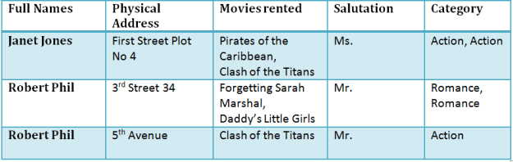
Table 1

Here you see Movies Rented column has multiple values.
Now let's move in to 1st Normal Form

1NF Rules
- Each table cell should contain single value.
- Each record needs to be unique.
The below table in 1NF-

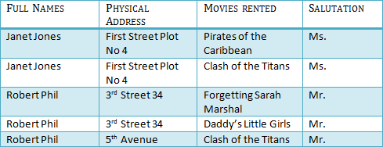
Table 1 : In 1NF Form

Before we proceed lets understand a few things --

What is a KEY ?
A KEY is a value used to uniquely identify a record in a table. A KEY could be a single column or combination of multiple columns
Note: Columns in a table that are NOT used to uniquely identify a record are called non-key columns.
What is a primary Key?
 | A primary is a single column values used to uniquely identify a database record.  It has following attributes  - A primary key cannot be NULL  - A primary key value must be unique  - The primary key values can not be changed  - The primary key must be given a value when a new record is inserted.

What is a composite Key?
A composite key is a primary key composed of multiple columns used to identify a record uniquely
In our database , we have two people with the same name Robert Phil but they live at different places.
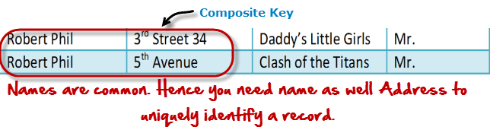
Hence we require both Full Name and Address to uniquely identify a record. This is a composite key.
Let's move into 2NF
2NF Rules
- Rule 1- Be in 1NF
- Rule 2- Single Column Primary Key
It is clear that we can't move forward to make our simple database in 2nd Normalization form unless we partition the table above.

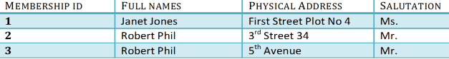
Table 1

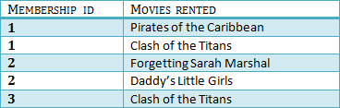
Table 2

We have divided our 1NF table into two tables viz. Table 1 and Table2. Table 1 contains member information. Table 2 contains information on movies rented.
We have introduced a new column called Membership_id which is the primary key for table 1. Records can be uniquely identified in Table 1 using membership id

Introducing Foreign Key!
In Table 2, Membership_ID is the foreign Key
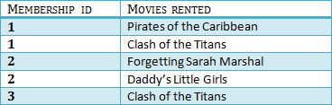
 | Foreign Key references primary key of another Table!It helps connect your Tables  - A foreign key can have a different name from its primary key  - It ensures rows in one table have corresponding rows in another  - Unlike Primary key they do not have to be unique. Most often they aren't  - Foreign keys can be null even though primary keys can not

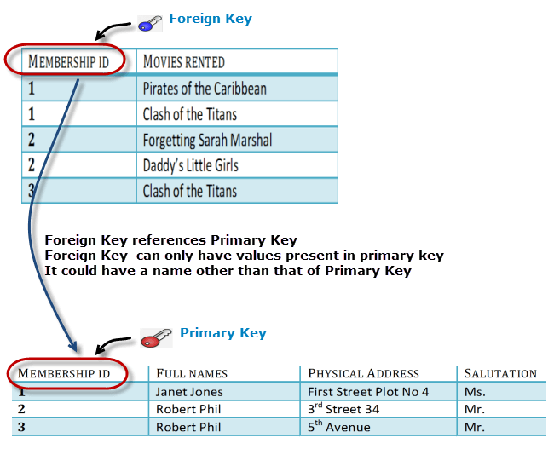
Why do you need a foreign key ?
Suppose an idiot inserts a record in Table B such as
You will only be able to insert values into your foreign key that exist in the unique key in the parent table. This helps in referential integrity.
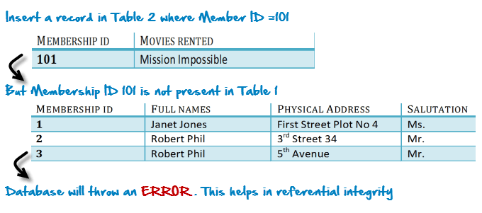
The above problem can be overcome by declaring membership id from Table2 as foreign key of membership id from Table1
Now , if somebody tries to insert a value in the membership id field that does not exist in the parent table , an error will be shown!

What is a transitive functional dependencies?
A transitive functional dependency is when changing a non-key column , might cause any of the other non-key columns to change
Consider the table 1. Changing the non-key column Full Name , may change Salutation.
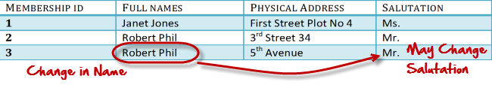
Let's move ito 3NF

3NF Rules
- Rule 1- Be in 2NF
- Rule 2- Has no transitive functional dependencies
To move our 2NF table into 3NF we again need to need divide our table.

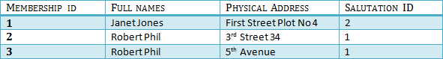
TABLE 1

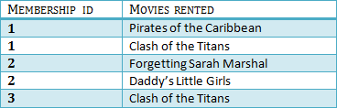
Table 2

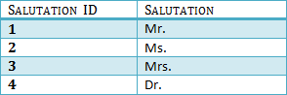
Table 3

We have again divided our tables and created a new table which stores Salutations.
There are no transitive functional dependencies and hence our table is in 3NF
In Table 3 Salutation ID is primary key and in Table 1 Salutation ID is foreign to primary key in Table 3
Now our little example is in a level that cannot further be decomposed to attain higher forms of normalization. In fact it is already in higher normalization forms. Separate efforts for moving in to next levels of normalization are normally needed in complex databases. However we will be discussing about next levels of normalizations in brief in the following.
Boyce-Codd Normal Form (BCNF)
Even when a database is in 3rd Normal Form, still there would be anomalies resulted if it has more than one Candidate Key.
Sometimes is BCNF is also referred as 3.5 Normal Form.

4th Normal Form
If no database table instance contains two or more, independent and multivalued data describing the relevant entity , then it is in 4th Normal Form.

5th Normal Form
A table is in 5th Normal Form only if it is in 4NF and it cannot be decomposed in to any number of smaller tables without loss of data.

6th Normal Form
6th Normal Form is not standardized yet however it is being discussed by database experts for some time. Hopefully we would have clear standardized definition for 6th Normal Form in near future.
That's all to Normalization!!!

Summary
- Database designing is critical to the successful implementation of a database management system that meets the data requirements of an enterprise system.
- Normalization helps produce database systems that are cost effective, cost effective and have better security models.
- Functional dependencies are a very important component of the normalization process
- Most database systems are normalized up to the third normal form.
- A primary uniquely identifies are record in a Table and cannot be null
- A foreign key helps connect table and references a primary key

