# System Overview (WIP)

* [System Context View](#SystemOverview(WIP)-SystemContextView)
* [Container View](#SystemOverview(WIP)-ContainerView)
  + [SSO & MySafe Applications v2](#SystemOverview(WIP)-SSO&MySafeApplicati)
* [Deployment Diagram](#SystemOverview(WIP)-DeploymentDiagram)
* [Use Case Model](#SystemOverview(WIP)-UseCaseModel)
* [Use Case Catalogue](#SystemOverview(WIP)-UseCaseCatalogue)
* [Other documentation (old)](#SystemOverview(WIP)-Otherdocumentation()

## System Context View

This model describes the external environment in which the Digital Identity Scotland system operates and identifies the parties which interact with or are used by the system.

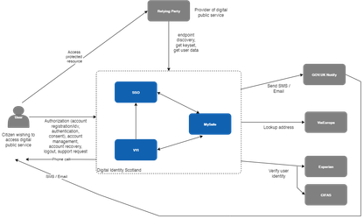

The Digital Identity Scotland service has a customer/supplier relationship with each enrolled public sector body. The public sector body is identified in this document as the **relying party**. Users (i.e. citizens of Scotland) will continue to be identified as **user**.

See: [C4 Model System Context Diagram](https://c4model.com/diagrams/system-context)

## Container View

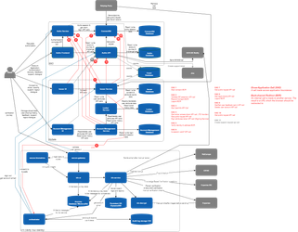

### SSO & MySafe Applications v2

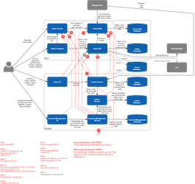

This diagram can be opened in [Draw.io](https://app.diagrams.net/) and is organised into multiple layers to help manage complexity.

See: [C4 Model Container Diagrams](https://c4model.com/diagrams/container)

## Deployment Diagram

Single Environment Diagram - Digital Identity Scotland Space - Confluence

## Use Case Model

This model describes all the high level functions of the Digital Identity Scotland system and the consumers of those functions.

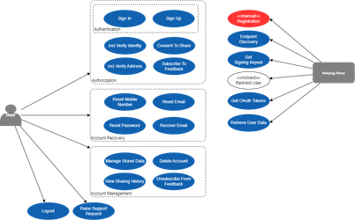

## Use Case Catalogue

Use Case 1.1: Sign In - OpenId Only - No valid ScotAccount session

Use Case 1.2: Sign In - OpenId Only - Existing ScotAccount session

Use Case 2.1: Sign Up - OpenId Only

## Other documentation (old)

