Suspected drug deaths in Scotland: XXXXXXXXXXXXXXXXX

## 1. Background

In January 2021 the Scottish Government announced a National Mission to reduce Scotland’s unacceptable drug death rates. Part of this commitment is to improve data and surveillance. This report is published quarterly and focusses on management information from Police Scotland on suspected drug deaths, to provide as timely an indication of current trends in drug deaths in Scotland as is possible. Statistics from the National Records of Scotland (NRS) are also presented for wider context.

## 2. Summary

Suspected drug deaths fell over the two most recent calendar quarters, with 40 fewer suspected deaths (-4%) recorded between January and September 2021 than over the same period of 2020. However, despite these recent decreases, suspected drug deaths remain at a high level and there continues to be an upward trend over the period for which data is available.

## 3. Drug death definitions

Classifying a death as drug related is complex. There are a number of different definitions of drug deaths, and this report focusses on two:

* **Annual drug-related deaths** (sometimes referred to as drug-misuse deaths) from National Records of Scotland (NRS) – this is the annual headline measure used in Scotland. NRS’s National Statistics [Drug-related deaths in Scotland](https://www.nrscotland.gov.uk/statistics-and-data/statistics/statistics-by-theme/vital-events/deaths/drug-related-deaths-in-scotland/2020) use this definition, with the most recent publication (July 2021) reporting 1,339 drug-related deaths for 2020. It covers all deaths with an underlying cause of drug poisoning or drug abuse, but only where any of the substances involved are controlled in the UK. This means that deaths from only e.g. aspirin or paracetamol are excluded.
* **Quarterly suspected drug deaths** – the operational measure used by Police Scotland, this includes deaths that the Police suspect involved illicit drugs, based on the reports of attending officers’ observations and initial enquiries at the scene of death.

More information on National Statistics drug deaths definitions can be found in the methodological annexes of the official drug-related deaths publication on the National Records of Scotland [webpage](https://www.nrscotland.gov.uk/statistics-and-data/statistics/statistics-by-theme/vital-events/deaths/drug-related-deaths-in-scotland/2020/methodological-annexes).

## 4. Recent trends in Police Scotland suspected drug deaths

Police Scotland management information gives an indication of recent trends in drug deaths in Scotland based on reports from police officers attending scenes of death. Classification as a suspected drug death is based on an officer’s observations and initial enquiries at the scene of death.

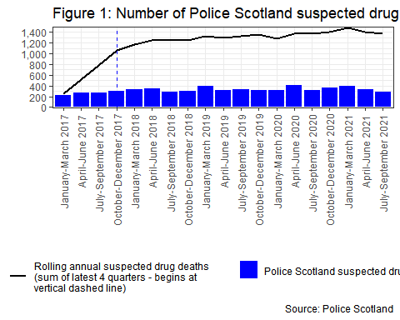

The number of suspected drug deaths between January and September of 2021 was 1,007, fewer than the same period of 2020 where 1,047 suspected drug deaths were recorded. While suspected drug deaths have fallen for two consecutive quarters in 2021, there continues to be a general upward trend over the period for which data is available.

Since January 2021:

* There have been 1,007 suspected drug deaths, 40 fewer (-4%) than during the same period of 2020.
* Males accounted for 72.1% of suspected drug deaths. This compares with 74.5% between January and September 2020.
* There were 281 suspected drug deaths of females, a change of 5% (14) compared with January and September 2020.
* Over two thirds (27.1%) of suspected drug deaths were of people aged between 35 and 54.
* There were 51 suspected drug deaths in the under 25 age group, 27.1% fewer than during January and September 2020.
* The Police Divisions with the greatest number of suspected drug deaths were: Greater Glasgow (265), Lanarkshire (98), North East (86), Edinburgh City (86).

For Q3, July-September 2021:

* There were 285 suspected drug deaths, -13.4% (-44) compared to the previous calendar quarter (April-June 2021), and -9.8% (-31) compared to the same calendar quarter in the previous year (July-September 2020)

Note that numbers of suspected drug deaths fluctuate from quarter to quarter and care should be taken not to interpret movements between individual calendar quarters as indicative of any long term trend.

For the rolling 12 month period, i.e., adding the most recent four quarters together:

* There were 1,371 suspected drug deaths over the 12 months to September 2021.
* This is -2.2% (-31) compared to the 12 months to June 2021, but still amongst the highest number recorded in any rolling 12 month period during the time frame for which data is available.

A breakdown of suspected drug deaths by police division by calendar quarter for the period January 2020 to September 2021 can be found in Annex A.

More detail on the statistics presented above is available in the workbook provided here [ADD HYPERLINK].

## 5. Other sources of drug deaths information in Scotland

### 5.1 Drug death data

There are two different sets of statistics on the number of drug deaths in Scotland:

* **National Statistics published annually by National Records of Scotland.** These are the official figures on the number of drug-related deaths registered in Scotland each year. Drug-related deaths are identified using data from death registration records supplemented with information from the Crown Office and Procurator Fiscal Service and forensic pathologists. [Drug-related deaths in Scotland in 2020](https://www.nrscotland.gov.uk/statistics-and-data/statistics/statistics-by-theme/vital-events/deaths/drug-related-deaths-in-scotland/2020) includes more detail on the sources of data used to produce these National Statistics.
* **Management information from Police Scotland on suspected drug deaths.** This operational data is available more rapidly and more frequently than the NRS annual statistics described above, and provides a more timely indication of the likely trend in drug-related deaths. However, this management information is not subject to the same level of validation and quality assurance as National Statistics as it is based on officers’ observations and other circumstantial evidence, and it is not a replacement for the final drug-related death statistics produced by NRS. Section 5.3 of this report, “Relationship between Police Scotland suspected drug deaths and NRS drug-related deaths”, has more detail on how this data correlates with the National Statistics produced by NRS.

More information on the data sources, methodologies and interpretation of the data can be found in Annex B.