m_moorproc_toolbox
OSNAP-CLASS version

Please note: this Document is a LiVe Document and might not always reflect the most current changes of the toolbox
Lewis Drysdale, Loic Houpert, Sam Jones, Kristin Burmeister, Yvonne Firing
Kristin.burmeister@sams.ac.uk

Contents
Setup and version control 3
1. Git 3
1.1. Git setup 3
1.2. Check the local and remote branches 4
1.3. Making changes 4
1.4. Push changes on the original remote repository 5
1.5. More on Git 7
2. Setup and run locally the toolbox 7
2.1. Get the most recent version of the toolbox 7
2.2. Create a branch for your development 8
2.3. Set up the toolbox in your matlab path 8
Real-time and delayed-time processing of microCAT data 8
1. Introduction 8
2. Set up directory structure 9
2.1. Processing scripts: 9
2.2. Shipboard calibration files 9
3. Processing of the moored microcat 10
4. Lowered microcat processing after the shipboard calibration casts 10
5. Delayed mode processing of the microcat data. 11
5.1. Set-up metadata files 11
5.2. Calculation of accurate nominal depth of the mooring instruments, update of the metadata files 11
5.3. Calculation of the pre- or post- deployment conductivity and temperature calibration coefficients 11
5.4. Gridding of the data: creation of a lowpass filtered, regular gridded data set. 12
5.5. merging of the several years of deployment (and if necessary moorings) 13
Processing of moored current meter and ADCP data 15
1. Introduction 15
2. Nortek current meter data processing 15
2.1. Stage0 – Data Download (done during the cruise $CRUISE) 15
2.2. Stage1 – Conversion to standard RDB format and basic statistics 15
2.3. Stage2 – Trimming of data, summary plots 16
2.4. Stage3 – Data editing, speed of sound correction, magnetic declination correction, data filtering 16
2.5. Stage 4 – Data gridding of individual deployment 18
DeepSeapHOx Data Processing 19
1. Stage 0 – Data Download 19
2. Stage 1 – Conversion to standard RDB format 19
Data reports tools 20
Export to oceansites format [if required] 24
Export to NetCDF for CLASS data working group 24
Appendix: Historical and OSNAP CTD profiles close to the moorings 25
1.1. RTEB1 25
1.2. RTWB1 26
1.3. RTWB2 28
1.4. RTADCP1 30

Setup and version control
Before using the toolbox and making any changes to branches it is essential that any user gains a basic understanding of git and github, which can be found here:
https://docs.github.com/en/get-started

Git
This toolbox is managed using git. The master branch should be the last working version used, updated and revised since the last mooring cruise. The master branch is protected and changes can only be merged via pull requests which are then revised by the administrators of the repository. The following strategy is used to manage the repository.

Updating the master branch with latest cruise branch
This should be normal text

- Before each cruise, users of this mooring processing toolbox should create and checkout a new branch, named based on their upcoming cruise, from the master branch. Any changes made on the cruise should be in this new branch.
- To keep the master branch up to date, a pull request to merge the cruise branch with the master branch should be raised following good housekeeping practices (below)
a) Directly after the cruise to push any important on-cruise changes
b) After on land post-processing when the calibration of the single intruments are finalised and there will be no changes anymore.
- One of the repository administrators who is not the creator of the branch will review the pull request and check the changes made.
- If the reviewer finds no issues they will continue to 5. If there are issues or even merge conflicts the reviewer will block the pull request and raise either discussions within the pull request or issues to be addressed by the branch creator. These are open discussion and any contributor are encourage to take part in them to find the best solution. Once an agreement is reached and the creator implemented any nessecary changes and any merge conflicts are resolved steps 2-4 will be repeated.
- If everything is ok the reviewer can verified the pull request and merge the cruise and master branch.
- If the cruise branch is finalised and no further changes are expected, it will be locked by one of the administrators making it read only and protecting it from being deleted.

Working on board
- A copy of the cruise branch should be physically taken on the ship on a computer or external hard drive as the internet connection cannot be guaranteed on the ship.
- The data (archived from previous cruise) is not tracked with git or kept on github and effort should be made to make sure that the most recent version is copied prior to the cruise/processing. Once the cruise is complete the cruise branch should be pushed to the remote repository (if not already happened during the cruise due to connection problems).

Housekeeping
It might be necessary to create feature branches from the cruise branches to solve certain issues (e.g. 'JC238-revise-CM-merging'). When merging the cruise branch into the master branch, any feature branches for the cruise branch should be merged with the cruise branch and deleted so that there is only one branch per cruise. After the final merging (2.b) the cruise branch will be locked by one of the administrators making it read only and no changes can be made.

Git setup
If you want to set up a local copy of the project git repository to track your changes and contribute to the project you should do the following steps:
- First make sure that you have Git installed! See more details here: https://git-scm.com/book/en/v2/Getting-Started-Installing-Git. If you are using windows you may also want to install a nice terminal (e.g. https://mobaxterm.mobatek.net)
- Open a terminal, move in your working directory (e.g. ~/Work) and then clone the project repository with the command:
git clone https://github.com/LewisDrysdale/m_moorproc_toolbox.git Enter the git repository:
cd m_moorproc_toolbox

Or, Fork the repository to your personal account. To do that just click the Fork button on the main repo page. Add your fork as a remote. This remote will be named after your github username for clarity. To do that, use the command: ”git remote add your-github-username fork-url”
For example, for a user named lhoupert, run the command:
git remote add lhoupert https://github.com/lhoupert/m_moorproc_toolbox.git

Check the local and remote branches

To list the local and remote branches, use the the command “git branch -av ” . This command returns for example:

$ git branch -av
JC238 3782c45 update for jc238 caldips
* JC238-dev 3782c45 update for jc238 caldips
master 4f85b54 Merge pull request #5 from ScotMarPhys/dy120_seaphox
remotes/origin/HEAD -> origin/master
remotes/origin/JC238 3782c45 update for jc238 caldips
remotes/origin/JC238-dev 3782c45 update for jc238 caldips
remotes/origin/add-IBmoors f735df3 de-bug oceansites code
remotes/origin/dy120 c7578cb Merge pull request #7 from ScotMarPhys/dy120-netCDF-dev
remotes/origin/master 4f85b54 Merge pull request #5 from ScotMarPhys/dy120_seaphox

We can see one local branch (master) and several remotes on the “origin” repository (corresponding to the repository cloned).

If you only have a local master branch (as in the example above) and you need to create a local copy of the other remote branches (“legacy”, “postdy120”, etc… ). You can do that with the one-time command:
git checkout -b postdy120 origin/postdy120
git checkout -b legacy origin/legacy

Making changes
Before any changes, a branch should be created. Best practices are to never commit to master branch. It is better to work on a specific branch and then merge the branch onto the “main” or “ master” branch. Your terminal should be set up to display the current active branch.
1) Update master. Before you make any changes, first checkout master (or another branch if you are working on another branch) and pull in the latest changes. In the example below we want to work on the branch postdy120 so we do:
git checkout postdy120
git pull
git pull is here a shortcut for git pull origin postdy120

2) Create a branch. Make a branch name that is short, descriptive, and unique. Some examples of good branch names are fix-install, docs-cleanup, and add-travis-ci. Some examples of bad branch names are feature, fix, and patch. To create the branch, do :
git checkout -b branch-name
(e.g.: git checkout -b add-IBmoors)
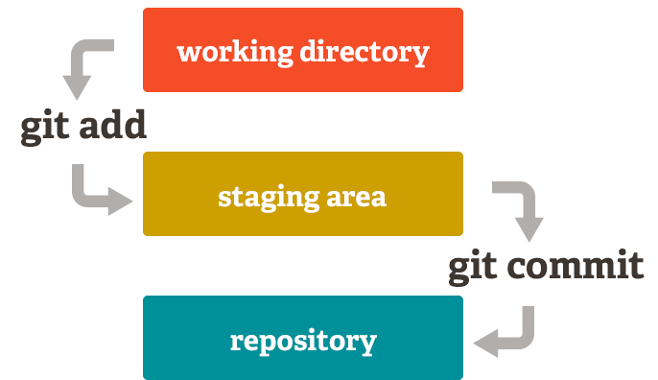
3) Make your changes and commit them. Keep commits atomic <-> each commit should represent a single unit of change. Also write helpful commit messages, so that someone can understand what the commit does just from reading the message without having to read the diff.
a. To see what file have been changes locally run the command ”git status” in a terminal
b. To stage your changes, add the different files with the command ”git add filename [filename2 …]”
(e.g. ”git add OSNAP_mooring_processing.docx”)
Figure 1: From https://git-scm.com/about/staging-area
c. To commit the changes to your repository run the command: git commit -m “message explaining what the commit does” (e.g. git commit -m "add Git section to doc" )
4) Push up your changes on your remote repository. Once the changes are committed, they are only applied to the local repository. To propagate the changes of the remote repository, the user needs to “push” the changes. It can easily be done on your fork repository by running the command:
git push your-github-username branch-name (e.g. ”git push lhoupert add-IBmoors“)

Push changes on the original remote repository
As owner of the “forked” github repository, it is easy to push the changes to it. However, because you are collaborating with other people, you will certainly want to push your changes back to the original repository so other users following changes on this repository can be aware of your modifications.

Case 1: Through a pull request (best practices - available for anyone)
Make a pull request. Once the changes are pushed on your forked repository, you can then go to your fork on GitHub. You should see a button to create a pull request from your branch. It will look something like this:
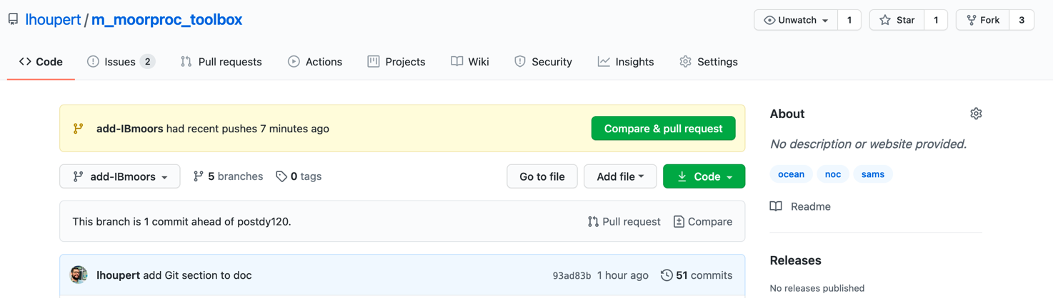

Then by selecting “comparing & pull request” , you will be presented a new page asking you more information about your request (name of the repository you want to merged your branch into, title of the request, description, etc…). You can find more information about the pull request workflow here: https://www.asmeurer.com/git-workflow/

Case 2: By pushing changes directly on the origin repository without pull request (only for authorized users).
When we started working on the postdy120 branch in November 2020, three people were working on the same files and therefore opening a “pull request” was not the most efficient way for everybody to have access to the same files in the last version of the file in real time.
Therefore, we decided to work on the same “original” repository. To do that the owner of the original repository needed first to grant “pushing rights” on his repository. This can be done by opening the settings of the repository, selecting “manage access” and “invite a collaborator”:

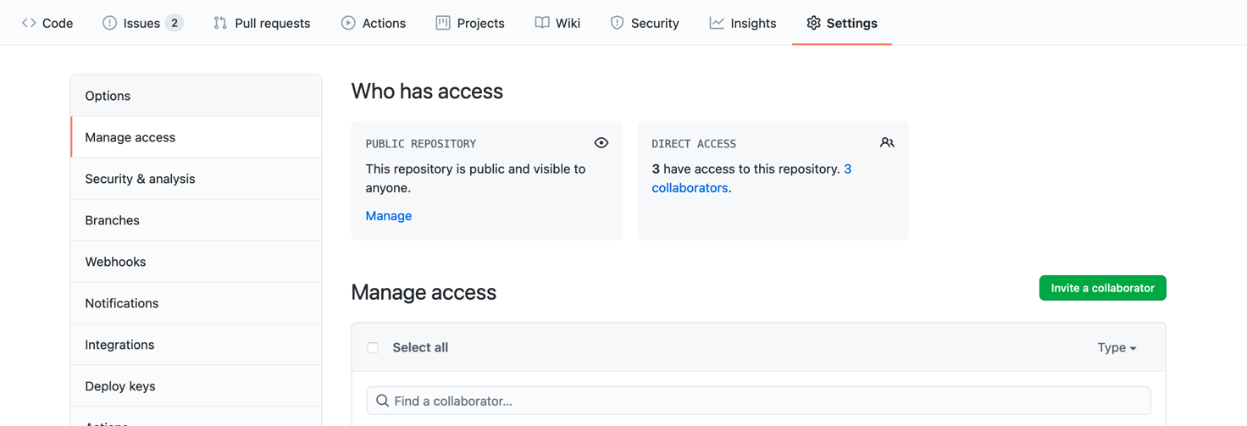

Once the user is added as a collaborator, he/she can push changes on the “main” repository using the command: ”git push your-github-username branch-name”
For example: ”git push origin add-IBmoors”

More on Git
- Tutorial about Git-workflow explained: https://www.asmeurer.com/git-workflow/
- More information on git commands: Run ”git help” or “git help -g“ in a terminal or have a look to the git website (e.g. https://git-scm.com/docs/giteveryday)
- Some notes on file manipulation with Git: https://gist.github.com/lhoupert/01daa22e0b2a4171c20a291df14e661b
- Git Cheat Sheet: https://training.github.com/downloads/github-git-cheat-sheet.pdf

Setup and run locally

Get the most recent version of the toolbox
If you don’t have a version of the git repository, get the last version of the code. Make sure you select the correct branch (e.g. postdy120, master, etc..), clone it or download the zip.
If you have already a git version of the repository set up following Section 1. Git, go in your git folder then run:
git checkout <branch>
git pull origin <branch>
where <branch> maybe be master or another branch-name if you have already created a specific cruise branch.
This will update the local version of the repository with the latest version of the remote directory.

Create a branch for your development
Before modifying the code, if not already working from a branch specific to your cruise, you should create a new branch. More information are given in the previous section, see 1.4)

Set up the toolbox in your matlab path
Once the mooring processing toolbox is set up, either a) copy the file in Documents/exampleofstartupfile.m to your matlab working directory and rename it (e.g. startup_moor_proc.m) add it to your Matlab startup (likely in ~/Documents/Matlab/startup.m), or b) simply use it as your startup file (replace ~/Documents/Matlab/startup.m with this file contents).
Open the startup file and edit the first lines setting basedir, progdir, and project; these will be used together to set the Matlab paths by calling moor_setup.m. For OSNAP and RAPID, a standardised directory structure is included; for another project, moor_setup.m will query the user for where to find data directories. For OSNAP, the expected structure in basedir/osnap/ is:

├── Documents
├── Figures
├── cruise_data
├── data
├── exec
├── matlab_diaries
└── users
Meanwhile progdir should contain m_moorproc_toolbox (and, if you are also using mexec to process/load CTD data, ocp_hydro_matlab).

Real-time and delayed-time processing of microCAT data

Introduction
→ calibration of the instruments is essential to obtain accurate measurements and minimize errors in the transport calculation
→ calibration data obtain for each moored CTD during intercalibration cast: Each moored CTD is attached to a shipboard CTD rosette frame and a deep cast is carried out prior to deployment and after the recovery of the moored instruments. During the cast, 12 bottle stops of 5 mins each are performed, from the bottom to the surface, in order to cover the different range of pressure of the moored instruments. The comparison with the 1Hz-bin averaged shipboard CTD data gives calibration coefficients for each sensor (T, C, P) on each moored instrument.

Outline of the processing stages:
- Initial processing setup: creation of a data processing metadata control file.
- Raw data downloading and archiving
- Conversion from instrument format to standard Rapid Data Base (RDB) format
- Trimming of data record, basic statistics and summary plots
- Calibrating and quality control of the moored CTD data:
- Gridding of the data: creation of a lowpass filtered, regular gridded data set

NOTE: the OSNAP data structure separates executable scripts (osnap/exec/…) from output files (osnap/data/moor/…). For clarity, file (or directory) names and paths for scripts are coloured red, input files are coloured blue, and output files are coloured green. The syntax
<moordatadir>/raw should be translated based on your directory configuration (set by the Matlab startup file and stored in global variable MOORPROC_G) to e.g. ~/projects/osnap/data/moor/raw._The output files of some scripts may become the input of a later script. Hopefully this will make navigation of this document a little easier.

Set up directory structure
Running the startup file will set a global variable, MOORPROC_G, containing paths to different input and output directories, e.g.:
MOORPROC_G.moordatadir: ‘/data/pstar/projects/osnap/data/moor’
The scripts are kept in a separate directory (e.g. /data/pstar/programs/gitvcd/m_moorproc_toolbox’).

Shipboard calibration files

Cruise ctd files (pre and post deployment)
- Create the directory for the cruise hydrographic data: <ctddir>
- Copy the cruise data from the archive directory of the cruise data (e.g. M:\Mar_Phys\Cruises\CRXXX) ;
- Look at the previous year cruise to copy the same type of ctd files ( *_1hz.nc, *.ros and *_align_ctm.cnv) for each caldip cast. The number of the caldip cast can be found in the cruise report or in osnap\data\moor\proc_calib\crxxx\cal_dip (cast*info.dat).

Microcat caldip data
- create a cast???info.dat file in osnap/data/moor/proc_calib/$cruise/cal_dip/ for each caldip that summarizes information about each caldip CTD cast (location, time) and the serial numbers and the deployment periods of the lowered microcats. The deployment period number is used later (part 6b) to create a metadata file of the mooring deployed during the deployment period.
- Create the directories that will host the raw microcat data files for each CTD cast, osnap/data/moor/raw/$cruise/microcat_cal_dip/cast???/ (where ??? is the cast number), and move in this directory the raw data file (.hex, .cnv, .xml, .xmlcon, etc..)

Microcat deployment files
- creation of a data processing control file $moorname$info.dat for each mooring in the directory osnap/data/moor/proc/$moorname$. The $moorname$info.dat file contains metadata for mooring position (lon, lat, waterdepth and mean magnetic deviation during the deployment), deployment period, nominal depths and serial numbers of each instrument. *see previous cruise folder for an example.
- copy the raw SBE37 files (with .cnv files) in the directory osnap/data/moor/raw/$cruise/microcat/. If the raw .cnv files are not named as $serialnumber_data.cnv, rename them.

Start and Set-up Matlab
- Open in a terminal and go in the root mooring processing directory (e.g.: OSNAP_mooring_data_processing/osnap/ ).
- Check that in the top of the startup.m file a “cd” command is sending you in the cruise directory you want to process (e.g. cd exec/pe400).
- Once matlab started under the osnap/ directory the startup.m file should move you in the cruise directory you are interested in. In the cruise directory osnap/exec/$cruise/, another startup.m file should be present, generating the different path related to the cruise data.

Processing of the moored microcat
- Stage 1: Edit (paths to the data, mooring name, year of the first measurement) and run the script osnap/exec/$cruise/stage1/microcat/mc_call_2_$cruise.m : convert the raw data to RDB formatted file .raw for an entire mooring. The processed data are stored in osnap/data/moor/proc/$moor/microcat/
- Stage 2: Check that the deployment time and recovery time are accurate in the corresponding $osnap/data/moor/proc/$moor/moor_info.dat file, then edit and run osnap/exec/$cruise/ stage2/microcat/microcat_raw2use_003_with_ODO.m . This script generates .use files (launching and recovery period removed) in osnap/data/moor/proc/$moor/microcat/ . The script also creates data overview sheet including basic statistics, and produces summary plots, including 2-day low-pass plots.

Lowered microcat processing after the shipboard calibration casts
The script osnap/exec/$cruise/stage1/microcat/mc_call_caldip_v4b.m loads:
- The raw microcat data located in osnap/data/moor/raw/$cruise/microcat_cal_dip/$castnber/ ,
- The shipboard CTD data (if new calibrated ctd files are available after the cruise, the *_raw.nc and *_psal.nc have to be replaced) files for the $castnber ( in osnap/data/$cruise/)
- The caldip metadata file castnnninfo.dat file located in osnap/data/moor/proc_calib/$cruise/cal_dip/.
The script writes to a directory ~/osnap/data/moor/proc_calib/cal_dip/$cruise/microcat/$castnber/ which is created manually. Plots are generated for all microcat data for one CTD cast with the shipboard CTD data.
Note that the raw microcat files have to be named as serialnumber_cal_dip_data.cnv.
The script osnap/exec/$cruise/stage1/microcat/mc_caldip_check_$cruise.m provides a quick quantitative comparison of Microcat cal-dip data with the SBE911 data from the CTD. Data obtained at the deepest bottle stops are used. For each instrument differences of conductivity, temperature and pressure between the instrument and the CTD sensor were calculated. The mean and standard deviation of the differences for each instrument are then presented in a table in ~/osnap/data/moor/proc_calib/cal_dip/$cruise/microcat/$castnber$/microcat_check$castnber$.log

Delayed mode processing of the microcat data.
Before starting the delayed mode processing of the microcat, make sure that you have the final calibrated CTD dataset.

Set-up metadata files
Manually add entries in two metadatabases: cruise_id.xls lists the cruise id and unique number identifier; microcat_calib_cruise.csv lists the mooring name, the associated deployment and recovery cruises number. The metadata files are under osnap/data/moor/cal_coef/

Calculation of accurate nominal depth of the mooring instruments, update of the metadata files

If there are large differences between the planned instrument depth and the actual depth for most of the deployment (due to trawling etc), it is possible to calculate this from the observed pressures. Generally, we have not needed to do this stage but the following might be useful.

Note this just updates the ‘nominal depth’ which is used for metadata and file organisation, but will not impact the final data product.
Except that deploymentdepths.dat file is used by insitu_cal_osnap2 …

The gridding algorithm pulls info directly from the pressure record for example. Run the function ctd_instrdpth2.m for each mooring. This will calculate accurate instrument depth from pressure record and update the info.dat file located in osnap/data/moor/proc/$mooring/
b) Manual creation of a osnap/data/moor/cal_coef/osnapXX_deploymentdepths.dat file, which lists all the instruments on every mooring deployed within the deployment period XX (by using the info.dat file for each mooring in osnap/data/moor/proc/$mooring/ )

Calculation of the pre- or post- deployment conductivity and temperature calibration coefficients
This step uses the .raw microcat data files generated by running stage 1 processing described in Section 3 – if you have not done that, do it now.
a) Before processing the mooring data, the calibration coefficient has to be calculated from the comparison between the calibrated shipboard CTD and the lowered mooring CTDs, this task is achieved by running the script osnap/exec/$cruise/delayed_processing_script/mcat_final_calibration/
caldip_coefficient_calculation.m. Several user parameters can be set (changed from default values) in the beginning of the caldip_coefficient_calculation.m script.
Insitu_cal_osnap2 sensortype***
Why does insitu_cal_osnap2 interpolate then average? How to deal with missing bottles in the middle?

Key parameters:
- P_insitucal.interval_move – this is the time intyerval n which data are selected for each bottle stop

c) Run caldip_coefficient_calculation.m for each caldip cast, the user can adjust the options for the figure at the beginning of the script. The script produces plots and a table of the calibration coefficients in osnap/data/moor/proc_calib/$cruise/cal_dip/microcat/$castnber/. The calibration coefficients are then manually entered into 3 CSV format database in osnap/data/moor/cal_coef/ (microcat_cond.csv, microcat_temp.csv and microcat_pres.csv). This process is quite arduous and ultimately we would like to automate. For a new cruise, a new set of 4 columns should be added in microcat_cond.csv, microcat_temp.csv. For microcat_pres.csv , two set of 4 columns are added: one for the mooring which have been recovered during the cruise and one for the mooring that have been deployed. Note the format used in the csv tables for previous ‘before-after deployment’ cruise pairings and emulate. If you freeze the column and row headings (‘freeze panes’ in Excel) you can keep them visible while manually entering. Triple check!

Entering pressure coefficients

After each cruise, and creation of the deployment depths document, you must run the caldip_coefficient_calculation.m script again for the previous cruise but with the next deployment depths

Each cruise has two sets of columns, one set for deployment and another set for recovery. Each set consist of a column for the mooring in the form MMMM_DD_YYYY, where MMMM is the mooring id (e.g. rteb1), DD is the deployment number (e.g 02), and YYYY is the year. In the recovery column you should enter the mooring that the instrument was recovered from including the deployment number and year of that deployment. In the recovery column, you should enter the mooring that the instrument was then deployed and the future deployment number and year. For example, instrument 1234 was recovered from rteb1_01_2020 and was deployed on ib3_02_2022.

dp is the interpolated and average pressure difference from bottle depths, dp_ext is the extrapolated difference if the CTD is shallower than the instrument deployment depth

d) Set-up the scripts that apply the calibration corrections ( in osnap/exec/$cruise/delayed_processing_script/ mcat_final_calibration/microcat_apply_cal_plus_rbr_idr_osnap.m).
Particularly:
  - the string formats for the reading of the .csv files has to be edited according to the number of columns in the csv files (variable strformat in the header of the script).
  - the reference CTD loaded for the QC plots. The cruises used for the plots are defined by the variable ctd_ref_cruises, then the user has to edit the end of the script (if/else section) by adding plotting instructions specific to each cruise.
e) Once the script is set-up, microcat_apply_cal_plus_rbr_idr_osnap.m applies the calibration coefficients for each time-series and bad data are removed. Constant offsets and conductivity pressure correction are applied if required.
- Average trend is
- General trend: to be applied when pre - or post cruise calibration is missing for individual instruments

The end result of this stage is the processed (but not gridded) microcat data in
osnap\data\moor\proc\$mooring\microcat.
Note that, if the script discovers a version of the processed data already exists in this directory, it will copy it, append its creation date and save it as a backup. Therefore the ‘to use’ data file is the one without any date appended, e.g. rtwb1_04_2017_001.microcat

Gridding of the data: creation of a lowpass filtered, regular gridded data set.
Update the mooring file names and microcat order field in the script \osnap\exec\$cruise\stage3\gridding\MCAT\grid_osnap_mcat_data.m
- Check initialisation parameters listed in that script.
- Update the mooring file names and microcat order.
- If you want to run the gridding on un-calibrated data you must update the instrument order and the uncomment p_hydrogrid.mc_int uncomment variable later in the script.
- It calls the worker script: hydro_grid_osnap_linear_interp.m in the same directory which does the following:
  - -Load microcat data
  - -Fill pressure gaps
  - -Convert conductivity to salinity and despike
  - -Apply low-pass temporal filter
  - -Close big gaps in salinity
  - -Interpolate vertically
  - -Save and generate plots.

Data are saved as a mat file in ~\osnap\data\moor\proc\hydro_grid\. The gridded .mat files have the variable naming conventions listed in Table 1

merging of the several years of deployment (and if necessary moorings)
First, we have to create 2 .dat files with instrument data from EB1 in one file. The same for WB1 and WB2 combined in the same file. Note, only instruments on WB2 that are at unique depth should be included. Note 2: in the .dat file, the 3rd columns correspond to the position of the mcat in the grid file created in 4) (can be found under ~/osnap/data/moor/proc/hydro_grid/
E.g.: ~\osnap\exec\$cruise\stage3\gridding\MCAT\ rtwb_osnap_03_2016.dat
Info can be found in:
~\osnap\data\moor\proc\rtwb1_03_2016\rtwb1_03_2016info.dat
Second, check and update paths and parameters under SET DIRECTORIES FOR MERGE and MERGE INITIALISATION (e,g, jg_end and lastyeardata) headers in grid_osnap_mcat_data.m
Last, update the scripts merge_osnap_data_west.m and merge_osnap_data_east.m by copy and pasting the last merge block section. In particular: create a new deployment by copying a previous one; change all the variable name (e.g. for osnap3, changes fileID2 -> fileID3, T2 -> T3, etc…); change the figure and titles (l326-331-336-341); and change concatenation.
-Run grid_osnap_mcat_data.m . This calls merge_osnap_data_west.m or merge_osnap_data_east.m depending on the mooring option you select. You are prompted to select the individual deployments to concatenate.
Output files are saved in: ~\osnap\data\moor\proc\hydro_grid_merged\.
Table 1. The gridded and merged .mat files have the following variable naming conventions using temperature data as an example:

Time grid
Jd_grid | julian day for ungridded data – 2 hour timesteps. NOTE the JD naming convention – currently the wrong way round!
jd | julian day for gridded data – interpolated onto 1/2-day timesteps
JG | Julian day
Time grid
T,C,S,P | Temporal interpolated data (1/12 day)
T,S,Pf | Low pass filtered (on 1/12 day)
T,S,Pfs | Temporal interpolated filtered (1/2 day)
T,S,PGfs | Temporal interpolated (1/2 day) filtered gridded (20 m)
Merge
T,S,Pfs | Temporal interpolated filtered (1/2 day)
T,S,PGfs | Merged temporal interpolated (1/2 day) filtered gridded (20 m)
T,SGfs2 | Merged de-spiked temporal interpolated (1/2 day) filtered gridded (20 m) horizontal interpolation

Processing of moored current meter and ADCP data

Introduction
The purpose of this document is to describe the data processing applied to all current meter records collected from the SAMS contribution of the UK-OSNAP project, including initial quality control of the data, data editing, corrections applied, and filtering.
The current meters used on the 4 SAMS-OSNAP moorings for the period 2014-2015 consisted of Nortek Aquadopps for 3 moorings (RTEB1, RTWB1 and RTWB2) and a RDI-ADCP 75kHz on RTADCP1. The Nortek Aquadopps had recording intervals of 20 minutes, while the ADCP has a recording interval of 1 hour.
Note: ~ refers to ~\OSNAP_mooring_data_processing
Note 2: the OSNAP data structure separates executable scripts (osnap/exec/…) from output files (osnap/data/moor/…). For clarity, file extensions for scripts are coloured red, input files are coloured blue, and output files are coloured green. The output files of some scripts may become the input of a later script. Hopefully this will make navigation of this document a little easier.

Nortek current meter data processing

Stage0 – Data Download (done during the cruise $CRUISE)
Raw instrument data are downloaded from the instrument after the recovery of the mooring. Record keeping of the download is done on paper and for each instrument a download sheet is completed. After the download, the data are backup and transferred to the network drive on the cruise directory $cruise/SAMS_moorings/nortek . Instrument setup details and data are sorted in different directory by mooring name.
Then the data (.dat, .aqd and .hdr files) are copied on the processing computer in the directory e.g ~\osnap\data\moor\raw\$cruise\nortek

Stage1 – Conversion to standard RDB format and basic statistics
You must start by running ~\OSNAP_mooring_data_processing\osnap\ startup_$cruise.m
A text file containing the serial numbers of the Nortek on the mooring and the filenames containing the data has to be created as follows:
~\osnap\data\moor\raw\$cruise\nortek/rteb1_03_2016_filenames.txt.
The script ~\osnap\exec\$cruise\stage1\nor/process_nors_$cruise.m performs stage1 and stage 2 processing on nortek data. It converts nortek data from raw to rodb format for an entire mooring. The user needs to modify the following information in the beginning of the script: cruise, the mooring name and operator.
process_nors_$cruise calls nortek2rodb_01, which saves the files downloaded by the instrument software (stage 0) to the RDB formatted file .raw (in /osnap/data/moor/proc/rteb1_03_2016/nor.). The script nortek2rodb_01 also create data overview sheet including basic statistics:
~\osnap\data\moor\proc\rteb1_03_2016\nor\rteb1_03_2016_Nortek_stage1.log

Stage2 – Trimming of data, summary plots
The script process_nors_$cruise also performs stage 2 processing on nortek data by calling the script nortek_raw2use_02. This script uses the raw data file mooring_serialnum.raw generated by stage1 and the <mooring>info.dat file:
~\osnap\data\moor\proc\rteb1_03_2016
and produces a .use file. It removes the launching and recovery period and produce summary and diagnostic plots (figure 1, 2), including filtered data for display and diagnostic purposes (figure3).

Stage3 – Data editing, speed of sound correction, magnetic declination correction, data filtering
The script proc_stage3_adcp_nortek in: ~\OSNAP_mooring_data_processing\osnap\exec\$cruise\delayed_processing_script\velocity\
is used to perform stage3 processing on current meter data, it calls the function cm_edit_NOCS.m. Once the data trimming procedure and an initial data control are completed, the data can be corrected for speed of sound and magnetic declination. Magnetic deviation value has to be defined in: ~\osnap\data\moor\proc\rteb1_03_2016\ $mooring_info.dat file by adding a line like “MagDeviation = -19.66”.
All Nortek current meters UK-OSNAP project use a fixed speed of sound (1500m/s), but this is still worth checking in the .cap files! The corrected sound speed is obtained by using measured values of pressure and temperature data from the Nortek and a local/regional value of salinity. For the OSNAP 2014 cruise, a mean salinity was defined for each Nortek current meter using the moored microcat and the CTD cruise profiles (Annex 2), and local salinity values are varying between 34.95 and 35.4. The corrected sound speed varies between 1491 and 1499 cm/s (Annex 3). Corrected velocities are then obtained by multiplying the uncorrected velocities with the ratio of the measured sound speed with a fixed sound speed.

Typical processing responses are:
Was a fixed value of sound speed of 1500 [m/s] used when the instrument was setup? y/n y
Do you want to use nearby microcat data to correct the speed of sound? y/n n
What constant value should be used as fixed salinity (in PSU) for speed of sound correction? 35.1
Mean deployment value for the old speed of sound [m/s]: 1500.00
Mean deployment value for the new speed of sound [m/s]: 1492.82
u-component despiking:
Further manual editing required? 0=no, 1=yes: 0
v-component despiking:
Further manual editing required? 0=no, 1=yes:

Then the recorded velocity components are transformed into true east and north components using the local magnetic declination estimated on the median of the deployment and recovery times of each mooring from the NOAA's National Geophysical Data Centre (http://www.ngdc.noaa.gov/geomag-web/).
Then spikes from the current meter data are removed using the spike/mean ratio criterion of 10, and visual inspection can also be used to identify remaining spikes. If data gaps are less than 24 hours, they are interpolated linearly in time, otherwise flag values are inserted.
Despiked data are low pass filtered using a 40-hour Butterworth filter to remove tidal and inertial oscillations, and are then interpolated onto 12-hour time steps (figure 4).
Finally, corrected data files that have been de-spiked and interpolated onto 12 hour time steps are saved in .edt files in ~\osnap\data\moor\proc\rteb1_XX_XXXX\nor\.

Stage 4 – Data gridding of individual deployment
A. Create new case and run the script:
~\osnap\exec\$cruise\stage3\gridding\CM\velocity_grid_nor
C. Data are saved as a mat file in ~\osnap\data\moor\proc\velocity_grid\
Stage 5 – Gridding and merging of the several years of deployment
Create dat files e.g
~ \osnap\exec\$cruise\stage3\gridding\CM\ rteb_CM_osnap_03_2016.dat
Note that if data instruments were not available (e.g. an instrument failed) then that should not be included in the .dat file. Make sure number order of instruments is sequential!
Copy old file e.g. CM_rteb_merging_02_2015.m and rename then edit as follows:
- Create new moor (e.g. moor3 = 'rteb_CM_osnap_03_2016')
- Rename directories
- Edit time variables jg_end and lastyeardata
- Add a new cruise (e.g. 2c. OSNAP 3 (DY053 --> $CRUISE)), copy the relevant code and rename variables to reflect new cruise number (i.e. 3 > 4, 4 > 5 etc.)

Thoroughly check through the script for other instances that need to be changed with the addition of a new mooring.

DeepSeapHOx Data Processing

Stage 0 – Data Download
After download the data are backed up and transferred to the network drive, then copied onto the processing computer in the directory osnap/data/moor/raw/$cruise/seaphox_caldip

Stage 1 – Conversion to standard RDB format
The script seaphox_call_caldip performs stage1 processing on DeepSeapHOx data. It converts the data from raw to RDB format. The user needs to modify some information in the beginning of the script like the directory trees, the mooring name or caldip cast number. This script calls seaphox2rodb_01, which saves the file downloaded by the instrument software (stage 0) to the RDB formatted file .raw and produce summary plots and statistics for each instrument.

Download DeepSeapHOx and transfer to the processing computer:
~/osnap/data/moor/raw/$cruise/seaphox/ . For the 2017-2018 deployment of the SeapHOx 117 the data appear to have been written on several files C00000*.CSV, and several data files from the test on DY078 where still present on the memory of the DeepSeapHOx. After keeping a copy of all the original files, the data files were manually edited to make sure than only the data relevant for the 2017-2018 RTEB1 deployment were kept in this the seaphox raw directory.

If the relevant data are present in several C000*.CSV file, edit and run the script (with bash shell) ~/osnap/data/moor/raw/$cruise/seaphox/merge_sort_CSVfiles.sh. This script will sort the lines of several CSV files generated by the SeapHOx and merge them into a single file. The name of this file, containing all the data, has to be indicated in the moor_filenames.txt file (e.g. rteb1_04_2017_filenames.txt).

Make sure that the relevant info.dat file contains the serial number of the DeepseapHOx (e.g. moor/proc/rteb1_04_2017/rteb1_04_2017 info.dat).
Run process_seaphox_$cruise.m producing timeseries for each instrument, converting raw data to RODB format and summary statistics.

Data reports tools
A set of scripts can be used to quickly generated summary statistics and figures for each mooring. These scripts can be run for stage 2 data (.use files) or stage 3 data (.microcat and .edt files). The scripts and functions are under osnap/exec/dy120/data_report_tool/ . The wrapper script batch_all.m can be run for a list of mooring and for a specific deployment period. It generated multiple figures which are saved under osnap/Documents/datareports . As an example, the list of figures generated for IB4 is indicated below.
ib4_01_2018_conductivity_overlay_proclvl_2_unfilt.png
ib4_01_2018_currents_stacked_hordirection_plot_proclvl_2_unfilt.png
ib4_01_2018_currents_stacked_horspeed_plot_proclvl_2_unfilt.png
ib4_01_2018_currents_stacked_u_plot_proclvl_2_unfilt.png
ib4_01_2018_currents_stacked_v_plot_proclvl_2_unfilt.png
ib4_01_2018_currents_stacked_w_plot_proclvl_2_unfilt.png
ib4_01_2018_horcurrents_overlay_dir_proclvl_2_unfilt.png
ib4_01_2018_horcurrents_overlay_speed_proclvl_2_unfilt.png
ib4_01_2018_pden1000_overlay_proclvl_2_unfilt.png
ib4_01_2018_plot_stacked_conductivity_plot_proclvl_2_unfilt.png
ib4_01_2018_plot_stacked_pden1000_plot_proclvl_2_unfilt.png
ib4_01_2018_plot_stacked_pressure_plot_proclvl_2_unfilt.png
ib4_01_2018_plot_stacked_ptmp1000_plot_proclvl_2_unfilt.png
ib4_01_2018_plot_stacked_salinity_plot_proclvl_2_unfilt.png
ib4_01_2018_plot_stacked_temperature_plot_proclvl_2_unfilt.png
ib4_01_2018_pres_vs_v.png
ib4_01_2018_pressure_overlay_proclvl_2_unfilt.png
ib4_01_2018_pro_vec_proclvl_2.png
ib4_01_2018_ptmp1000_overlay_proclvl_2_unfilt.png
ib4_01_2018_sal_vs_u.png
ib4_01_2018_salinity_overlay_proclvl_2_unfilt.png
ib4_01_2018_stick_plot_proclvl_2_unfilt.png
ib4_01_2018_temperature_overlay_proclvl_2_unfilt.png

One of the main advantages of running batch_all.m after processing the stage 2 data (.use) is the ability to see on a single figure a specific variable (temperature, conductivity, pressure, horizontal current) measured by all the mooring instruments. The subpanels for “stacked” figures are created from the info.dat file, therefore a missing instrument will clearly appear as a blank subpanel (Figure M3).
In addition, the wrapper script batch_all.m is calling the function stats_table.m which produces a summary table with statistics for every instrument (Figure M4). The output ascii files are saved under osnap/Documents/datareports/stats/ .

batch_all_severalyr.m is also a useful wrapper script as it allows to plot time-series of multiple deployments on a same figure (Figure M5). It can particularly be useful to check the coherence between several deployment (e.g conductivity) and spot any anomalies.

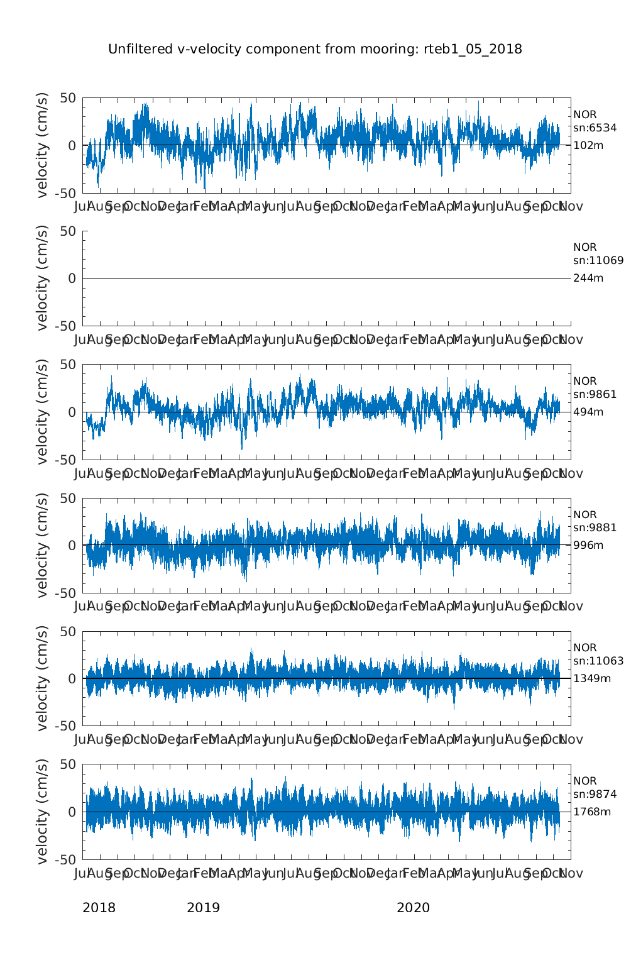
Figure M3: Figure of the meridional velocity at RTEB1 generated by the script batch_all.m

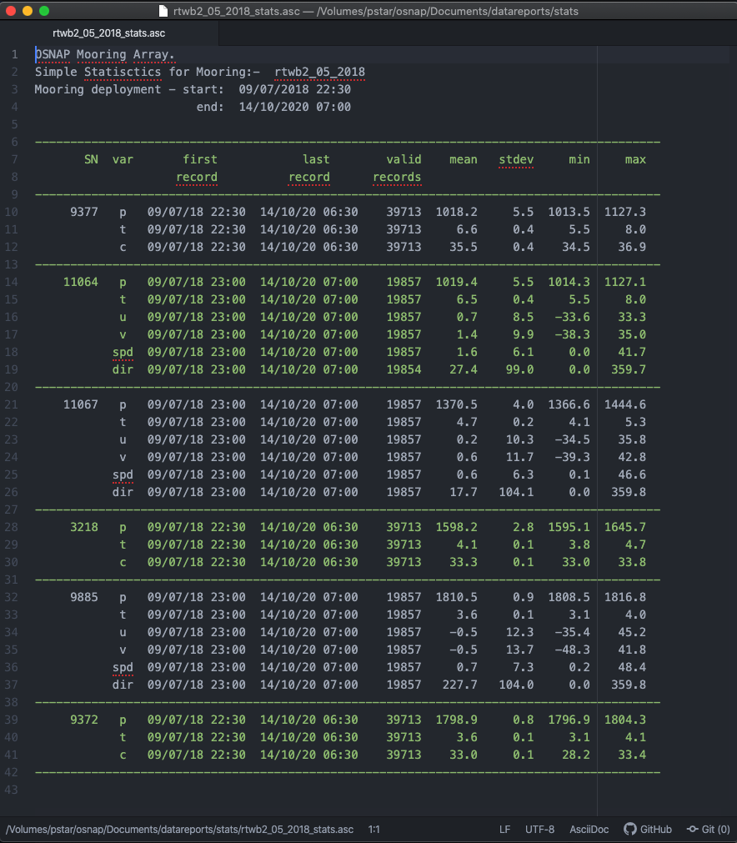
Figure M4: Example of summary statistics file generated by the wrapper script batch_all.m

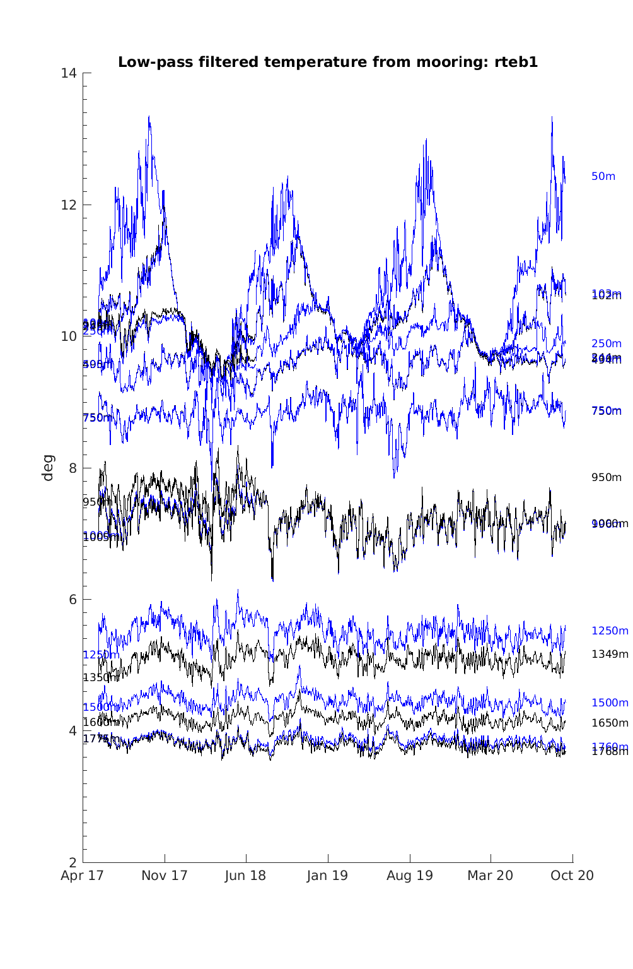
Figure M5: Temperature time-series at RTEB1 generated by the script batch_all_severalyr.m . Figures are saved under osnap/Documents/datareports/figs/rteb1_04_2017_05_2018/

Export to oceansites format [if required]
The mooring data are annually submitted to Feili Li (OSNAP) in Oceansites netcdf format. Currently we are generating this format (08/2019) though ultimately it may become BODC’s remit. Loic modified a suite of scripts to do this in osnap\exec\$cruise\export_Oceansites.
The top-level script osnap\exec\$cruise\export_Oceansites\convert_SAMS_mooring_to_oceansites.m
sets up directory paths and declares metadata to populate the netcdf file. This script has to be run once per mooring, note the commented out moorings on lines ~26-29. Scan through the script for any other tweaks necessary for the new mooring deployment. This script calls
osnap\exec\$cruise\export_Oceansites\rodb_to_oceansitesnetcdf
which loads the Microcat and current meter datafiles and converts them to netcdf.
Note: the script searches for known instrument IDs (Microcat = 337 or 335, Nortek = 368 or 370) to populate its arrays. This caused some indexing issues when ODO Microcats (with oxygen sensors) were added to the array for the 04_2017 mooring. Be aware that some careful checking will be required if another new instrument type is added to the moorings, including (but not limited to) lines ~56 – 83 and 86-98. This also applied to the gridding scripts (stages 4 and 5).
Data and plots are saved to
osnap\exec\$cruise\export_Oceansites\oceansites_format

These tend to be small files which can be emailed as a .zip file or similar.

Export to NetCDF for CLASS data working group

Change the filenames in the script osnap\exec\$cruise\export_THREDDS/Export_moor_to_NetCDF,m to reflect the most recently processed data and run.

Appendix: Historical and OSNAP CTD profiles close to the moorings

RTEB1
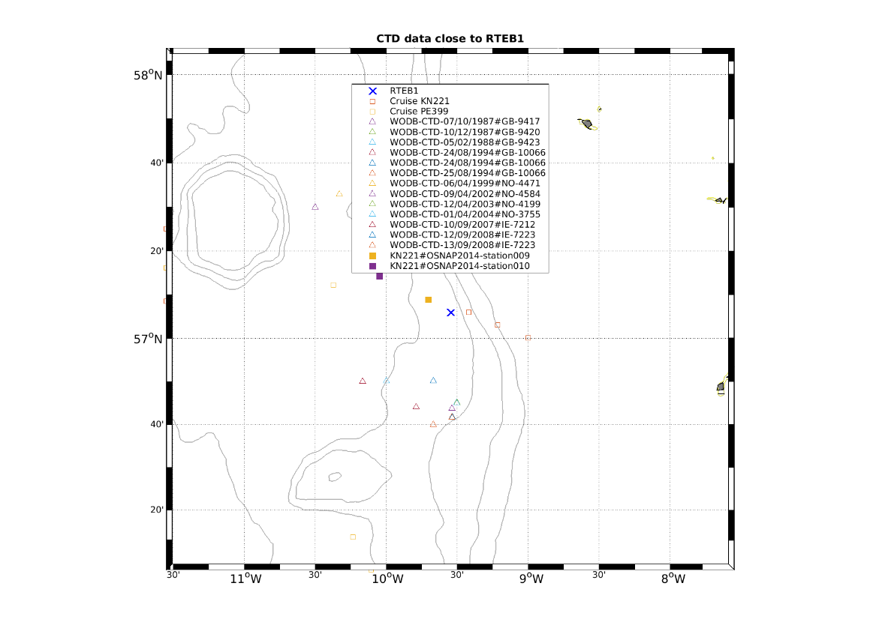
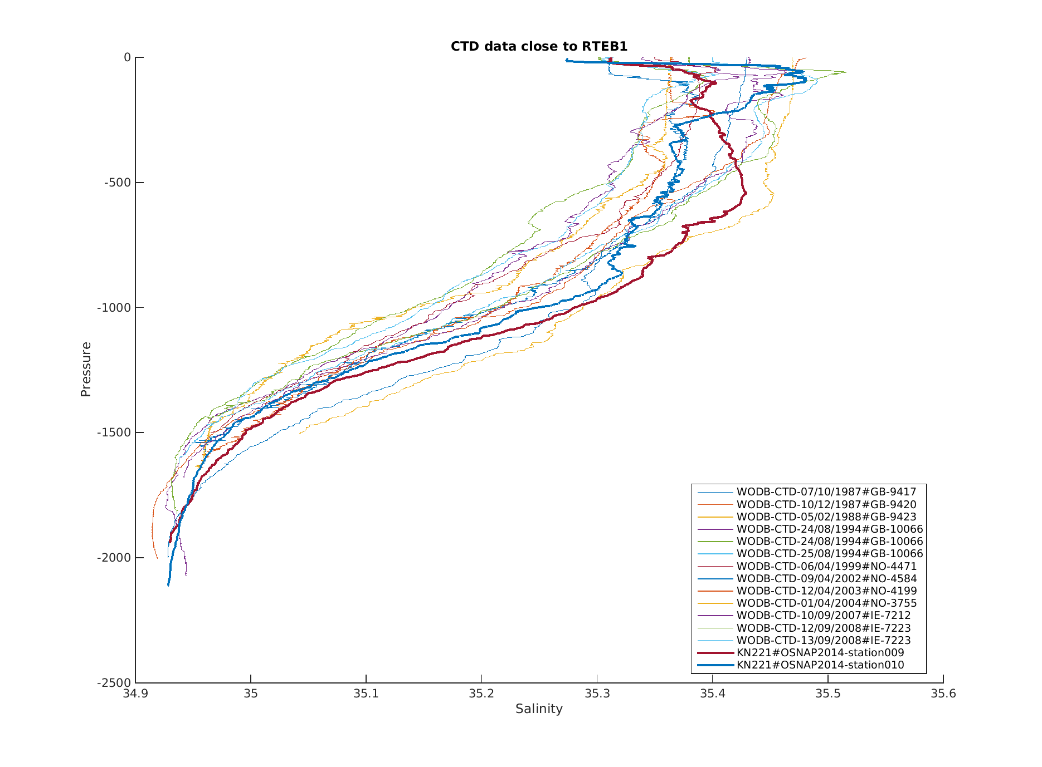

RTWB1
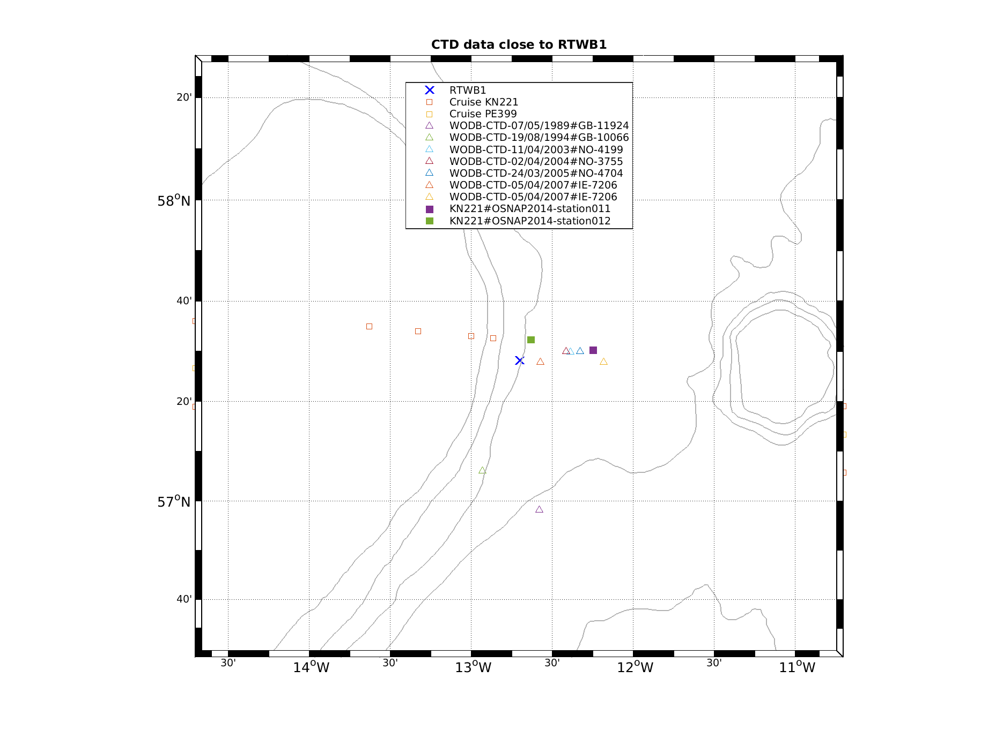
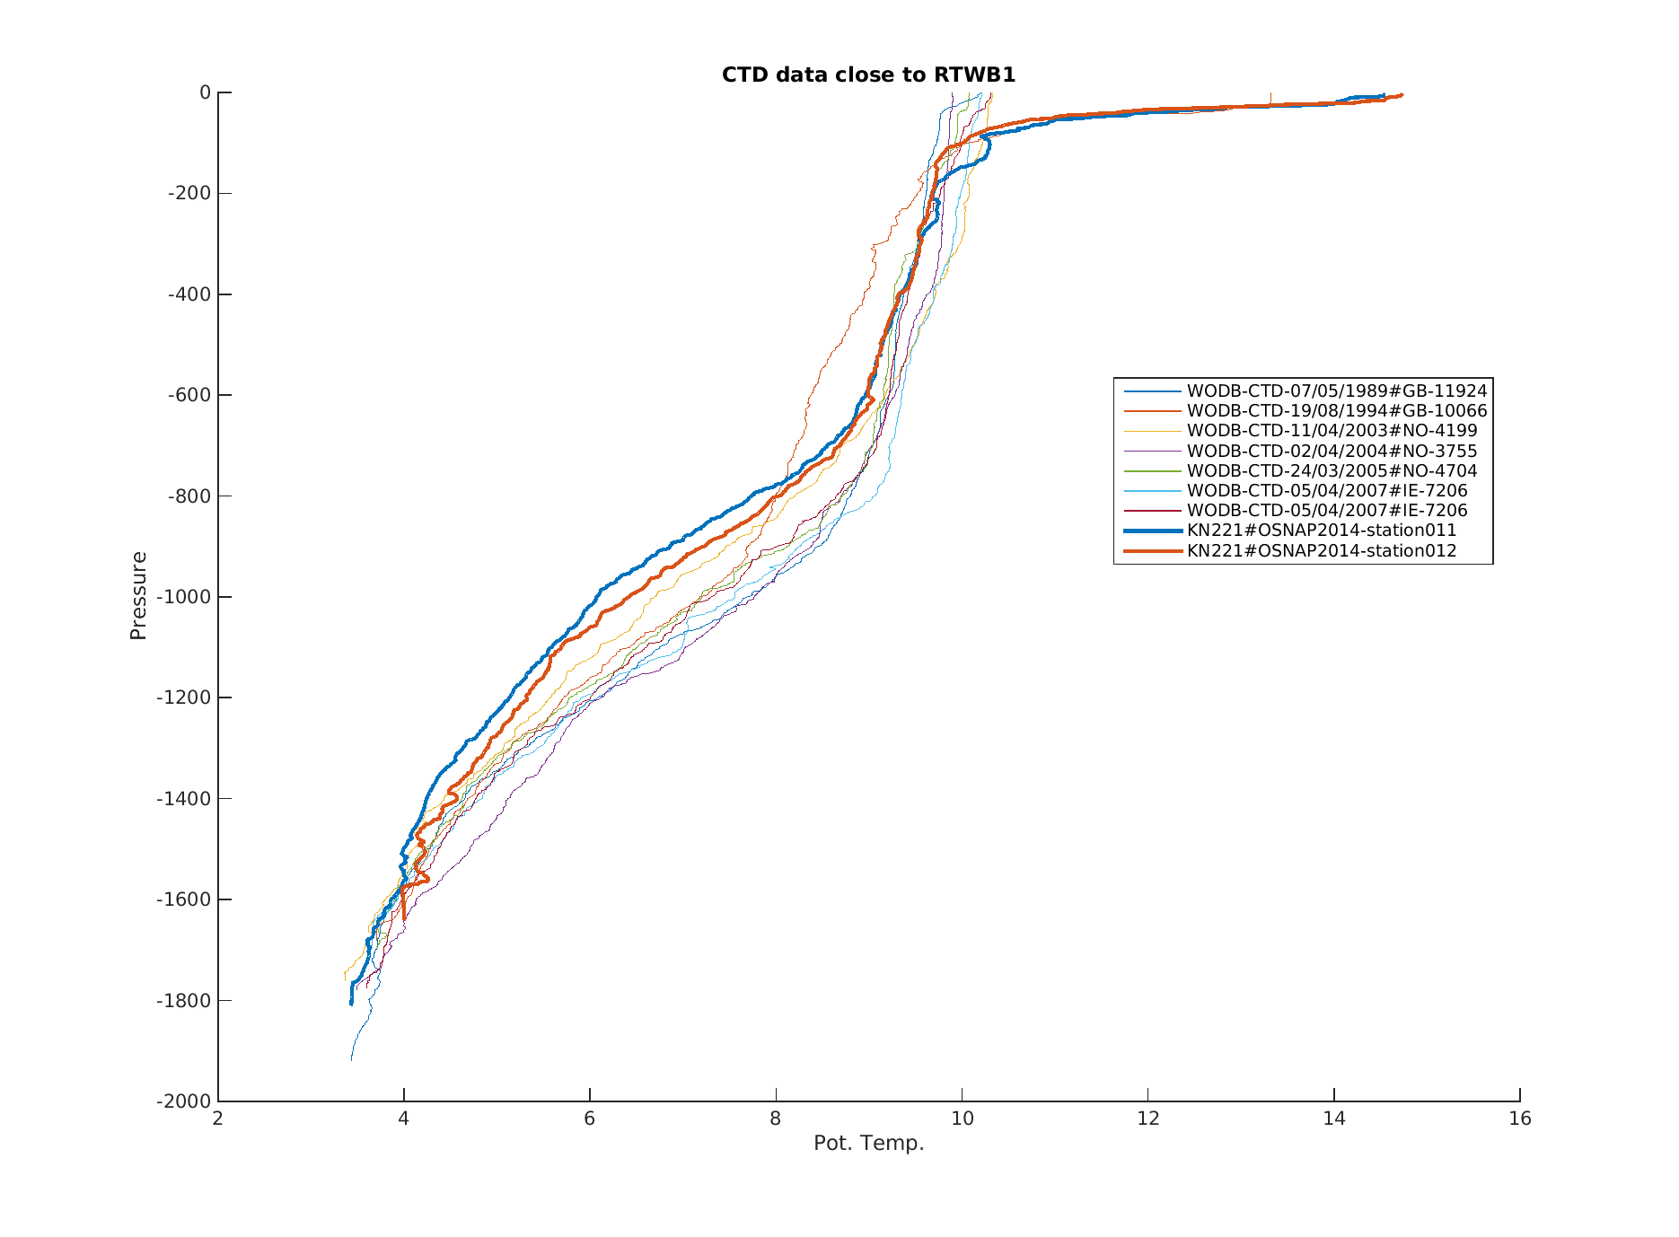

RTWB2
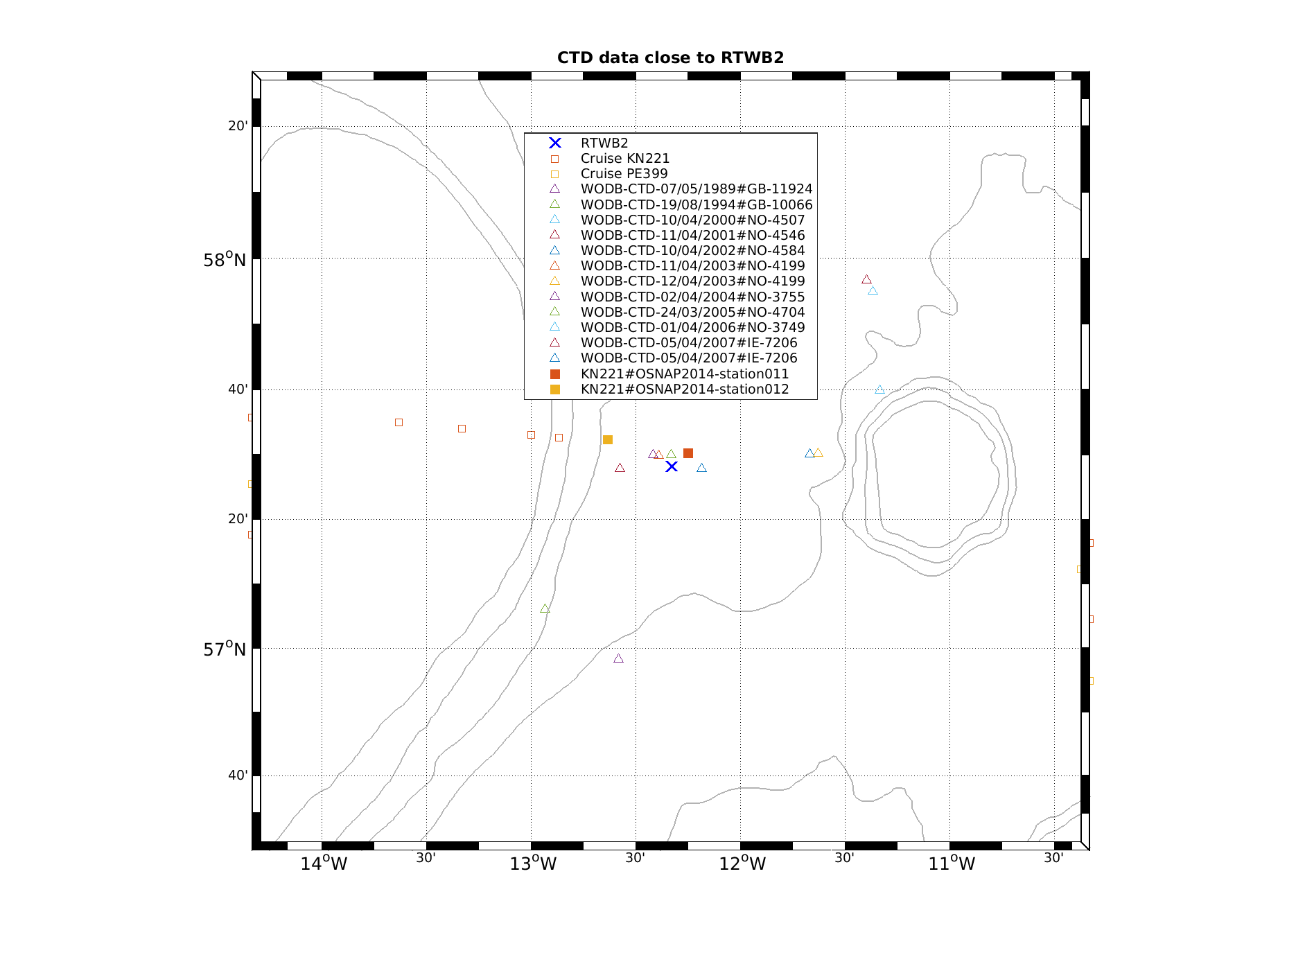
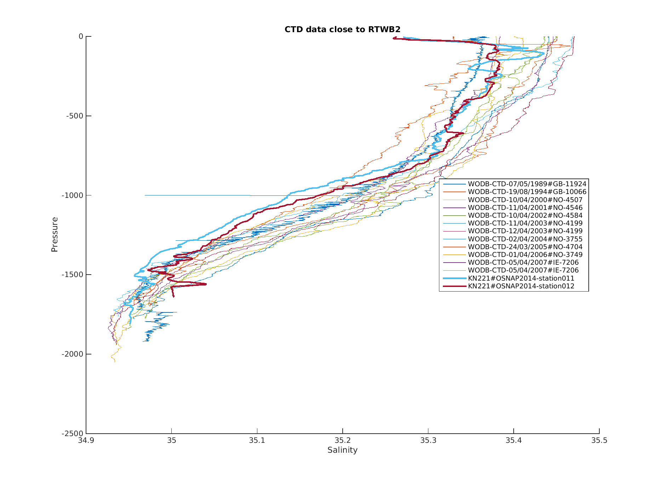

RTADCP1
