UK-OSNAP processing of moored current meter and ADCP data during the DY078 cruise

Introduction

The purpose of this document is to describe the data processing applied to all current meter records collected from the SAMS contribution of the UK-OSNAP project, including initial quality control of the data, data editing, corrections applied, and filtering.
The current meters used on the 4 SAMS-OSNAP moorings for the period 2014-2015 consisted of Nortek Aquadopps for 3 moorings (RTEB1, RTWB1 and RTWB2) and a RDI-ADCP 75kHz on RTADCP1. The Nortek Aquadopps had recording intervals of 20 minutes, while the ADCP has a recording interval of 1 hour.

Note: ~ refers to M:\Mar_Phys\OSNAP_mooring_data_processing

Note 2: the OSNAP data structure separates executable scripts (osnap/exec/…) from output files (osnap/data/moor/…). For clarity, file extensions for scripts are coloured red, input files are coloured blue, and output files are coloured green. The output files of some scripts may become the input of a later script. Hopefully this will make navigation of this document a little easier.

Nortek current meter data processing

Stage0 – Data Download (done during the cruise DY078)
Raw instrument data are downloaded from the instrument after the recovery of the mooring. Record keeping of the download is done on paper and for each instrument a download sheet is completed. After the download, the data are backup and transferred to the network drive on the cruise directory dy078/SAMS_moorings/nortek . Instrument setup details and data are sorted in different directory by mooring name.
Then the data (.dat, .aqd and .hdr files) are copied on the processing computer in the directory e.g ~\osnap\data\moor\raw\dy078\nortek

Stage1 – Conversion to standard RDB format and basic statistics
Warning: the processing scripts in their current form do not work on Matlab versions R2017a onwards without some modifications. Consider running on R2016a.
You must start by running M:\Mar_Phys\OSNAP_mooring_data_processing\osnap\ startup_$cruise.m
A text file containing the serial numbers of the Nortek on the mooring and the filenames containing the data has to be created as follows:
~\osnap\data\moor\raw\dy078\nortek/rteb1_03_2016_filenames.txt.
The script ~\osnap\exec\dy078\stage1\nor/process_nors_dy078.m performs stage1 and stage 2 processing on nortek data. It converts nortek data from raw to rodb format for an entire mooring. The user needs to modify the following information in the beginning of the script: cruise, the mooring name and operator.
process_nors_dy078 calls nortek2rodb_01, which saves the files downloaded by the instrument software (stage 0) to the RDB formatted file .raw (in /osnap/data/moor/proc/rteb1_03_2016/nor.). The script nortek2rodb_01 also create data overview sheet including basic statistics (Annex1):
~\osnap\data\moor\proc\rteb1_03_2016\nor\rteb1_03_2016_Nortek_stage1.log

Stage2 – Trimming of data, summary plots
The script process_nors_dy078 also performs stage 2 processing on nortek data by calling the script nortek_raw2use_02. This script uses the raw data file mooring_serialnum.raw generated by stage1 and the <mooring>info.dat file:
~\osnap\data\moor\proc\rteb1_03_2016
and produces a .use file. It removes the launching and recovery period and produce summary and diagnostic plots (figure 1, 2), including filtered data for display and diagnostic purposes (figure3).
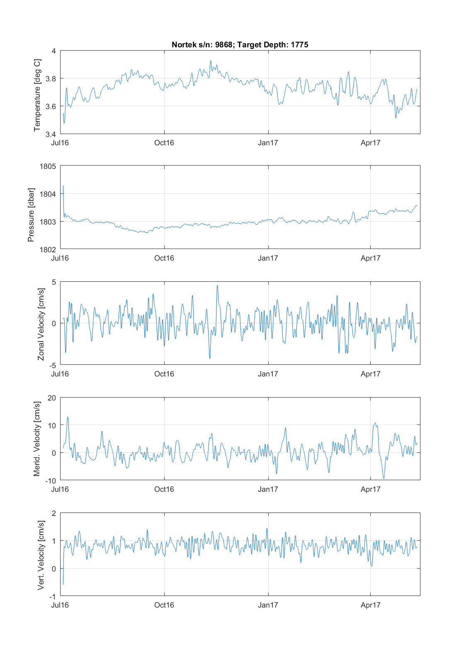
Figure 1: Summary plot from the stage2 processing of the Nortek S/N 9868, deployed on RTEB1 from June 2016 to May 2017.

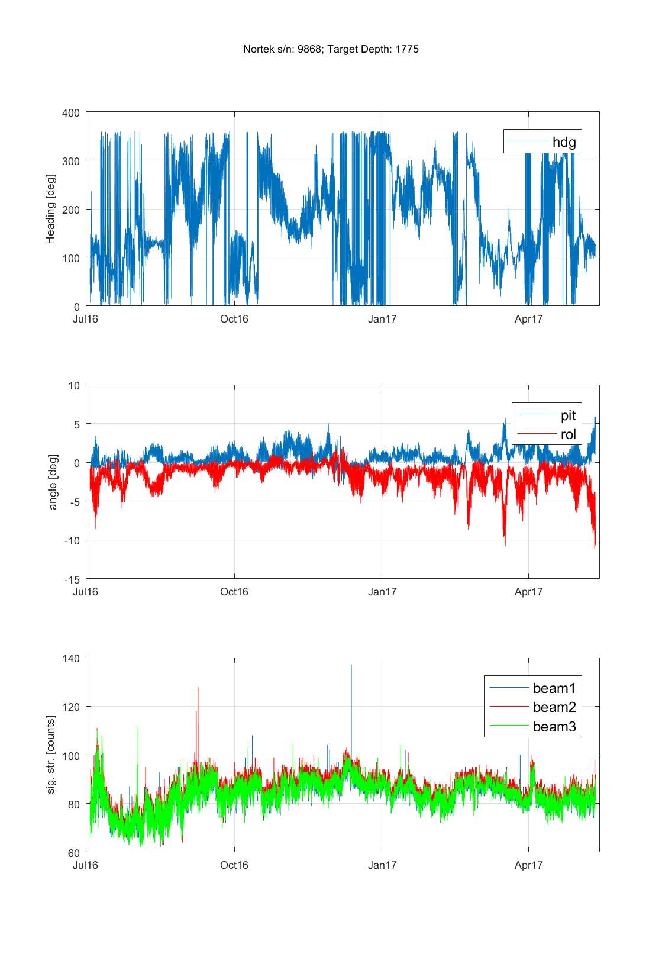

Figure 2: Diagnostic plot from the stage2 processing of the Nortek S/N 9868, deployed on RTEB1 from June 2016 to May 2017.

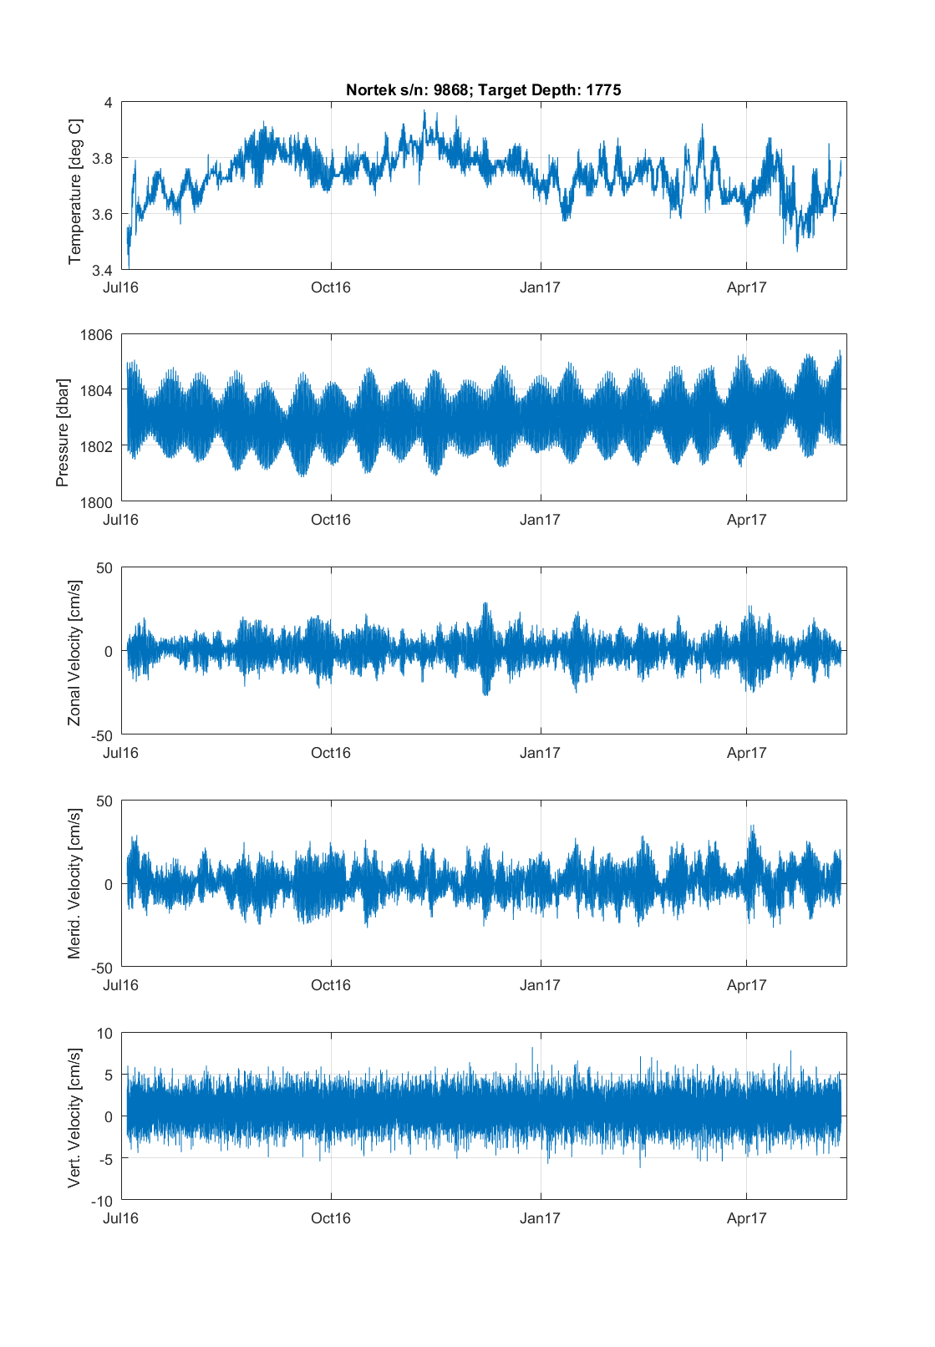
Figure 2: Overview of the filtered data after the stage2 processing of the Nortek S/N 9868, deployed on RTEB1 from June 2016 to May 2017.

Stage3 – Data editing, speed of sound correction, magnetic declination correction, data filtering
??The script proc_stage3_adcp_nortek in:
~\OSNAP_mooring_data_processing\osnap\exec\dy078\delayed_processing_script\nor\
is used to perform stage3 processing on current meter data, it calls the function cm_edit_NOCS_v3. Once the data trimming procedure and an initial data control are completed, the data can be corrected for speed of sound and magnetic declination. Magnetic deviation value has to be defined in:
~\osnap\data\moor\proc\rteb1_03_2016\ $mooring_info.dat file
by adding a line like “MagDeviation = -19.66”.
All the Nortek current meters deployed during the 1st year of the UK-OSNAP project were using a fixed speed of sound (1500m/s). The corrected sound speed is obtained by using measured values of pressure and temperature data from the Nortek and a local/regional value of salinity. For the OSNAP 2014 cruise, a mean salinity was defined for each Nortek current meter using the moored microcat and the CTD cruise profiles (Annex 2), and local salinity values are varying between 34.95 and 35.4. The corrected sound speed varies between 1491 and 1499 cm/s (Annex 3). Corrected velocities are then obtained by multiplying the uncorrected velocities with the ratio of the measured sound speed with a fixed sound speed.
%%
Then the recorded velocity components are transformed into true east and north components using the local magnetic declination estimated on the median of the deployment and recovery times of each mooring from the NOAA's National Geophysical Data Centre (http://www.ngdc.noaa.gov/geomag-web/).
Then spikes from the current meter data are removed using the spike/mean ratio criterion of 10, and visual inspection can also be used to identify remaining spikes. If data gaps are less than 24 hours, they are interpolated linearly in time, otherwise flag values are inserted.
Despiked data are low pass filtered using a 40-hour Butterworth filter to remove tidal and inertial oscillations, and are then interpolated onto 12-hour time steps (figure 4).
Finally, corrected data files that have been de-spiked and interpolated onto 12 hour time steps are saved in .edt files (WHERE??).

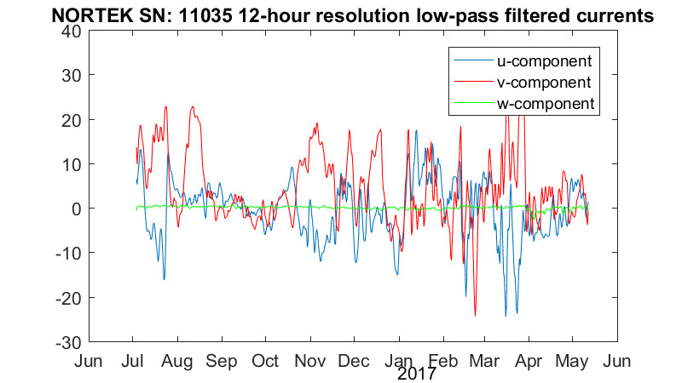
Figure 3: Data de-spiked, lowpass filtered and interpolated on 12 hour time steps after the stage3 processing of the Nortek S/N 11035, deployed on RTWB1 from June 2016 to May 2017.

Stage 4 – Data gridding of individual deployment
A. Create new case and run the script:
~\osnap\exec\dy078\stage3\gridding\CM\velocity_grid_nor
C. Data are saved as a mat file in ~\osnap\data\moor\proc\velocity_grid\

Stage 5 – Gridding and merging of the several years of deployment
Create dat files e.g
~ \osnap\exec\dy078\stage3\gridding\CM\ rteb_CM_osnap_03_2016.dat

Copy old file e.g. CM_rteb_merging_02_2015.m and edit as follows:
Create new moor e.g. moor3 = 'rteb_CM_osnap_03_2016';
Line 95: boundarydir = [basedir '/exec/dy078/stage3/gridding/CM/'];
Line 108 & 109: change jg_end and lastyeardata
Add a new cruise e.g. 2c. OSNAP 3 (DY053 --> DY078)
Edit the following lines:
disp('--------- OSNAP 3 (DY053 --> DY078) ---------')
fileID3 = fopen([boundarydir, moor3, '.dat']);
file3_data = textscan(fileID3……
fclose(fileID3);
mooring3 = file3_data{1};
sn3 = file3_data{2};
cm3 = file3_data{3};
z3 = file3_data{4};
lon3 = file3_data{5};
Ufs = [Ufs1;Ufs2;Ufs3];
Vfs = [Vfs1;Vfs2;Vfs3];
Wfs = [Wfs1;Wfs2;Wfs3];
Pfs = [Pfs1;Pfs2;Pfs3];

U2 = zeros(length(sn3), length(JG));
V3 = zeros(length(sn3), length(JG));
W3 = zeros(length(sn3), length(JG));
P3 = zeros(length(sn3), length(JG));
for i = 1: length(sn3)
infile = [hydrodir, mooring3{i,:}, '_velocity_grid.mat'];
uuu = interp1(jdnew(1:end-1), ufi(cm3(i),1:end-1)', JG)';
vvv = interp1(jdnew(1:end-1), vfi(cm3(i),1:end-1)', JG)';
www = interp1(jdnew(1:end-1), wfi(cm3(i),1:end-1)', JG)';
ppp = interp1(jdnew(1:end-1), pfi(cm3(i),1:end-1)', JG)';
Ufs3(j,:) = uuu;
Vfs3(j,:) = vvv;
Wfs3(j,:) = www;
Pfs3(j,:) = ppp;
plot(JG, Ufs3(i, :), col{:,i},'LineWidth',2); (and V W P)

Thoroughly check through the script for other instances that need to be changed with the addition of a new mooring.

Annex 1: Log files for Nortek processing for stage 1

RTEB1
Transformation of Nortek ascii data to rodb format
Processing carried out by mstar
at 13-May-2017 15:18:54

Mooring rteb1_03_2016
Latitude 57.101
Longitude -9.562

infile : /home/mstar/osnap/data/moor/raw/dy078/nortek/986801_data.dat
outfile: rteb1_03_2016_9868.raw
Nortek serial number : 9868
Instrument Target Depth[m] : 1775
Start date and time : 03-Jul-2016 12:40:00
End date and time : 13-May-2017 14:00:00
Sampling Frequency [per day]: 72
Number of samples : 22613; expected: 22613
Median temperature Nortek [deg C] : 3.74
Median pressure Nortek [dbar] : 1802.981
Median velocity u / v / w [cm/s] : 0.0 0.0 0.0
Median heading / pitch / roll [deg] : 170.1 0.5 -1.2
Median velocity signal amplitude u / v / w [count] : 84 86 84
Median speed [cm/s] : 0.1
Median direction [cm/s] : 178.86
Median power input level [V] : 12.3

infile : /home/mstar/osnap/data/moor/raw/dy078/nortek/1104801_data.dat
outfile: rteb1_03_2016_11048.raw
Nortek serial number : 11048
Instrument Target Depth[m] : 495
Start date and time : 03-Jul-2016 12:40:00
End date and time : 13-May-2017 14:20:00
Sampling Frequency [per day]: 72
Number of samples : 22614; expected: 22614
Median temperature Nortek [deg C] : 9.74
Median pressure Nortek [dbar] : 492.690
Median velocity u / v / w [cm/s] : -0.0 0.0 0.0
Median heading / pitch / roll [deg] : 156.6 0.9 -0.4
Median velocity signal amplitude u / v / w [count] : 68 66 69
Median speed [cm/s] : 0.1
Median direction [cm/s] : 180.41
Median power input level [V] : 12.4

infile : /home/mstar/osnap/data/moor/raw/dy078/nortek/1313001_data.dat
outfile: rteb1_03_2016_13130.raw
Nortek serial number : 13130
Instrument Target Depth[m] : 1000
Start date and time : 03-Jul-2016 12:40:00
End date and time : 13-May-2017 13:40:00
Sampling Frequency [per day]: 72
Number of samples : 22612; expected: 22612
Median temperature Nortek [deg C] : 7.54
Median pressure Nortek [dbar] : 1012.562
Median velocity u / v / w [cm/s] : 0.0 0.0 0.0
Median heading / pitch / roll [deg] : 184.8 -0.5 0.0
Median velocity signal amplitude u / v / w [count] : 68 74 68
Median speed [cm/s] : 0.1
Median direction [cm/s] : 176.51
Median power input level [V] : 12.5

infile : /home/mstar/osnap/data/moor/raw/dy078/nortek/1314201_data.dat
outfile: rteb1_03_2016_13142.raw
Nortek serial number : 13142
Instrument Target Depth[m] : 1350
Start date and time : 03-Jul-2016 12:40:00
End date and time : 13-May-2017 13:40:00
Sampling Frequency [per day]: 72
Number of samples : 22612; expected: 22612
Median temperature Nortek [deg C] : 4.96
Median pressure Nortek [dbar] : 1374.511
Median velocity u / v / w [cm/s] : 0.0 -0.0 0.0
Median heading / pitch / roll [deg] : 184.6 0.9 -0.6
Median velocity signal amplitude u / v / w [count] : 67 61 62
Median speed [cm/s] : 0.1
Median direction [cm/s] : 173.35
Median power input level [V] : 12.4

Transformation of Nortek ascii data to rodb format
Processing carried out by
^C at 31-Jul-2017 15:19:46

Mooring rteb1_03_2016
Latitude 57.101
Longitude -9.562

infile : /media/SAMS/m/Mar_Phys/OSNAP_mooring_data_processing/osnap/data/moor/raw/dy078/nortek/9867_data.dat
outfile: rteb1_03_2016_9867.raw
Nortek serial number : 9867
Instrument Target Depth[m] : 95
Start date and time : 03-Jul-2016 12:40:00
End date and time : 29-Jun-2017 10:40:00
Sampling Frequency [per day]: 72
Number of samples : 25987; expected: 25987
Median temperature Nortek [deg C] : 10.23
Median pressure Nortek [dbar] : 86.621
Median velocity u / v / w [cm/s] : 0.0 0.0 -0.0
Median heading / pitch / roll [deg] : 167.2 1.1 -0.9
Median velocity signal amplitude u / v / w [count] : 85 84 84
Median speed [cm/s] : 0.1
Median direction [cm/s] : 170.84
Median power input level [V] : 12.5

infile : /media/SAMS/m/Mar_Phys/OSNAP_mooring_data_processing/osnap/data/moor/raw/dy078/nortek/11035_data.dat
outfile: rteb1_03_2016_11035.raw
Nortek serial number : 11035
Instrument Target Depth[m] : 245
Start date and time : 01-Jul-2016 14:00:00
End date and time : 29-Jun-2017 10:20:00
Sampling Frequency [per day]: 72
Number of samples : 26126; expected: 26126
Median temperature Nortek [deg C] : 9.99
Median pressure Nortek [dbar] : 237.856
Median velocity u / v / w [cm/s] : 0.0 0.0 0.0
Median heading / pitch / roll [deg] : 171.7 1.3 -0.7
Median velocity signal amplitude u / v / w [count] : 83 81 81
Median speed [cm/s] : 0.1
Median direction [cm/s] : 171.87
Median power input level [V] : 12.4

infile : /media/SAMS/m/Mar_Phys/OSNAP_mooring_data_processing/osnap/data/moor/raw/dy078/nortek/986801_data.dat
outfile: rteb1_03_2016_9868.raw
Nortek serial number : 9868
Instrument Target Depth[m] : 1775
Start date and time : 03-Jul-2016 12:40:00
End date and time : 13-May-2017 14:00:00
Sampling Frequency [per day]: 72
Number of samples : 22613; expected: 22613
Median temperature Nortek [deg C] : 3.74
Median pressure Nortek [dbar] : 1802.981
Median velocity u / v / w [cm/s] : 0.0 0.0 0.0
Median heading / pitch / roll [deg] : 170.1 0.5 -1.2
Median velocity signal amplitude u / v / w [count] : 84 86 84
Median speed [cm/s] : 0.1
Median direction [cm/s] : 178.86
Median power input level [V] : 12.3

infile : /media/SAMS/m/Mar_Phys/OSNAP_mooring_data_processing/osnap/data/moor/raw/dy078/nortek/1104801_data.dat
outfile: rteb1_03_2016_11048.raw
Nortek serial number : 11048
Instrument Target Depth[m] : 495
Start date and time : 03-Jul-2016 12:40:00
End date and time : 13-May-2017 14:20:00
Sampling Frequency [per day]: 72
Number of samples : 22614; expected: 22614
Median temperature Nortek [deg C] : 9.74
Median pressure Nortek [dbar] : 492.690
Median velocity u / v / w [cm/s] : -0.0 0.0 0.0
Median heading / pitch / roll [deg] : 156.6 0.9 -0.4
Median velocity signal amplitude u / v / w [count] : 68 66 69
Median speed [cm/s] : 0.1
Median direction [cm/s] : 180.41
Median power input level [V] : 12.4

infile : /media/SAMS/m/Mar_Phys/OSNAP_mooring_data_processing/osnap/data/moor/raw/dy078/nortek/1313001_data.dat
outfile: rteb1_03_2016_13130.raw
Nortek serial number : 13130
Instrument Target Depth[m] : 1000
Start date and time : 03-Jul-2016 12:40:00
End date and time : 13-May-2017 13:40:00
Sampling Frequency [per day]: 72
Number of samples : 22612; expected: 22612
Median temperature Nortek [deg C] : 7.54
Median pressure Nortek [dbar] : 1012.562
Median velocity u / v / w [cm/s] : 0.0 0.0 0.0
Median heading / pitch / roll [deg] : 184.8 -0.5 0.0
Median velocity signal amplitude u / v / w [count] : 68 74 68
Median speed [cm/s] : 0.1
Median direction [cm/s] : 176.51
Median power input level [V] : 12.5

infile : /media/SAMS/m/Mar_Phys/OSNAP_mooring_data_processing/osnap/data/moor/raw/dy078/nortek/1314201_data.dat
outfile: rteb1_03_2016_13142.raw
Nortek serial number : 13142
Instrument Target Depth[m] : 1350
Start date and time : 03-Jul-2016 12:40:00
End date and time : 13-May-2017 13:40:00
Sampling Frequency [per day]: 72
Number of samples : 22612; expected: 22612
Median temperature Nortek [deg C] : 4.96
Median pressure Nortek [dbar] : 1374.511
Median velocity u / v / w [cm/s] : 0.0 -0.0 0.0
Median heading / pitch / roll [deg] : 184.6 0.9 -0.6
Median velocity signal amplitude u / v / w [count] : 67 61 62
Median speed [cm/s] : 0.1
Median direction [cm/s] : 173.35
Median power input level [V] : 12.4

Transformation of Nortek ascii data to rodb format
Processing carried out by sams\sa05cd
at 17-Nov-2017 11:06:58

Mooring rteb1_03_2016
Latitude 57.101
Longitude -9.562

infile : M:\Mar_Phys\OSNAP_mooring_data_processing\osnap\data\moor/raw/dy078/nortek/9867_data.dat
outfile: rteb1_03_2016_9867.raw
Nortek serial number : 9867
Instrument Target Depth[m] : 95
Start date and time : 03-Jul-2016 12:40:00
End date and time : 29-Jun-2017 10:40:00
Sampling Frequency [per day]: 72
Number of samples : 25987; expected: 25987
Median temperature Nortek [deg C] : 10.23
Median pressure Nortek [dbar] : 86.621
Median velocity u / v / w [cm/s] : 0.0 0.0 -0.0
Median heading / pitch / roll [deg] : 167.2 1.1 -0.9
Median velocity signal amplitude u / v / w [count] : 85 84 84
Median speed [cm/s] : 0.1
Median direction [cm/s] : 170.84
Median power input level [V] : 12.5

infile : M:\Mar_Phys\OSNAP_mooring_data_processing\osnap\data\moor/raw/dy078/nortek/11035_data.dat
outfile: rteb1_03_2016_11035.raw
Nortek serial number : 11035
Instrument Target Depth[m] : 245
Start date and time : 01-Jul-2016 14:00:00
End date and time : 29-Jun-2017 10:20:00
Sampling Frequency [per day]: 72
Number of samples : 26126; expected: 26126
Median temperature Nortek [deg C] : 9.99
Median pressure Nortek [dbar] : 237.856
Median velocity u / v / w [cm/s] : 0.0 0.0 0.0
Median heading / pitch / roll [deg] : 171.7 1.3 -0.7
Median velocity signal amplitude u / v / w [count] : 83 81 81
Median speed [cm/s] : 0.1
Median direction [cm/s] : 171.87
Median power input level [V] : 12.4

infile : M:\Mar_Phys\OSNAP_mooring_data_processing\osnap\data\moor/raw/dy078/nortek/986801_data.dat
outfile: rteb1_03_2016_9868.raw
Nortek serial number : 9868
Instrument Target Depth[m] : 1775
Start date and time : 03-Jul-2016 12:40:00
End date and time : 13-May-2017 14:00:00
Sampling Frequency [per day]: 72
Number of samples : 22613; expected: 22613
Median temperature Nortek [deg C] : 3.74
Median pressure Nortek [dbar] : 1802.981
Median velocity u / v / w [cm/s] : 0.0 0.0 0.0
Median heading / pitch / roll [deg] : 170.1 0.5 -1.2
Median velocity signal amplitude u / v / w [count] : 84 86 84
Median speed [cm/s] : 0.1
Median direction [cm/s] : 178.86
Median power input level [V] : 12.3

infile : M:\Mar_Phys\OSNAP_mooring_data_processing\osnap\data\moor/raw/dy078/nortek/1104801_data.dat
outfile: rteb1_03_2016_11048.raw
Nortek serial number : 11048
Instrument Target Depth[m] : 495
Start date and time : 03-Jul-2016 12:40:00
End date and time : 13-May-2017 14:20:00
Sampling Frequency [per day]: 72
Number of samples : 22614; expected: 22614
Median temperature Nortek [deg C] : 9.74
Median pressure Nortek [dbar] : 492.690
Median velocity u / v / w [cm/s] : -0.0 0.0 0.0
Median heading / pitch / roll [deg] : 156.6 0.9 -0.4
Median velocity signal amplitude u / v / w [count] : 68 66 69
Median speed [cm/s] : 0.1
Median direction [cm/s] : 180.41
Median power input level [V] : 12.4

infile : M:\Mar_Phys\OSNAP_mooring_data_processing\osnap\data\moor/raw/dy078/nortek/1313001_data.dat
outfile: rteb1_03_2016_13130.raw
Nortek serial number : 13130
Instrument Target Depth[m] : 1000
Start date and time : 03-Jul-2016 12:40:00
End date and time : 13-May-2017 13:40:00
Sampling Frequency [per day]: 72
Number of samples : 22612; expected: 22612
Median temperature Nortek [deg C] : 7.54
Median pressure Nortek [dbar] : 1012.562
Median velocity u / v / w [cm/s] : 0.0 0.0 0.0
Median heading / pitch / roll [deg] : 184.8 -0.5 0.0
Median velocity signal amplitude u / v / w [count] : 68 74 68
Median speed [cm/s] : 0.1
Median direction [cm/s] : 176.51
Median power input level [V] : 12.5

infile : M:\Mar_Phys\OSNAP_mooring_data_processing\osnap\data\moor/raw/dy078/nortek/1314201_data.dat
outfile: rteb1_03_2016_13142.raw
Nortek serial number : 13142
Instrument Target Depth[m] : 1350
Start date and time : 03-Jul-2016 12:40:00
End date and time : 13-May-2017 13:40:00
Sampling Frequency [per day]: 72
Number of samples : 22612; expected: 22612
Median temperature Nortek [deg C] : 4.96
Median pressure Nortek [dbar] : 1374.511
Median velocity u / v / w [cm/s] : 0.0 -0.0 0.0
Median heading / pitch / roll [deg] : 184.6 0.9 -0.6
Median velocity signal amplitude u / v / w [count] : 67 61 62
Median speed [cm/s] : 0.1
Median direction [cm/s] : 173.35
Median power input level [V] : 12.4

RTWB1
Transformation of Nortek ascii data to rodb format
Processing carried out by mstar
at 10-May-2017 19:20:53

Mooring rtwb1_03_2016
Latitude 57.470
Longitude -12.711

infile : /home/mstar/osnap/data/moor/raw/dy078/nortek/8365_data.dat
outfile: rtwb1_03_2016_8365.raw
Nortek serial number : 8365
Instrument Target Depth[m] : 95
Start date and time : 03-Jul-2016 19:00:00
End date and time : 10-May-2017 14:20:00
Sampling Frequency [per day]: 72
Number of samples : 22379; expected: 22379
Median temperature Nortek [deg C] : 10.05
Median pressure Nortek [dbar] : 71.837
Median velocity u / v / w [cm/s] : 0.0 -0.1 0.0
Median heading / pitch / roll [deg] : 233.1 0.4 -1.4
Median velocity signal amplitude u / v / w [count] : 85 85 85
Median speed [cm/s] : 0.2
Median direction [cm/s] : 171.53
Median power input level [V] : 12.4

infile : /home/mstar/osnap/data/moor/raw/dy078/nortek/11051_data.dat
outfile: rtwb1_03_2016_11051.raw
Nortek serial number : 11051
Instrument Target Depth[m] : 495
Start date and time : 03-Jul-2016 20:00:00
End date and time : 10-May-2017 15:20:00
Sampling Frequency [per day]: 72
Number of samples : 22379; expected: 22379
Median temperature Nortek [deg C] : 9.09
Median pressure Nortek [dbar] : 477.001
Median velocity u / v / w [cm/s] : -0.0 -0.1 0.0
Median heading / pitch / roll [deg] : 202.0 -1.7 -1.7
Median velocity signal amplitude u / v / w [count] : 64 61 62
Median speed [cm/s] : 0.1
Median direction [cm/s] : 182.30
Median power input level [V] : 12.5

infile : /home/mstar/osnap/data/moor/raw/dy078/nortek/11069_data.dat
outfile: rtwb1_03_2016_11069.raw
Nortek serial number : 11069
Instrument Target Depth[m] : 995
Start date and time : 03-Jul-2016 19:00:00
End date and time : 10-May-2017 15:00:00
Sampling Frequency [per day]: 72
Number of samples : 22381; expected: 22381
Median temperature Nortek [deg C] : 6.88
Median pressure Nortek [dbar] : 989.096
Median velocity u / v / w [cm/s] : -0.0 -0.1 0.0
Median heading / pitch / roll [deg] : 274.9 1.8 -1.4
Median velocity signal amplitude u / v / w [count] : 62 66 64
Median speed [cm/s] : 0.1
Median direction [cm/s] : 189.14
Median power input level [V] : 12.5

infile : /home/mstar/osnap/data/moor/raw/dy078/nortek/11046_data.dat
outfile: rtwb1_03_2016_11046.raw
Nortek serial number : 11046
Instrument Target Depth[m] : 1350
Start date and time : 03-Jul-2016 20:00:00
End date and time : 10-May-2017 14:40:00
Sampling Frequency [per day]: 72
Number of samples : 22377; expected: 22377
Median temperature Nortek [deg C] : 5.00
Median pressure Nortek [dbar] : 1351.287
Median velocity u / v / w [cm/s] : -0.0 -0.1 0.0
Median heading / pitch / roll [deg] : 116.0 1.8 0.2
Median velocity signal amplitude u / v / w [count] : 68 66 66
Median speed [cm/s] : 0.1
Median direction [cm/s] : 192.22
Median power input level [V] : 12.4

infile : /home/mstar/osnap/data/moor/raw/dy078/nortek/13018_data.dat
outfile: rtwb1_03_2016_13018.raw
Nortek serial number : 13018
Instrument Target Depth[m] : 1570
Start date and time : 03-Jul-2016 20:00:00
End date and time : 10-May-2017 15:00:00
Sampling Frequency [per day]: 72
Number of samples : 22378; expected: 22378
Median temperature Nortek [deg C] : 4.22
Median pressure Nortek [dbar] : 1580.316
Median velocity u / v / w [cm/s] : -0.0 -0.1 0.0
Median heading / pitch / roll [deg] : 296.7 1.8 -1.7
Median velocity signal amplitude u / v / w [count] : 80 76 79
Median speed [cm/s] : 0.1
Median direction [cm/s] : 188.13
Median power input level [V] : 12.4

RTWB2
Transformation of Nortek ascii data to rodb format
Processing carried out by mstar
at 10-May-2017 17:07:38

Mooring rtwb2_03_2016
Latitude 57.468
Longitude -12.312

infile : /home/mstar/osnap/data/moor/raw/dy078/nortek/9861_data.dat
outfile: rtwb2_03_2016_9861.raw
Nortek serial number : 9861
Instrument Target Depth[m] : 1350
Start date and time : 03-Jul-2016 19:00:00
End date and time : 10-May-2017 10:20:00
Sampling Frequency [per day]: 72
Number of samples : 22367; expected: 22367
Median temperature Nortek [deg C] : 4.82
Median pressure Nortek [dbar] : 1368.055
Median velocity u / v / w [cm/s] : 0.0 -0.0 0.0
Median heading / pitch / roll [deg] : 204.0 1.7 -0.3
Median velocity signal amplitude u / v / w [count] : 65 62 62
Median speed [cm/s] : 0.1
Median direction [cm/s] : 173.56
Median power input level [V] : 12.4

infile : /home/mstar/osnap/data/moor/raw/dy078/nortek/9877_data.dat
outfile: rtwb2_03_2016_9877.raw
Nortek serial number : 9877
Instrument Target Depth[m] : 1765
Start date and time : 03-Jul-2016 19:00:00
End date and time : 10-May-2017 09:40:00
Sampling Frequency [per day]: 72
Number of samples : 22365; expected: 22365
Median temperature Nortek [deg C] : 3.64
Median pressure Nortek [dbar] : 1807.831
Median velocity u / v / w [cm/s] : 0.0 -0.0 0.0
Median heading / pitch / roll [deg] : 173.9 -1.2 3.7
Median velocity signal amplitude u / v / w [count] : 103 103 94
Median speed [cm/s] : 0.2
Median direction [cm/s] : 178.84
Median power input level [V] : 12.4

infile : /home/mstar/osnap/data/moor/raw/dy078/nortek/9881_data.dat
outfile: rtwb2_03_2016_9881.raw
Nortek serial number : 9881
Instrument Target Depth[m] : 1000
Start date and time : 03-Jul-2016 19:00:00
End date and time : 10-May-2017 10:40:00
Sampling Frequency [per day]: 72
Number of samples : 22368; expected: 22368
Median temperature Nortek [deg C] : 6.73
Median pressure Nortek [dbar] : 1014.314
Median velocity u / v / w [cm/s] : 0.0 0.0 0.0
Median heading / pitch / roll [deg] : 151.8 -0.2 0.4
Median velocity signal amplitude u / v / w [count] : 70 66 68
Median speed [cm/s] : 0.1
Median direction [cm/s] : 147.09
Median power input level [V] : 12.5

Transformation of Nortek ascii data to rodb format
Processing carried out by mstar
at 10-May-2017 17:22:10

Mooring rtwb2_03_2016
Latitude 57.468
Longitude -12.312

infile : /home/mstar/osnap/data/moor/raw/dy078/nortek/9861_data.dat
outfile: rtwb2_03_2016_9861.raw
Nortek serial number : 9861
Instrument Target Depth[m] : 1350
Start date and time : 03-Jul-2016 19:00:00
End date and time : 10-May-2017 10:20:00
Sampling Frequency [per day]: 72
Number of samples : 22367; expected: 22367
Median temperature Nortek [deg C] : 4.82
Median pressure Nortek [dbar] : 1368.055
Median velocity u / v / w [cm/s] : 0.0 -0.0 0.0
Median heading / pitch / roll [deg] : 204.1 1.7 -0.3
Median velocity signal amplitude u / v / w [count] : 65 62 62
Median speed [cm/s] : 0.1
Median direction [cm/s] : 173.53
Median power input level [V] : 12.4

infile : /home/mstar/osnap/data/moor/raw/dy078/nortek/9877_data.dat
outfile: rtwb2_03_2016_9877.raw
Nortek serial number : 9877
Instrument Target Depth[m] : 1765
Start date and time : 03-Jul-2016 19:00:00
End date and time : 10-May-2017 09:40:00
Sampling Frequency [per day]: 72
Number of samples : 22365; expected: 22365
Median temperature Nortek [deg C] : 3.64
Median pressure Nortek [dbar] : 1807.831
Median velocity u / v / w [cm/s] : 0.0 -0.0 0.0
Median heading / pitch / roll [deg] : 173.8 -1.2 3.7
Median velocity signal amplitude u / v / w [count] : 103 103 94
Median speed [cm/s] : 0.2
Median direction [cm/s] : 178.83
Median power input level [V] : 12.4

infile : /home/mstar/osnap/data/moor/raw/dy078/nortek/9881_data.dat
outfile: rtwb2_03_2016_9881.raw
Nortek serial number : 9881
Instrument Target Depth[m] : 1000
Start date and time : 03-Jul-2016 19:00:00
End date and time : 10-May-2017 10:40:00
Sampling Frequency [per day]: 72
Number of samples : 22368; expected: 22368
Median temperature Nortek [deg C] : 6.73
Median pressure Nortek [dbar] : 1014.314
Median velocity u / v / w [cm/s] : 0.0 0.0 0.0
Median heading / pitch / roll [deg] : 151.7 -0.2 0.4
Median velocity signal amplitude u / v / w [count] : 70 66 68
Median speed [cm/s] : 0.1
Median direction [cm/s] : 147.09
Median power input level [V] : 12.5

Annex 2: Historical and OSNAP CTD profiles close to the moorings

RTEB1
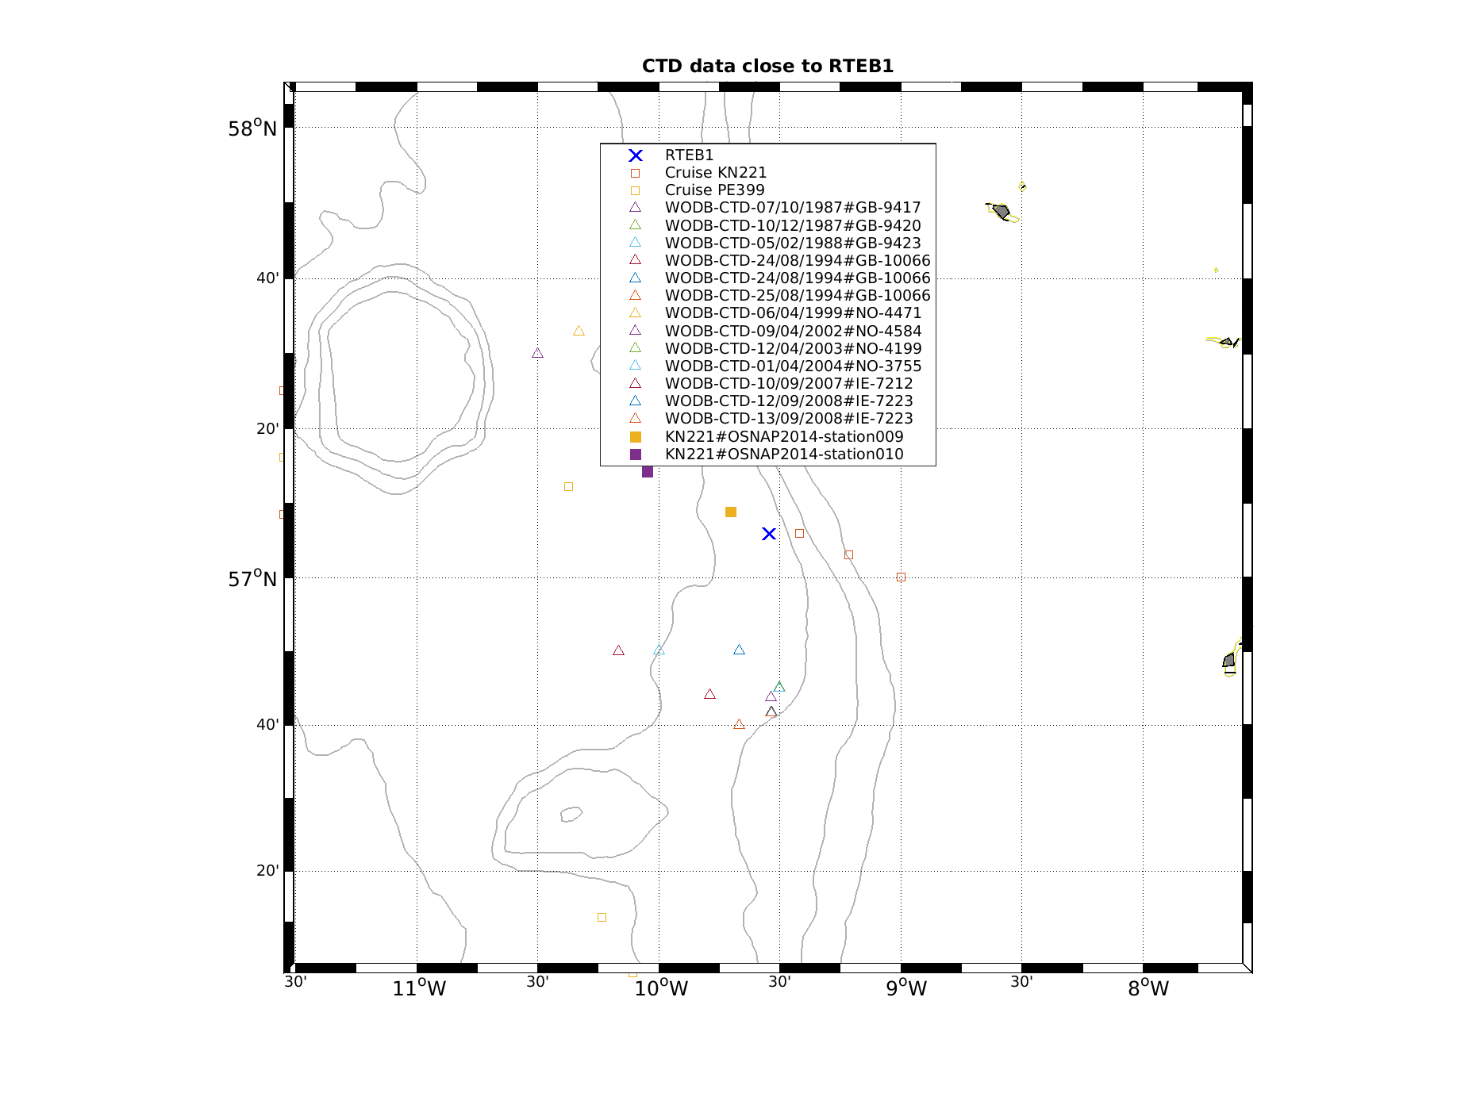
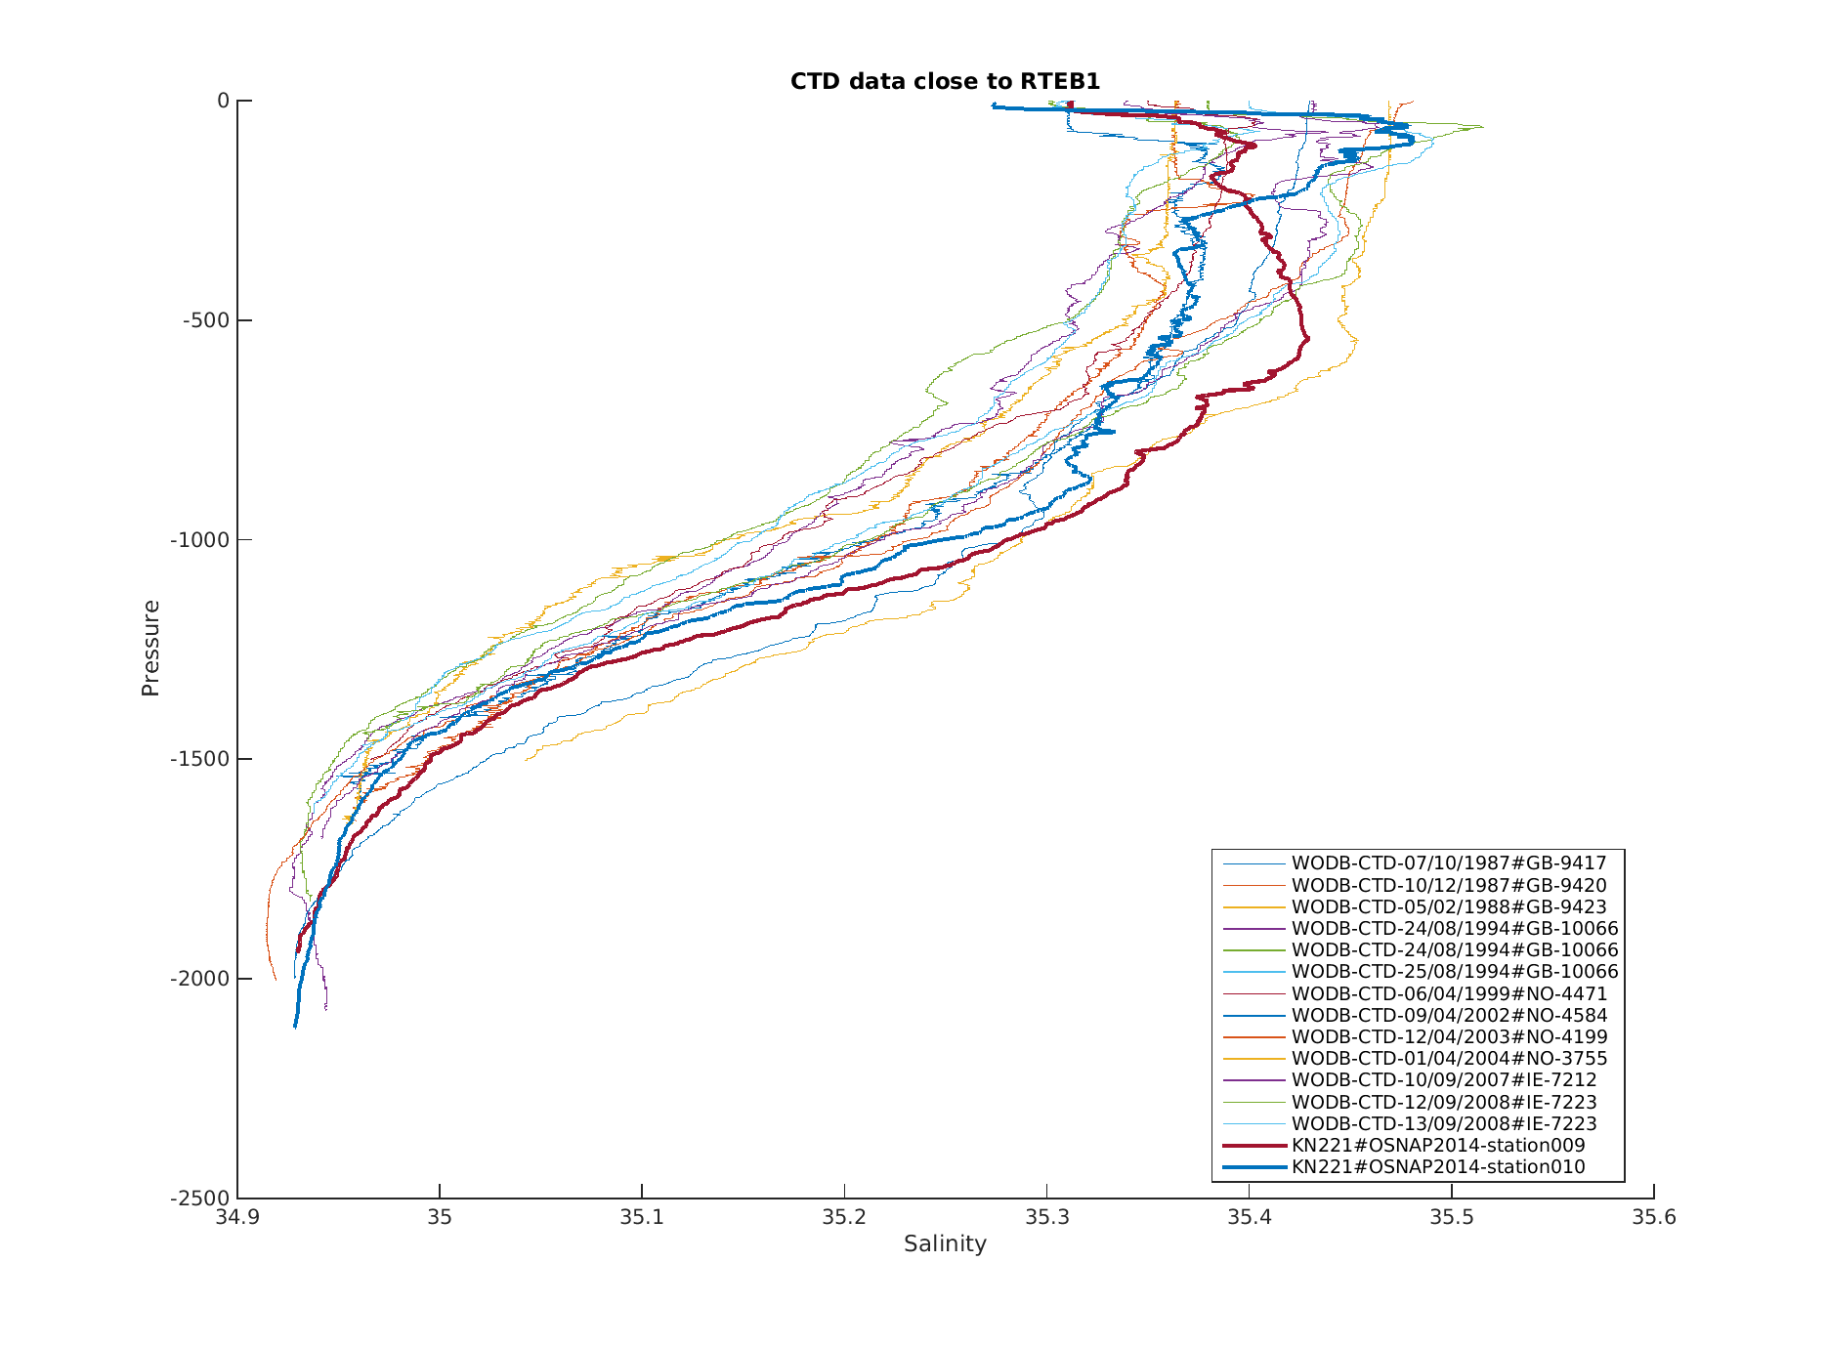

RTWB1
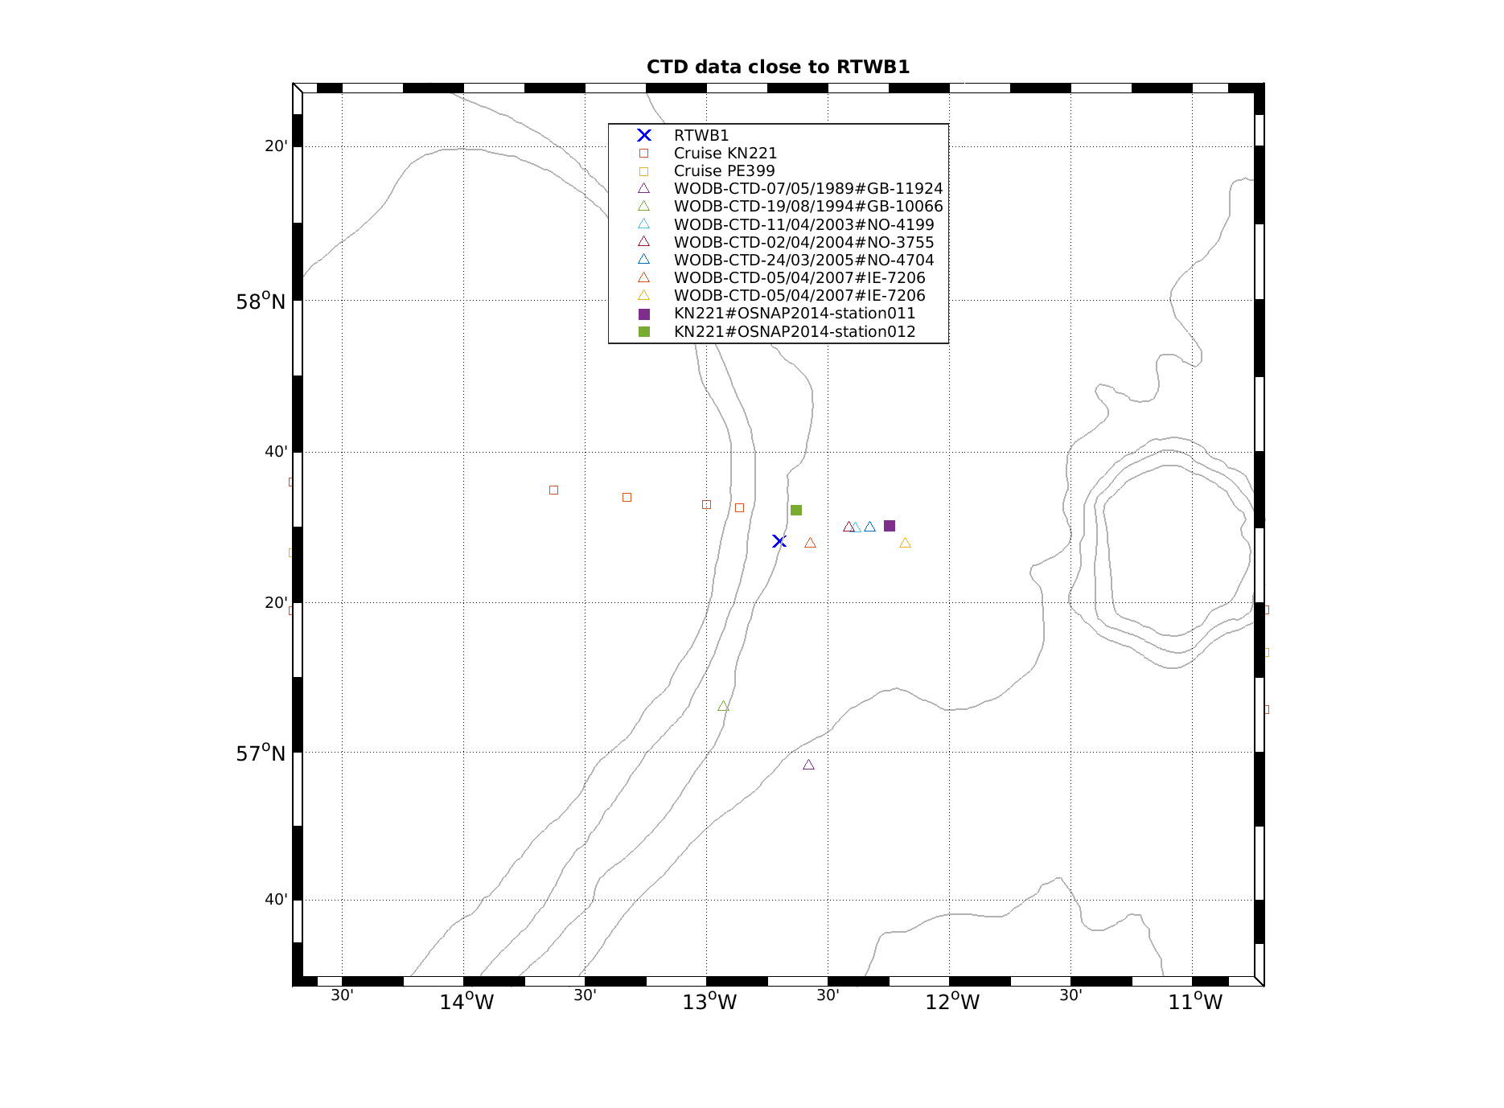
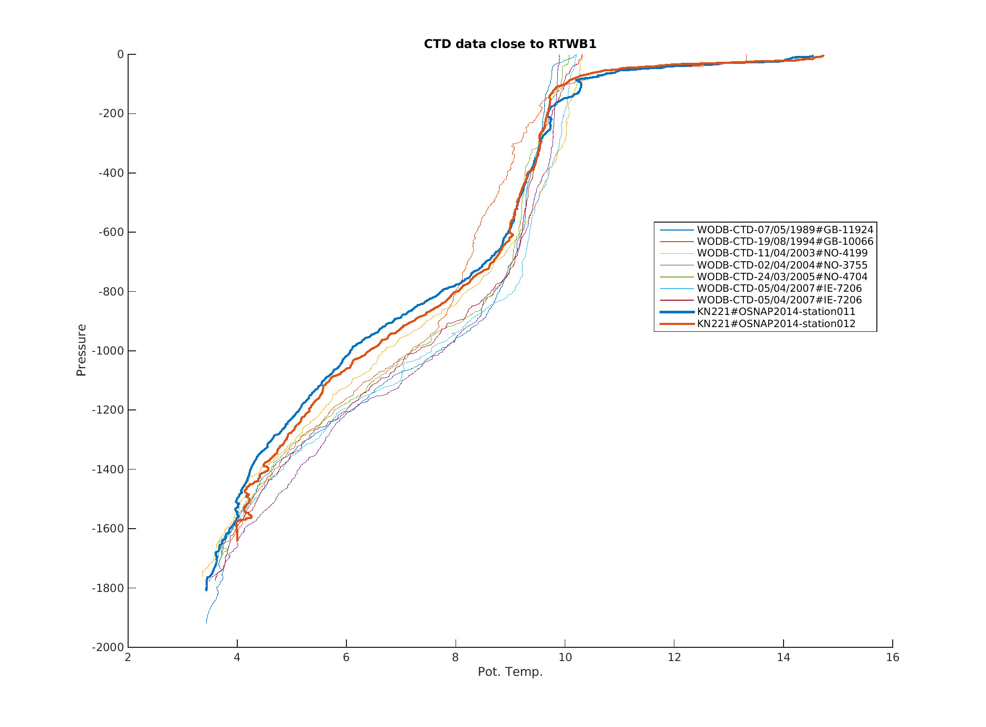

RTWB2
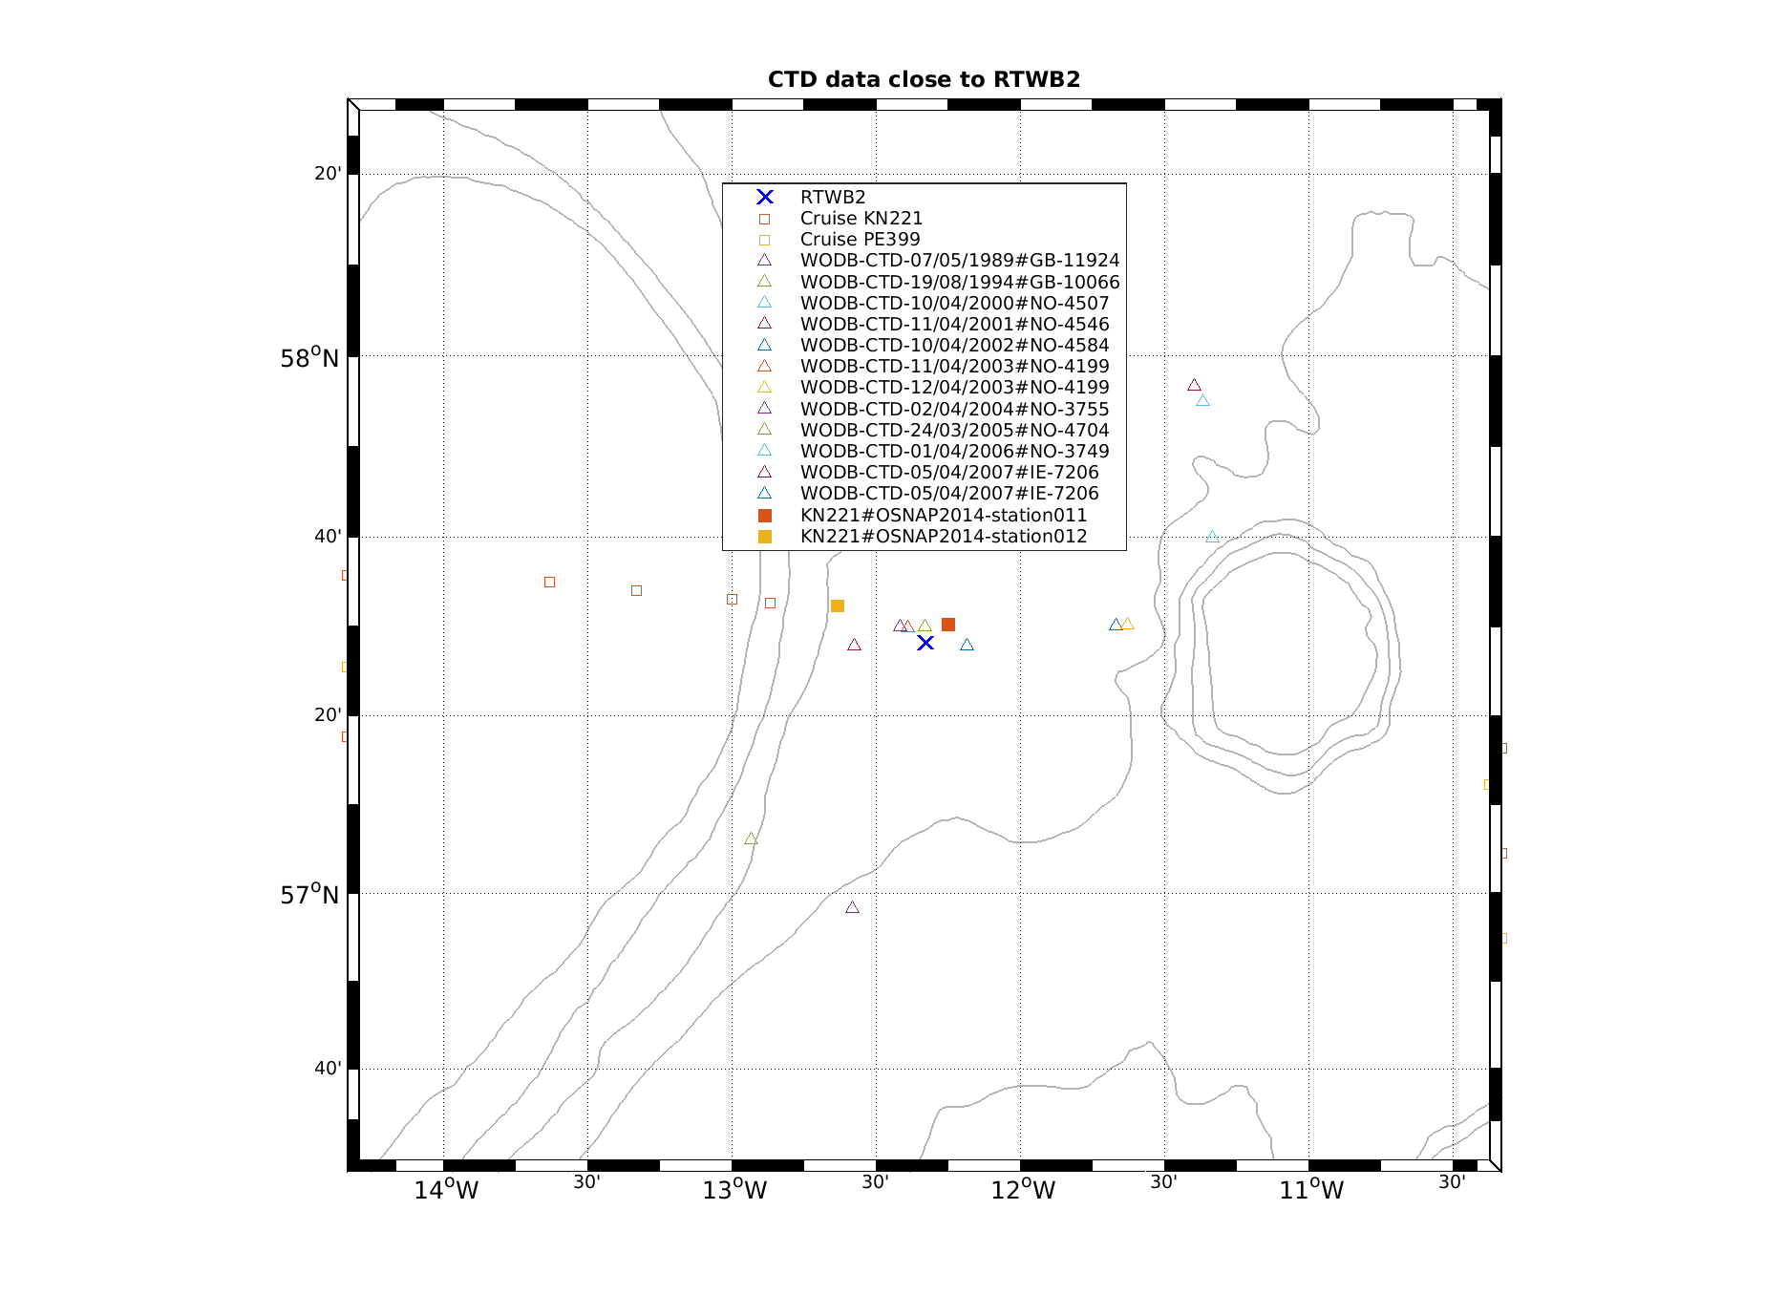
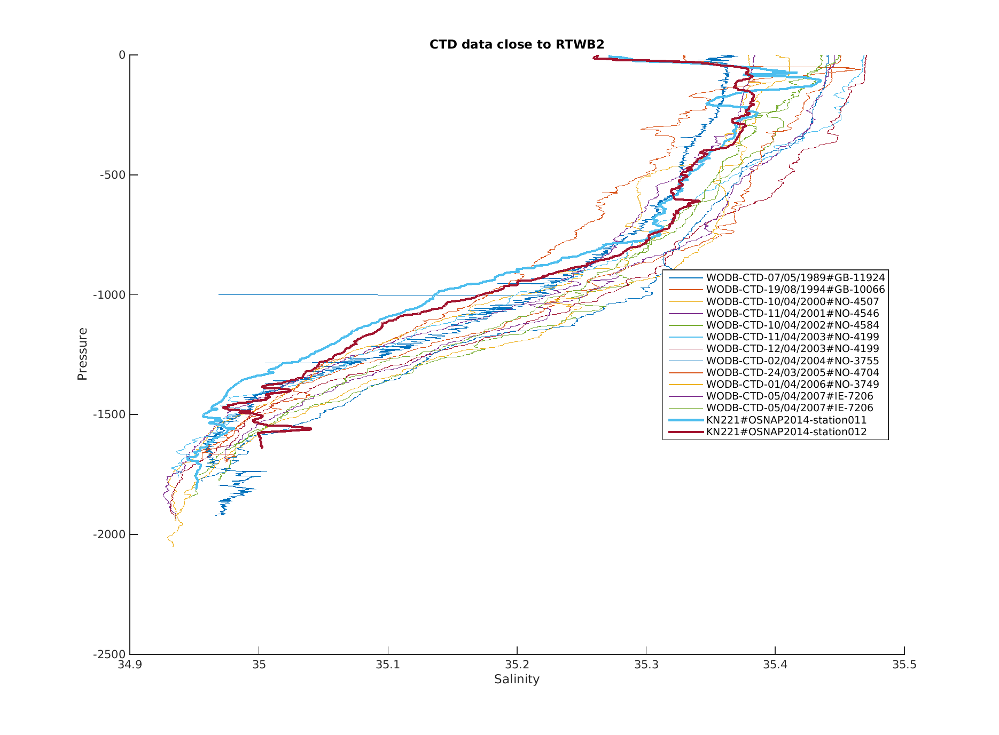

RTADCP1
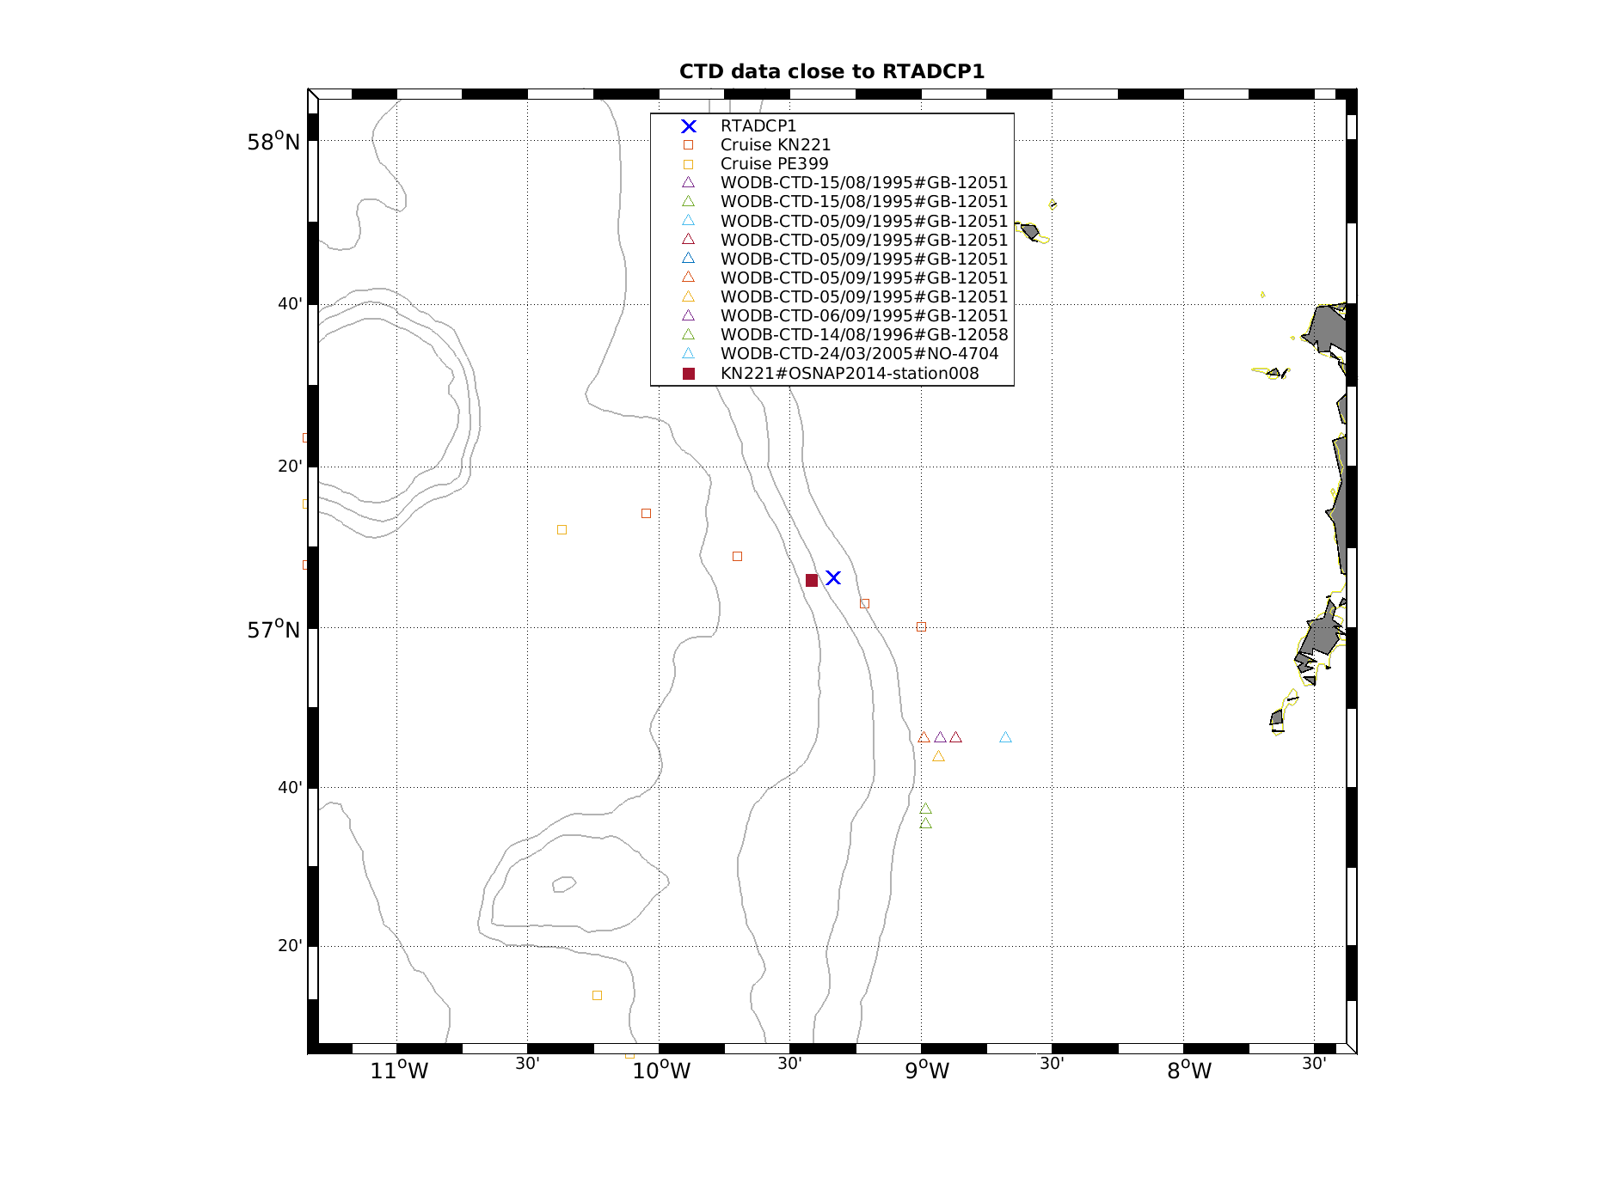
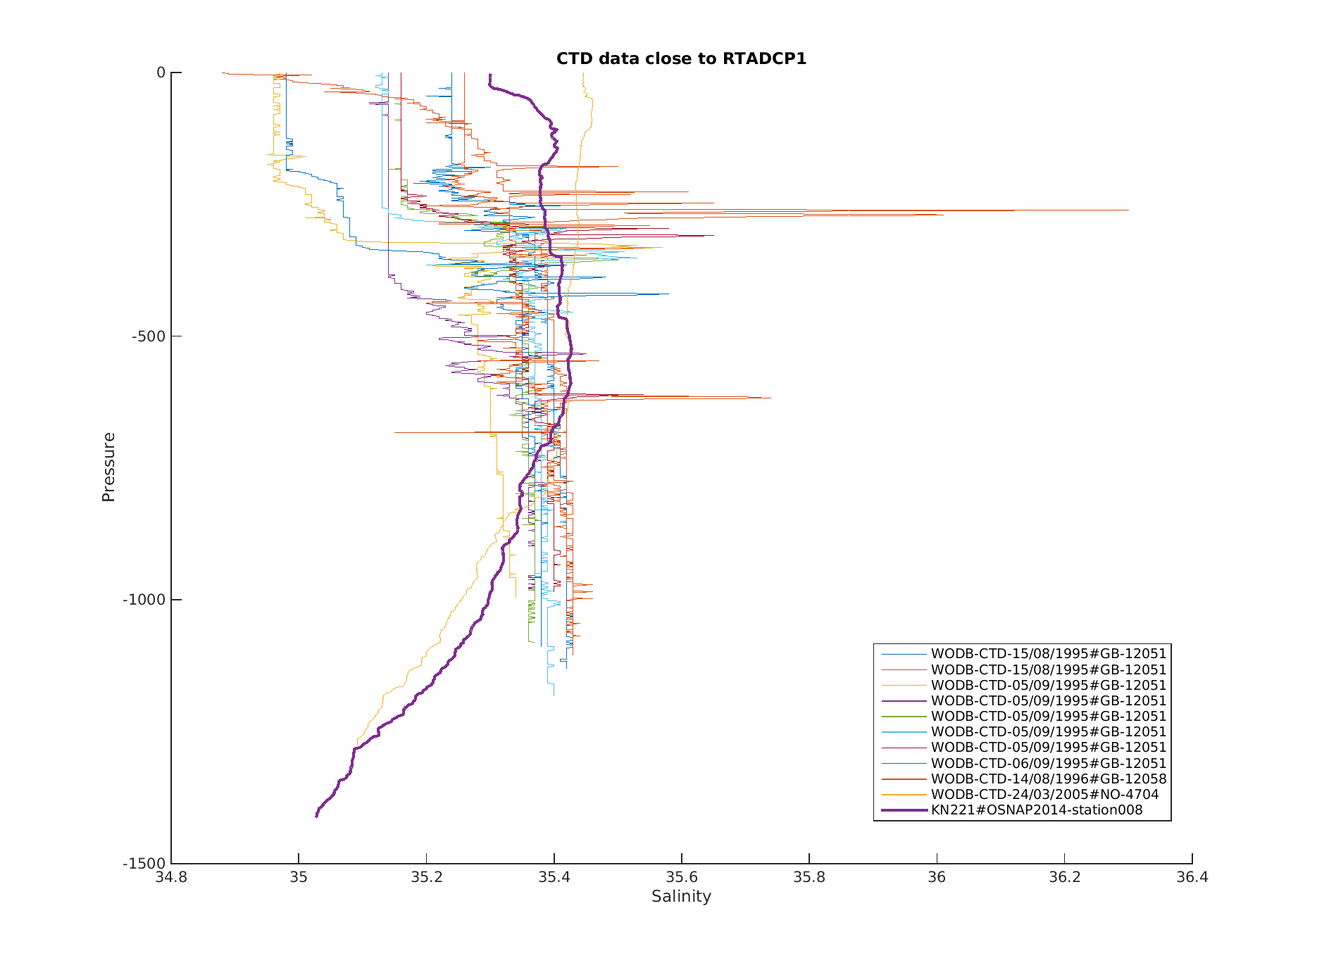

Annex 3: Log files for Nortek processing stage 3

RTEB1
cm_edit_NOCS.m:
File: M:/Mar_Phys/OSNAP_mooring_data_processing/osnap/data/moor/proc/rteb1_03_2016\nor\rteb1_03_2016_13142.edt
Magnetic Declination: -5.230
Salinity value when instrument was set up: 35.1000
Fixed salinity value for speed of sound correction: 35.1000
Mean value for the new speed of sound: 1493.3748
cm_edit_NOCS.m:
File: m:/Mar_Phys/OSNAP_mooring_data_processing/osnap/data/moor/proc/rteb1_03_2016\nor\rteb1_03_2016_13130.edt
Magnetic Declination: -5.230
Salinity value when instrument was set up: 35.3000
Fixed salinity value for speed of sound correction: 35.3000
Mean value for the new speed of sound: 1497.7917
cm_edit_NOCS.m:
File: m:/Mar_Phys/OSNAP_mooring_data_processing/osnap/data/moor/proc/rteb1_03_2016\nor\rteb1_03_2016_11048.edt
Magnetic Declination: -5.230
Salinity value when instrument was set up: 35.4000
Fixed salinity value for speed of sound correction: 35.4000
Mean value for the new speed of sound: 1497.4912
cm_edit_NOCS.m:
File: m:/Mar_Phys/OSNAP_mooring_data_processing/osnap/data/moor/proc/rteb1_03_2016\nor\rteb1_03_2016_11035.edt
Magnetic Declination: -5.230
Salinity value when instrument was set up: 35.4000
Fixed salinity value for speed of sound correction: 35.4000
Mean value for the new speed of sound: 1494.0614
cm_edit_NOCS.m:
File: m:/Mar_Phys/OSNAP_mooring_data_processing/osnap/data/moor/proc/rteb1_03_2016\nor\rteb1_03_2016_9868.edt
Magnetic Declination: -5.230
Salinity value when instrument was set up: 34.9500
Fixed salinity value for speed of sound correction: 34.9500
Mean value for the new speed of sound: 1495.2968
cm_edit_NOCS.m:
File: m:/Mar_Phys/OSNAP_mooring_data_processing/osnap/data/moor/proc/rteb1_03_2016\nor\rteb1_03_2016_9867.edt
Magnetic Declination: -5.230
Speed of sound used in the original data: 1500.0000
Fixed salinity value for speed of sound correction: 35.4000
Mean value for the new speed of sound: 1492.5026

RTWB1
cm_edit_NOCS.m:
File: m:/Mar_Phys/OSNAP_mooring_data_processing/osnap/data/moor/proc/rtwb1_03_2016\nor\rtwb1_03_2016_13018.edt
Magnetic Declination: -6.950
Speed of sound used in the original data: 1500.0000
Fixed salinity value for speed of sound correction: 35.0000
Mean value for the new speed of sound: 1493.6384
cm_edit_NOCS.m:
File: m:/Mar_Phys/OSNAP_mooring_data_processing/osnap/data/moor/proc/rtwb1_03_2016\nor\rtwb1_03_2016_11069.edt
Magnetic Declination: -6.950
Speed of sound used in the original data: 1500.0000
Fixed salinity value for speed of sound correction: 35.2000
Mean value for the new speed of sound: 1494.7580
cm_edit_NOCS.m:
File: m:/Mar_Phys/OSNAP_mooring_data_processing/osnap/data/moor/proc/rtwb1_03_2016\nor\rtwb1_03_2016_11051.edt
Magnetic Declination: -6.950
Speed of sound used in the original data: 1500.0000
Fixed salinity value for speed of sound correction: 35.2600
Mean value for the new speed of sound: 1494.6913
cm_edit_NOCS.m:
File: m:/Mar_Phys/OSNAP_mooring_data_processing/osnap/data/moor/proc/rtwb1_03_2016\nor\rtwb1_03_2016_11046.edt
Magnetic Declination: -6.950
Speed of sound used in the original data: 1500.0000
Fixed salinity value for speed of sound correction: 35.0800
Mean value for the new speed of sound: 1493.1227
cm_edit_NOCS.m:
File: m:/Mar_Phys/OSNAP_mooring_data_processing/osnap/data/moor/proc/rtwb1_03_2016\nor\rtwb1_03_2016_8365.edt
Magnetic Declination: -6.950
Speed of sound used in the original data: 1500.0000
Fixed salinity value for speed of sound correction: 35.2500
Mean value for the new speed of sound: 1491.5704

RTWB2
cm_edit_NOCS.m:
File: m:/Mar_Phys/OSNAP_mooring_data_processing/osnap/data/moor/proc/rtwb2_03_2016\nor\rtwb2_03_2016_9881.edt
Magnetic Declination: -6.770
Speed of sound used in the original data: 1500.0000
Fixed salinity value for speed of sound correction: 35.1500
Mean value for the new speed of sound: 1494.5561
cm_edit_NOCS.m:
File: m:/Mar_Phys/OSNAP_mooring_data_processing/osnap/data/moor/proc/rtwb2_03_2016\nor\rtwb2_03_2016_9877.edt
Magnetic Declination: -6.770
Speed of sound used in the original data: 1500.0000
Fixed salinity value for speed of sound correction: 34.9700
Mean value for the new speed of sound: 1494.9939
cm_edit_NOCS.m:
File: m:/Mar_Phys/OSNAP_mooring_data_processing/osnap/data/moor/proc/rtwb2_03_2016\nor\rtwb2_03_2016_9861.edt
Magnetic Declination: -6.770
Speed of sound used in the original data: 1500.0000
Fixed salinity value for speed of sound correction: 35.0000
Mean value for the new speed of sound: 1492.5814

