CS 577: Project Report

Project Number : | 4
Group Number: | 4
Name of the top modules: | crypto_sign_keypair
Link for GitHub Repo: | github.com/deepraj88/project4

Group Members | Roll Numbers
- Kapil Kukreja  - Anasuya Jana  - Megha Moon  - Priyanka Khare | 194101024  194101004  194101033  194101023

INTRODUCTION

PHASE-1

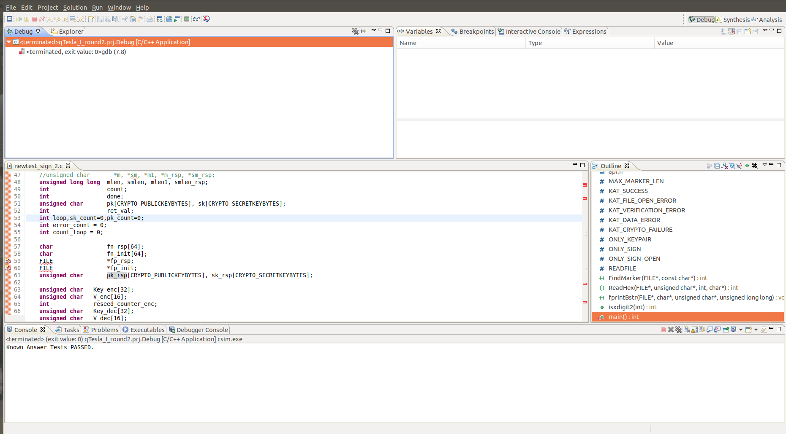
Running the algorithm

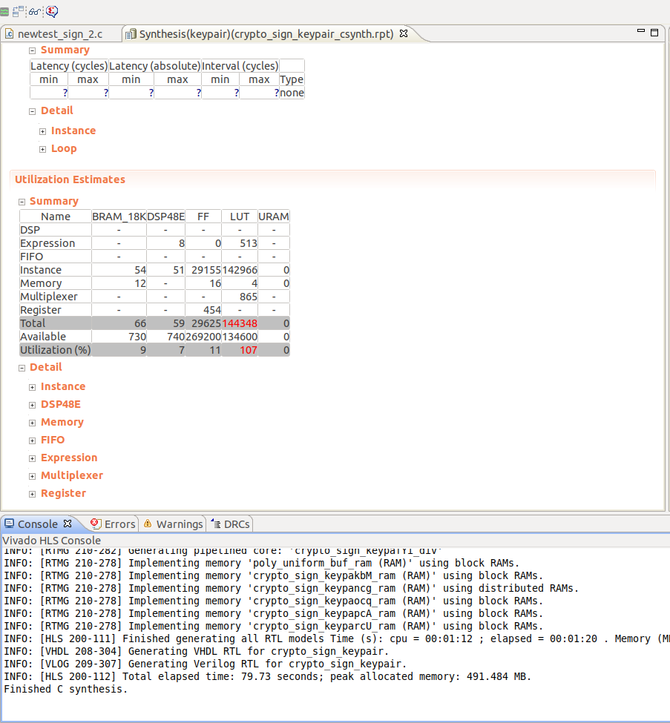
1.2 Synthesis screenshot

C/RTL co-simulation screenshot
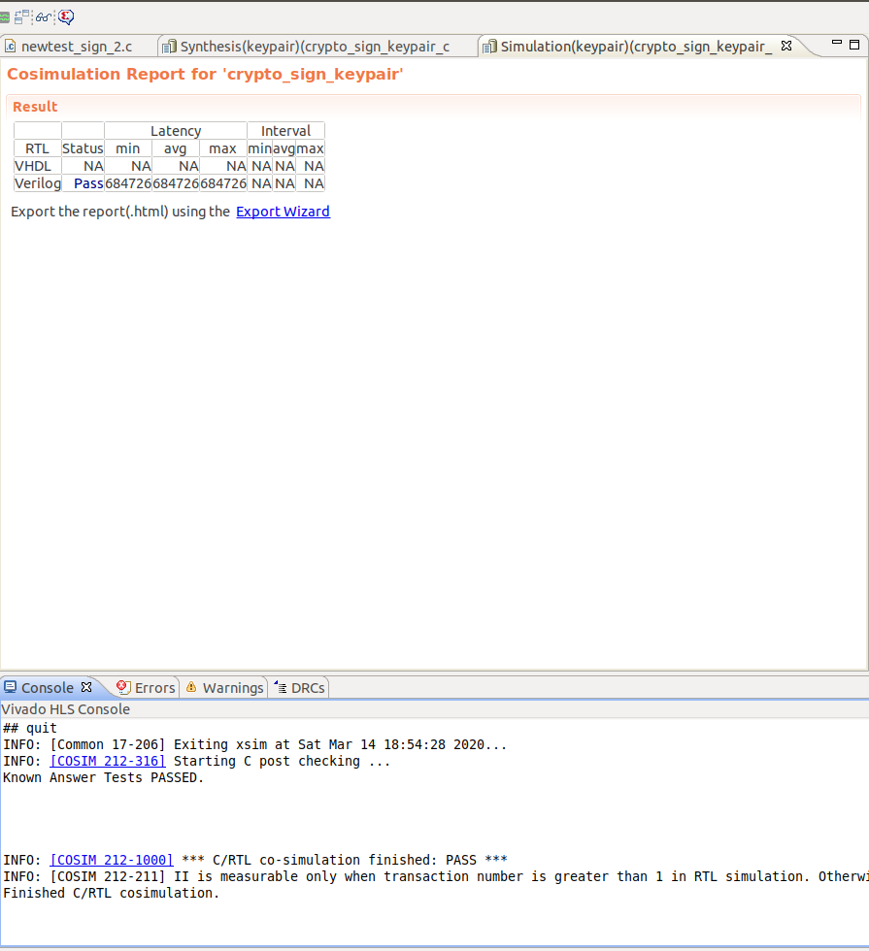

Flowchart

Flowchart 1: Key Generation (Generate Public, Private Key Pair)

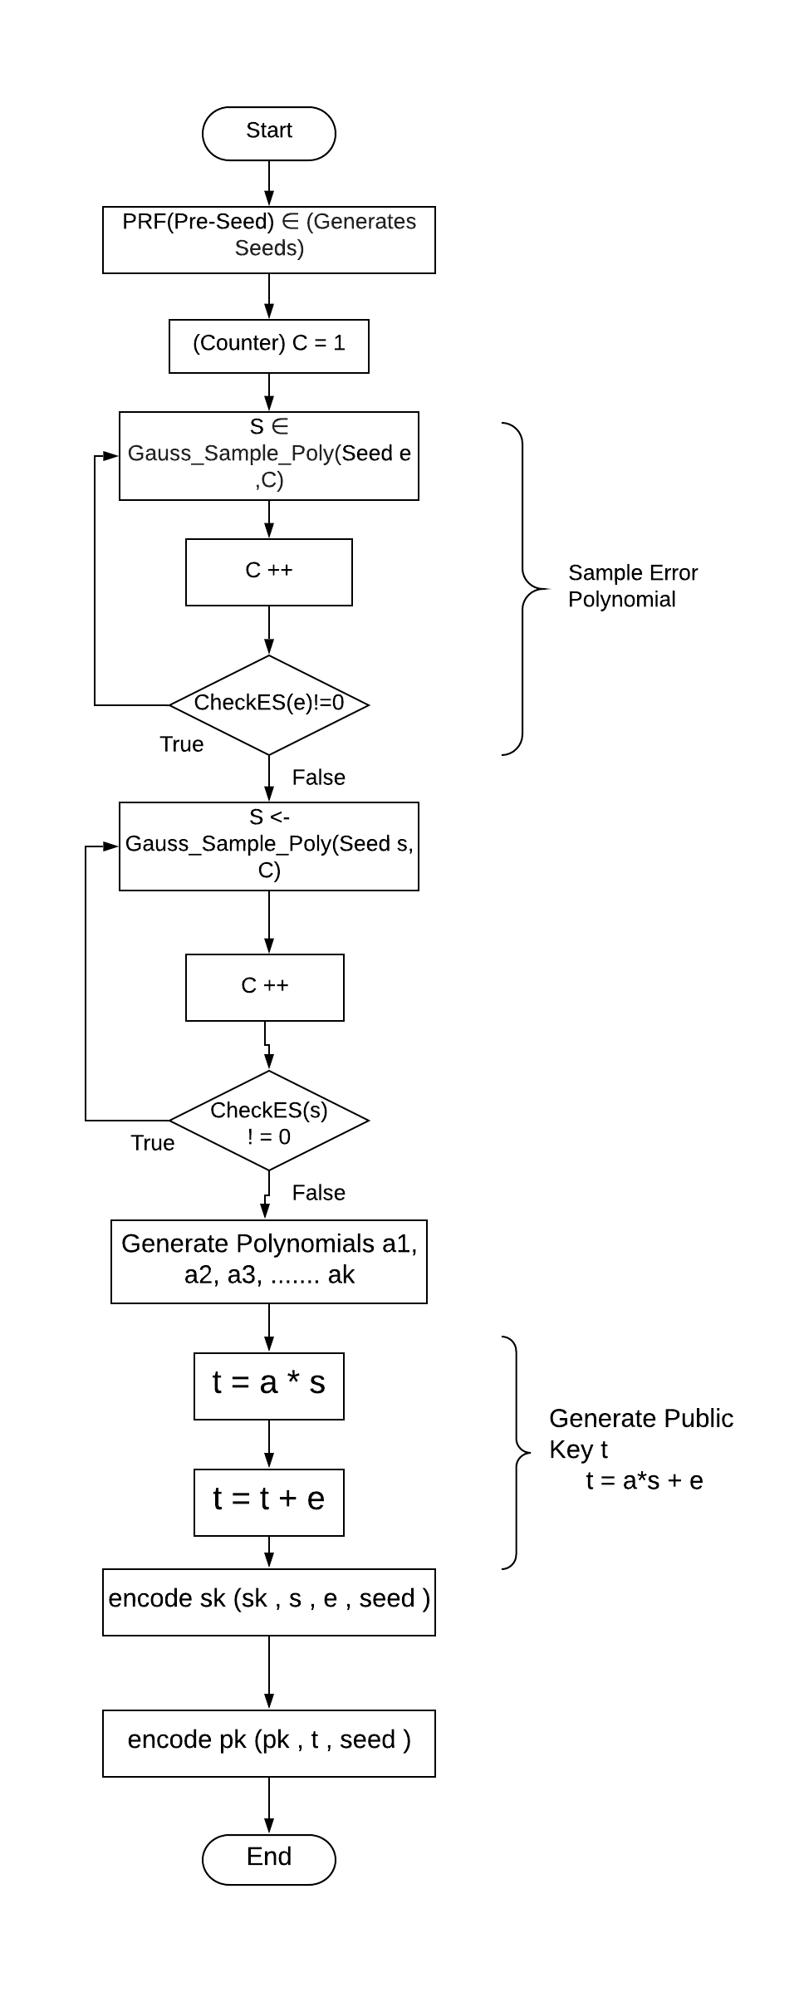

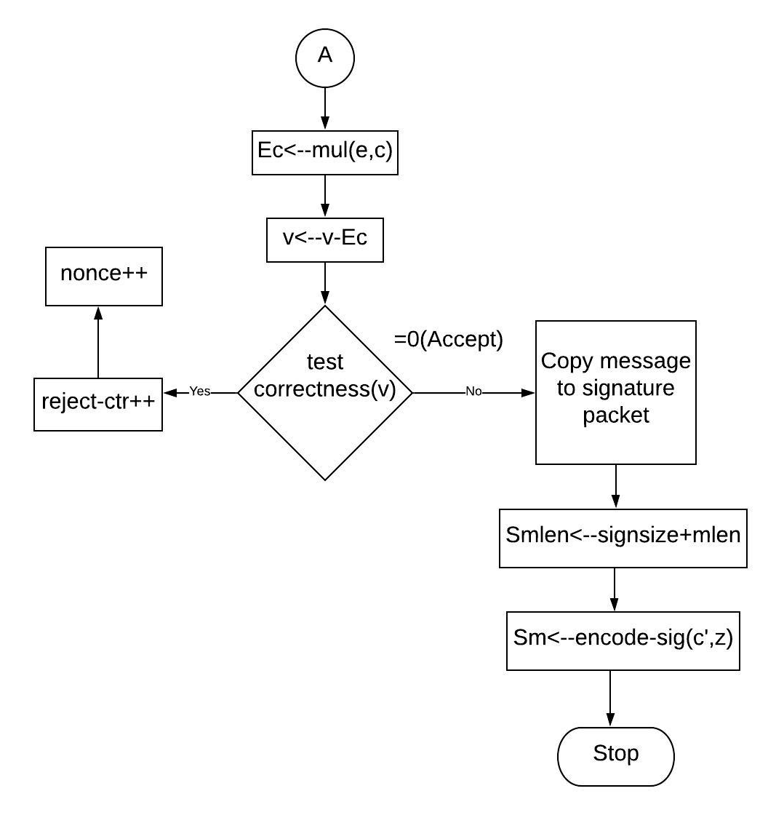
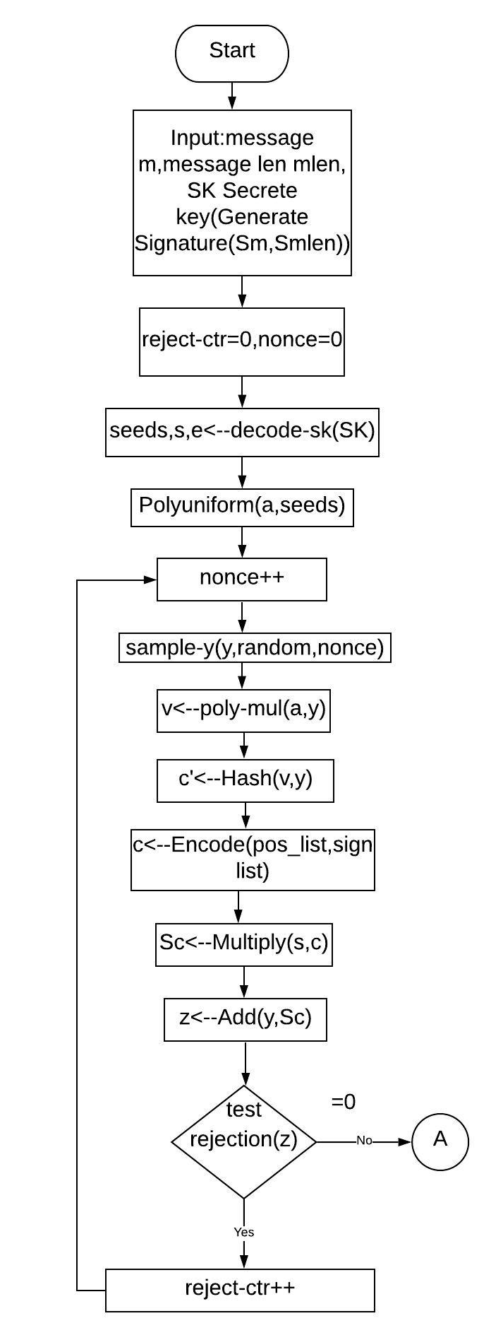
Flowchart 2: Crypto Sign (Generate Signature)

Flowchart 3 : Verifies Signature Sm
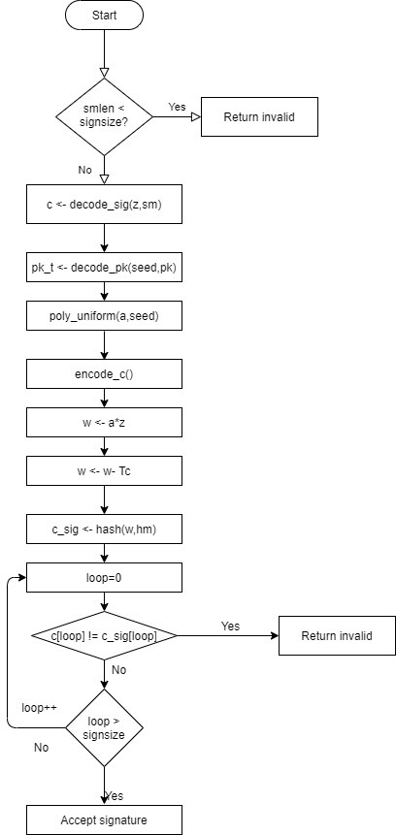

Result

FPGA Part | Name of Top Module | FF | LUT | BRAM | DSP | Latency | II
Artix-7  xc7a200t-fbg676-2 | crypto-sign-keypair | 29625 | 144348 | 66 | 59 | 684726 | N.A.

3.1 Explain the result
The current usage of the various components, such as Flip-flops, Lookup Table, BRAM etc., available on FGPA board is as shown in the table above. The result generated after RTL-C co-simulation shows the latency of the RTL design as on the board with current design and usage of various components.

3.2 Problems and its solution
Major challenge in design is LUT usage which is originally at 107% of the available limit. The goal is to reduce the area by reducing the components usage by targeting each component, critically LUT. Further trying to reduce the area, and then proceeding to reduce latency is a major goal.

PHASE-2
The target FPGA board is xc7a200t-fbg676-2.
Benchmark | Type  (Area /Latency) | Resource Utilization |  |  |  | Latency |  | Major  Optimizations
Benchmark | Type  (Area /Latency) | LUT | FF | DSP | B RAM | No of Clock cycle/latency | Clock period | Major  Optimizations
Baseline | B | 144348  (107%) | 29625  (11%) | 59  (7%) | 66  (9%) | 6,84,726 | 12.65ns | NA
Optimization 1 | Area | 70388  (52%) | 18316  (6%) | 59  (7%) | 94  (12%) | 11,30,537 | 12.65ns | keccakStatePermute()  In fips202.c
Optimization 2 | Area | 43683  (32%) | 12121  (4%) | 59  (7%) | 94  (12%) | 6,85,167 | 12.65ns | Reducing no. of duplicate instances of same function
Optimization 3 | Area | 28146  (20%) | 11267  (4%) | 57  (7%) | 74  (10%) | 12,32,661 | 12.65ns | As in 2 + some functions rewriting
Optimization 4 | Latency | 129138 (95%) | 76481  (28%) | 58  (7%) | 67  (9%) | 5,98,919 | 12.65ns | Pipelining in check_ES()  Loop unrolling in gauss.c

- Optimization 1:
Target: To reduce LUT usage
Observation: Very high LUT usage in function keccakStatePermute() in fips202.c
Solution: There were huge no. of local variables and operations on them. Mapped these to a 2-D Array to shift it to using BRAM instead.

- Optimization 2:
Target: To reduce LUT usage at original latency
Observation: Duplication of instances (such as KeccakSqueezeBlocks) at different hierarchy levels.
Solution: Inline recursive the top functions with explicit inline=off on such functions.

- Optimization 3:
Target: To further reduce area.
Observation: Same as 1 in multiple locations
Solution: Same as 1.

- Optimization 4:
Target: To reduce latency
Observation: Some loops having very high iteration latency
Approach: Reducing iteration latency could reduce latency significantly. Thus, applied Pipeline.
Problem: RAM doesn’t have enough ports to pipeline the function. As in check_ES()
Solution: Array Partition.

