# Welcome!

Thank you for applying for Cigna’s mobile developer position. We are leading the industry in mobile development and are looking for qualified candidates like you.

Please complete the brief coding assignment below. It will help us evaluate your level of experience.

**Requirements**

Create an app that will retrieve a list of episodes from a popular TV show “Game of Thrones”. Each item in the list will be clickable and will display details of given episode. User will be able to click “back arrow” to return to list screen.

See screenshots below:

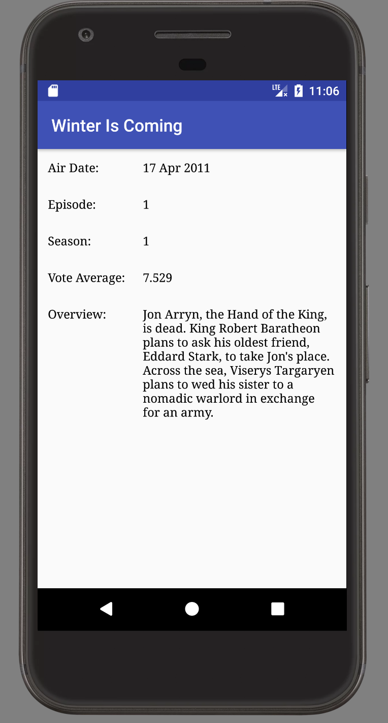

List of Clickable Episodes

Title of Episode Selected

Brief Episode Details

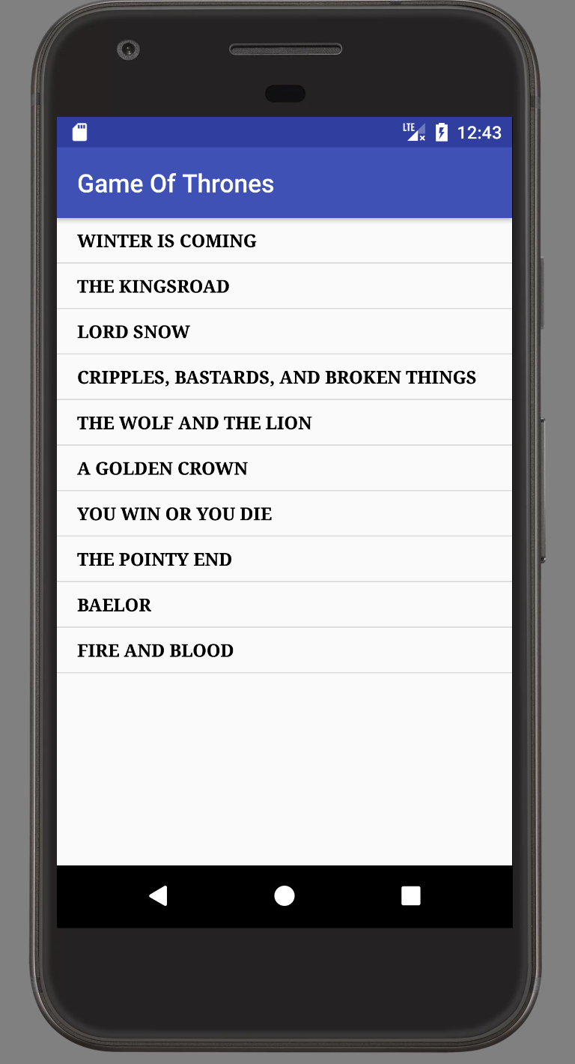

**Note:**  Feel free to use any color theme that you like.

**Note:** You will need to sign up for an account with TMDB in order to receive an API key, which you will use in the service request below.

**Android API Support**: Min. 19 – Max. 23

**Service Request and Response**

* Episode List and Details
  + Request: **http://api.themoviedb.org/3/tv/1399/season/1?api_key=your_api_key_here&language=en-US**
  + Response: open request URL in any browser to see example

**Deliverables**

1. Create app as specified above. Please pay attention to screen mockup specifics above.
2. Create GitHub account and upload your code there, as well as, the debug apk file.
3. Send e-mail to original requestor with link to your GitHub account.

Please do not hesitate to contact us with any questions. Thank you for participating.

Good luck.

**References**

* API Documentation website: <https://www.themoviedb.org/documentation/api?language=en>
* GitHub: <https://github.com/>