**Mobile Applications Development – SET08114**

**Coursework Report**

**Introduction**

The following report sets out to explain and evaluate an application made for a coursework assignment. The coursework brief was to design, implement and evaluate a prototype of a mobile application for the Android platform. There were two options to choose from for the assignment. Option A which was a continuation of the modules practical lab work creating a travel companion application or option B which was to create your own application. The application made for option B required that the application must have multiple activities that also support appropriate user interaction. This report will be covering an application made to fulfil the requirements of option B in full. The application that was chosen to be created was a unit converter app. This app would allow a user to take a unit of one type and convert into another for example kilograms to pounds. Applications of this sort are popular with the top three on the Google Play store cumulating over sixteen million downloads. This is because near every person at one point would want to swap one type of unit to another whether it be temperature, distance or currency conversions. A brief overview of the application would be a simple and effective app that would allow you to quickly and simply select the type of unit you want to convert, the type to be converted to and enter the value you want converted then having the conversion outputted to the screen. This choice of application was inspired by the needs of many parents to complete conversions regularly for the creation of meals and preparations of medicines for their disabled children. The main pre-existing app that informed my decision and inspired my design was an app called “Unit Converter “made by “Digit Grove” which is available on the Google play store.

**Software Design**

To begin the design of the unit converter application a guideline class diagram was created. This was created to give an outlined structure to the classes needed for the application to be functional. The class diagram can be seen below in Figure 1, it does not contain all the classes and methods used in the final application but was still a key component to the identification of variables and methods required.

(Figure 1 shows UML Class Diagram for the unit converter application.)

After completing the class diagram a prototype user interface was made using Vectr that can be seen below in Figure 2.

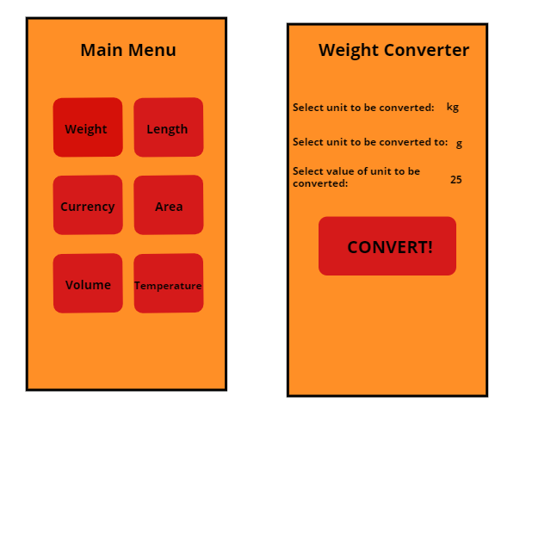

(Figure 2 shows the prototype user interface for the unit converter application.)

The applications implementation shows one hub main menu, seen below in Figure 3, that has collection of buttons that can all be used to navigate to a new activity. An example of one of these activities can be seen below in Figure 4, which shows the user interface for the weight conversion activity.

(Figure 3 - Application main menu.) (Figure 4 – Weight conversion activity.)

From a secondary activity a unit type can then be selected from a spinner to choose the starting unit, seen in Figure 5. This can be repeated in the second spinner to select the unit that the user wishes to convert to. Figure 6 shows a filled-out version of the volume conversion activity screen which shows the user text input too.

(Figure 5 - The selection spinner.) (Figure 6 – A filled-in activity for the app.)

Once the activity has all values filled in and the convert button is pressed the output of the conversion is sent to the screen in the form of an alert this can be seen in Figure 7. Conversely if either of the spinners do not have a unit value selected then and error message is displayed via a toast which can be seen in Figure 8.

(Figure 7 – Conversion output.) (Figure 8 – Error output.)

**Evaluation**

To begin the evaluation of the unit conversion app first we compare the final product with the original concept. The original overview was to create an app that would be simple and effective at taking in the users’ unit and value of the unit and converting it to another selected unit type. The current implementation of the application matches the original concept very well and stays true to the idea of a simple and easy to use application. All separate buttons lead to their respective conversion activities and each manages and outputs conversions correctly.

When the application creating for the assignment is compared to the top unit conversion application on Google Play store it can be observed that many of the features are paralleled across both applications however the top downloaded app does have many more conversion options including a scientific converter. Another notable difference is that rather than outputting a specific value when converting a unit, it instead shows a list of other all other units that the selected unit and value could be converted to. This is a particularly good feature if a user would like to convert the same value into more than one unit however if a user were trying to only convert to a specific unit finding that unit may be more difficult in the middle of a list and this could lead to some human error when reading the right converted value from the output.

Finally comparing the application created for the assignment to the original application that inspired the development of this application, “Unit Converter: Smart Tools, Currency Converter” made by “Digit Grove”. The first glaring difference is just the sheer number of display options available in the Digit Grove app including a dark mode and the option to set the number of decimal places the output displays to. The other main difference is again the large number of conversion options available dwarf the app that has been created for this assignment. The user interface also contains small images to represent each unit type this is a good visual aid to the application this as well as subheadings for the types of unit that can be selected such as common units or engineering units. These subheadings can also be collapsed to hide sections that a user may not want to ever use for easier and faster selection of the desired unit type wanted for the conversion. These features are all very well executed but with the raw number of options available in this app it could be argued that many parts of this app would be redundant to the application designed for the assignment. An example of one of these features is the compass tool this tool would be better suited for its own application rather than being included in a unit conversion application. If this feature had been implemented in the assignment app it would no longer be true to the original concept of being simple and easy to use unit converter.

Overall compared to other applications of this type of app the app created for this assignment is lacking some of the finer touches already implemented by these apps. It also has less conversion options than the other apps of this type meaning it could be expanded.

There are many other improvements that could be made to the created application that would greatly increase its competitiveness with the other apps that already exist on the market. One of these features would be the inclusion of a saved conversion section, where a user could save a search they have done to a list if they think they may want to repeat this search in the future saving them having to complete the entire conversion process again. To be able to rival the pre-existing apps in this space the created app would need to extend the types of conversion it can complete including more uncommon conversion types that are already included in other applications of this kind.

**Resource Summary**

All images used in this assignment were sourced online through royalty free websites and are all referenced separately in the reports’ reference list. These images were used in the conversion output to improve the quality of the final output from the application. To accurately complete the unit conversion formulae had to be found, these formulae were found through conversion websites listed in the reference list and from the Google Unit converter. In order to create the application in the desired way some parts of the code had to be research. This was done through online forums that are listed in the reference list, one such example of this is the use of a snackbar with a dismiss button.

**Reference List**

Clipart Library, 2021. *Free Computer Cliparts #2499749*. [image] Available at: <http://clipart-library.com/clipart/1127036.htm> (Accessed 31 March 2021).

Clipart Library, 2021. *currency-cliparts #3111482*. [image] Available at: < http://clipart-library.com/clipart/currency-cliparts_3.htm> [Accessed 31 March 2021].

Clipart Library, 2021. *Measuring Length Cliparts #2714573.* [image] Available at: < http://clipart-library.com/clipart/1977745.htm> (Accessed 31 March 2021).

Clipart Library, 2021. *Thermometer Clip Art*. [image] Available at: <http://clipart-library.com/clipart/thermometer-clipart_5.htm> (Accessed 31 March 2021).

Clipart Panda, 2021 *liquid-volume-clipart*. [image] Available at <<http://www.clipartpanda.com/clipart_images/liquid-volume-clipart-1-65527308>> (Accessed 31 March 2021).

Developer, 2020 *Spinners* Available at: https://developer.android.com/guide/topics/ui/controls/spinner (Accessed: 17 March 2021).

freeCodeCamp,org. (2020) *Android Development for Beginners – Full Course*. 26 May. Available at: https://www.youtube.com/watch?v=fis26HvvDII&t=33412s&ab_channel=CalebCurry (Accessed: 25 March 2021).

GOGRAPH, 2021 *Vector Art - Cooking. EPS clipart gg69833886.* [image] Available at < https://www.gograph.com/clipart/cooking-gg69833886.html> (Accessed 31 March 2021).

Google, 2021. *Unit converter.* Available at: https://www.google.com/search?q=unit+converter&ei=HFpkYJ33BJiP9u8Pi5GpmAY (Accessed on 19 March 2021).

Google Play Store, 2021. *Unit Converter.* Available at: https://play.google.com/store/apps/details?id=com.androidapps.unitconverter&hl=en&gl=US (Accessed: 30 March 2021).

Google Play Store, 2021. *Unit Converter.* Available at: https://play.google.com/store/apps/details?id=kr.sira.unit (Accessed: 30 March 2021).

Metric Conversions (2018) Length Conversion. Available at: https://www.metric-conversions.org/length-conversion.htm (Accessed: 18 March 2021).

Nicepng, 2021. *Weight Scale Royalty Free Vector Clip Art Illustration - Weight Clipart Png.* [image] Available at <https://www.nicepng.com/ourpic/u2e6w7o0e6u2w7q8_weight-scale-royalty-free-vector-clip-art-illustration/>(Accessed 31 March 2021).

Pinclipart, 2021. *Map And Location Png Transparent Png.* [image] Available at < https://www.pinclipart.com/pindetail/TTbTbR_location-clipart-gps-tracker-map-and-location-png/> (Accessed 31 March 2021).

RapidTables, 2020. *Ounces to Grams conversion* Available at: https://www.rapidtables.com/convert/weight/ounce-to-gram.html (Accessed: 18 March 2021).

Stackoverflow, 2015*. How to dismiss a Snackbar using it's own Action button?* Available at: https://stackoverflow.com/questions/36415889/how-to-efficiently-display-the-correct-pop-up-window-in-android-studio (Accessed 28 March 2021).

Stackoverflow, 2016*. how to efficiently display the correct pop up window in android studio.* Available at: https://stackoverflow.com/questions/36415889/how-to-efficiently-display-the-correct-pop-up-window-in-android-studio (Accessed 25 March 2021).

Stackoverflow, 2011*. How to put an image in an AlertDialog? Android.* Available at: https://stackoverflow.com/questions/36415889/how-to-efficiently-display-the-correct-pop-up-window-in-android-studio (Accessed 30 March 2021).

Stackoverflow, 2010*. Round a double to 2 decimal places [duplicate].* Available at: https://stackoverflow.com/questions/36415889/how-to-efficiently-display-the-correct-pop-up-window-in-android-studio (Accessed 27 March 2021).

What’s Cooking America, 2016. *Cooking Equivalent Measurements.* Available at: https://whatscookingamerica.net/equiv.htm (Accessed: 19 March 2021).

Xe, 2021. *Xe Currency Converter.* Available at: https://www.xe.com/currencyconverter/ (Accessed: 19 March 2021).