Student ID: 103116463

Name: Scott Fitzwilliam

# TASK 1 Screenshot

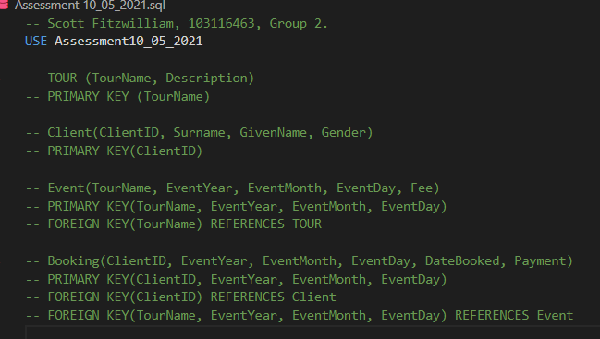

# Task 2 Screenshot

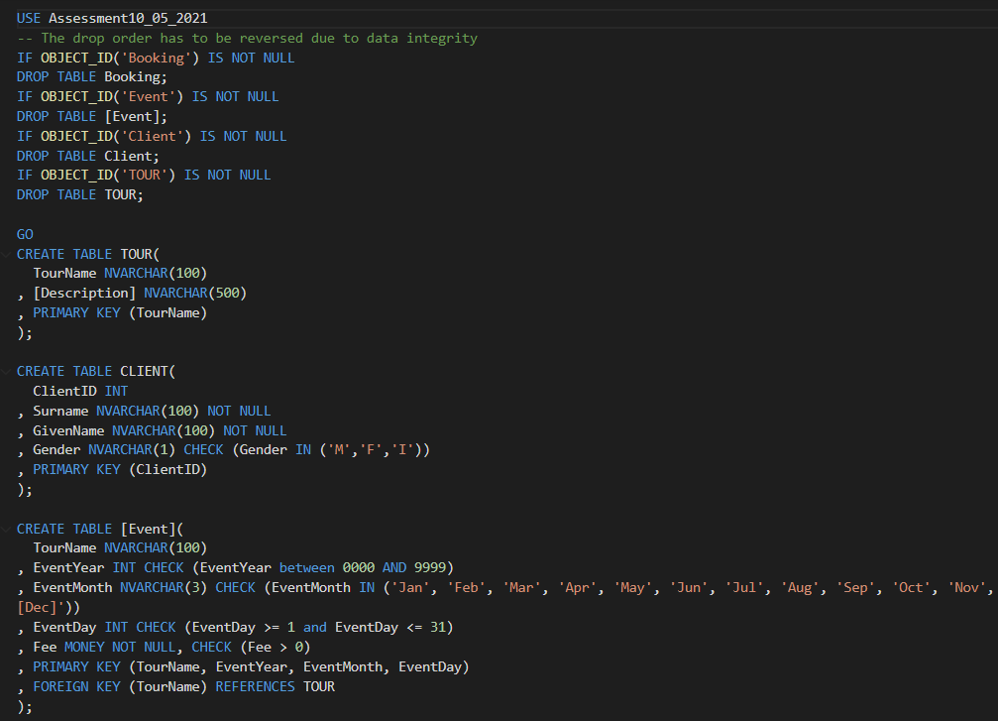



# Task 3 Screenshot



# Task 4 Screenshot

# Task 5 Screenshot

# Task 6 Screenshot