Admin Dashboard Manual
Audience: `Admin` users
Generated: RPL-KPIs
Mind Over Mountains Dashboard Guide

Contents

Update the table in Word if entries do not appear immediately.

Admin Dashboard Manual

Audience: Admin users
Scope: user accounts, password resets, data refresh, audit review, and full reporting access

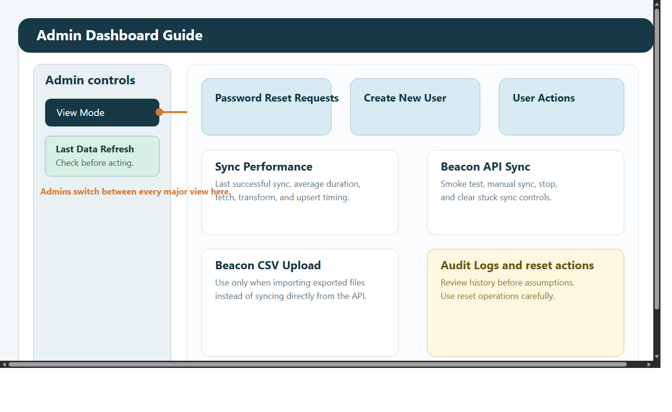

1. Introduction
This manual explains how to use the dashboard as an Admin.

Admins are responsible for keeping the system working safely and making sure the right people have the right access.

Admin users can open:

Admin Dashboard
KPI Dashboard
Custom Reports Dashboard
Case Studies
Data Request Form
Funder Dashboard
ML Dashboard

Admin access should be used carefully. Many actions affect other users. Some actions affect the whole dataset or the overall health of the dashboard.

2. What the Admin role is for
The Admin role is designed for:

user account management
role assignment
password support
sync monitoring
manual sync actions
controlled data maintenance
audit review
support investigations

The Admin role is not simply a stronger reporting role. It is an operational support role with governance responsibility.

3. Before you make changes
Before making any important change:

Confirm that you are signed in with your own named Admin account.
Check Last Data Refresh.
Be clear about what problem you are solving.
Use the smallest action that solves it.
Record a clear reason for any significant access change or destructive action.

Good Admin habits:

avoid shared accounts
avoid deleting users unless removal is genuinely required
prefer updating an existing user rather than recreating them
check the audit log if you are not sure what already happened

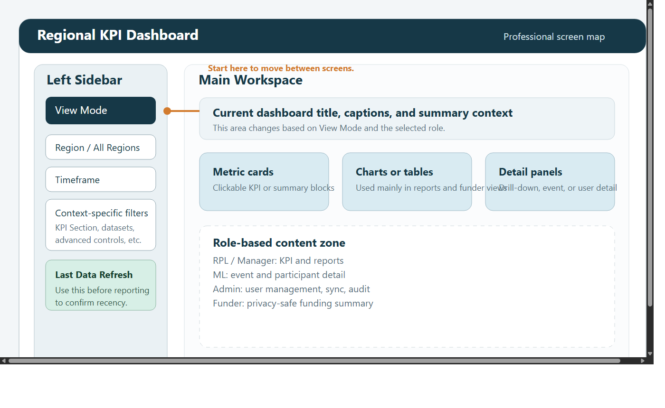

4. Signing in and moving around
Open the dashboard link.
Enter your email address and password.
Change your password if prompted.
Use View Mode in the left sidebar to move between screens.

If you see a message such as Admin client not available, some Admin configuration is missing. In that situation, user-management functions may not work correctly and should be checked before you continue.

5. Main areas of the Admin Dashboard
The Admin Dashboard is the control centre for administration and support.

Main sections usually include:

Password Reset Requests
Create New User
Existing Users & Actions
Sync Performance
Beacon API Sync
Beacon CSV Upload
reset or rebuild actions
Audit Logs

Think of the page in three broad areas:

user access and security
sync and data operations
audit and investigation

6. Password reset requests

6.1 When to use this section
Use Password Reset Requests when a user has triggered Forgot password? and cannot complete sign-in.

6.2 Step-by-step reset workflow
Open Password Reset Requests.
Select the user's email address from the pending list.
Enter a temporary password.
Click Set Temporary Password.
Tell the user to sign in and change the password immediately.

6.3 What should happen next
After a successful reset:

the reset request should be marked as completed
the user should be prompted to change password at next sign-in
the action should be recorded in the audit log

6.4 Good practice
use a temporary password that is strong but can still be communicated safely
avoid sending repeated resets unless necessary
if the same user needs multiple resets, investigate whether there is a wider login problem

7. Creating a new user

7.1 When to create a new account
Create a new account when:

a new staff member needs access
an existing person needs a separate account
a new funder contact needs a restricted reporting account

7.2 Step-by-step workflow
Open Create New User.
Enter the person's full name.
Enter their email address.
Enter a starting password.
Choose the role or roles.
If the user is not a funder, choose the correct region.
If the user is a funder, choose or enter the correct funder name.
Click Create User.
Confirm the creation result.

7.3 Choosing the correct role
Use least privilege.

Typical role choices:

RPL for summary reporting and regional monitoring
Manager for operational review across multiple views
ML for event-by-event delivery work
Funder for restricted summary access
Admin only for people who genuinely need administrative control

7.4 Good practice
use a named work email where possible
avoid shared accounts
check the region carefully
check funder mapping carefully for funder users
review the saved record after creation

8. Updating an existing user
The Existing Users & Actions area lets you manage current users without deleting and recreating them.

You can usually:

reset a password
update roles
update user details
delete a user

8.1 Reset Password
Use this when the user needs immediate access help and the self-service route is not enough.

Steps:

Open Reset Password.
Select the user.
Enter the temporary password.
Apply the change.
Tell the user to change the password after sign-in.

8.2 Update Role
Use this when a user's job changes or they need different access.

Steps:

Open Update Role.
Select the user.
Choose the correct role or roles.
If Funder is included, confirm the funder name carefully.
Enter the reason for the change.
Confirm the action.
Click Update Role.

Checks to make:

does the user still need their previous role
is the requested access broader than necessary
is the reason clear enough for later audit review

8.3 Update User Details
Use this when a name, email address, or region needs correction.

Steps:

Open Update User Details.
Select the user.
Edit the full name if needed.
Edit the email address if needed.
Choose the correct region, or confirm the funder mapping for funder users.
Enter the reason for the update.
Confirm the action.
Click Update User Details.

8.4 Delete User
Delete a user only when the person should no longer retain access at all.

Steps:

Open Delete User.
Select the user.
Enter the reason for deletion.
Confirm the action.
Click Delete User.

Before deleting, ask:

should the account be updated rather than deleted
should the role simply be reduced
is the reason clear enough for audit review

9. Sync Performance

9.1 What this section is for
Sync Performance helps you understand whether the data pipeline is healthy.

Use it when:

the dashboard looks stale
data appears to be missing
a manual sync seems slow
you need to know whether the latest refresh completed normally

9.2 What to review
Typical indicators may include:

last total sync duration
fetch time
transform time
upsert time
average recent duration
whether the latest run was automatic or manual

9.3 How to interpret it
Use this section to answer questions such as:

did a sync actually complete
was it unusually slow
did the issue begin after a particular run

If the figures look normal but the data still looks wrong, the issue may be with source data rather than sync speed.

10. Beacon API Sync

10.1 Smoke test
Use Run Beacon API Smoke Test as the first low-risk check when troubleshooting connectivity or refresh issues.

It helps confirm:

the Beacon connection is reachable
the response shape is valid
the dashboard can talk to the source

10.2 Manual sync
Use a manual sync when:

the data is out of date
you need the latest records immediately
you are checking a support issue and need a fresh import

Step-by-step:

Open Beacon API Sync.
If you are troubleshooting, run a smoke test first.
Click Sync Beacon API to Database.
Watch the progress messages.
Wait for the success or error result.
Recheck the relevant dashboard view.

10.3 Stop or clear a stuck sync
Use Stop Manual API Sync only when a sync is genuinely stuck or was started in error.

Use Clear Stuck Sync only after checking that no live sync still is running.

These are intervention actions, not routine buttons.

11. Beacon CSV Upload
Use this when you are intentionally importing exported CSV files instead of relying on the API.

Typical reasons:

API access is unavailable
you have been asked to use a controlled export file set
you are supporting a recovery or special maintenance task

Before using CSV upload:

Confirm why CSV upload is needed.
Confirm the files are the correct files.
Confirm the scope of what will be affected.

12. Data reset and rebuild actions
Reset or rebuild actions should be treated as controlled maintenance work.

Use them only when:

a bad import needs to be cleared
support work has agreed that a rebuild is required
the dataset is clearly in a broken state

Before using a reset action:

Confirm the reason.
Confirm the target scope.
Check whether a smaller corrective action would solve the issue.
Record the reason clearly.

13. Audit Logs
The audit log is the main place to check what happened in the system.

Use it to answer questions such as:

who changed a role
who changed a profile
who reset a password
who started a sync
who deleted a user

Use the audit log whenever the history of an issue is unclear.

14. Data Request Form and Temporary Access
Admins can use Data Request Form to both review requests and manage temporary access.

14.1 Reviewing requests
When a request is submitted:

it is saved in the system
Admin and Manager users are notified in the dashboard
the request appears in the review section of Data Request Form

Admins can review the request list and change the request status to:

Pending
In Review
Completed

14.2 Granting temporary access
Admins can also grant temporary access permissions to a single user from the same page.

This feature is designed for time-limited access only.

Required inputs include:

the target user
one or more temporary roles
an expiry date and time
the reason for the temporary access

Good practice:

grant the smallest access needed
set the shortest realistic expiry
write a clear reason
revoke access early if it is no longer needed

14.3 How temporary access behaves
Temporary access is additive. It adds temporary role access on top of the user's normal role until the expiry time or until it is revoked.

Use it when:

a single user needs short-term access for a defined task
permanent role change would be too broad
a request has been reviewed and approved for limited-duration access

15. Using the other dashboards as an Admin

14.1 KPI Dashboard
Use this for:

headline KPI review
checking what operational users see
opening drill-downs
validating figures with Show KPI Debug

14.2 Custom Reports Dashboard
Use this for:

detailed analysis
exports
charts
advanced filtering
comparison work
distance analysis

Admins can also use it to:

combine multiple datasets in one report
validate whether row-level data supports a KPI
compare groups directly with Comparison Analysis
inspect travel patterns with Distance Analysis
confirm what other roles will or will not see

14.3 ML Dashboard
Use this for:

one-event-at-a-time checking
operational detail review
participant, medical, and emergency review where supported by source data

14.4 Funder Dashboard
Use this to check:

what funder-facing users see
whether sponsor-facing figures make sense
whether the restricted presentation is appropriate

14.5 Case Studies
Use this for:

reading supporting stories
checking date and region tagging
uploading new qualitative evidence

16. Recommended Admin working pattern
For most support issues:

Check Last Data Refresh.
Review Sync Performance if the data looks old or unusual.
Run a smoke test before a manual sync if troubleshooting.
Make access changes carefully and always record a clear reason.
Check Audit Logs if the history is unclear.
Verify the result in the relevant dashboard view after making a change.

17. Troubleshooting

`Admin client not available`
Check the Admin-side configuration and confirm the required credentials are loaded correctly.

A user cannot sign in
Check whether they requested a password reset.
Reset the password manually if needed.
Confirm the account still has a valid role.
Confirm the email address is correct.

The dashboard looks out of date
Check Last Data Refresh.
Review Sync Performance.
Run a smoke test.
Run a manual sync if appropriate.

A sync looks stuck
Review the current sync status.
Use Stop Manual API Sync only if needed.
Use Clear Stuck Sync only after confirming nothing active is still running.

A user has the wrong access
Review the user's current role.
Confirm what access they actually need.
Update the role with a clear reason.
Ask the user to sign out and back in if needed.

