Full Regional KPI Dashboard Manual
Combined guide for `RPL`, `Manager`, `ML`, `Admin`, and `Funder` users
Generated: RPL-KPIs
Mind Over Mountains Dashboard Guide

Contents

Update the table in Word if entries do not appear immediately.

Full Regional KPI Dashboard Manual

Combined guide for RPL, Manager, ML, Admin, and Funder users

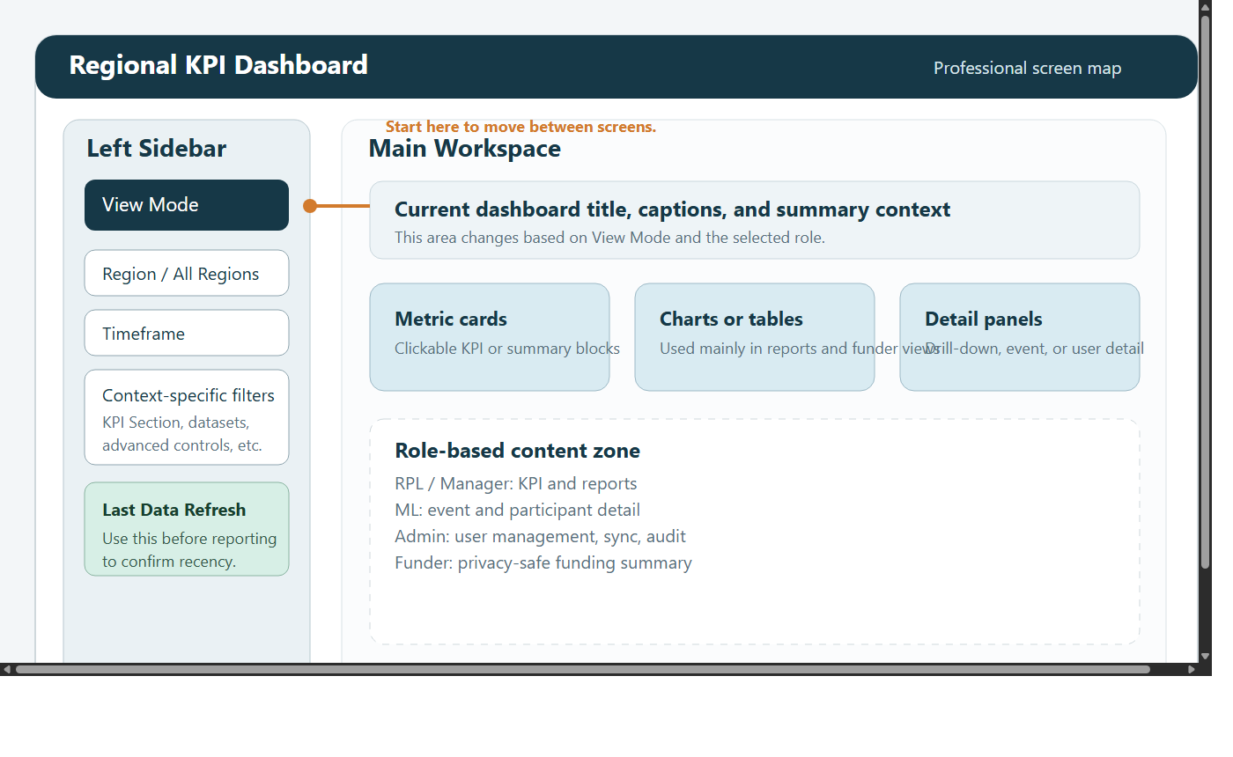

1. Introduction
This is the full handbook for the Regional KPI Dashboard.

It is intended for:

new starters
support staff
managers helping other users
anyone who wants one complete guide to the whole system

The dashboard combines several types of work in one place:

headline KPI review
structured reporting and exports
event-level operational review
funder-facing summary reporting
qualitative case study capture
administrative support and maintenance

Not every user sees every part of the dashboard. Access depends on role.

2. Core ideas shared across the dashboard

2.1 View Mode
Users move between screens using View Mode in the left sidebar.

Common screens include:

Admin Dashboard
KPI Dashboard
Custom Reports Dashboard
Case Studies
Data Request Form
Funder Dashboard
ML Dashboard

2.2 Region and timeframe
Most views depend on:

region filters
timeframe filters

If expected data is missing, start broad and then narrow down.

2.3 Last Data Refresh
The sidebar shows when the dashboard last refreshed.

Always check this before using data in:

meetings
reports
presentations
support decisions

2.4 Drill-down
Many KPI cards can be opened to show the rows behind a total.

Drill-down helps users move from:

summary

to:

explanation

2.5 Role-based access
Different users see different views and different levels of detail. This is intentional. Missing screens or missing fields often reflect role design rather than a problem.

3. Role overview
Role | Main views | Typical use | Main limits
`RPL` | KPI, Custom Reports, Case Studies | regional monitoring and reporting | no Admin, no ML, no personal data
`Manager` | KPI, Custom Reports, Case Studies, Funder, ML | operational management and validation | no Admin
`ML` | ML, Case Studies | event-by-event operational work | no KPI, reports, funder, or admin access
`Admin` | all views | user management, sync control, full reporting | highest responsibility
`Funder` | Funder only | safe high-level reporting | no operational drill-down or personal data

4. Screen-by-screen guide

4.1 KPI Dashboard
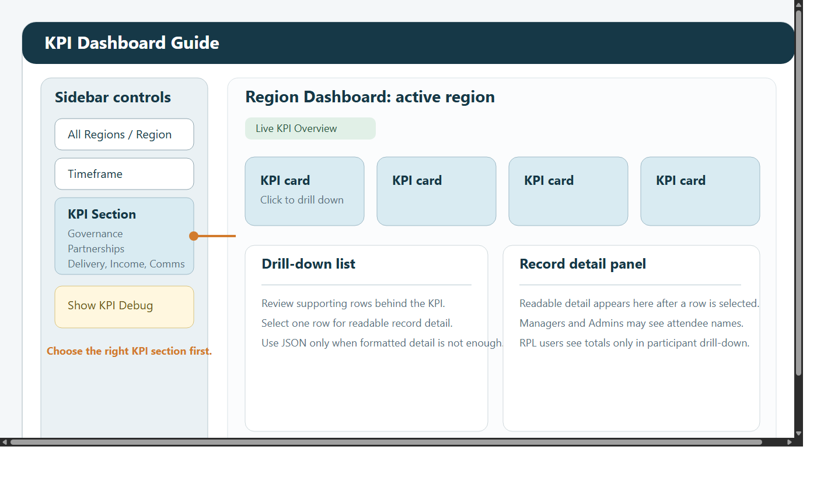

Use KPI Dashboard for:

headline KPI review
checking delivery, governance, and partnerships
opening drill-downs behind KPI cards
reviewing separate Gender and Age demographics cards in the Delivery section

Typical workflow:

Choose a region.
Choose a timeframe.
Choose a KPI section.
Review the cards.
Open drill-downs where needed.

Use this screen first when you want the fastest answer.

In the Delivery section:

the Gender card can include Men, Women, Trans / Non-binary / Gender diverse, Prefer not to say, and Unknown / Not provided
the Age card can include 18-30, 30-40, 40-45, 45-65, 65-75, 75+, and Unknown Age

If Unknown Age appears, attendee records exist but age data is missing or unusable for some or all of the filtered rows.

4.2 Custom Reports Dashboard
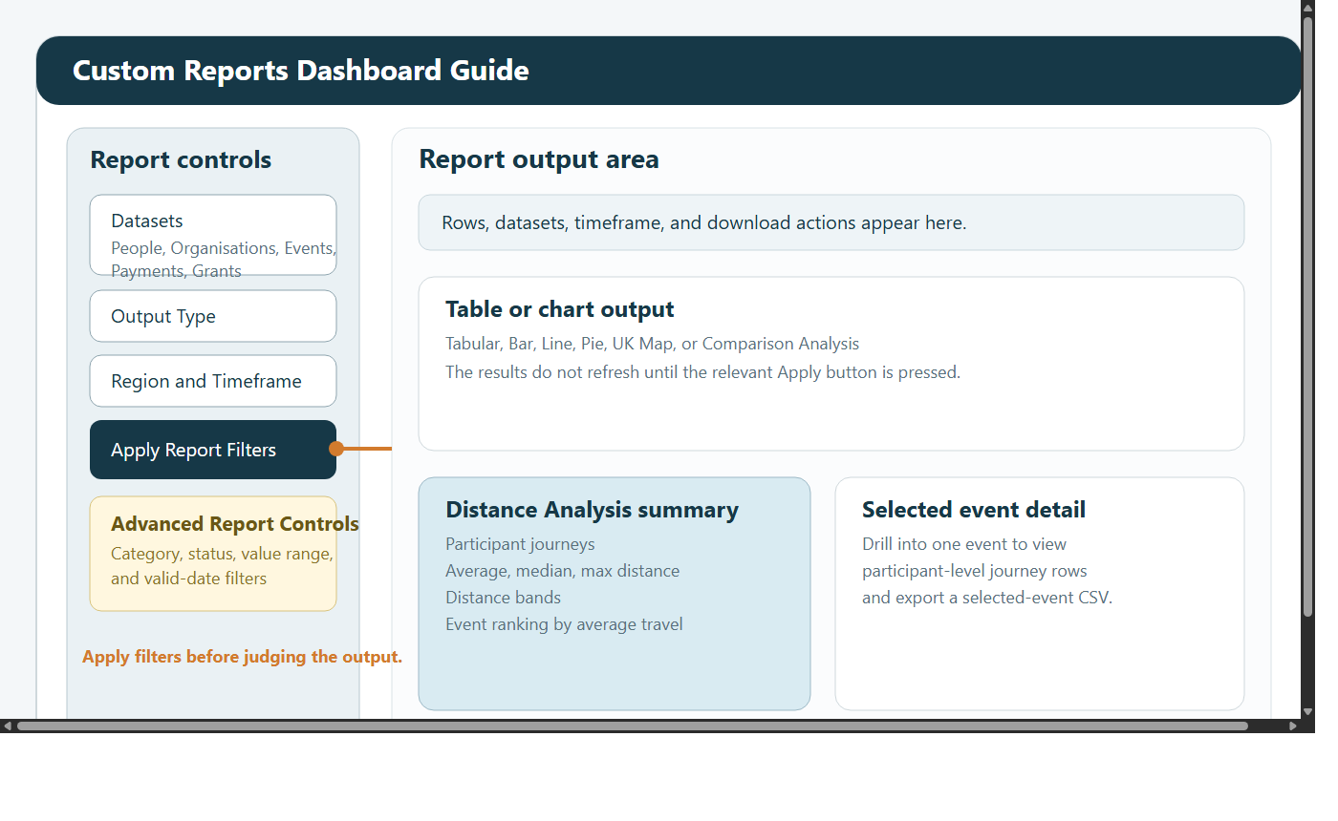

Use Custom Reports Dashboard for:

row-level tables
charts
filtered analysis
exports
comparison work
distance analysis

Typical workflow:

Choose one or more datasets.
Choose an output type.
Set region and timeframe.
Click Apply Report Filters.
Use advanced filters if needed.
Review or export the result.

This screen uses two levels of filtering:

the main report filters control datasets, output type, region, and timeframe
the advanced filters refine the rows after the main report has loaded

Available datasets can include:

People where the role allows it
Organisations
Events
Payments
Grants

Available output types include:

Tabular
Bar
Line
Pie
UK Map
Comparison Analysis
Distance Analysis

Use Tabular for row checking and exports, Line for time trends, Comparison Analysis for direct group-versus-group comparison, and Distance Analysis for participant travel summaries.

4.3 ML Dashboard
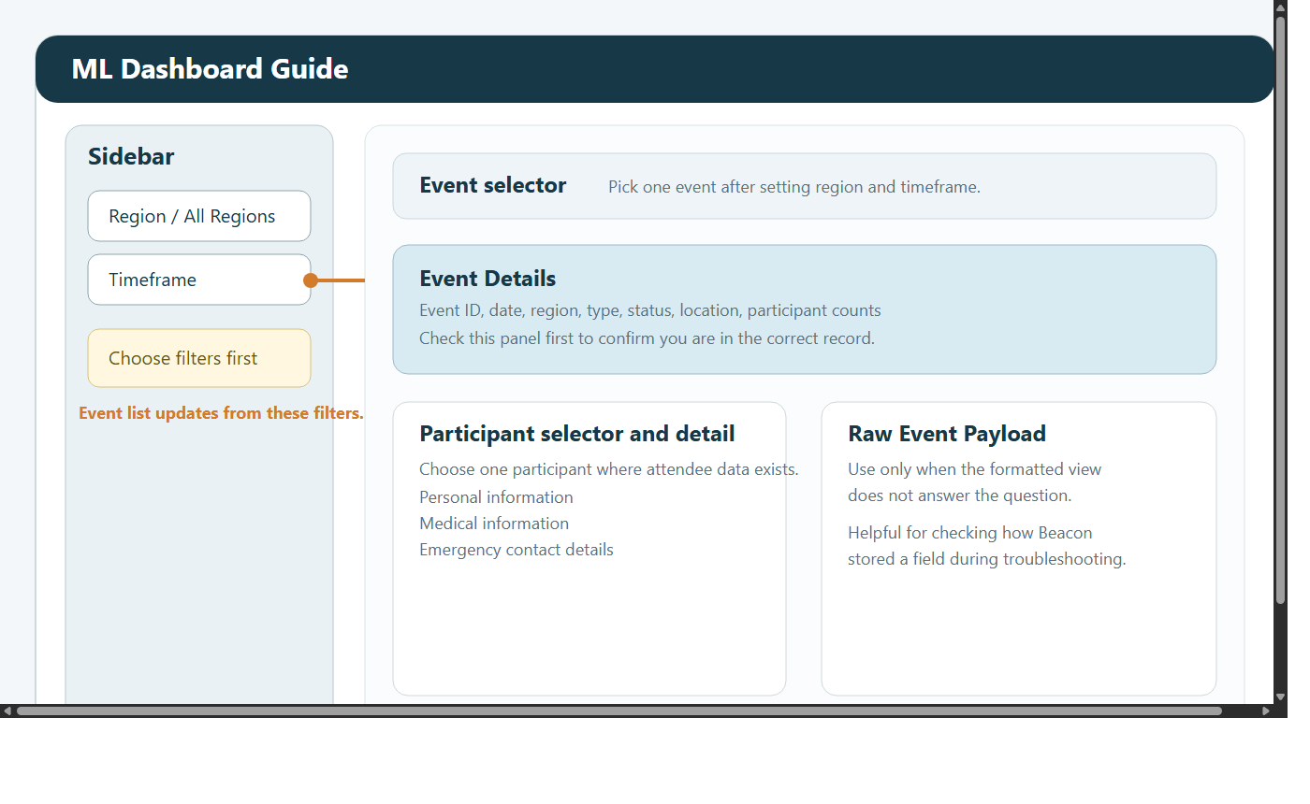

Use ML Dashboard for:

reviewing one event at a time
checking event details
reviewing participant information where the role allows it
reviewing medical and emergency information where available

Typical workflow:

Set region and timeframe.
Choose the event.
Review Event Details.
Review participant or additional event information.

4.4 Funder Dashboard
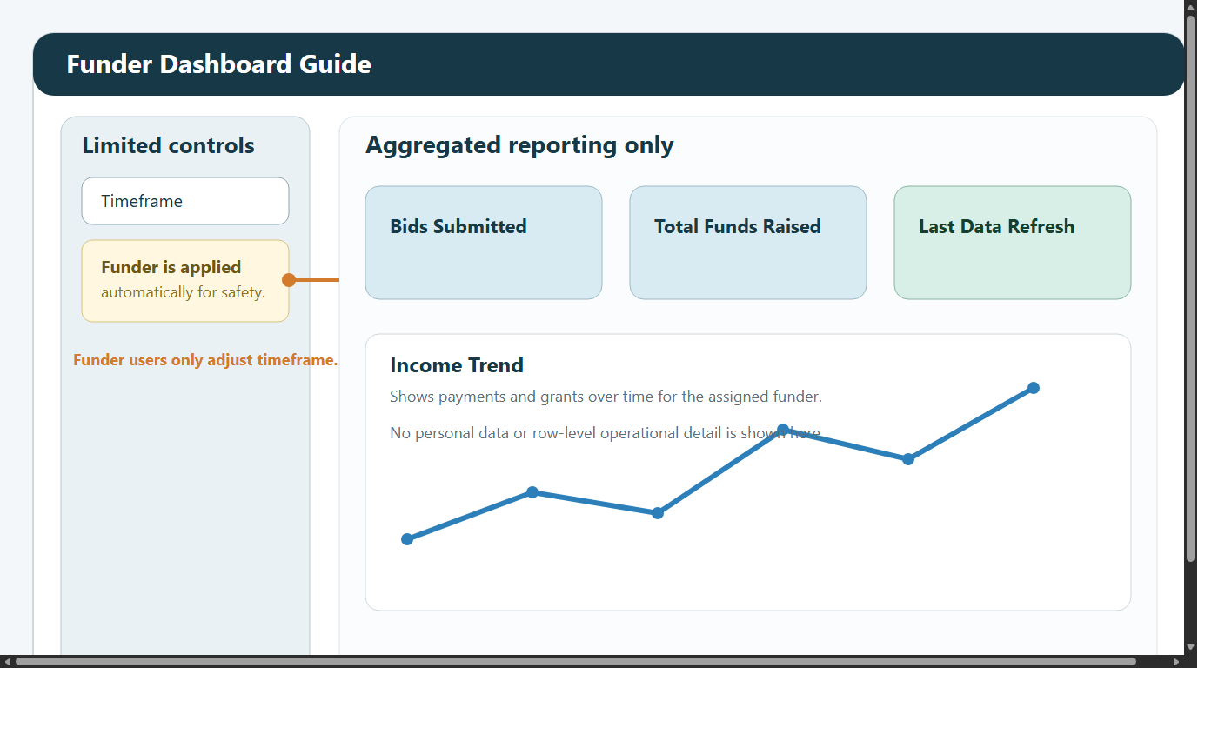

Use Funder Dashboard for:

safe external-style reporting
bids submitted
funds raised
funding trends over time

Typical workflow:

Set the timeframe.
Review the headline cards.
Review the trend.
Check Last Data Refresh.

4.5 Admin Dashboard
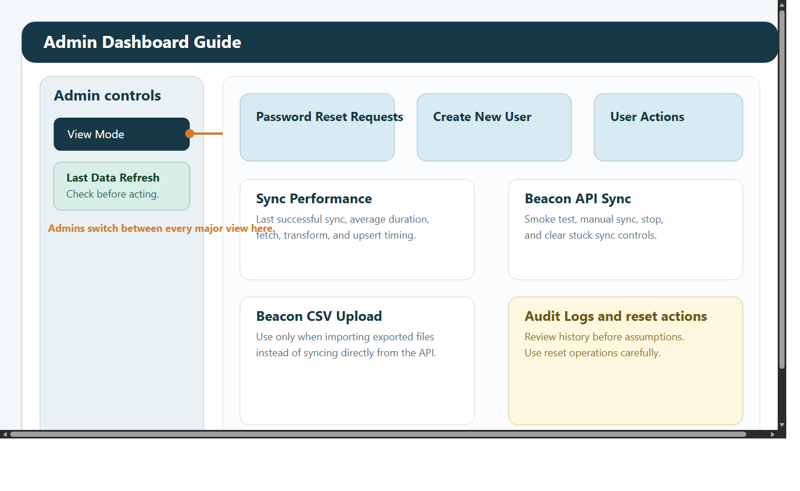

Use Admin Dashboard for:

creating and updating users
resetting passwords
checking sync health
running manual sync actions
reviewing audit history

Admin work should be deliberate and reasoned because many actions affect other users.

4.6 Case Studies
Use Case Studies for:

reading stories and testimonials
adding narrative evidence to reporting
uploading new qualitative evidence

Typical workflow:

Filter first to avoid duplicates.
Review existing entries.
Add a clear title, date, region, and story text when uploading.

4.7 Data Request Form
Use Data Request Form for formal data access requests.

All fields are required:

Name
Email
Date
Time
Reason for data request

When a request is submitted, Admin and Manager users are notified in the dashboard.

Admins can also use the same page to grant temporary access permissions to a single user with an expiry date and time.

5. Role-by-role guide

5.1 RPL
RPL users mainly work with:

KPI Dashboard
Custom Reports Dashboard
Case Studies
Data Request Form

Best for:

summary monitoring
regional reporting
structured exports
narrative evidence

Important limit:

RPL users should not see personal data

5.2 Manager
Managers mainly work with:

KPI Dashboard
Custom Reports Dashboard
Case Studies
Data Request Form
ML Dashboard
Funder Dashboard

Best for:

KPI validation
operational review
event-level checking
leadership reporting
sponsor-facing quality assurance

5.3 ML
ML users mainly work with:

ML Dashboard
Case Studies
Data Request Form

Best for:

checking one event at a time
confirming operational details
reviewing participant information where available

5.4 Admin
Admins can use every view and are responsible for:

user management
password resets
sync review
manual refresh actions
audit and support work
temporary access review and granting

5.5 Funder
Funder users mainly work with:

Funder Dashboard
Data Request Form

Best for:

high-level funding review
restricted summary reporting

6. Common tasks

6.1 Check a KPI
Open KPI Dashboard.
Set region and timeframe.
Choose the KPI section.
Review the headline card.
Open the drill-down if needed.

6.2 Build a report
Open Custom Reports Dashboard.
Choose the datasets.
Choose an output type.
Apply the main filters.
Apply advanced filters if required.
Review the result.
Export CSV if needed.

6.3 Review participant travel
Open Custom Reports Dashboard.
Choose Distance Analysis.
Apply the main filters.
Review the summary metrics.
Drill into a single event if needed.
Export the results if needed.

6.4 Review a single event
Open ML Dashboard.
Set region and timeframe.
Choose the event.
Review event details.
Review participant or operational information as needed.

6.5 Handle a password reset
Open Admin Dashboard.
Open Password Reset Requests.
Set a temporary password.
Ask the user to change it after sign-in.

6.6 Submit or review a data request
Open Data Request Form.
Complete the required fields.
Submit the request.
If you are an Admin or Manager, review the submitted request list and update its status.
If you are an Admin, grant temporary access only where justified and with an expiry time.

7. How to read the main outputs

7.1 Headline cards
Best for:

quick checks
status updates
meeting preparation

7.2 Drill-downs
Best for:

understanding what sits behind a number
checking whether records look reasonable
validating unusual totals

7.3 Reports
Best for:

structured analysis
exports
comparison across regions, dates, statuses, or categories

7.4 Case studies
Best for:

adding context to a number
giving a real-life example
supporting reports with narrative evidence

8. Good working practice
check Last Data Refresh before using figures
widen filters first if something appears to be missing
use the correct screen for the task
validate unusual numbers before circulating them
handle personal data carefully and only where the role allows it

9. Troubleshooting

No data is showing
Widen the timeframe.
Try All Regions where available.
Confirm that you are in the correct screen.

A report is not updating
Click Apply Report Filters.
Click Apply Advanced Filters if you changed advanced options.

Participant names are missing
not all source records include names
some roles are not permitted to see personal data

The dashboard looks out of date
Check Last Data Refresh.
Ask an Admin to review sync health if needed.

A user cannot do something they expect to do
Check the user's role first.
Confirm whether the task belongs in another view.
Ask an Admin if access may need to change.

