Funder Dashboard Manual
Audience: `Funder` users
Generated: RPL-KPIs
Mind Over Mountains Dashboard Guide

Contents

Update the table in Word if entries do not appear immediately.

Funder Dashboard Manual

Audience: Funder users
Scope: safe, high-level funding and delivery summary information

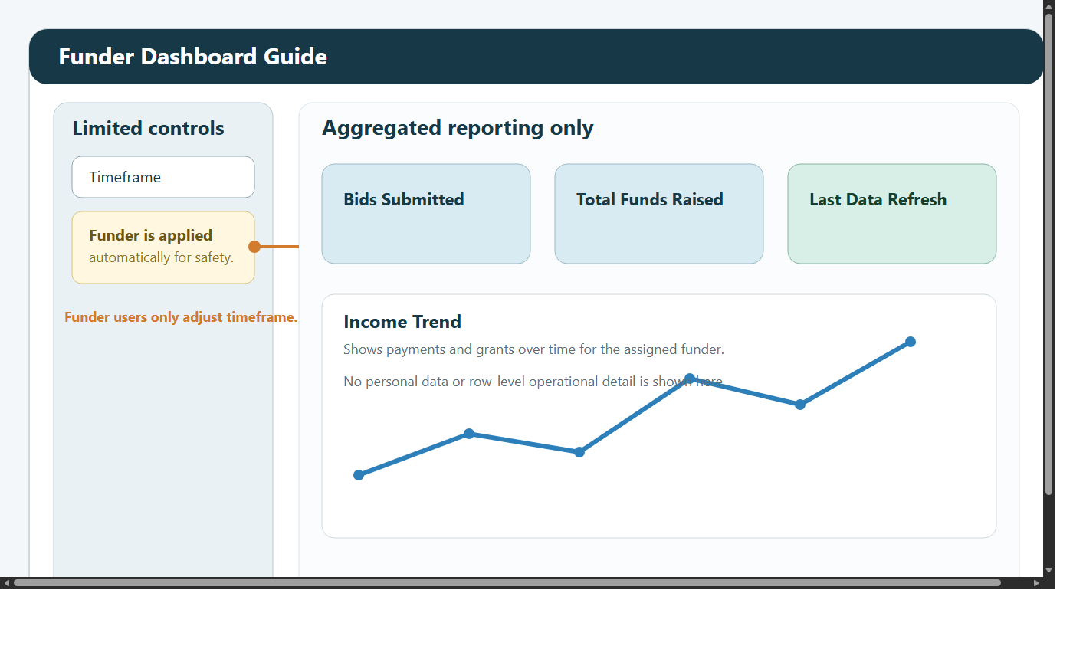

1. Introduction
This manual explains how funder users should use the dashboard.

The Funder role is designed to provide a safe, clear summary view without exposing operational or personal detail.

Funder users can open:

Funder Dashboard
Data Request Form

Funder users cannot open:

Admin Dashboard
KPI Dashboard
Custom Reports Dashboard
ML Dashboard
Case Studies

This role is intentionally limited. It is designed for high-level review rather than investigation.

2. What the Funder Dashboard is for
Use this dashboard when you want to answer questions such as:

how many bids have been submitted
how much funding has been raised
how funding is changing over time
whether the dashboard has refreshed recently enough to rely on

This view is designed to be readable, safe, and appropriate for restricted or external-facing use.

3. Signing in and first checks
When you sign in:

Enter your email address and password.
Change your password if prompted.
Confirm the timeframe you want to review.
Check Last Data Refresh before using the figures.

The refresh time matters. A number may be correct but still not current enough for your meeting or report.

4. What you will see
The Funder Dashboard usually includes:

summary metric cards
bid totals
funding totals
a trend view over time
a refresh timestamp

It does not include:

personal data
participant-level records
detailed event records
operational drill-down
custom reporting tools

If you need more detail than this view provides, request a managed report from the organisation rather than expecting to find that detail in the dashboard.

5. Privacy and access
The Funder role is intentionally restricted.

This usually means:

region is fixed to a high-level context such as Global
operational screens are hidden
personal data is never shown

These limits are not an error. They are part of how the role is designed.

6. Filters
Funder users have limited controls by design.

6.1 What you can change
You can usually change:

timeframe

6.2 What you cannot change
You normally cannot change:

region
user settings
operational access
detailed report structure

Typical timeframe options include:

All Time
Year
Quarter
Month
Custom Range

7. Reading the dashboard

7.1 Headline cards
The top cards usually show:

Bids Submitted
Total Funds Raised

Use these cards when you need a quick factual statement such as:

how many bids were submitted in the selected period
how much funding was raised in the selected period

Always check the timeframe before quoting either value.

7.2 Trend view
The trend view helps you understand whether activity is:

steady
seasonal
concentrated in particular periods

Use it to compare a recent period with a wider one. For example, look at All Time first, then narrow to Year or Quarter.

7.3 Last Data Refresh
Always check the refresh time before using the dashboard in:

a report
a review meeting
a funder update
a presentation

If the refresh date looks too old, contact the dashboard administrator rather than relying on stale figures.

8. Step-by-step workflows

8.1 Prepare for a review meeting
Open the dashboard.
Set the timeframe for the period you care about.
Review Bids Submitted.
Review Total Funds Raised.
Review the trend view.
Check Last Data Refresh.
Note the figures only after confirming the timeframe and refresh point.

8.2 Compare recent activity with a wider period
Start with All Time.
Review the overall pattern.
Narrow to Year, Quarter, or Month.
Compare how the cards change.
Compare how the trend shape changes.

8.3 Check whether figures are current enough to use
Open the dashboard.
Look at Last Data Refresh.
Decide whether that refresh point is suitable for your meeting, report, or update.
If not, contact the dashboard administrator.

9. Data Request Form
Funder users can also open Data Request Form.

Use it when:

you need a more formal data request
you need to explain why additional information is being requested
you want the request reviewed by the operational team

All fields are required:

Name
Email
Date
Time
Reason for data request

When you submit a request, Admin and Manager users are notified in the dashboard.

10. What this role cannot do
Funder users cannot:

switch to operational dashboards
inspect personal records
run custom reports
review event-level participant detail
manage users
run sync actions

These limits are intentional and support privacy-safe reporting.

11. Good working practice
check the timeframe before quoting any number
check the refresh date before sharing any figure
use the dashboard for summary reporting, not detailed investigation
request a managed report if you need more context
use the Data Request Form when you need formal review of an additional request

12. Troubleshooting

I cannot see any data
Widen the timeframe.
Check whether the assigned funder context has activity in that period.
If the screen still appears empty, contact the dashboard administrator.

The figures look old
Check Last Data Refresh.
If it looks too old for your needs, contact the dashboard administrator.

I need participant-level evidence
That is not available in the Funder role. Request a managed report from the organisation instead.

I expected to see another dashboard screen
The Funder role includes only the Funder Dashboard. This is expected behaviour.

