Manager Dashboard Manual
Audience: `Manager` users
Generated: RPL-KPIs
Mind Over Mountains Dashboard Guide

Contents

Update the table in Word if entries do not appear immediately.

Manager Dashboard Manual

Audience: Manager users
Scope: operational reporting, KPI validation, event review, case studies, and funder-facing oversight

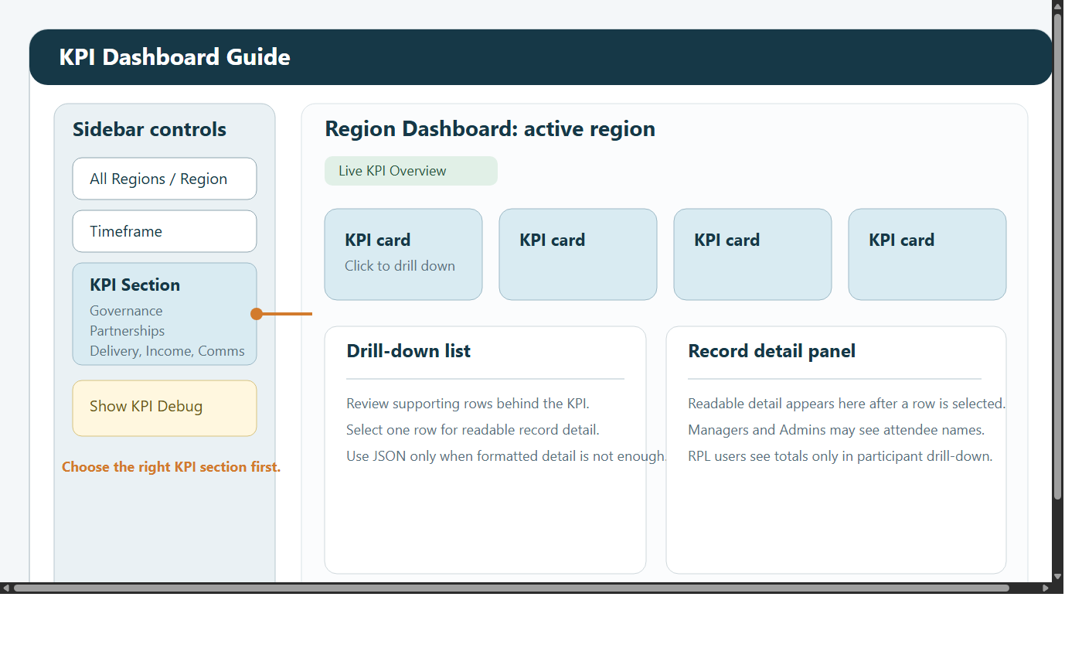

1. Introduction
This manual explains how Managers use the dashboard across the main reporting and operational views.

The Manager role is designed for people who need to move between:

headline oversight
KPI validation
structured reporting
event-level review
funder-facing summary checks
case study capture and review

Managers can open:

KPI Dashboard
Custom Reports Dashboard
Case Studies
Data Request Form
Funder Dashboard
ML Dashboard

Managers cannot open:

Admin Dashboard

Managers have broader operational visibility than RPL users, but they still are not system administrators. If a task involves user access, password resets, sync control, or audit review, it belongs with an Admin.

2. What the Manager role is for
Use the Manager role when you need to:

review performance across multiple dashboard areas
validate a KPI before it is shared more widely
check one event in operational detail
prepare a chart or export for leadership use
review what a funder-facing screen shows
confirm whether unusual data reflects a real change or a data issue

This role is not intended for:

creating or deleting users
running sync maintenance
changing system configuration

3. Signing in and first checks
When you sign in:

Enter your email address and password.
Change your password if prompted.
Check Last Data Refresh.
Choose the correct screen in View Mode.
Confirm your region and timeframe settings before beginning any review.

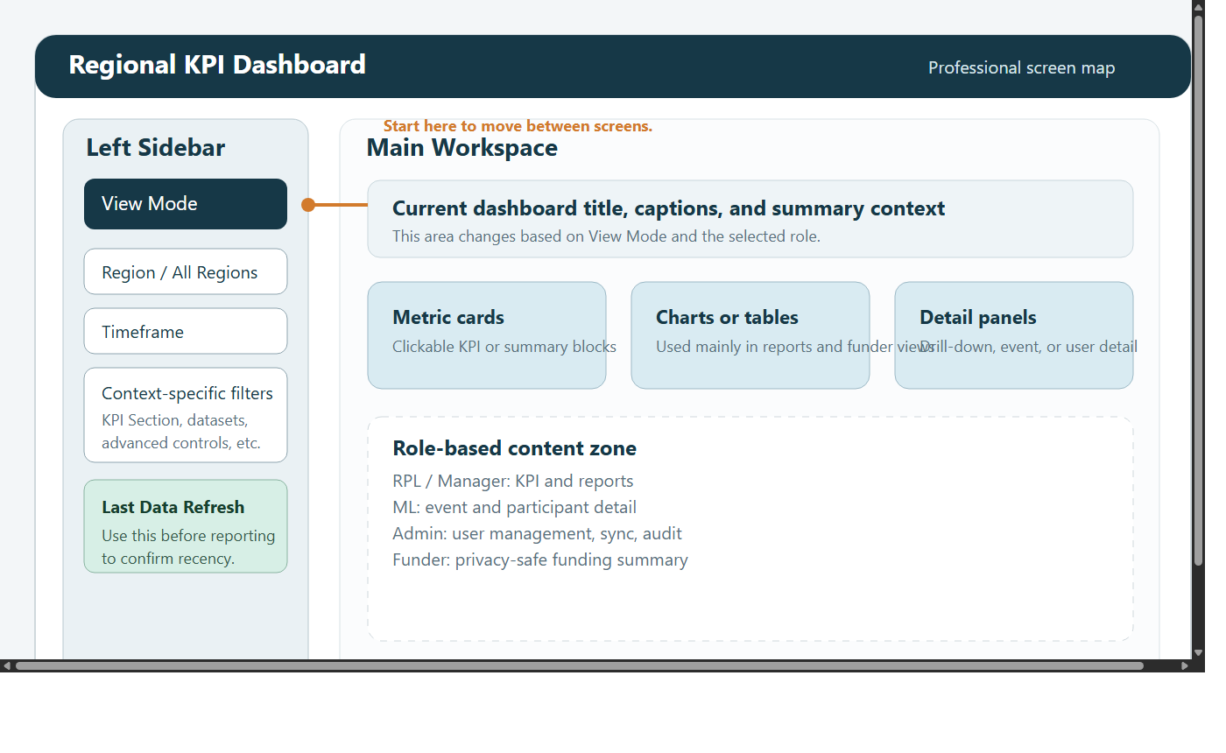

A Manager often switches between more than one screen during the same task. That is expected. Start with the view that gives the fastest answer, then move into a more detailed screen if the question requires it.

4. Understanding the layout
The left sidebar controls most navigation.

Important controls usually include:

View Mode
region controls
timeframe controls
screen-specific controls such as KPI Section

Use the screens like this:

KPI Dashboard for headline review
Custom Reports Dashboard for structured analysis, exports, and charts
ML Dashboard for one-event-at-a-time review
Funder Dashboard for sponsor-facing summary checks
Case Studies for narrative evidence
Data Request Form for submitting and reviewing data access requests

5. Filters and navigation
Good filtering habits matter because a wrong region or timeframe can make correct data look wrong.

5.1 Region filtering
Use All Regions when:

you are checking whether something exists at all
you need a high-level organisational picture
you want to compare one region with the wider context

Use a single region when:

you are validating a regional KPI
you are reviewing a regional trend
you want a cleaner chart or export
you are following up on a regional issue

5.2 Timeframe filtering
Typical timeframe options include:

All Time
Year
Quarter
Month
Week
Custom Range

Recommended practice:

Start with a wider timeframe if you are uncertain.
Confirm the records exist.
Narrow to the exact reporting period.

5.3 Recommended navigation pattern
For most Manager tasks:

Start in KPI Dashboard.
Identify the KPI section involved.
Open drill-down if needed.
Move to Custom Reports Dashboard if you need structure or export.
Move to ML Dashboard if the issue is event-specific.
Move to Funder Dashboard if you need to check what an external-style restricted view shows.

6. KPI Dashboard
The KPI Dashboard is the main place for headline operational review.

6.1 When to use KPI Dashboard
Use it when you want to:

see the current headline picture quickly
review delivery, governance, and partnerships
identify where a result has shifted
check whether a number looks credible
open the supporting rows behind a KPI card

6.2 KPI sections
Depending on the region context, the sections can include:

Governance
Partnerships
Delivery
Income
Comms
Case Studies

The section selector is important. If a number seems to be missing, first confirm that you are in the correct section.

In the Delivery section, demographics are split into separate Gender and Age cards.

The Gender card can include Men, Women, Trans / Non-binary / Gender diverse, Prefer not to say, and Unknown / Not provided.

The Age card can include:

18-30
30-40
40-45
45-65
65-75
75+
Unknown Age

If Unknown Age appears, attendee rows are present but no usable age value has been synced for some or all of the selected records.

6.3 Step-by-step KPI review
Open KPI Dashboard.
Set the relevant region.
Set the relevant timeframe.
Choose the correct KPI section.
Review the visible cards.
Note anything that looks unusual.
Click the relevant KPI card.
Review the rows returned by the drill-down.
Decide whether the KPI is correct, unclear, or needs a deeper report-based check.

6.4 Using drill-down
Drill-down is the quickest way to understand what sits behind a KPI.

Use it when:

a KPI is unexpectedly high or low
someone asks what is included in a total
you want to identify which records are driving a change

When reviewing drill-down results:

confirm the timeframe still matches your question
look for obvious duplicate or missing records
note whether the supporting rows match the story the headline card suggests

If the drill-down gives only part of the answer, rebuild the question in Custom Reports Dashboard.

6.5 Using KPI Debug
Managers can use Show KPI Debug.

This shows extra support counts such as:

people
volunteers
steering volunteers
events
participants
grants
bids submitted

Use Show KPI Debug when:

the headline KPI looks wrong
you need to understand whether the source population looks plausible
you want to separate a source-data problem from a calculation problem

Suggested process:

Review the headline KPI.
Turn on Show KPI Debug.
Compare the supporting counts with what you expect.
Decide whether the issue looks like source data, filtering, or KPI logic.

7. Custom Reports Dashboard
Use Custom Reports Dashboard when you need structured analysis, exportable data, or chart-based output.

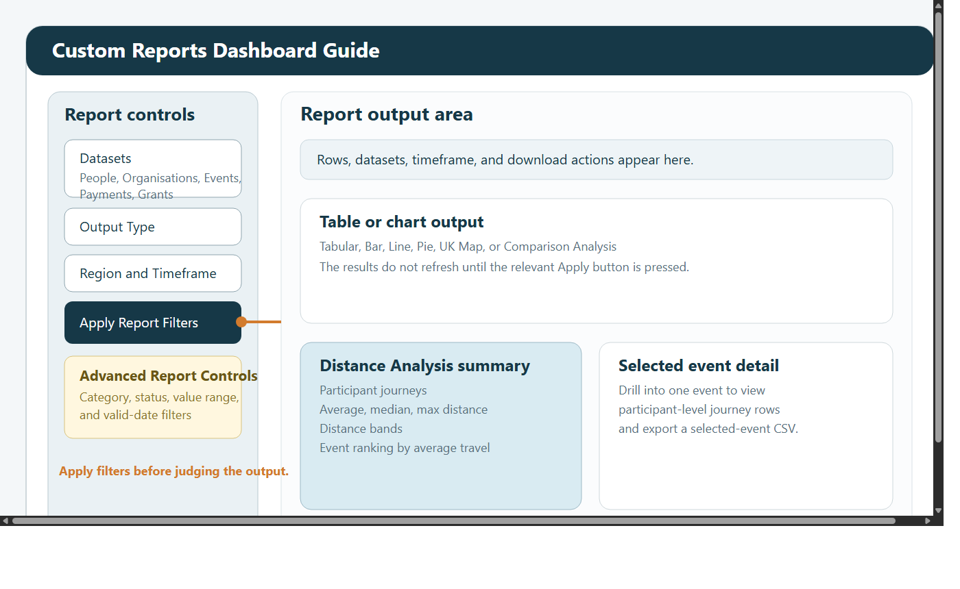

7.1 What this screen is for
Use it when you need to:

inspect rows directly
export CSV data
build charts for packs or presentations
compare categories, statuses, or regions
validate a KPI against row-level data
review travel analysis

7.2 Datasets available to Managers
Managers can work with:

People
Organisations
Events
Payments
Grants

Use them like this:

People: participant or people-record analysis where your role permits it
Organisations: organisation activity, partnership analysis, and status review
Events: delivery volume, event type, event timing, event status, and regional delivery questions
Payments: income records and timing
Grants: grant lifecycle, outcomes, awards, and closures

7.3 Main report workflow
Use the same pattern every time:

Open Custom Reports Dashboard.
Choose one or more datasets.
Choose the Output Type.
Set region and timeframe.
Click Apply Report Filters.
Review the returned result.
Open Advanced Report Controls if the result is too broad.
Apply advanced filters.
Review the revised output.
Download CSV if needed.

This screen works in two stages:

Apply Report Filters refreshes dataset, output type, region, and timeframe
Apply Advanced Filters narrows the already returned rows

7.4 Output types explained
Available output types are:

Tabular
Bar
Line
Pie
UK Map
Comparison Analysis
Distance Analysis

Choose them like this:

Tabular for row-level review and export
Bar for simple grouped comparisons
Line for trends over time
Pie for share-of-total views
UK Map for regional distribution
Comparison Analysis for direct group-versus-group comparison
Distance Analysis for participant travel questions

7.5 Grouping, metrics, and aggregation
Most chart outputs require three choices:

Group By
Metric
Aggregation

These choices determine what the chart actually means:

Group By decides how the report is split
Metric decides what value is measured
Aggregation decides whether you are summing values, counting rows, or taking an average

Always sense-check the chart title and axes after making these selections so that you know the visual matches the question you are trying to answer.

7.6 Advanced Report Controls
Advanced controls include:

Limit to datasets
Category filter
Status filter
Metric value range
Only include rows with valid date

Practical uses:

use Status filter to isolate active, completed, approved, or similar statuses
use Category filter when you need one strand of activity rather than the full mix
use Metric value range to remove outliers or zero-value rows
use Only include rows with valid date before using Line
use Limit to datasets when you selected broadly at the start and want to narrow inside the current result

If the result becomes empty:

Remove the most restrictive advanced filter.
Reapply.
Add filters back one at a time.

7.7 Comparison Analysis
Comparison Analysis lets you compare one group against another on the same dimension.

This is useful for questions such as:

how one region compares with another
whether one status materially differs from another
whether one category is larger than another
what the absolute and percentage gap is between two groups

Typical workflow:

Choose the relevant dataset.
Choose Comparison Analysis.
Apply the main filters.
Choose the comparison dimension.
Select the baseline value.
Select the comparison value.
Review the totals, difference, and percentage gap.

7.8 Distance Analysis
Distance Analysis focuses on participant travel to events.

It can show:

participant journeys
average distance
median distance
maximum distance
distance bands
events ranked by average travel distance

You can also:

filter by event type
keep only rows with resolved distance
drill into a selected event
inspect journey-level rows
download a CSV for the selected event or the full analysis

Use it when you need to discuss:

reach
accessibility
travel burden
whether some events draw participants from further away than others

If the result looks thin, check:

timeframe
event type filters
missing postcode data
whether unresolved rows are being filtered out

7.9 Example report workflows
To validate a KPI:

Note the KPI region and timeframe.
Open Custom Reports Dashboard.
Choose Tabular.
Choose the relevant dataset.
Match the same region and timeframe.
Review whether the rows support the KPI story.

To prepare a presentation chart:

Choose the relevant dataset.
Choose Bar or Line.
Set a readable grouping.
Narrow the report so the chart stays clear.
Review the title and axes before using the chart externally.

8. ML Dashboard
Managers can use the ML Dashboard for one-event-at-a-time checking.

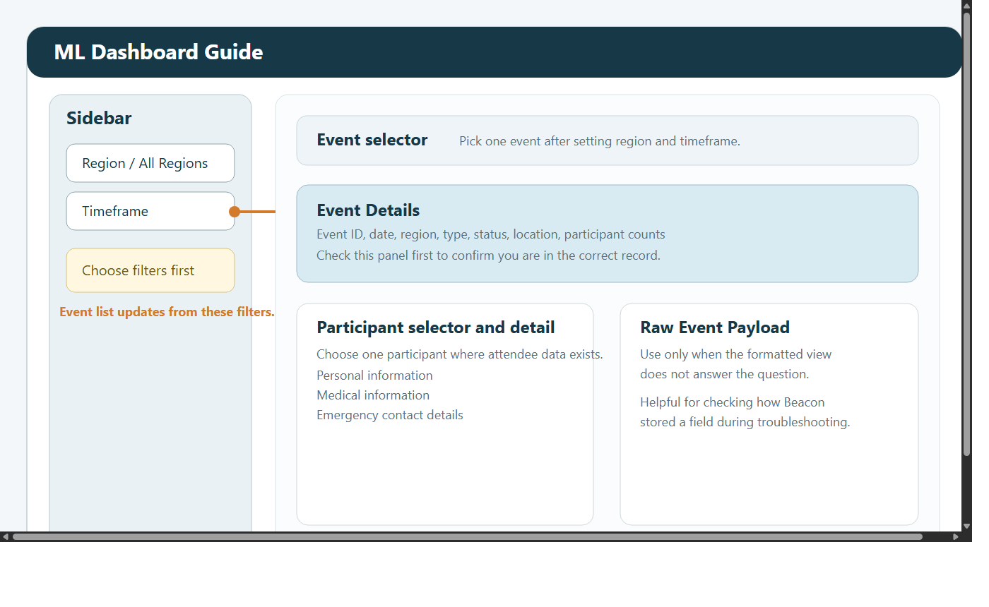

8.1 When to use ML Dashboard
Use it when:

the question is about one event rather than a region-wide trend
you need to review event details
you need to check participant information where available
you need to confirm whether an event record looks complete
you need to review medical or emergency details for operational reasons

8.2 Workflow
Open ML Dashboard.
Set region and timeframe.
Choose the event.
Review event details first.
Review participant information where needed.
Review medical or emergency detail only where operationally necessary.

8.3 Good practice
always confirm the event details before reviewing participant information
use participant and medical information only for legitimate operational need
if details are missing, check whether the source data simply does not contain them before assuming there is a system fault

9. Funder Dashboard
Managers can open Funder Dashboard to review sponsor-facing summary figures.

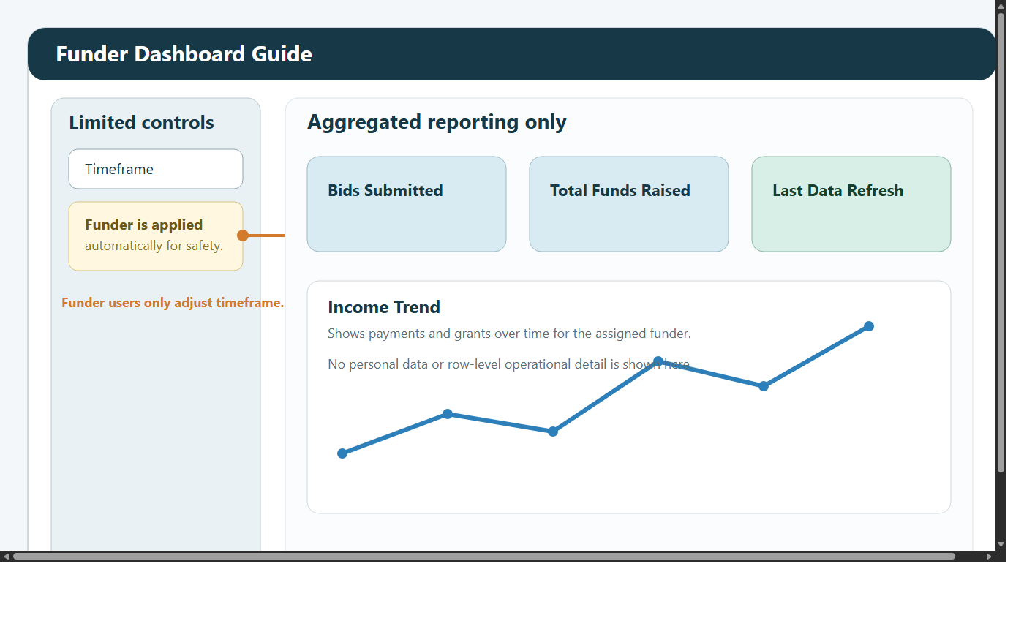

9.1 When to use Funder Dashboard
Use it when:

preparing for sponsor or funder conversations
checking bids submitted and total funds raised
reviewing the high-level trend view
quality-assuring what a restricted funder user will see

9.2 Workflow
Open Funder Dashboard.
Set the timeframe.
Review the headline cards.
Review the trend view.
Check Last Data Refresh.

10. Case Studies
Managers can read and upload case studies.

Use them when:

a KPI needs narrative context
a report needs a real example
a team wants to capture a strong story after delivery

10.1 Reading case studies
Open Case Studies.
Filter by date or region if needed.
Review titles and dates.
Select the most relevant story for the reporting period or discussion.

10.2 Uploading case studies
Open Case Studies.
Filter first to avoid duplicates.
Add a clear title.
Add the story text.
Set the correct date.
Set the correct region.
Submit and review the saved result.

11. Data Request Form
Managers can use Data Request Form in two ways:

to submit a request themselves
to review requests submitted by other users

11.1 Submitting a request
All fields are required:

Name
Email
Date
Time
Reason for data request

Workflow:

Open Data Request Form.
Choose the matching name and email for the user making the request.
Set the date and time.
Enter a clear reason.
Submit the form.

11.2 Reviewing requests
Managers also see the request review area on the same page.

Use it to:

review recently submitted requests
see whether a request is Pending, In Review, or Completed
update request status after you have reviewed it

When a request is submitted, Managers are notified in the dashboard.

12. Recommended working pattern
For most Manager tasks:

Start in KPI for the headline view.
Use drill-down or Show KPI Debug if something needs checking.
Move to Custom Reports Dashboard for structured validation or export.
Move to ML Dashboard if the issue is event-specific.
Move to Funder Dashboard if you need a sponsor-facing view.
Use case studies when the numbers need narrative evidence.

13. Good working practice
check Last Data Refresh before quoting figures
widen filters first if expected data is missing
treat operational and personal information carefully
use the right screen for the job rather than forcing one screen to answer every question
export only what you actually need
update data request statuses when you complete a review

14. Troubleshooting

A KPI number looks wrong
Recheck the region and timeframe.
Open the KPI drill-down.
Turn on Show KPI Debug.
Rebuild the question in Custom Reports Dashboard if needed.

A report does not refresh
Click Apply Report Filters if you changed the main report settings.
Click Apply Advanced Filters if you changed advanced controls.

Attendee detail is missing
not all events contain complete attendee detail
visibility depends on source data

The Funder Dashboard looks empty
widen the timeframe
check whether the selected funder context has matching data

The wrong event appears in ML Dashboard
Check region and timeframe.
Reselect the event after changing filters.
Confirm the event name and date before continuing.

