Mountain Leader Dashboard Manual
Audience: `ML` users
Generated: RPL-KPIs
Mind Over Mountains Dashboard Guide

Contents

Update the table in Word if entries do not appear immediately.

Mountain Leader Dashboard Manual

Audience: ML users
Scope: event review, participant checks, and case study capture

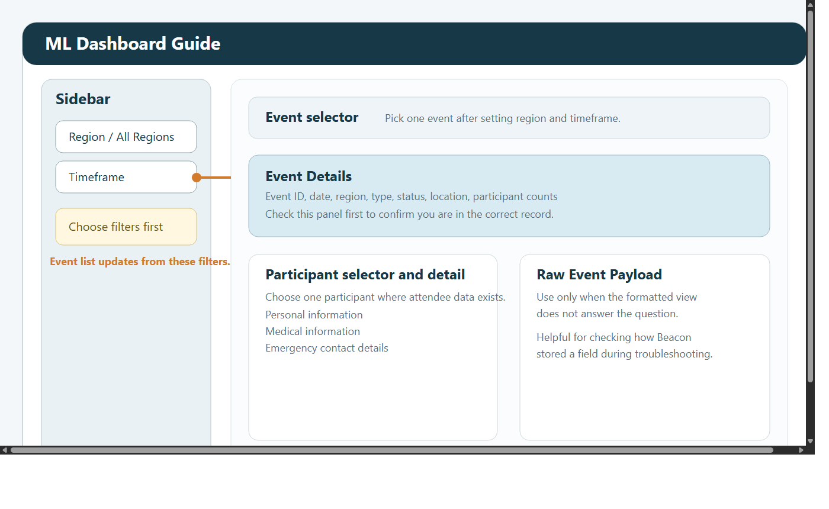

1. Introduction
This manual explains how Mountain Leaders use the dashboard for event-by-event operational work.

The ML role is designed for people who need to:

review one event at a time
check event details before delivery
review participant information where it is available
review medical and emergency information where it is operationally necessary
record or review case studies after delivery

ML users can open:

ML Dashboard
Case Studies
Data Request Form

ML users cannot open:

Admin Dashboard
KPI Dashboard
Custom Reports Dashboard
Funder Dashboard

This role is intentionally focused. It is not for broad reporting or system administration. It is for safe, event-level operational checking.

2. Before you begin
When you sign in:

Enter your email address and password.
Change your password if prompted.
Use View Mode to confirm whether you need ML Dashboard or Case Studies.
Check your region and timeframe before selecting an event.

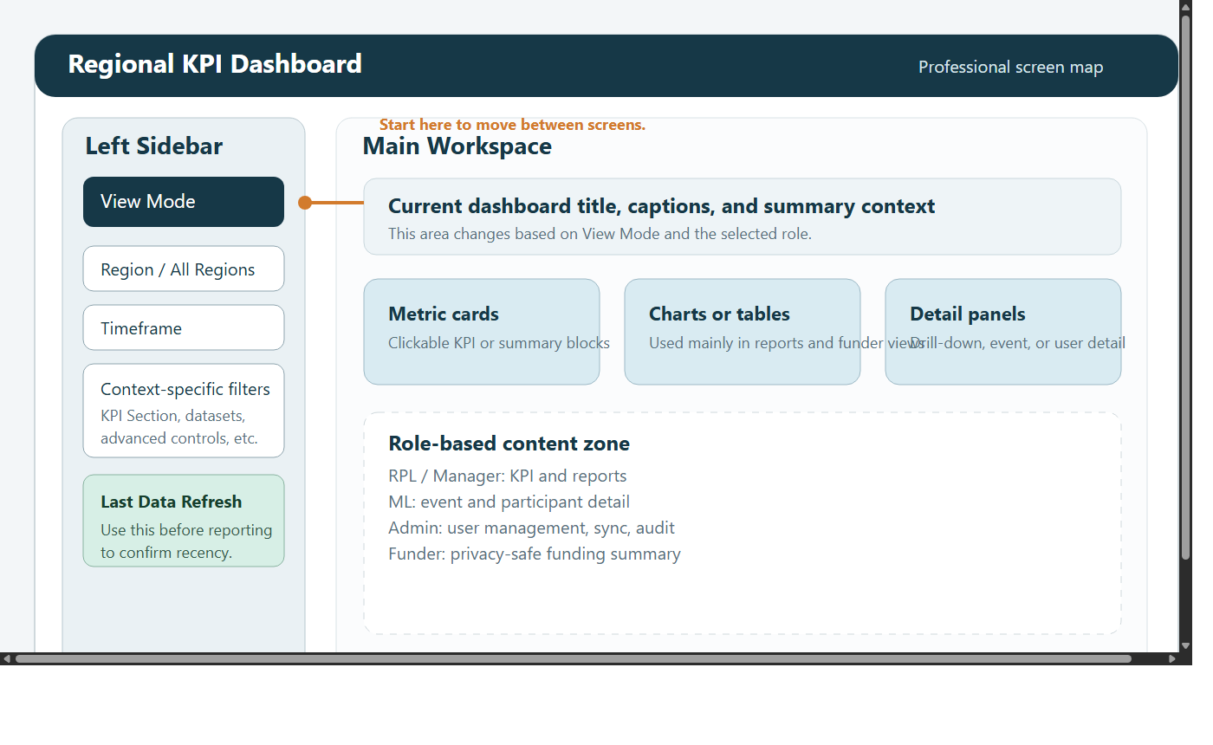

The most common reason an event appears to be missing is not that the event is absent, but that the region or timeframe is too narrow.

3. What the ML role is for
Use this role when you need to:

review the details of a single event
confirm you are looking at the correct event before delivery
check participant information where the source data contains it
review medical or emergency notes where appropriate
add a case study after the event

Do not use this role as if it were a reporting dashboard. If your question is about trends, totals, exports, or wider performance, that belongs with a Manager, RPL, or Admin user.

4. Finding the right event
The sidebar usually gives you:

All Regions or a specific region
timeframe controls

After setting those filters, use the Event selector on the page to choose the event.

4.1 Recommended workflow
Start with the broadest sensible timeframe.
Use All Regions if you are unsure which region the event appears under.
Open the event selector.
Choose the event by name and date.
Confirm the event details before reading participant information.

4.2 If the event is not visible
Check these in order:

Widen the timeframe.
Switch to All Regions.
Look again in the event selector.
If it still is not there, ask a Manager or Admin to confirm that the event exists in the synced source data.

5. Event Details
When you select an event, the dashboard shows an Event Details area.

Typical information may include:

event ID
event name
date
region
event type
participant count
location
status
description

5.1 Why this section matters
Always review Event Details first. This confirms:

you chose the correct event
the date matches what you expect
the region matches what you expect
the event type and status make sense

5.2 Step-by-step review
Read the event name.
Read the event date.
Check the region.
Check the event type.
Check the participant count.
Check the location and status if shown.
Only then move on to participant information.

This order reduces the risk of reviewing the wrong record.

6. Participant information
If attendee data exists, the dashboard lets you review participants one at a time.

Possible information areas include:

personal information
participant record details
medical information
emergency contact details

Not every event contains every field. Some events contain only partial attendee information. Some may contain counts but not full person-level detail.

6.1 Step-by-step participant review
Choose the event.
Open the participant selector if it is shown.
Choose the participant you need.
Review the available information carefully.
Move to the next participant only if there is a legitimate operational need.

6.2 Good practice
review only what you need
avoid casual browsing of personal records
treat all participant data as sensitive
if something looks missing, remember the source data may not include it

7. Medical and emergency information
Some records include medical or emergency details.

These fields should be used carefully and only when there is a clear operational reason.

7.1 When it is appropriate to use this information
Use it for:

safe event delivery
checking essential support needs
confirming important practical information before or during an event

7.2 When it is not appropriate
Do not use it:

out of curiosity
in casual discussion
for wider sharing than is necessary

7.3 If the section is blank
If medical or emergency sections are blank, the usual explanation is that the source record simply does not contain those values. It does not always mean something is broken.

8. Additional event information
The page may include extra event information in a readable format beyond the main summary panel.

Use this area when:

the main event summary does not show enough detail
you need to check how the event was recorded
support staff ask you to confirm a field from the event record

Always cross-check the extra detail against the main Event Details area so that you stay clear about which event you are reviewing.

9. Case Studies
ML users can also read and upload case studies.

This is useful for recording:

participant feedback
a short story of impact
reflections after an event

9.1 Reading case studies
Open Case Studies.
Use region and date filters if needed.
Review the titles and dates.
Read the most relevant story.

9.2 Adding a case study
Use this process:

Open Case Studies.
Filter first to avoid creating a duplicate.
Add a clear title.
Add the story text.
Set the correct date.
Set the correct region.
Submit the form.
Review the saved result.

9.3 Good case study practice
make the title specific
keep the story factual and readable
check the date carefully
choose the right region
avoid sharing unnecessary sensitive personal detail

10. Data Request Form
Use Data Request Form when you need to request data access or ask for a formal review of what information can be shared.

All fields are required:

Name
Email
Date
Time
Reason for data request

Suggested workflow:

Open Data Request Form.
Choose your name.
Choose your email.
Set the relevant date and time.
Explain the request clearly.
Submit the form.

After submission, Admin and Manager users are notified in the dashboard.

11. Common tasks

10.1 Check an event before delivery
Open ML Dashboard.
Set region and timeframe.
Choose the event.
Review Event Details.
Review participant information where available.
Review medical and emergency detail where appropriate.

10.2 Confirm participant information after delivery
Open ML Dashboard.
Choose the event.
Open the participant selector.
Review the available participant detail carefully.
If key information appears to be missing, ask a Manager or Admin to confirm the source data.

10.3 Add a case study after an event
Open Case Studies.
Filter first to avoid duplicates.
Add the story with a clear title.
Set the correct date and region.
Submit and review the saved result.

10.4 Submit a data request
Open Data Request Form.
Complete all required fields.
Submit the request.
Wait for Manager or Admin follow-up.

12. Good working practice
set the correct date range before choosing an event
confirm the event details before reviewing participants
review medical and emergency information only where needed
report missing or surprising data if the event should contain it
use the dashboard for operational need, not casual browsing
use the Data Request Form for permission questions rather than informal messages

13. Troubleshooting

No events are showing
Widen the timeframe.
Switch to All Regions.
Check again in the event selector.
If still missing, ask a Manager or Admin to confirm the event has synced.

No participant names are shown
some events include only counts or partial attendee data
visibility depends on what exists in the source data

Medical or emergency sections are blank
the source record may not contain those values
not every event includes them

The wrong event appears selected
Check the date in the selector.
Adjust region and timeframe.
Choose the event again.
Confirm the event details before continuing.

