Admin Dashboard Manual

Audience: Admin users
Scope: user management, data refresh operations, audit review, and full reporting access

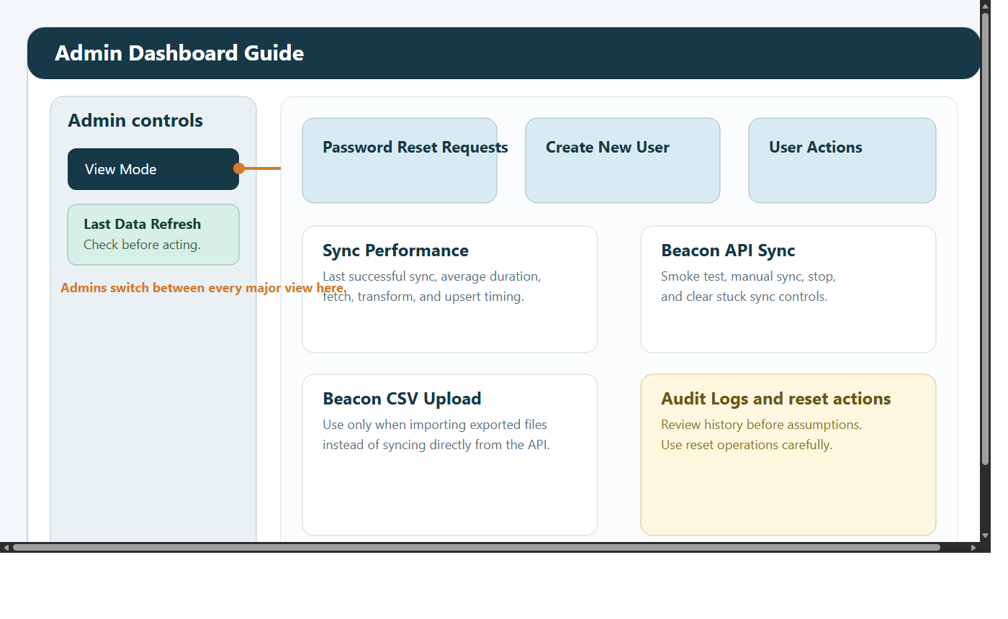

1. What this manual covers
Admins have the broadest access in the Regional KPI Dashboard. This role is responsible for:

maintaining user access
handling password reset requests
assigning and updating roles
monitoring Beacon sync health
triggering manual sync or CSV import when needed
reviewing audit activity
supporting Managers, RPLs, MLs, and Funders

Available views:

Admin Dashboard
KPI Dashboard
Custom Reports Dashboard
Case Studies
Funder Dashboard
ML Dashboard

2. Before you start
Use this checklist before making any administrative change:

Confirm you are signed in with your own Admin account.
Check the Last Data Refresh card in the sidebar.
Record a clear business reason before changing roles, deleting users, or resetting data.
Prefer the smallest action that solves the problem.

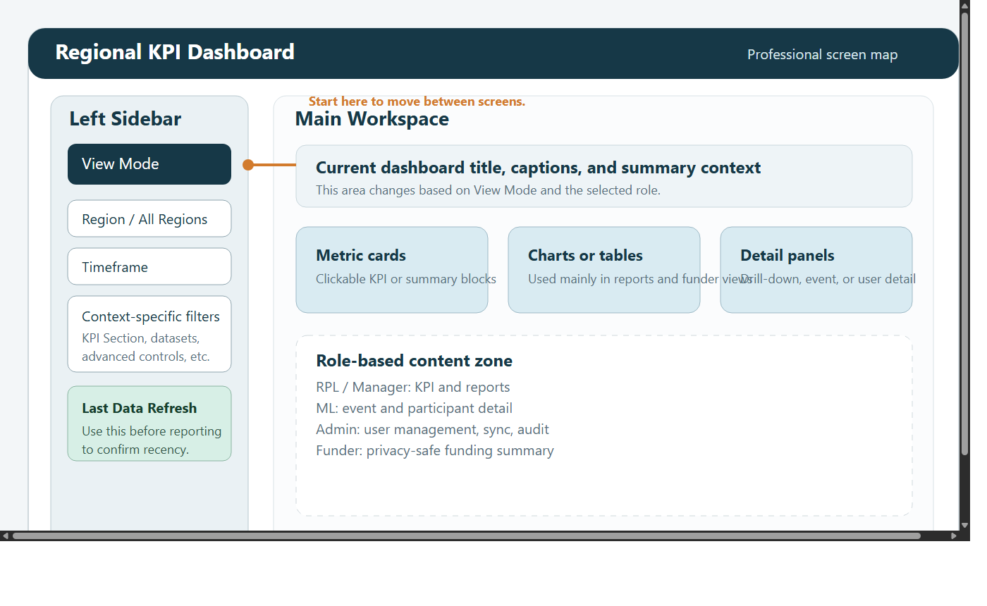

3. Signing in and moving around
Open the dashboard URL.
Enter your email address and password.
If prompted, change your password before continuing.
Use View Mode in the left sidebar to move between dashboards.

If the application reports Admin client not available, the admin Supabase configuration is likely incomplete and should be checked before you continue.

4. Admin Dashboard screen tour
The Admin Dashboard is the operational control panel for the application.

Main areas:

Password Reset Requests: pending self-service reset requests
Create New User: create staff, admin, ML, RPL, manager, or funder users
Existing Users & Actions: reset passwords, update roles, delete users
Sync Performance: timing and status for recent sync activity
Beacon API Sync: smoke test, manual sync, stop, and stuck-sync controls
Beacon CSV Upload: manual import from exported CSV files
data reset actions: controlled rebuild or refresh operations
Audit Logs: review of administrative and user activity

5. User management workflows

5.1 Handle a password reset request
Use this when a user has selected Forgot password? and needs access restored.

Open Password Reset Requests.
Select the pending email address.
Enter a temporary password.
Click Set Temporary Password.
Tell the user to sign in and change the password immediately.

Expected result:

the request is marked as completed
the user is forced to change password on next login
the action is recorded in the audit trail

5.2 Create a new user
Open Create New User.
Enter full name, email, and a starting password.
Select one or more roles.
If Funder is included, choose the funder name or enter a new one.
Submit the form.

Good practice:

use named organisational email addresses where possible
avoid shared accounts
confirm the least-privilege role before saving

5.3 Reset an existing user's password
Find the user in Existing Users & Actions.
Choose Reset Password.
Enter the new temporary password.
Confirm the reset.

Use this when the self-service route is unavailable or urgent support is required.

5.4 Update roles
Select the user.
Choose the revised role set.
If Funder is included, verify the mapped funder.
Enter a reason that explains the change.
Confirm and apply the update.

Prefer updating the role over deleting and recreating an account. It preserves continuity and makes the audit history easier to follow.

5.5 Delete a user
Select the user record.
Enter the deletion reason.
Confirm the action carefully.
Click Delete User.

Use deletion only when the account should no longer have dashboard access. If the person still works with the system, a role change is usually safer.

6. Sync and data operations

6.1 Read the Sync Performance panel
Use Sync Performance to understand whether the data pipeline is healthy.

Key indicators:

last total sync duration
fetch, transform, and upsert timings
average duration across recent successful syncs
last successful sync time
whether the latest run was automatic or manual

Use this section when:

the dashboard looks stale
overnight syncs may have failed
a manual sync seems slower than expected

6.2 Run a Beacon smoke test
Use Run Beacon API Smoke Test first when diagnosing a sync issue.

This is the lowest-risk check because it validates connectivity and response shape without running a full import.

6.3 Run a manual sync
Open Beacon API Sync.
Start with a smoke test if you are troubleshooting.
Click Sync Beacon API to Database.
Monitor progress messages.
Use Stop Manual API Sync only if the run is genuinely stuck or was started by mistake.
Use Clear Stuck Sync only after confirming no live sync is still running.

6.4 Upload Beacon CSV exports
Use this route only when you intentionally want to import exported files instead of using the API.

Open Beacon CSV Upload.
Select the required CSV files.
Start the import.
Review the outcome before moving on to reporting.

6.5 Refresh or rebuild data
Administrative reset actions should be treated as controlled maintenance tasks.

Use them only when:

a failed import needs a clean restart
the working dataset must be rebuilt
support or data QA has agreed a reset is necessary

Do not use them casually during active reporting periods.

7. Audit logs
Audit review is the first place to look before assuming a user error or data issue.

The log can help confirm:

who changed a role
who reset a password
who started a sync
who deleted a user
who saved or shared reports
which major dashboard interactions took place

Use the audit trail for support tickets, governance checks, and internal accountability.

8. Using the other dashboards as Admin
Admins can use every operational and reporting view.

KPI Dashboard
full regional KPI access
drill-down into supporting rows
Show KPI Debug for validation checks
attendee names and IDs visible where source data supports them

Custom Reports Dashboard
all datasets and report outputs
CSV export
advanced filter controls
distance analysis for participant travel review

ML Dashboard
event-by-event operational review
participant, medical, and emergency fields where available
raw event payload for support investigation

Funder Dashboard
funder summary view with selectable funder
useful for preparing sponsor updates or QA of funder-facing figures

Case Studies
read, filter, and upload qualitative evidence

9. Recommended admin operating pattern
Check Last Data Refresh.
Review Sync Performance if the data looks old.
Run a smoke test before a manual sync.
Make user-access changes with a clear reason recorded.
Validate suspicious numbers in KPI or Custom Reports before responding to stakeholders.
Review audit logs if the history of an issue is unclear.

10. Troubleshooting

`Admin client not available`
check the admin Supabase secrets and service-role configuration
confirm the application has the required admin credentials loaded

Sync appears stuck
review the sync status first
use Stop Manual API Sync if a manual run is genuinely hung
use Clear Stuck Sync only after confirming the process is not still active

Users cannot sign in
check whether there is a pending reset request
reset the password manually if needed
confirm the account still has a valid role assignment

Dashboard data looks out of date
check Last Data Refresh
review Sync Performance
run a smoke test, then a manual sync if needed

A user asks for more access
review whether a role change is sufficient
apply least privilege
record the reason in the audit trail

