Full Regional KPI Dashboard Manual

Combined handbook for RPL, Manager, ML, Admin, and Funder users

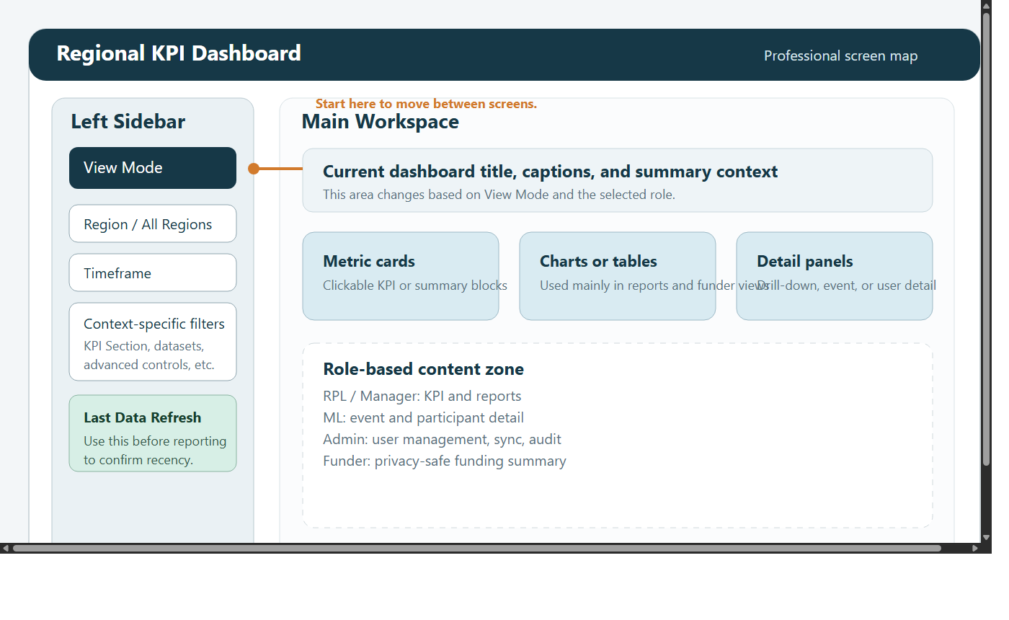

1. Purpose
This document is the master guide for the Regional KPI Dashboard. Use it when:

onboarding multiple user types
supporting staff across roles
checking which role should perform a task
needing one handbook instead of several short manuals

2. Dashboard areas
The application is organised into these views:

Admin Dashboard
KPI Dashboard
Custom Reports Dashboard
Case Studies
Funder Dashboard
ML Dashboard

Most users move between views using View Mode in the left sidebar.

3. Shared concepts

Region and timeframe
Most operational screens use:

region selection
timeframe selection

When investigating missing data, start broad, then narrow.

Drill-down
KPI cards can open a detailed popup showing the source rows behind a number.

Last Data Refresh
The sidebar includes a refresh status card showing how current the dashboard data is.

Audit logging
Major changes and important interactions are recorded for governance and support.

4. Role comparison
Role | Main views | Typical purpose | Key restrictions
`RPL` | KPI, Custom Reports, Case Studies | regional monitoring and self-service reporting | no Admin, no ML, no named attendee detail in KPI participant drill-down
`Manager` | KPI, Custom Reports, Case Studies, Funder, ML | operational management and validation | no Admin
`ML` | ML, Case Studies | event-by-event operational review | no KPI, reports, funder, or admin views
`Admin` | all views | access management, data operations, full reporting | highest responsibility, use admin actions carefully
`Funder` | Funder only | aggregated funding summary | no operational drill-down or personal data

5. Screen guide

KPI Dashboard
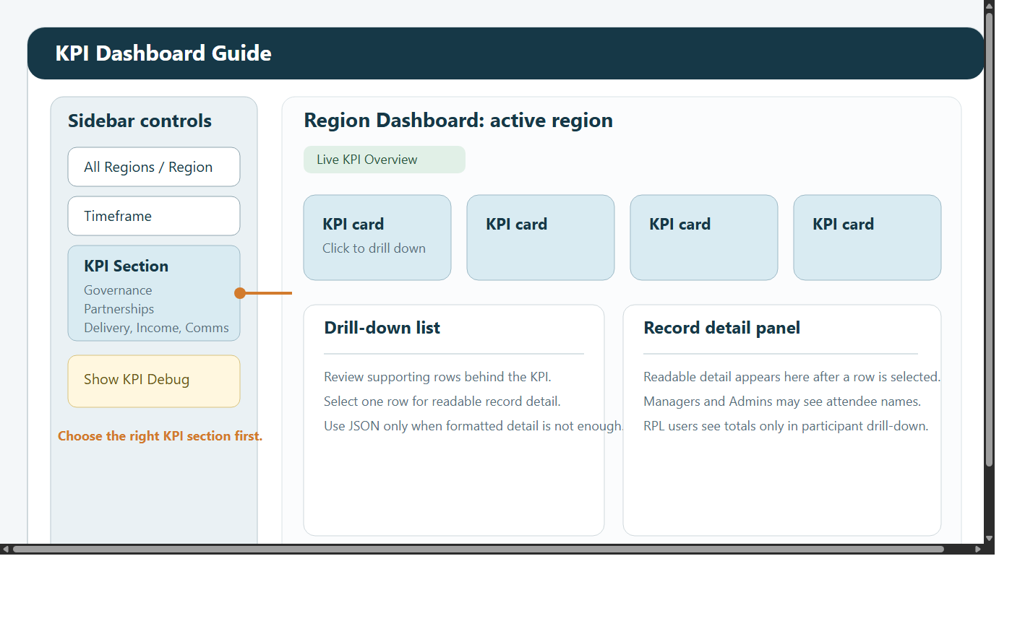

Best for:

headline KPIs
governance and delivery review
validating figures with drill-down

Custom Reports Dashboard
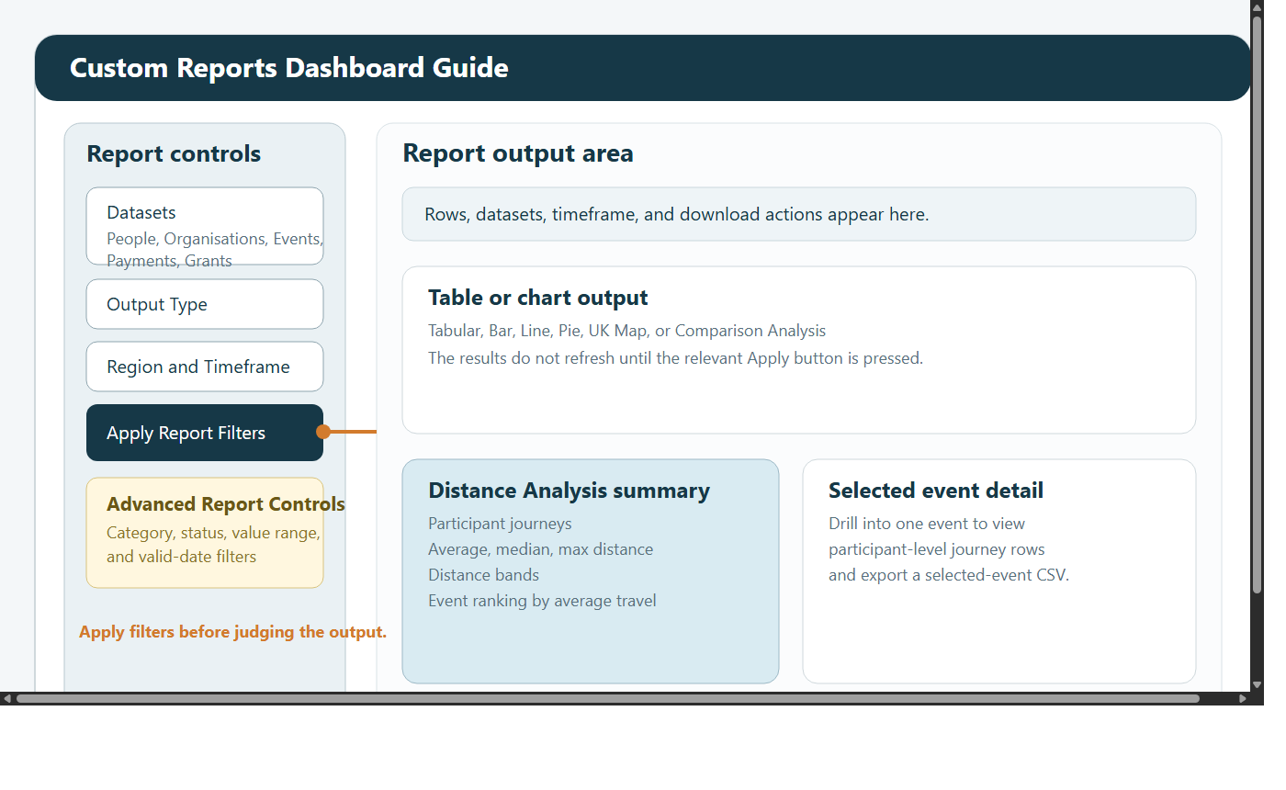

Best for:

tables and charts
advanced filtering
CSV export
distance analysis

ML Dashboard
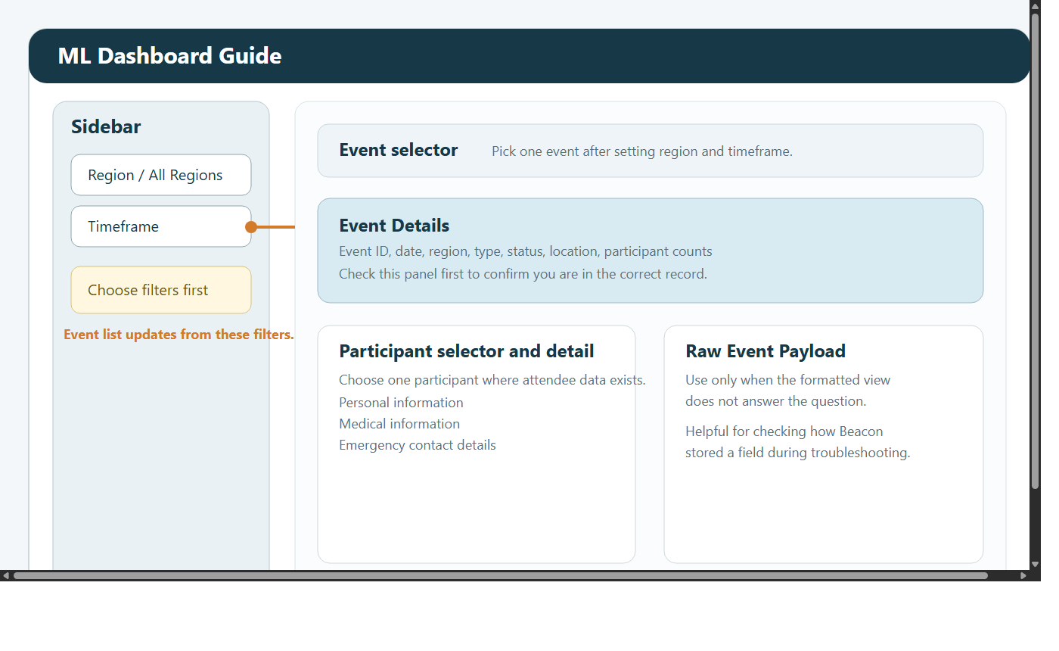

Best for:

selecting one event
reviewing attendees
checking medical and emergency information where available

Funder Dashboard
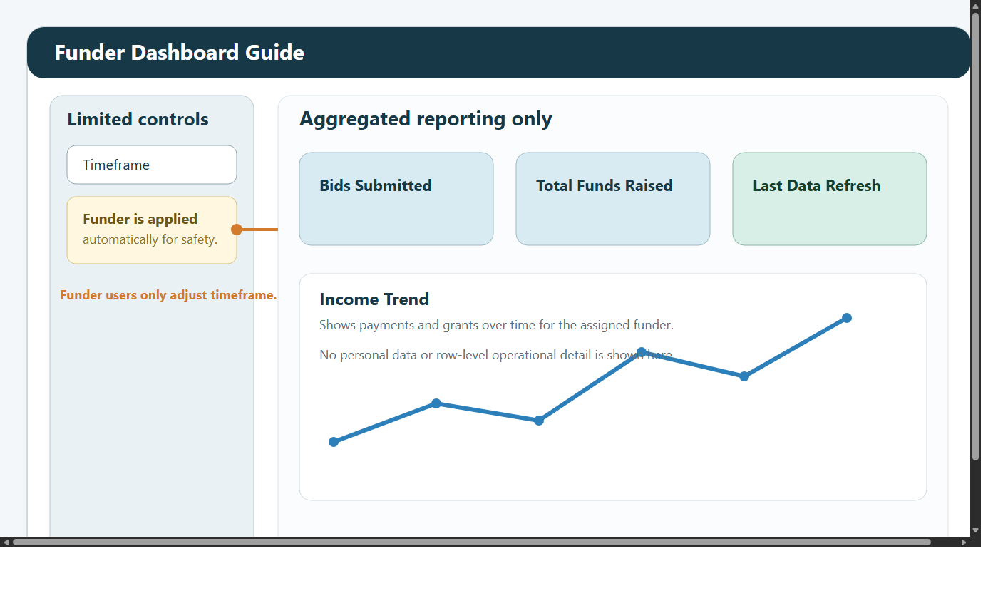

Best for:

GDPR-safe sponsor reporting
bids submitted
funds raised
income trend

Admin Dashboard
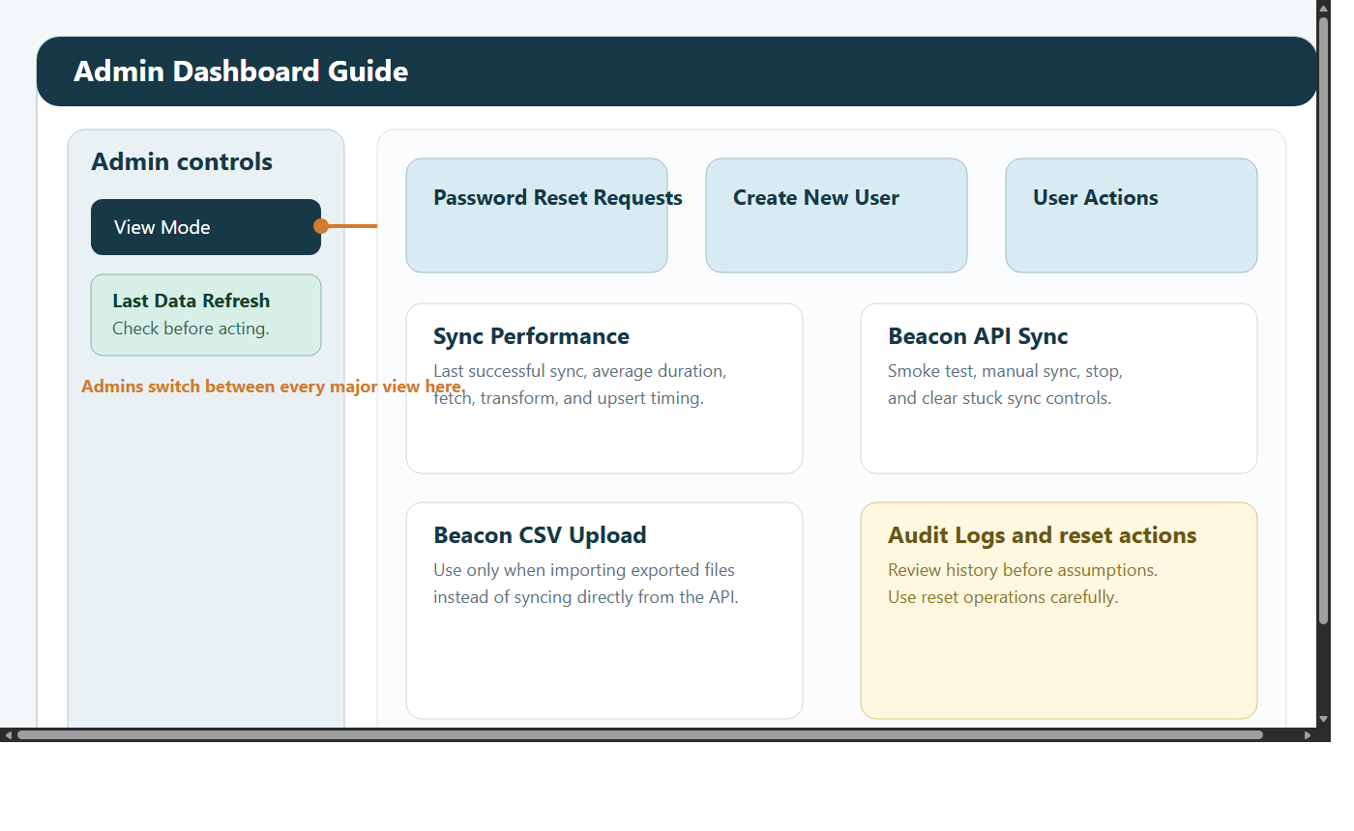

Best for:

user administration
password reset handling
sync monitoring and control
audit review

6. Role-by-role operating guide

RPL
Use RPL access for:

KPI monitoring
self-service reports
CSV export
case study uploads

RPL users should move from KPI to Custom Reports when they need more than a headline number.

Manager
Use Manager access for:

KPI validation
event and participant investigation
sponsor-facing review
broader operational analysis

Managers can see attendee names and IDs in KPI delivery drill-downs where the data exists.

ML
Use ML access for:

reviewing one event at a time
checking participant information before delivery
reading or adding case studies

Admin
Use Admin access for:

creating and updating users
resetting passwords
running sync checks and manual refresh activity
reviewing audit logs

Funder
Use Funder access for:

summary-level funding oversight
time-based review of bids and funds raised
checking refresh recency

7. Common workflows

Check a KPI
Open KPI Dashboard.
Set region and timeframe.
Choose the correct KPI section.
Click the KPI card to inspect supporting rows.

Run a report
Open Custom Reports Dashboard.
Choose datasets and output type.
Set region and timeframe.
Click Apply Report Filters.
Optionally use Advanced Report Controls.
Click Apply Advanced Filters.
Export CSV if required.

Investigate participant travel
Open Custom Reports Dashboard.
Set Output Type to Distance Analysis.
Keep Events selected.
Apply filters.
Drill down into a selected event.
Review or export the participant journey rows.

Review a live or recent event
Open ML Dashboard.
Set region and timeframe.
Choose the event.
Review event details and participant information.

Handle a password reset
Open Admin Dashboard.
Open Password Reset Requests.
Set a temporary password.
Tell the user to change it on next login.

8. Troubleshooting

No data appears
widen the timeframe
try All Regions where available
confirm you are in the correct dashboard view

Reports do not refresh
click Apply Report Filters
click Apply Advanced Filters

Participant names are missing
not every event provides names in Beacon
RPL users do not get named attendee detail in KPI participant drill-down

Dashboard looks stale
check Last Data Refresh
ask an Admin to review sync status if needed

Funder data looks empty
widen the timeframe
confirm the selected or assigned funder has matching records

9. File guide
Role manuals:

docs/manuals/RPL-MANUAL.md
docs/manuals/MANAGER-MANUAL.md
docs/manuals/ML-MANUAL.md
docs/manuals/ADMIN-MANUAL.md
docs/manuals/FUNDER-MANUAL.md

Shared visuals:

docs/manuals/images/dashboard-navigation.svg
docs/manuals/images/kpi-dashboard-guide.svg
docs/manuals/images/custom-reports-guide.svg
docs/manuals/images/ml-dashboard-guide.svg
docs/manuals/images/funder-dashboard-guide.svg
docs/manuals/images/admin-dashboard-guide.svg

