Funder Dashboard Manual

Audience: Funder users
Scope: privacy-safe, aggregated funding and delivery summary information

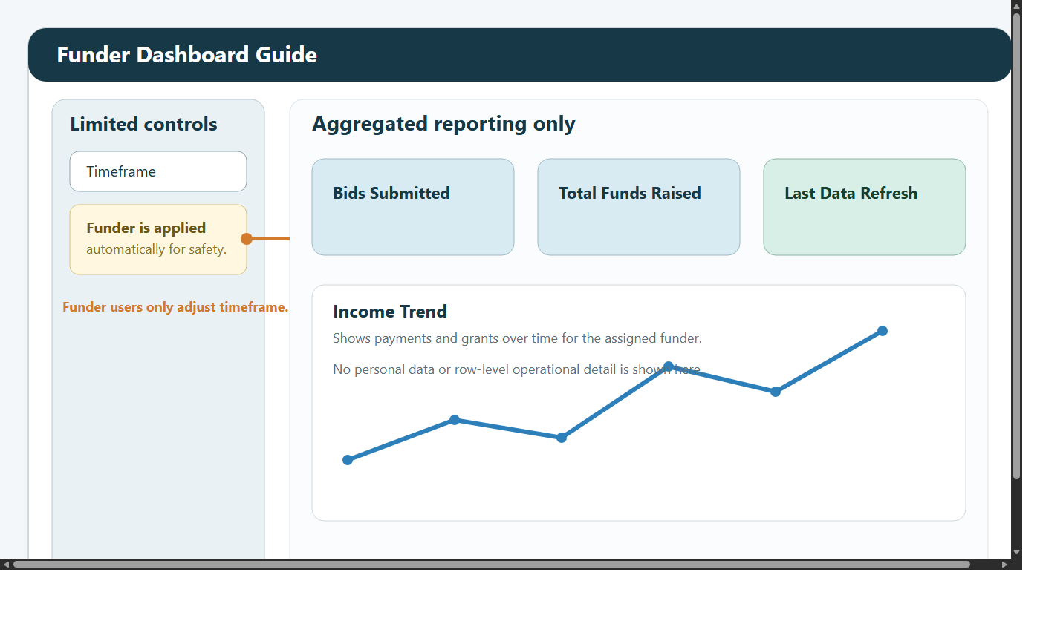

1. Role overview
The Funder Dashboard is designed for external or restricted users who need a concise, GDPR-safe reporting view.

Available view:

Funder Dashboard

Funder users cannot access:

Admin Dashboard
KPI Dashboard
Custom Reports Dashboard
ML Dashboard
row-level operational drill-down

2. What this dashboard is for
The screen is intended to answer high-level questions such as:

how many bids have been submitted
how much funding has been raised
what the income trend looks like over time
when the dashboard was last refreshed

Your assigned funder is applied automatically, so the page opens in a safe filtered state.

3. Signing in and getting started
Open the dashboard link.
Sign in with your email address and password.
Change your password if prompted.
Review the current timeframe and the Last Data Refresh timestamp before using the numbers in a meeting or report.

4. Privacy model
The Funder Dashboard is intentionally restricted.

It shows:

aggregated counts
aggregated funding totals
grouped charts and summaries

It does not show:

personal data
attendee-level records
named participants
raw operational drill-down rows

If you need a deeper pack, request it from the organisation rather than expecting it from the Funder view.

5. Filters
Available controls are intentionally limited.

As a Funder user:

region is fixed to Global
your assigned funder is already applied
you can change the timeframe

Typical timeframe options:

All Time
Year
Quarter
Month
Custom Range

6. Reading the dashboard

Headline metrics
The top-level cards show:

Bids Submitted
Total Funds Raised

These update with the selected timeframe and your assigned funder.

Income trend
The Income Trend chart summarises how funding has moved over time.

It combines:

payments
grants

Use it to identify whether activity is:

steady
seasonal
concentrated in particular periods

Last Data Refresh
Use the refresh timestamp to check whether the figures are current enough for your purpose.

If the timestamp appears too old, ask the dashboard administrator before relying on the numbers.

7. Typical funder tasks

Prepare for a review meeting
Open the dashboard.
Set the timeframe for the reporting period.
Review Bids Submitted, Total Funds Raised, and the Income Trend.
Note the Last Data Refresh timestamp.

Compare current activity with a wider period
Start with All Time.
Review the overall trend.
Narrow to Year, Quarter, or Month.
Compare how the headline cards change.

8. What funder users cannot do
Funder users cannot:

switch to the other dashboards
inspect personal records
access participant detail
run custom reports
manage users or sync operations

These limits are intentional and support privacy-safe external reporting.

9. Troubleshooting

I see no data
widen the timeframe first
confirm your assigned funder has grant or payment records in the selected period

The figures look out of date
check Last Data Refresh
contact the dashboard administrator if the timestamp is older than expected

I need participant-level evidence
that is not available in the Funder role
request a managed report from the organisation instead

