Manager Dashboard Manual

Audience: Manager users
Scope: operational reporting, KPI validation, event review, funder conversations, and case study evidence

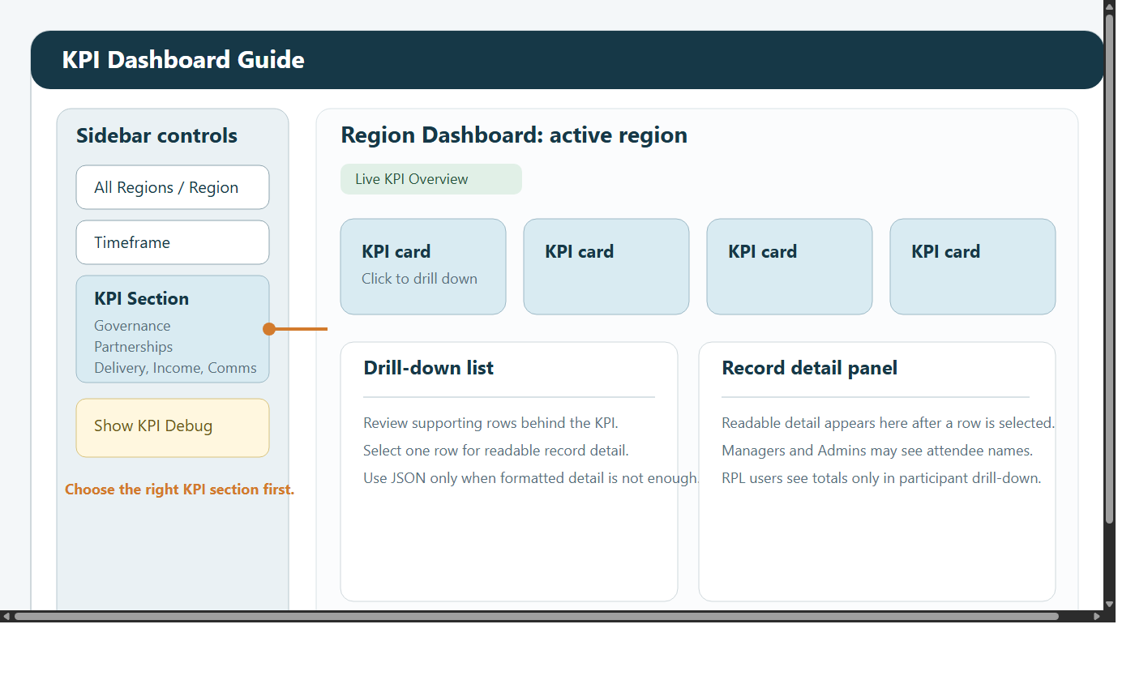

1. Role overview
Managers have broad operational access across the reporting and delivery views.

Available views:

KPI Dashboard
Custom Reports Dashboard
Case Studies
Funder Dashboard
ML Dashboard

Managers cannot access:

Admin Dashboard

2. Quick start
Sign in and change your password if prompted.
Use View Mode in the sidebar to switch between screens.
Check Last Data Refresh before relying on figures for external reporting.
Start with KPI for summary, then move to reports or ML view when you need detail.

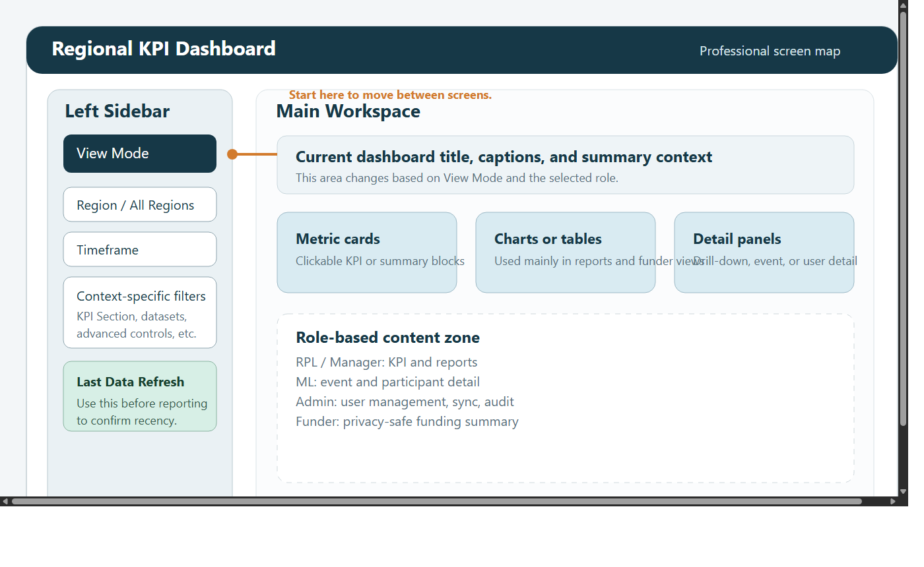

3. Shared filters and navigation
Across most manager workflows you will use:

View Mode
region filters
timeframe filters

Typical timeframes:

All Time
Year
Quarter
Month
Week
Custom Range

Use a wide range first when investigating missing data, then narrow once you know the records are present.

4. KPI Dashboard
The KPI screen is the main operational summary view for managers.

4.1 KPI sections
Use the section selector to move between:

Governance
Partnerships
Delivery
Income when region is Global
Comms when region is Global
Case Studies

4.2 Drill-down behaviour
Managers can click KPI cards and inspect supporting rows in detail.

In Delivery > Total Participants, managers can see:

attendee names where available
attendee IDs where available
placeholder entries when only participant counts exist

This makes the manager role suitable for reconciling participant totals or validating delivery evidence.

4.3 KPI Debug
Managers can turn on Show KPI Debug from the sidebar.

Debug mode exposes validation counters such as:

people in region
volunteers
steering volunteers
events in region
walk events
participants
grants in region
bids submitted

Use it when a headline figure looks wrong and you want to confirm whether the underlying dataset is the issue or the KPI logic is the issue.

5. Custom Reports Dashboard
The report builder is the best place for structured analysis and export.

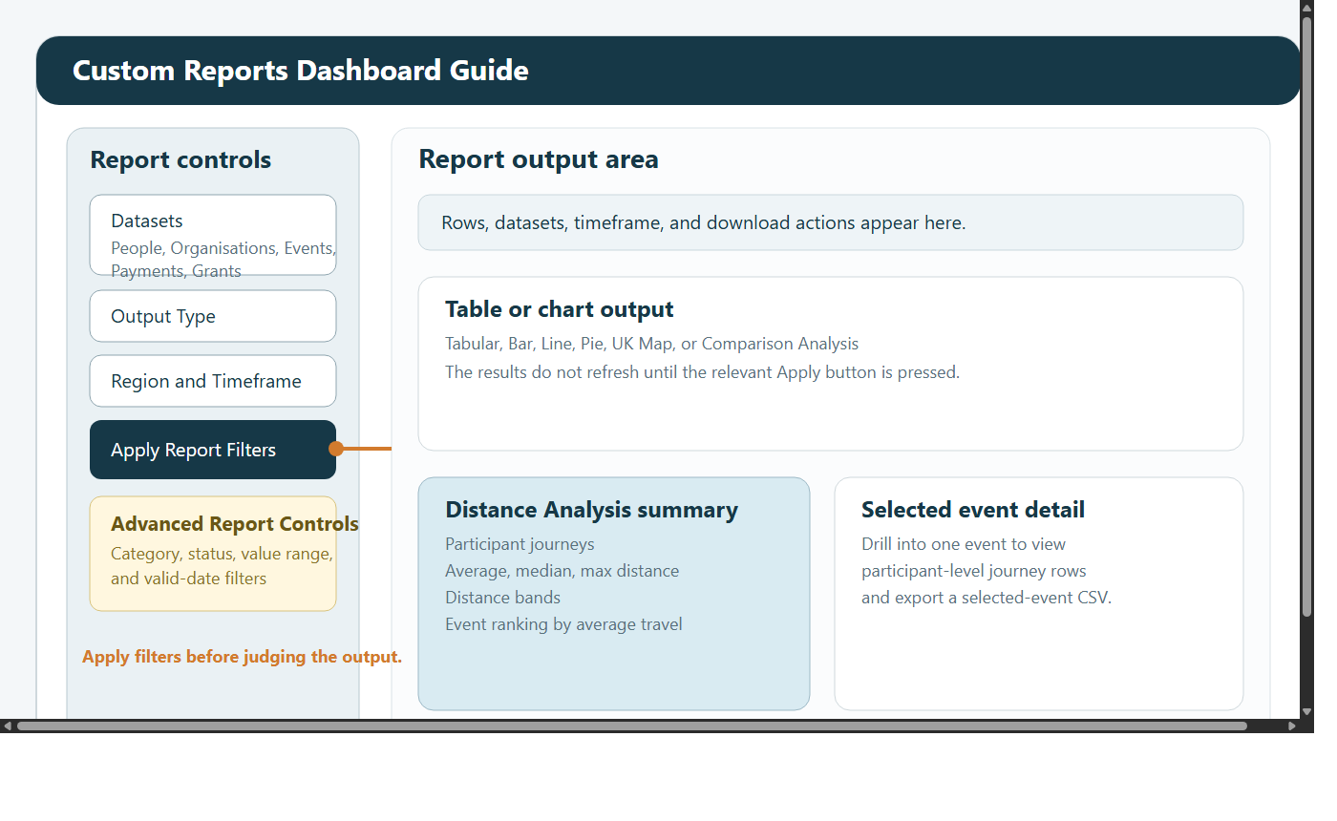

5.1 Standard workflow
Choose the relevant datasets.
Select the output type.
Set region and timeframe.
Click Apply Report Filters.
Refine with Advanced Report Controls if needed.
Click Apply Advanced Filters.
Export the resulting CSV if required.

5.2 Strong use cases for managers
monthly and quarterly reporting packs
regional comparisons
grant and payment reviews
delivery trend reviews
evidence packs for leadership or trustees

5.3 Distance Analysis
Distance Analysis is especially useful for managers because it reveals reach and travel burden across delivery.

Use it to:

rank events by average participant travel
inspect the participant-level journey rows for one event
export a selected event or the full dataset

If the output is empty, review postcode quality and whether resolved distance filtering is excluding rows.

6. ML Dashboard
Managers can use the ML screen for event-level operational detail without needing Admin permissions.

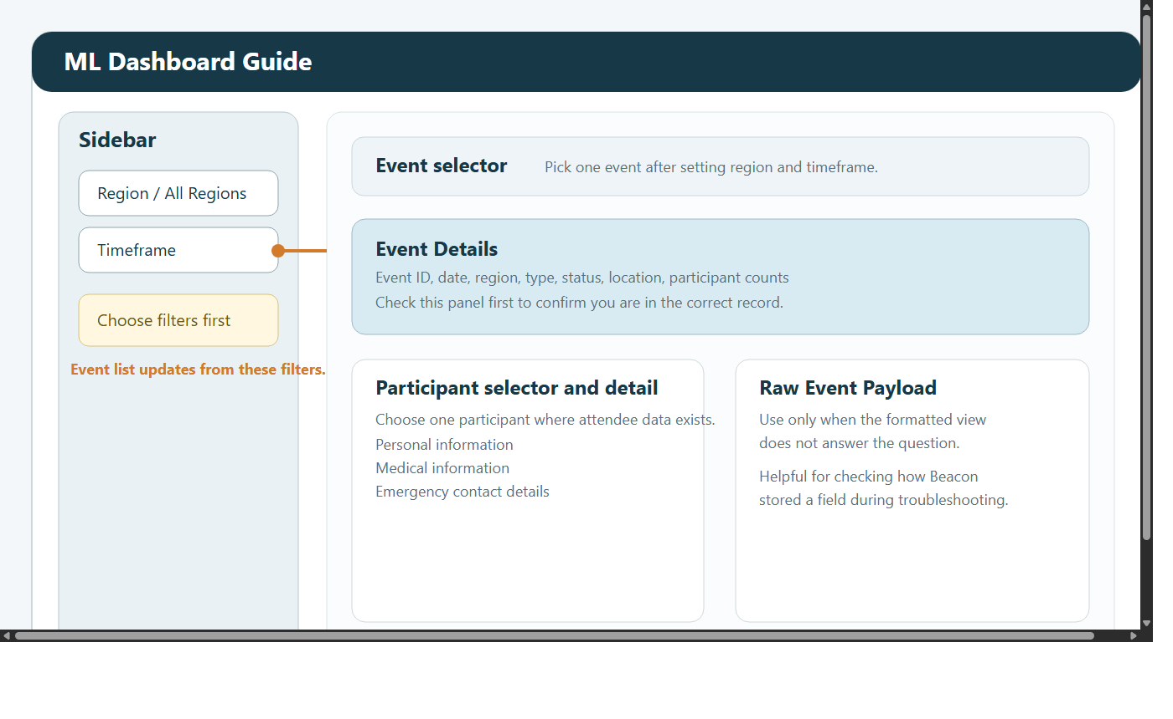

Recommended workflow:

Set the region and timeframe.
Choose the relevant event.
Review the event details panel.
Select a participant if attendee data exists.
Review personal, medical, and emergency fields carefully.
Use the raw event payload only when deeper investigation is needed.

Use this screen when:

an event record needs checking
attendee detail needs validating
support staff ask for confirmation of what Beacon supplied

7. Funder Dashboard
Managers can open the Funder Dashboard and choose a funder from the selector.

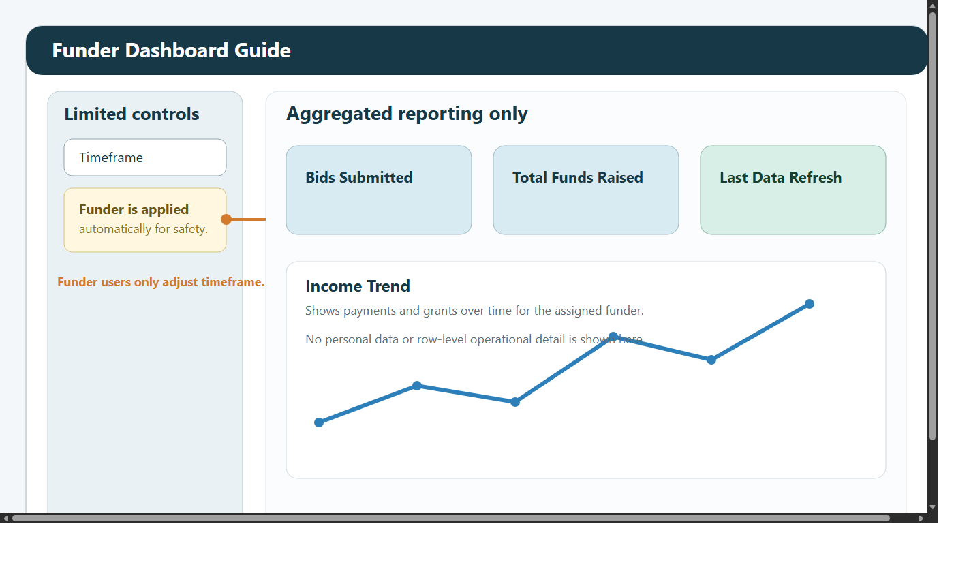

Use it for:

sponsor update meetings
checking funding trends
reviewing bid totals and funds raised
quality-assuring what a funder-facing user will see

Important interpretation note:

funder-related financial measures follow the selected funder
wider operational figures remain region and timeframe based

8. Case Studies
Managers can read, filter, and upload case studies.

This is useful when you need a narrative example to sit alongside KPI or report data.

Suggested use:

add case studies after notable delivery
tag the right region and date
keep titles descriptive so other staff can find them later

9. Recommended operating pattern
Start in KPI for the headline view.
Use Show KPI Debug if a number needs validating.
Move to Custom Reports for structured analysis or export.
Move to ML Dashboard when the question is event-specific.
Use Funder Dashboard for sponsor-facing summaries.

10. Troubleshooting

A KPI number looks wrong
switch on Show KPI Debug
narrow the timeframe
drill into the KPI card to inspect the source rows

The report did not refresh
click Apply Report Filters
click Apply Advanced Filters if advanced controls changed

No attendee detail is visible
some events only contain counts or partial attendee detail
names and IDs depend on the source Beacon payload

The Funder Dashboard looks empty
try All Time
change the selected funder
confirm the selected funder appears in grants or payments

