Mountain Leader Dashboard Manual

Audience: ML users
Scope: event-by-event review, participant detail checks, and case study capture

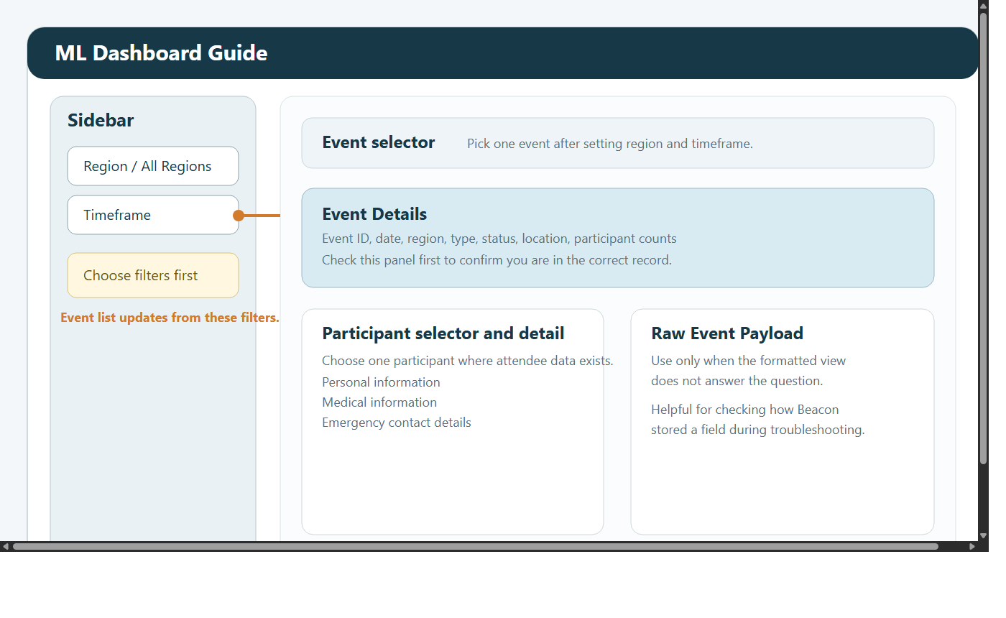

1. Role overview
Mountain Leaders mainly use the dashboard for delivery support rather than broad management reporting.

Available views:

ML Dashboard
Case Studies

ML users cannot access:

Admin Dashboard
KPI Dashboard
Custom Reports Dashboard
Funder Dashboard

2. Quick start
Sign in with your dashboard account.
Use View Mode to switch between ML Dashboard and Case Studies.
Choose the correct region and timeframe before selecting an event.
Review the event panel first, then the participant details.

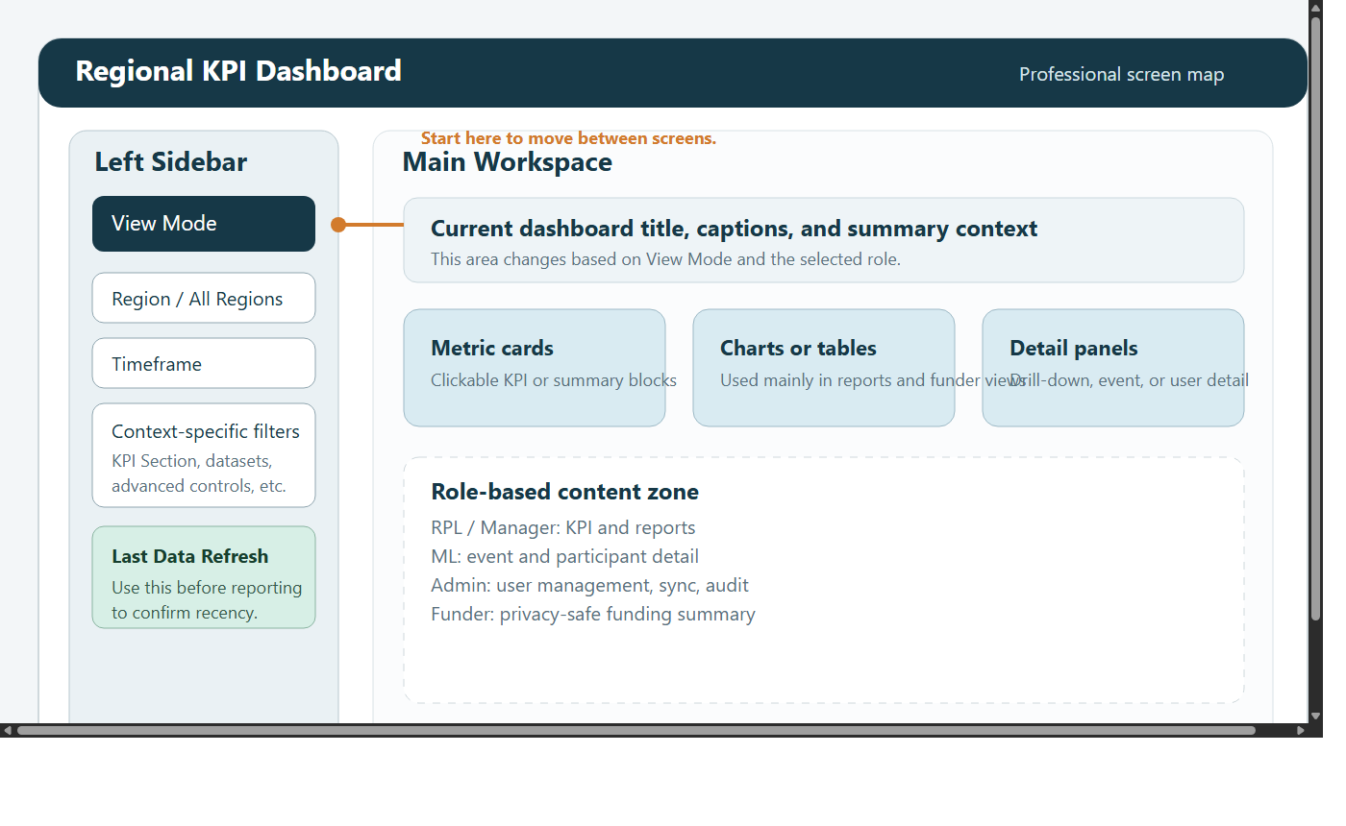

3. ML Dashboard purpose
The ML Dashboard is designed to help you work on one event at a time.

It supports:

confirming you are looking at the correct event
checking event information before delivery
reviewing participant details where available
surfacing medical and emergency fields when Beacon supplies them
checking the raw source payload during troubleshooting

4. Filters and event selection
Use the sidebar to set:

All Regions or a specific region
timeframe

Then use the Event selector on the page to choose the event you need.

If the event list is empty:

widen the timeframe
switch to All Regions
confirm the event has synced from Beacon

5. Event Details panel
Once an event is selected, the dashboard shows an Event Details area.

Typical fields include:

event ID
event name
date
region
event type
participant count
location
status
description

Always check this panel first to confirm you are working in the right record.

6. Participant selection and detail
If attendee detail is available, the dashboard provides a participant chooser.

Typical workflow:

Select the event.
Open the participant selector.
Choose one participant at a time.
Review the available fields carefully.

Possible detail sections:

Personal Information
Medical Information
Emergency Contact Details
Participant Record

Not every attendee will have every field. Blank or missing sections usually mean Beacon did not provide that value.

7. Event-level medical and emergency information
Below the participant-level sections, the dashboard may also surface event-level medical or emergency fields extracted from the event payload.

Use these as an operational prompt, not as a substitute for normal safety procedures.

8. Raw Event Payload
The Raw Event Payload expander is for deeper checking.

Use it when:

a value appears to be missing from the formatted sections
support staff ask how Beacon stored a field
you need to confirm exactly what synced into the app

Only use this section when needed. The formatted view is easier to read for day-to-day work.

9. Case Studies
ML users can also read and upload case studies.

This is useful after delivery when you want to capture:

participant feedback
outcome stories
short event reflections

Suggested upload steps:

Open Case Studies.
Check whether the story already exists.
Add a descriptive title.
Paste the story text.
Choose the correct date and region.
Submit.

10. Good working practice
set the correct date range before selecting an event
confirm the event details panel before reviewing participants
treat medical and emergency information carefully and only for operational need
report missing attendee data to Managers or Admins when the source record should contain it

11. Troubleshooting

No events are showing
widen the timeframe
choose All Regions
confirm the event exists in Beacon and has synced

No participant names are shown
some events only sync counts or limited attendee data
this depends on the Beacon source structure

Medical or emergency sections are blank
the source record may not contain those fields
not all events or attendees include those values in Beacon

The selected event looks wrong
check the event date in the selector
adjust the region and timeframe filters
reselect the event after changing filters

