RPL Dashboard Manual

Audience: Regional Programme Leads (RPL)
Scope: KPI monitoring, self-service reporting, exports, and case study management

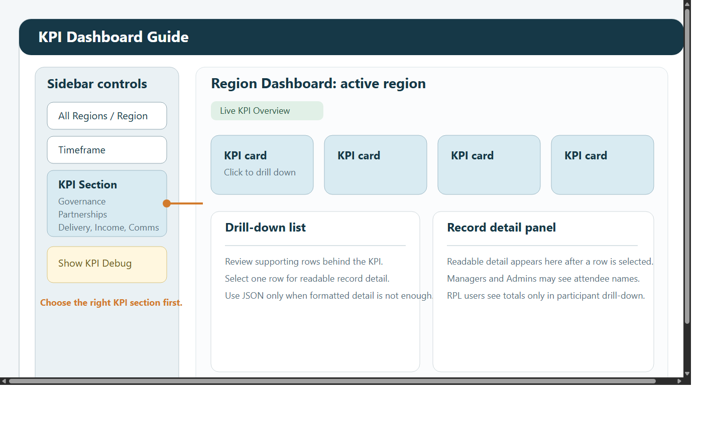

1. What this manual covers
RPL users use the dashboard to monitor delivery, review trends, validate headline numbers, and prepare evidence for internal reporting.

RPL access includes:

KPI Dashboard
Custom Reports Dashboard
Case Studies

RPL users cannot access:

Admin Dashboard
ML Dashboard
named attendee details inside KPI event drill-downs

2. Quick start
Sign in with your email address and password.
Use View Mode in the left sidebar to choose the screen you need.
Start with All Regions and a broad timeframe if you are not sure where data sits.
Narrow the filters once you confirm the records are present.

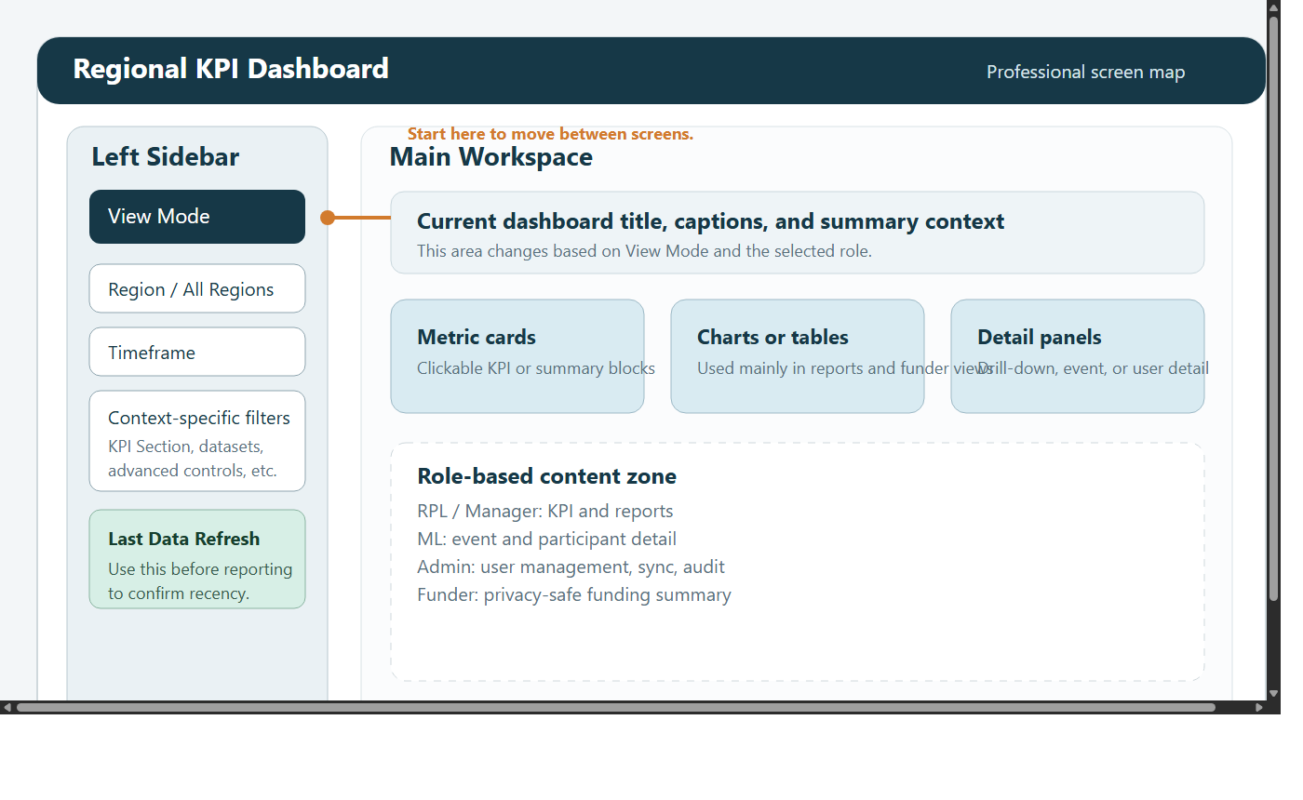

3. Shared filters and navigation
Most RPL tasks begin in the left sidebar.

Main controls:

View Mode
All Regions or a specific region
Timeframe
KPI Section on the KPI screen

Typical timeframe options:

All Time
Year
Quarter
Month
Week
Custom Range

Best practice:

start broad
confirm the data is present
then narrow to the reporting period you need

4. KPI Dashboard
The KPI Dashboard is the fastest way to review headline figures.

4.1 Screen tour
Use KPI Section to move between:

Governance
Partnerships
Delivery
Income when region is Global
Comms when region is Global
Case Studies

The page title shows the active region. KPI cards update from the chosen filters.

4.2 What each section is for
Governance

steering group and volunteer-related metrics
useful for oversight and governance reporting

Partnerships

active organisations and partnership-related counts
useful for regional relationship tracking

Delivery

events delivered
total participants
aggregated demographics and other delivery measures

Income

available only when the region is Global
funding totals, bids submitted, partner-related measures

Comms

available only when the region is Global
communications-related summary measures

Case Studies

qualitative evidence alongside KPI reporting

4.3 Drill-down and validation
Click any KPI card to inspect the source records behind the number.

Typical flow:

Click the KPI card.
Review the list of supporting rows.
Select a row to inspect it in readable detail.
Open Technical View (JSON) only if you need the raw structure.

Use drill-down when:

a KPI looks unexpectedly high or low
you need confidence before sharing a figure
a stakeholder asks which records are included

4.4 Important RPL privacy limit
In Delivery > Total Participants, RPL users can review totals but not named attendee details or IDs.

This is intentional. If participant-level operational detail is required, ask a Manager or Admin to review it in the appropriate view.

5. Custom Reports Dashboard
The Custom Reports screen is the main self-service analysis workspace for RPL users.

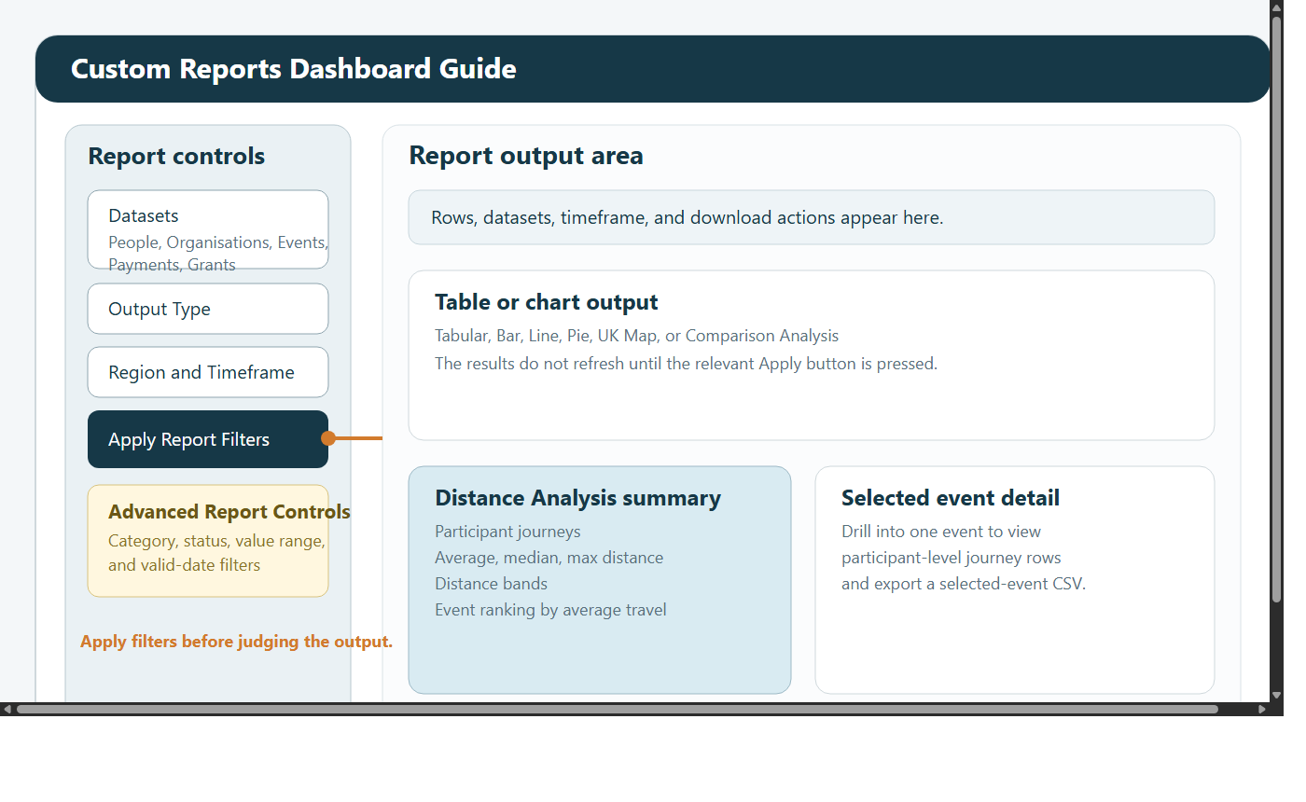

5.1 What you can do
combine datasets
build tables and charts
narrow by date and region
apply advanced filters
download CSV files for offline analysis

5.2 Datasets
Available datasets:

People
Organisations
Events
Payments
Grants

5.3 Output types
Available outputs:

Tabular
Bar
Line
Pie
UK Map
Comparison Analysis
Distance Analysis

5.4 Standard report workflow
Choose one or more datasets.
Select an output type.
Set region and timeframe.
Click Apply Report Filters.
Open Advanced Report Controls if you need extra filtering.
Click Apply Advanced Filters.
Review the results and export if needed.

If you change a filter and the report does not move immediately, that is expected until the relevant Apply button is clicked.

5.5 Advanced filtering
Advanced controls can be used to limit the result set by:

dataset
category
status
metric value range
rows with valid dates only

This is useful for tidying large mixed reports before export.

5.6 Distance Analysis
Distance Analysis estimates participant travel from home postcode to the event location.

It can show:

participant journey count
average, median, and maximum distance
distance bands
events ranked by average travel distance
participant-level journey rows

Recommended workflow:

Set Output Type to Distance Analysis.
Keep Events selected in the dataset filter.
Click Apply Report Filters.
Limit to event types if needed.
Decide whether to keep Only include rows with resolved distance turned on.
Use Drill down into event to inspect one event in detail.
Download the selected-event or full CSV when needed.

Important notes:

road distance is used when routing is configured
otherwise the report falls back to straight-line miles
missing participant or event postcode data will reduce the available rows

6. Case Studies
Case Studies adds qualitative evidence to the numbers.

Use it to:

read regional stories and testimonials
filter by date and region
upload a new case study for future reporting

Suggested workflow for uploads:

Open Case Studies.
Choose Upload New Case Study.
Add a clear title.
Paste the story or testimonial.
Enter the correct date.
Assign the correct region.
Submit and review the saved result.

7. Typical RPL tasks

Check a KPI before a meeting
Open KPI Dashboard.
Choose the right section.
Set the region and timeframe.
Click the KPI card to validate the supporting rows.

Prepare a CSV for offline analysis
Open Custom Reports Dashboard.
Choose the relevant dataset and output type.
Apply filters.
Refine with advanced controls if required.
Click Download Report CSV.

Add a case study to support a monthly update
Open Case Studies.
Filter first to avoid duplicating an existing story.
Upload the new case study with a clear title and date.

8. Troubleshooting

I see no KPI data
check region and timeframe first
try All Regions and All Time
confirm you are on the correct KPI section

The report looks unchanged
click Apply Report Filters
click Apply Advanced Filters if you changed advanced controls

Distance Analysis shows no rows
confirm Events is included as a dataset
widen the date range
try clearing Only include rows with resolved distance

I cannot see participant names
that is expected for the RPL role in KPI drill-downs

9. Good working practice
use KPI cards for fast monitoring
use Custom Reports when you need evidence, export, or charting
validate unusual numbers with drill-down before circulating them
pair a quantitative report with a case study where possible

