YouTube Finfluencers and Stock Returns
Do transcript-supported recommendations contain tradable creator-skill alpha, or do they mostly relay public attention?
FIN 496 Capstone
Frozen repository commit: 5a81aa3e497a358fa9e154ee67b146510e325f40
Generated: 2026-05-19

Abstract
YouTube finance channels now distribute equity narratives to audiences that rival traditional market commentary, yet the empirical question is narrower than whether creators are popular: do transcript-supported recommendations earn abnormal returns after realistic timing, market benchmarks, public-information overlap, and institutional context are considered? I study the frozen v2 FIN 496 sample at commit `5a81aa3e497a358fa9e154ee67b146510e325f40`: 9,992 transcript-video rows, 12,083 candidate windows, and 2,341 accepted recommendation events across 35 creators and 24 tickers. Return matching is available for 2,322 1-day events and 2,299 5-day events. The design computes SPY-adjusted abnormal returns, BHARs, CARs, factor-adjusted event alphas, calendar-time HAC regressions, news and analyst confound screens, Bloomberg validation variables, matched controls, placebo tests, and a targeted audit of extreme return events. The headline result is negative for broad alpha. The mean 1-day abnormal return is -0.002%, and the mean 5-day abnormal return is 0.056%; both are statistically indistinguishable from zero. Heterogeneity is more informative than the average: top-5 ticker events earn a 0.441% 5-day SPY-adjusted BHAR, while non-top events earn -0.471%. Bloomberg coverage shows that many recommendations occur in information-rich stocks: analyst coverage count and analyst consensus are available for 2,326 of 2,341 events, news and liquidity proxies for 2,328 events, and short-interest proxies for 1,064 events. The largest-move audit is especially restrictive. Among 75 unique events selected from the largest positive and negative 1-day and 5-day abnormal returns, 56 are official-confounded, 15 media-confounded, 2 Bloomberg-news-flow-high, 2 market-attention-high, and 0 candidate-clean. The evidence supports an attention-amplification and consensus-relay interpretation, not a public-news-clean, tradable creator-skill alpha claim.

1. Introduction
Retail investors increasingly encounter equity analysis through video feeds rather than sell-side notes, brokerage research portals, or financial television. A creator can publish a twenty-minute thesis on Nvidia, Tesla, or a smaller growth stock and reach viewers before many of them have read an earnings release. That distribution channel matters for finance because attention is scarce. When many investors are exposed to the same ticker narrative at roughly the same time, trading pressure can move prices even when the underlying information is already public. The central empirical problem is to separate that attention channel from stock-picking skill.
This project asks whether transcript-supported YouTube recommendations exhibit broad, tradable abnormal returns after accounting for event timing, market benchmarks, public information, analyst relay, and execution realism. The wording is intentional. A recommendation can coincide with a return without causing it. A creator may discuss a stock after earnings, after a filing, after a market move, or after analyst coverage has already shaped expectations. A return pattern can also be mechanically concentrated in popular mega-cap names. The paper therefore treats YouTube recommendations as dated information events and evaluates them with increasingly conservative filters rather than assuming that every return around the upload is attributable to the creator.
Event-study methods are well suited to this question because they measure security returns around a discrete date and compare them with a benchmark expectation [1,2]. Short horizons are the most defensible setting: the shorter the window, the less room there is for unrelated information to dominate the measured abnormal return [3]. The FIN 496 pipeline builds on that logic but adds controls tailored to social-media finance. It uses transcript evidence to define recommendation events, adjusts returns relative to SPY, tracks right-censoring at longer horizons, estimates factor-adjusted alphas, separates top-5 ticker salience from non-top names, screens for public-information confounds, validates institutional context with Bloomberg fields, and runs placebo and matched-control diagnostics.
The answer is not that YouTube has no market relevance. The data reject a stronger and more useful claim: the evidence does not support broad, tradable, public-news-clean creator-skill alpha. The full-sample 1-day and 5-day averages are near zero. Raw positive performance is concentrated in heavily followed top names, while non-top names are weaker. Once factor, placebo, news, analyst, and execution-realism layers are considered, the most credible interpretation is attention amplification, consensus relay, ticker selection, and public-information overlap. That conclusion matters for investors, regulators, and researchers. Investors should not treat creator recommendations as stand-alone alpha signals. Regulators should distinguish influence and attention from advice quality. Researchers should view finfluencer returns as an information-environment problem rather than a simple skill-ranking exercise.
Takeaway: the empirical object is not "Do creators matter?" but "Do dated transcript-supported recommendations produce abnormal returns that survive conservative controls?" In this frozen sample, the answer is no for broad tradable alpha and yes for economically meaningful heterogeneity.

2. Related Literature and Motivation
The first strand of literature is the event-study tradition. Fama, Fisher, Jensen, and Roll used stock splits to study the adjustment of prices to new information, establishing a template for measuring abnormal returns around identifiable corporate events [1]. MacKinlay formalized the event-study workflow, including event dates, estimation windows, benchmark models, and test statistics [2]. Kothari and Warner later emphasized the asymmetry between short-horizon and long-horizon event studies: short windows can be informative when the event date is sharp, while long horizons are vulnerable to model misspecification, cross-sectional dependence, survivorship, and overlapping-event problems [3]. This project follows that warning. It reports longer horizons because they are informative about persistence and reversal, but the central evidence comes from 1-day and 5-day windows and from robustness checks that make the long-run interpretation conservative.
The second strand is behavioral finance on limited attention. Barber and Odean show that individual investors tend to buy attention-grabbing stocks, including stocks in the news, stocks with high abnormal volume, and stocks with extreme returns [4]. Da, Engelberg, and Gao use search intensity as a direct proxy for investor attention and connect attention shocks to temporary buying pressure [5]. Those papers do not study YouTube creators directly, but they provide the economic mechanism that makes the FIN 496 setting interesting. A finfluencer recommendation can function as an attention event even when it contains no novel fundamental information. If the audience is disproportionately retail and attention-constrained, the channel can amplify demand for salient tickers.
The third strand studies media, online discussion, and social information. Tetlock links media pessimism to market outcomes, showing that public language can contain or transmit information relevant to prices [6]. Antweiler and Frank study stock message boards and find that online discussion contains signal but also substantial noise [7]. Chen, De, Hu, and Hwang show that social-media opinions can carry value-relevant information in some settings [8]. These papers motivate a skeptical but open design: online discussion may matter, yet the measured relationship can combine information, sentiment, selection, and investor attention. That mix is exactly why this paper layers public-news, analyst, and placebo diagnostics on top of baseline event returns.
The emerging finfluencer literature adds a fourth motivation. Recent working papers and legal scholarship emphasize that financial influencers can shape retail beliefs while operating outside the institutional safeguards that govern registered investment advice [9,10]. Industry and regulatory discussions by the CFA Institute and the SEC warn that social-media investment content may blur education, entertainment, promotion, and advice [11,12]. Those concerns do not imply that finfluencers generate alpha. They imply that the channel deserves empirical measurement with claim discipline. A popular creator can influence attention without producing a tradable signal, and a coincident return can reflect public news rather than creator insight.
This study contributes a transcript-based event design. The unit is not a creator's channel-level popularity or a video's title. It is an accepted recommendation event supported by local transcript language and mapped to a ticker and trading date. That design is narrower than a broad social-media sentiment study, but it is better suited to event-time finance because the recommendation date and direction are explicit. The repo also carries a reproducibility advantage: scripts, derived exports, tables, figures, and the source audit are all tied to the frozen commit [13].
Takeaway: the literature predicts that finfluencer content may amplify attention, especially around salient stocks, but it does not justify interpreting post-video returns as skill without public-information and benchmark controls.

3. Data and Sample Construction
The frozen v2 sample begins with 9,992 transcript-video rows and 12,083 candidate transcript windows. The accepted event panel contains 2,341 recommendation events from 1,153 distinct videos, 35 creators, and 24 tickers. The event sample is directional: 1,823 events are buy recommendations and 518 are sell recommendations. Return matching is high but not complete. The 1-day panel contains 2,322 matched events, while the 5-day panel contains 2,299 matched events. Table 1 reports the full construction funnel from transcript rows to event-study availability.
Table 1. Sample construction
Metric | Count
live_transcript_rows | 9,992
successful_transcript_rows | 9,977
candidate_windows | 12,083
accepted_recommendation_events | 2,341
distinct_event_videos | 1,153
buy_recommendations | 1,823
sell_recommendations | 518
creators | 35
tickers | 24
return_matched_1d | 2,322
return_matched_5d | 2,299
low_lookahead_events | 803
duplicate_collapsed_events | 1,710
top5_events | 1,362
non_top_events | 979

The primary observation is an accepted recommendation event. A single video can generate multiple events when it contains clear directional language for multiple tickers, and a single creator can appear many times across dates. That event-level unit is appropriate for an event study because the return window is tied to the ticker-date pair rather than the creator or video as a whole. It also creates dependence risks: events can overlap by ticker, creator, and date. Later sections address that through duplicate-collapsed samples, calendar-time portfolios, and placebo tests.
The sample is concentrated in recent years. Event counts rise from 20 in 2020 to 707 in 2025, with 559 events in 2026 through the frozen sample date. This time profile reflects the expansion of transcript coverage and creator sampling rather than a claim that the YouTube-finance ecosystem mechanically grew at the same rate. Figure 1 and Table 2 show the year distribution. The concentration matters because recent events are more likely to be right-censored at long horizons.
Table 2. Event counts by year
Year | Events
2020 | 20
2021 | 29
2022 | 91
2023 | 345
2024 | 590
2025 | 707
2026 | 559

Figure 1. Accepted events by year
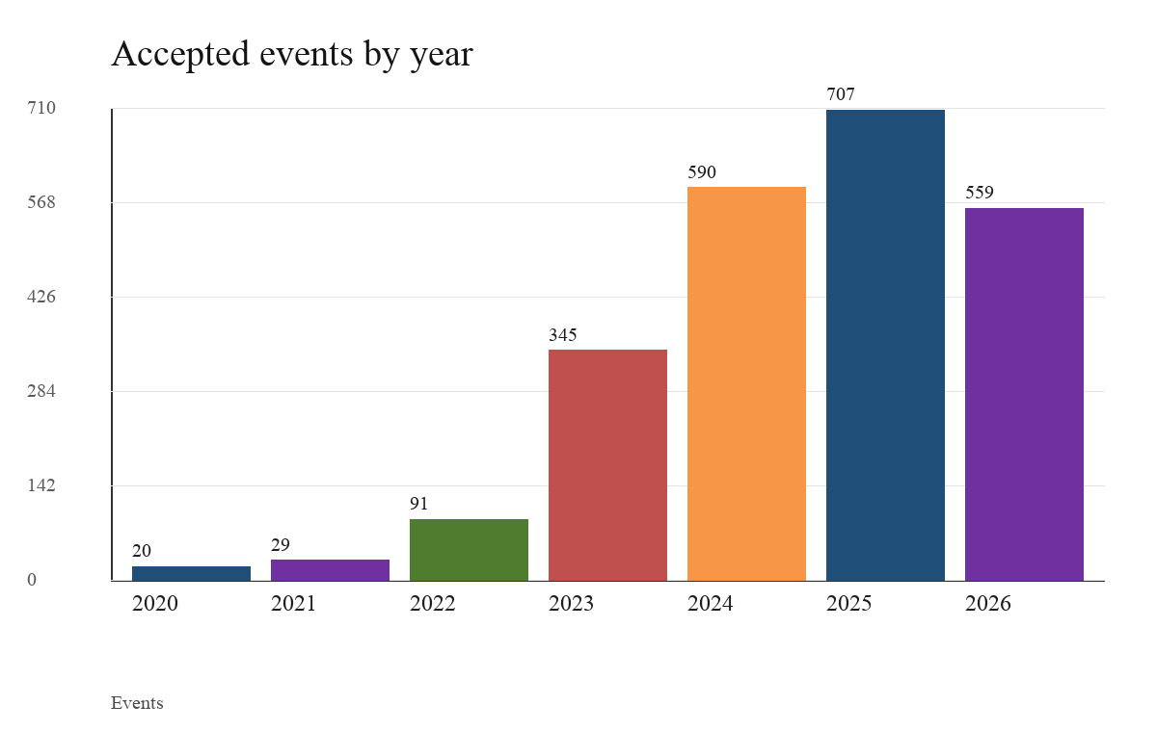

Buy recommendations dominate the panel, as shown in Table 3 and Figure 2. That imbalance is economically intuitive: creator content is often built around identifying opportunities rather than warning viewers away from stocks. It also means that a naive long-only interpretation would mostly reflect buy calls. Sell recommendations are retained because they test whether negative directional language contains different information, but the sell sample is smaller and should not be overinterpreted.
Table 3. Event counts by recommendation type
Type | Events
buy | 1823
sell | 518

Figure 2. Events by recommendation type
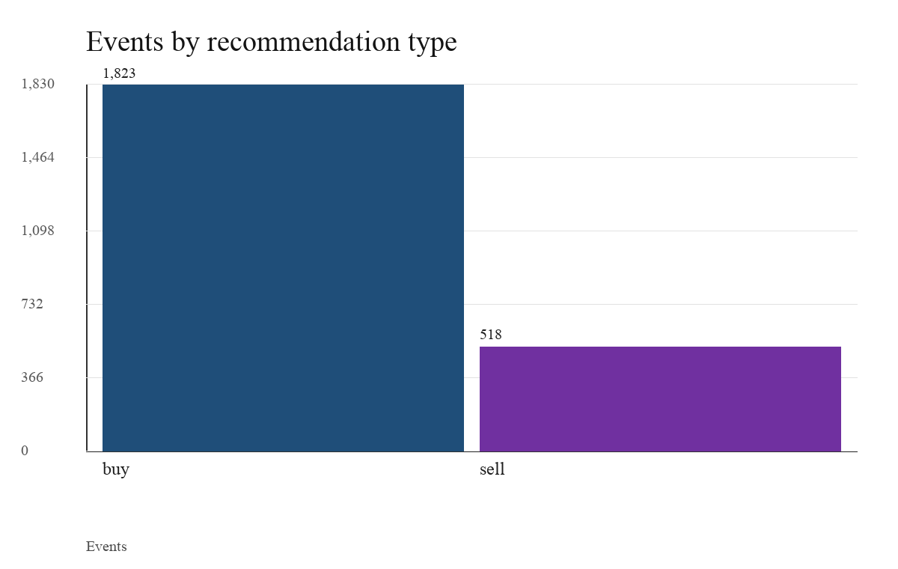

The sample is not a random draw of all U.S. equities. The top-5 ticker set, defined in the export as NVDA, TSLA, AAPL, AMD, and AMZN, accounts for 1,362 events; non-top tickers account for 979. That split is central because top-name recommendations are likely to be more liquid, more news-covered, more analyst-followed, and more attention-sensitive. A top-name return reaction could be audience amplification, but it could also be a market-wide AI theme, an earnings cycle, or institutional consensus moving through retail media.
Takeaway: the dataset is large enough for systematic event-time analysis, but its composition already points toward the central mechanism: recommendation events are clustered in salient, information-rich stocks rather than uniformly distributed across obscure names.

4. Recommendation Detection and Event Construction
The transcript pipeline exists because video metadata alone cannot identify the research object. A title such as "Stocks I Am Watching" may contain no recommendation, while a video with a generic title may include a clear statement such as "I am buying Nvidia" or "I would avoid PayPal." The repository therefore stores transcript evidence and applies deterministic parsing rules before an event enters the return panel. The relevant code lives mainly in `src/finfluencer_alpha/transcript_ingestion.py`, `src/finfluencer_alpha/transcript_classify.py`, `src/finfluencer_alpha/classify.py`, and the locked-sample construction scripts under `scripts/`.
Transcript ingestion preserves source and provenance. The repository documentation explains why the official YouTube captions API is not a scalable public transcript source for third-party videos and why provider labels must remain attached to transcript rows. The collection design routes through documented transcript providers and fallback methods, stores transcript status and source labels, and avoids committing raw transcript bodies. That matters for the paper because the event-study sample is based on accepted evidence snippets and metadata, not on unbounded raw text exported into the public repo.
Recommendation detection then operates locally around ticker mentions. In `src/finfluencer_alpha/transcript_classify.py`, transcript segments are loaded, ticker mentions are deduplicated, and `_window_for_mention` builds a local evidence window around the mention. `_focused_action_text` narrows the phrase to the clause or nearby words most relevant to the ticker. `_process_transcript_row` then calls `classify_text` from `src/finfluencer_alpha/classify.py` and accepts the candidate only if the focused text contains the ticker, the stance is bullish or bearish, the actionability score clears the threshold, the label is not news-only or retrospective, and the phrase is not negated. Accepted rows are inserted into `transcript_recommendation_events`; rejected windows remain in `transcript_candidate_windows` with exclusion reasons.
The resulting manifest, `locked_sample_v2/02_v2_event_manifest.csv`, carries the fields needed for event-time analysis: `event_id`, `video_id`, `creator`, `ticker`, `company_name`, `recommendation_type`, `event_date`, `effective_trading_event_date`, `upload_timing_bucket`, and `quality_score`. The quality distribution is concentrated in score 3, with smaller groups at scores 2, 4, and 5. Timing buckets distinguish before-open, during-market, after-close, and weekend-or-holiday uploads, which helps prevent look-ahead bias. In the baseline table, the low-lookahead slice contains the before-open and weekend-or-holiday events; it does not produce a broad positive abnormal-return result.
This classifier should be understood as a transparent proxy, not as proof of creator intent or executed trades. A transcript can misrecognize words, omit sarcasm, or lose context. A recommendation phrase can express education, entertainment, or personal positioning rather than an instruction to trade. The conservative response is not to discard the sample but to keep the claim narrow: these are transcript-supported recommendation events suitable for diagnostic event-study analysis.
Takeaway: the event definition is reproducible and auditable, but it is still a proxy. The paper therefore evaluates abnormal returns around transcript-supported statements, not verified creator trades or individualized investment advice.

5. Event-Study Design and Methodology
The baseline event study compares each recommended stock's return with the contemporaneous SPY return. Let `R_i,t` denote the stock return for event `i` on event-time day `t`, and let `R_m,t` denote the SPY benchmark return. The daily abnormal return is `AR_i,t = R_i,t - R_m,t`. The cumulative abnormal return over horizon `h` is `CAR_i(h) = sum_{t=1}^{h} AR_i,t`. The buy-and-hold abnormal return is `BHAR_i(h) = product_{t=1}^{h}(1 + R_i,t) - product_{t=1}^{h}(1 + R_m,t)`. CAR is additive and maps cleanly to daily abnormal-return aggregation; BHAR better matches the return to holding the recommended stock over the window. The paper reports both in the generated exports, with emphasis on SPY-adjusted BHAR for the main horizon comparisons.
The reported horizons are 1, 5, 21, 63, and 126 trading days. The 1-day and 5-day horizons are the cleanest tests of immediate event-time reaction. The 21-day horizon approximates a trading month and helps detect short-lived drift or reversal. The 63-day and 126-day horizons are more diagnostic because overlapping events, changing news, and right-censoring become more important. The coverage export records that 2,322 events have 1-day return support, 2,299 have full 5-day windows, and longer horizons lose full-window coverage as the sample approaches the freeze date.
Factor adjustment is a second layer of discipline. The factor scripts estimate expected returns using CAPM, Fama-French specifications, Carhart momentum, and an FF5 plus momentum model where factor data and estimation windows are available. Conceptually, the model is `R_i,t - R_f,t = alpha_i + beta_i'F_t + epsilon_i,t`, and event alpha is the realized stock return less the expected factor return over the post-event window. The relevant implementation is `scripts/build_v2_factor_adjusted_alpha.py`; calendar-time portfolios with Newey-West/HAC standard errors are built in `scripts/build_v2_calendar_time_factor_regressions.py`. These regressions matter because a creator who repeatedly discusses high-beta growth stocks can appear to generate abnormal returns in raw event time even when the pattern is compensation for systematic exposures.
The design also addresses timing and duplication. The `upload_timing_bucket` variable separates events that could have been observed before trading from those uploaded during or after the trading day. Duplicate collapsing uses creator-ticker-date clusters so repeated recommendations are not counted as independent discoveries. Top-5 and non-top ticker splits test whether results are concentrated in highly salient names. Buy and sell splits test whether direction matters. Calendar-time regressions aggregate overlapping positions into daily portfolios and use HAC errors to reduce the false precision that would come from treating every overlapping event as independent.
Public-information controls are the most important interpretive layer. The master news and confound exports combine official filing and earnings flags, media/news diagnostics, FNSPID media indicators, market-implied attention variables, and Bloomberg validation fields. The rule is conservative: unknown news coverage is unknown, not clean. A provider failure, quota limitation, missing key, or incomplete archive is never treated as evidence that no news existed. This choice reduces the size of any "clean" sample, but it prevents the paper from mistaking data absence for information absence.
Takeaway: the methodology does not claim causal identification. It asks whether the recommendation events retain abnormal returns after benchmark, factor, timing, duplication, public-information, and placebo checks. That diagnostic question is the appropriate one for a student capstone with frozen public exports.

6. Baseline Results
The full-sample baseline is close to zero. Table 4 reports that the accepted v2 events have a mean 1-day SPY-adjusted abnormal return of -0.002% with `t = -0.029` and `p = 0.976636`. The 5-day mean is 0.056% with `t = 0.431` and `p = 0.666561`; the 5-day median is negative and the win rate is 48.3%. These values do not support a broad short-window alpha claim. They are economically small and statistically indistinguishable from zero.
Table 4. Baseline SPY-adjusted abnormal returns
Spec | N1 | 1D | N5 | 5D | p5
all accepted events | 2322 | -0.00% | 2299 | 0.06% | 0.666561
top-5 tickers | 1362 | 0.30% | 1356 | 0.42% | 0.017462
non-top tickers | 960 | -0.44% | 943 | -0.47% | 0.008921
buy-only | 1808 | 0.13% | 1787 | 0.17% | 0.227842
sell-only | 514 | -0.45% | 512 | -0.35% | 0.244296

The baseline table also shows why the average alone is incomplete. Top-5 tickers have positive short-window abnormal returns, while non-top tickers are negative. In the baseline 5-day matched sample, top-5 events average 0.423% and non-top events average -0.473%. The longer-horizon BHAR export reports a closely related 5-day contrast of 0.441% for top-5 events and -0.471% for non-top events. Figure 3 visualizes the split through 63 trading days.
Figure 3. Top-5 vs non-top SPY-adjusted BHAR
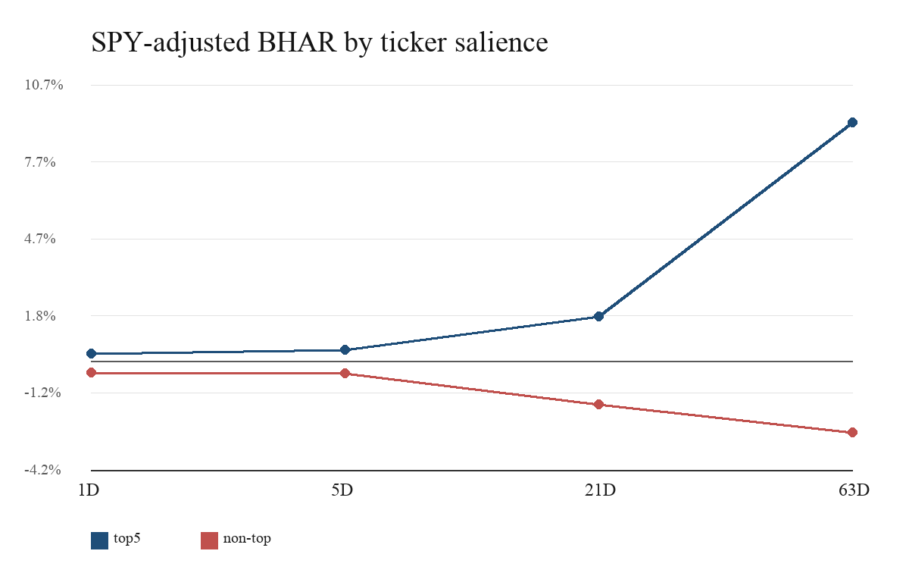

The economic interpretation is not that creators are skilled at selecting top stocks. Top names are more liquid, more institutionally covered, more likely to be discussed after public news, and more likely to attract retail attention. A positive return after a top-name recommendation may therefore reflect market-wide thematic momentum or attention amplification rather than creator-specific information. Conversely, negative non-top performance may reflect adverse selection into speculative or lower-quality names, weaker liquidity, or stale narratives. The return sign is informative, but it is not causal evidence.
Buy and sell splits reinforce the same caution. Buy-only events have a 5-day mean of 0.171%, with `p = 0.227842`. Sell-only events have a 5-day mean of -0.348%, with `p = 0.244296`. The signs line up with intuitive direction, but neither split provides statistically persuasive broad alpha in the short-window baseline. The low-lookahead and duplicate-collapsed checks also remain statistically weak. If a signal only appears in a subset that is also the most attention-exposed, the safer interpretation is mechanism heterogeneity rather than tradability.
Takeaway: the baseline event study rejects broad alpha but reveals a sharp top-name versus non-top contrast. That contrast becomes the organizing empirical fact for the rest of the paper.

7. Heterogeneity Results
Table 5 expands the top-5 versus non-top comparison across horizons. Top-5 events show positive SPY-adjusted BHARs from 1 day through 126 days, while non-top events are negative over the same reported horizons. At 21 days, top-5 events average 1.731%, while non-top events average -1.689%. At 63 days, the split widens to 9.271% for top-5 events and -2.777% for non-top events. These longer-window results should not be read as a clean strategy because the horizons are more exposed to censoring, overlapping events, and unrelated information. They do, however, show that ticker salience is not a minor nuisance variable.
Table 5. Top-5 vs non-top SPY-adjusted BHAR
Sample | H | N | Full | AR | t
top5 | 1D | 1362 | 1362 | 0.30% | 3.263
top5 | 5D | 1362 | 1356 | 0.44% | 2.481
top5 | 21D | 1362 | 1293 | 1.73% | 4.781
top5 | 63D | 1362 | 1183 | 9.27% | 13.452
top5 | 126D | 1362 | 1000 | 17.42% | 17.588
non_top | 1D | 960 | 960 | -0.44% | -3.113
non_top | 5D | 960 | 943 | -0.47% | -2.645
non_top | 21D | 960 | 880 | -1.69% | -4.295
non_top | 63D | 960 | 777 | -2.78% | -4.904
non_top | 126D | 960 | 592 | -4.27% | -5.14

Ticker-level summaries point in the same direction. The most frequent tickers are large, attention-rich names: NVDA has 391 events, TSLA 307, AMZN 246, GOOGL 240, AAPL 231, and MSFT 226. Their 5-day means differ materially. NVDA and GOOGL are positive in the ticker export, while MSFT is negative. That dispersion makes it hard to describe the sample as a uniform creator signal. The channel seems to sort attention toward a small set of familiar stocks, and the return outcome then depends on the stock's own information environment.
Creator-level heterogeneity is also visible but fragile. The creator summary contains 35 creators. The largest creator contributes 497 events, while the median creator has 24 events and the smallest creator has only 1. Some creators have positive 5-day means and others negative means, but small samples, ticker concentration, duplicate events, and selection into popular names make creator rankings unstable. A creator who discusses Nvidia during a strong AI momentum period can look skilled ex post; a creator who discusses payments or smaller growth names during weak periods can look poor. The design cannot separate creator ability from ticker selection with causal certainty.
The more useful interpretation is attention amplification and consensus relay. Attention amplification means that a video can increase retail focus on an already salient stock, potentially creating short-lived demand pressure. Consensus relay means that the creator may be repackaging public narratives from earnings calls, analyst commentary, market momentum, or news coverage. Neither mechanism requires the creator to possess private information. Both mechanisms predict stronger effects in widely followed tickers than in obscure ones, and both are consistent with the top-5 concentration observed here.
Takeaway: heterogeneity is real, but it does not rescue a skill claim. It shows that the return pattern is conditional on ticker salience, public narratives, and sample composition.

8. Bloomberg Validation and Information Environment
The Bloomberg validation layer adds institutional context to the event panel. `scripts/ingest_bloomberg_validation_workbook.py` parses the manually supplied Bloomberg validation workbook and appends the supplemental analyst coverage field `TOT_ANALYST_REC` when the standalone analyst workbook is detected. The parsed analyst coverage sheet is `Sheet1`; the source field is `TOT_ANALYST_REC`; the source panel contains 13,491 observations, 13,035 valid observations, and dates from 2018-01-05 to 2026-05-15. These rows are not raw data ingested for new analysis in this manuscript; they are committed derived validation outputs already frozen in the repository.
Table 8 reports event-level availability. Analyst consensus and analyst coverage count are each available for 2,326 of 2,341 events. Earnings estimates are available for 2,332 events. News proxies and liquidity proxies are available for 2,328 events. Short-interest proxies are available for 1,064 events. Event total return availability covers 2,328 events. Figure 4 shows that most institutional-context fields have near-complete coverage, while short-interest fields are much thinner.
Table 8. Bloomberg event-level coverage
Feature | Events | Covered | Pct
total return | 2341 | 2328 | 99.4%
analyst consensus | 2341 | 2326 | 99.4%
analyst coverage count | 2341 | 2326 | 99.4%
estimates | 2341 | 2332 | 99.6%
news proxy | 2341 | 2328 | 99.4%
liquidity proxy | 2341 | 2328 | 99.4%
short interest | 2341 | 1064 | 45.5%

Figure 4. Bloomberg event-level coverage
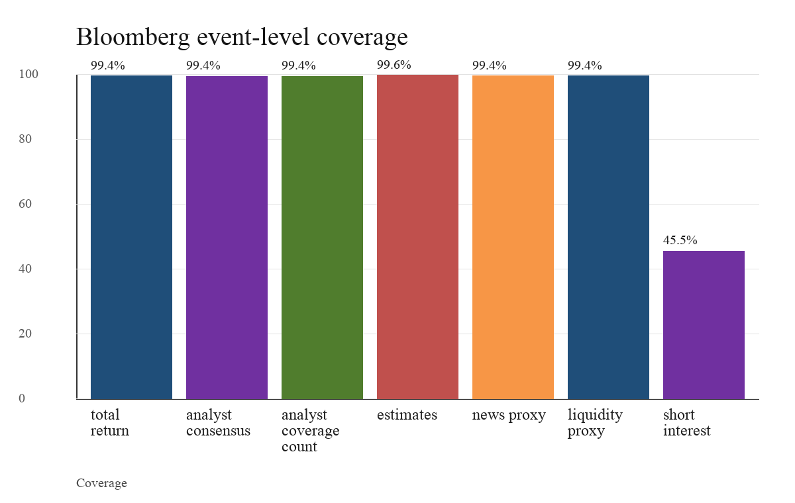

The variables have distinct meanings. `event_tot_analyst_rec` measures the number of analysts with Bloomberg coverage around the event. `event_eqy_rec_cons` summarizes recommendation consensus. `event_best_eps`, `event_best_sales`, and target-price fields capture expectations. `event_news_heat` and `event_news_sentiment` proxy for Bloomberg news flow and tone. Liquidity fields such as volume, bid-ask spread, dollar volume, and volume average describe trading conditions. Short-interest fields measure the short-selling environment where available. None of these variables proves that a creator copied analysts, and none makes an event news-clean. They describe whether the recommendation happened in a dense information environment.
That context helps interpret the top-5 pattern. If a recommendation involves a stock with many analysts, high liquidity, Bloomberg news flow, and active public valuation context, the video is unlikely to be the only relevant information event. The recommendation may still affect viewers, but it is more plausible as a relay or amplification channel than as an independent discovery. This is why the paper treats Bloomberg validation as mechanism evidence, not causal identification.
Takeaway: Bloomberg validation strengthens the information-environment interpretation. Many events occur in stocks already followed by analysts and news systems, which weakens a clean creator-skill explanation even when raw returns are positive.

9. Extreme-Event News Audit
The extreme-event audit asks a targeted question: among the largest return reactions, do any events look candidate-clean after the available confound layers are checked? This is the place where a creator-skill story should have its best anecdotal evidence. If videos were producing unique stock-picking alpha, the most dramatic positive and negative abnormal returns should include at least some cases without obvious public-information overlap.
The audit is implemented in `scripts/build_v2_extreme_event_news_audit.py`. It selects the top and bottom 25 1-day abnormal-return events and the top and bottom 25 5-day abnormal-return events, then deduplicates to 75 unique event IDs. For each event, the script merges official filing and earnings flags, the conservative `news_confound_master` panel, FNSPID media indicators, Alpha Vantage and GDELT diagnostics where available, fallback provider metadata, market-implied attention variables, and Bloomberg News Heat, News Sentiment, analyst coverage, analyst consensus, liquidity, and short-interest proxies. The classification rule is deliberately conservative and ordered: official confounds take priority, followed by media confounds, high Bloomberg news flow, high market attention, institutional following, unresolved unknown, and candidate-clean.
The result is stark. Table 9 shows 56 official-confounded events, 15 media-confounded events, 2 Bloomberg-news-flow-high events, 2 market-attention-high events, 0 institutionally followed primary labels, 0 unresolved unknown primary labels, and 0 candidate-clean extreme events. Figure 5 gives the same result visually. The largest return moves are generally not clean evidence of creator stock-picking skill.
Table 9. Extreme-event audit classification
Label | Count | Pct
audited unique events | 75 | 100.0%
bucket positive 1d | 25 | 33.3%
bucket negative 1d | 25 | 33.3%
bucket positive 5d | 25 | 33.3%
bucket negative 5d | 25 | 33.3%
official confounded | 56 | 74.7%
media confounded | 15 | 20.0%
bloomberg news flow high | 2 | 2.7%
market attention high | 2 | 2.7%
institutionally followed | 0 | 0.0%
unresolved unknown | 0 | 0.0%
candidate clean extreme | 0 | 0.0%
selection rows before dedup | 100

Figure 5. Extreme-event audit labels
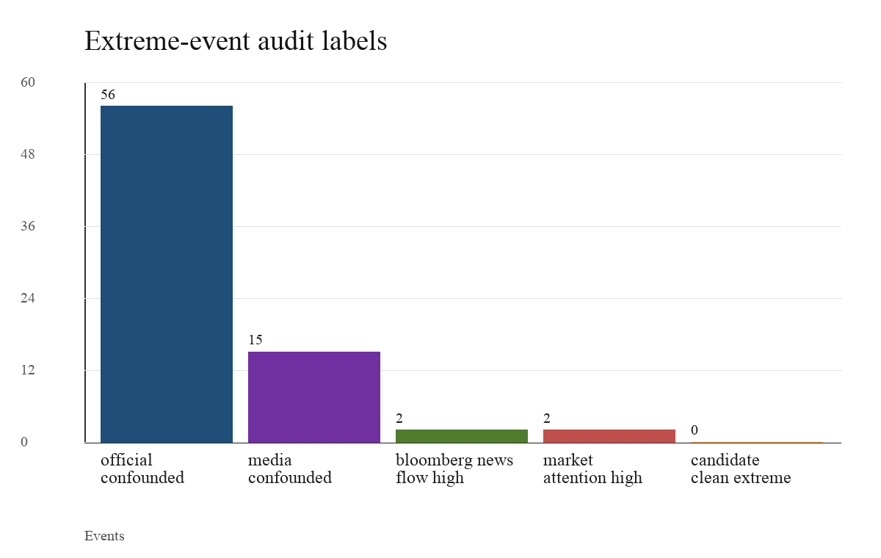

This audit is diagnostic rather than exhaustive. It does not certify the full sample, and it does not prove that YouTube never contributes to price pressure. Its contribution is narrower and stronger: the most eye-catching returns do not provide clean creator-skill examples under the frozen evidence layers. Most coincide with official information or media indicators; the rest align with Bloomberg news-flow or market-attention proxies. The correct inference is that the tails are heavily contaminated by simultaneous public information.
Takeaway: the extreme-event audit blocks the most tempting anecdotal alpha argument. The largest returns are not candidate-clean, so they should not be used as evidence that creators discovered mispriced stocks.

10. Robustness and Falsification Tests
The robustness package is designed to detect spurious alpha. Table 10 summarizes the main checks. The strict multi-source public-news-clean sample contains 0 events at the reported horizons. This is a limitation for causal inference, but it is also a useful discipline device: the paper cannot claim that returns survive full public-news cleaning because there is no such clean sample in the frozen build. Market-quiet conditions provide a secondary sensitivity rather than a news-clean test. In the non-top market-quiet slice, the 21-day SPY BHAR is -0.561% with `n = 694`, `t = -1.719`, and `p = 0.085647`; the sign is consistent with non-top weakness, but market quiet is not the same as absence of news.
Table 10. Robustness and falsification summary
Check | Value | Interpretation
Multi-source clean events | 0 | No public-news-clean return claim is supported.
Non-top market-quiet 21D SPY BHAR | -0.56% | Secondary sensitivity only; market quiet is not news clean.
Cross-ticker placebo 5D mean diff | 0.19% | Economically near-zero falsification benchmark.
Label-shuffle placebo, 5D | 0.91% | Permutation p=0.0; descriptive heterogeneity check.
Label-shuffle placebo, 21D | 3.42% | Permutation p=0.0; descriptive heterogeneity check.

Factor adjustment further weakens broad alpha language. Table 6 reports FF5 plus momentum event alphas. For all events, the 5-day FF5+MOM alpha is -0.081% with `p = 0.506545`. Top-5 5-day alpha is -0.018% with `p = 0.9135`; non-top 5-day alpha is -0.175% with `p = 0.318624`. The 21-day non-top FF5+MOM alpha is negative, but it should be interpreted as heterogeneity, not a clean short strategy. Across models, the all-event 5-day CAPM alpha is more negative, while Carhart and FF5+MOM are closer to zero. That sensitivity is exactly why the paper avoids claiming a model-free creator signal.
Table 6. FF5+momentum factor-adjusted event alpha
Sample | H | N | Alpha | t | p
all | 21D | 2048 | -0.612% | -2.359 | 0.01832
all | 5D | 2119 | -0.081% | -0.664 | 0.506545
all | 63D | 1760 | 0.381% | 0.773 | 0.439818
top5 | 21D | 1234 | -0.357% | -1.05 | 0.293573
top5 | 5D | 1268 | -0.018% | -0.109 | 0.9135
top5 | 63D | 1078 | 0.950% | 1.397 | 0.162281
non_top | 21D | 814 | -0.998% | -2.496 | 0.012564
non_top | 5D | 851 | -0.175% | -0.997 | 0.318624
non_top | 63D | 682 | -0.518% | -0.758 | 0.448355

Calendar-time regressions ask whether event-based findings survive aggregation into overlapping daily portfolios. Table 7 reports equal-weighted FF5+MOM HAC estimates for long-all-buy, long-top5-buys-only, and a diagnostic short-non-top-buys strategy at 5-day and 21-day holdings. The estimates are not statistically significant. For example, the 5-day long-all-buy daily alpha is 0.017% with `p = 0.665593`, and the 21-day long-top5-buys-only daily alpha is 0.043% with `p = 0.349363`. These regressions do not support a tradable portfolio conclusion.
Table 7. Calendar-time HAC regressions
Strategy | H | N days | Daily a | t | p
long all buy | 5 | 1534 | 0.017% | 0.4322 | 0.665593
long all buy | 21 | 1534 | 0.049% | 1.1872 | 0.235164
short non top buys diagnostic | 5 | 1272 | -0.030% | -0.8314 | 0.405753
short non top buys diagnostic | 21 | 1272 | -0.040% | -1.4136 | 0.157484
long top5 buys only | 5 | 1534 | 0.004% | 0.0921 | 0.926633
long top5 buys only | 21 | 1534 | 0.043% | 0.9358 | 0.349363

Placebo and matched-control tests point in the same direction. The creator cross-ticker placebo has a 5-day treated-minus-placebo mean difference of 0.188% across 2,299 rows, which the handoff correctly frames as economically near zero. The matched-control diagnostic compares treated 5-day abnormal returns with same-ticker/month and similar-pretrend controls: treated-minus-control averages -0.059%, with `t = -0.340` and `p = 0.733820`. A permutation test that shuffles event dates within ticker produces an observed 5-day mean of 0.056%, a permutation mean of 0.050%, and `p = 0.666`. These tests are not causal proof, but they reduce the likelihood that the full-sample null result is an artifact of the event-study machinery.
Takeaway: the robustness checks consistently narrow the claim. The data contain heterogeneity, but factor models, calendar-time regressions, news-clean discipline, matched controls, and placebos do not support broad tradable alpha.

11. Limitations
The first limitation is classification error. The event detector is transparent and auditable, but transcript text is imperfect and context can be subtle. A creator may quote another person, discuss a hypothetical, describe a past trade, or use language that sounds directional without intending a recommendation. The pipeline excludes many ambiguous, retrospective, third-party, and news-only references, yet accepted events remain proxies. They should not be interpreted as verified trades or personalized advice.
The second limitation is public-information coverage. Unknown is not clean. Provider failures, missing keys, quota limits, short archives, and incomplete coverage are all treated as unknown rather than evidence of no news. This conservative rule is why the strict multi-source clean sample is empty. It prevents overclaiming but also means the paper cannot estimate a public-news-clean return effect. The extreme-event audit partially addresses the most important tail cases, but it is not a full manual headline audit of all 2,341 events.
The third limitation is execution realism. The event study uses closing-price style return windows and benchmark returns, not actual viewer execution prices. It does not model bid-ask spreads, market impact, order timing, taxes, borrow availability for shorts, or slippage. A video may be uploaded after the market close or during a trading day; a viewer may watch it hours later. The low-lookahead timing bucket helps, and calendar-time portfolios are more realistic than isolated event means, but the design still does not establish a tradable strategy.
The fourth limitation is horizon dependence. Short windows are cleaner but may miss delayed attention. Long windows can capture drift or reversal, but they are exposed to overlapping events, new public information, factor-model instability, and right-censoring. The coverage export shows that right-censoring rises materially at longer horizons, especially near 126 and 504 trading days. Long-horizon results are therefore diagnostic and should not be used as the primary alpha claim.
The final limitation is scope. This is a student capstone built from a frozen repository, not a proprietary institutional dataset. It covers a defined set of YouTube creators, tickers, transcript providers, market data, and derived validation outputs. It does not ingest new data for this manuscript, compare all social platforms, estimate viewer-level trading, or identify causal treatment effects. Those constraints are real, but they also keep the paper honest: every empirical number in the manuscript is tied to committed exports and listed in `paper/MANUSCRIPT_SOURCE_AUDIT.md`.
Takeaway: the limitations do not overturn the negative alpha result. They mainly prevent stronger causal, public-news-clean, and tradability claims.

12. Conclusion
The frozen evidence does not support broad, tradable, public-news-clean creator-skill alpha in transcript-supported YouTube stock recommendations. The full-sample 1-day and 5-day abnormal returns are near zero and statistically insignificant. Positive raw performance is concentrated in the most salient tickers, while non-top recommendations are weaker. Factor-adjusted event alphas, calendar-time HAC regressions, matched controls, and placebo diagnostics do not convert that heterogeneity into a defensible trading strategy.
The strongest empirical contribution is the information-environment interpretation. Many recommendations occur in stocks that are already liquid, analyst-followed, news-covered, and popular with retail attention. Bloomberg validation confirms broad availability of analyst, estimate, news, and liquidity context. The extreme-event audit shows that none of the 75 largest return reactions qualifies as candidate-clean under the frozen evidence layers. Those facts are more consistent with attention amplification, consensus relay, ticker selection, and public-information overlap than with standalone creator stock-picking skill.
For investors, the practical implication is straightforward: finfluencer content should be treated as commentary or entertainment unless independently validated. A recommendation may identify a stock worth researching, but the evidence here does not justify trading it as a mechanical alpha signal. For regulators and market observers, the study suggests a distinction between influence and skill. YouTube creators may shape attention and retail narratives without producing reliable abnormal returns. Future research could test cross-platform spillovers, viewer-level brokerage behavior, randomized exposure, or richer causal designs that separate attention shocks from simultaneous public news.
Takeaway: the paper rejects the strongest alpha story but preserves the economically interesting one. YouTube finance content appears to matter most as part of the public information and attention system, not as a broad source of clean creator-skill returns.

References
[1] Fama, Eugene F., Lawrence Fisher, Michael C. Jensen, and Richard Roll. 1969. "The Adjustment of Stock Prices to New Information." International Economic Review 10 (1): 1-21.
[2] MacKinlay, A. Craig. 1997. "Event Studies in Economics and Finance." Journal of Economic Literature 35 (1): 13-39.
[3] Kothari, S. P., and Jerold B. Warner. 2006. "Econometrics of Event Studies." In Handbook of Corporate Finance: Empirical Corporate Finance, edited by B. Espen Eckbo. Elsevier.
[4] Barber, Brad M., and Terrance Odean. 2008. "All That Glitters: The Effect of Attention and News on the Buying Behavior of Individual and Institutional Investors." Review of Financial Studies 21 (2): 785-818.
[5] Da, Zhi, Joseph Engelberg, and Pengjie Gao. 2011. "In Search of Attention." Journal of Finance 66 (5): 1461-1499.
[6] Tetlock, Paul C. 2007. "Giving Content to Investor Sentiment: The Role of Media in the Stock Market." Journal of Finance 62 (3): 1139-1168.
[7] Antweiler, Werner, and Murray Z. Frank. 2004. "Is All That Talk Just Noise? The Information Content of Internet Stock Message Boards." Journal of Finance 59 (3): 1259-1294.
[8] Chen, Hailiang, Prabuddha De, Yu Jeffrey Hu, and Byoung-Hyoun Hwang. 2014. "Wisdom of Crowds: The Value of Stock Opinions Transmitted Through Social Media." Review of Financial Studies 27 (5): 1367-1403.
[9] Kakhbod, Ali, Seyed Mohammad Kazempour, Dmitry Livdan, and Norman Schuerhoff. "Finfluencers." Working paper.
[10] Guan, Sue S. 2023. "The Rise of the Finfluencer." New York University Journal of Law and Business.
[11] CFA Institute. 2024. "The Finfluencer Appeal: Investing in the Age of Social Media."
[12] U.S. Securities and Exchange Commission, Office of Investor Education and Advocacy. Investor alerts and public guidance on social media, online promotion, and investment fraud.
[13] Scott Switzer. FIN 496 Capstone repository, finfluencer-alpha, frozen at commit 5a81aa3e497a358fa9e154ee67b146510e325f40. Numeric claims in this manuscript are sourced to committed CSV/MD exports listed in MANUSCRIPT_SOURCE_AUDIT.md.

