BethesdaIT

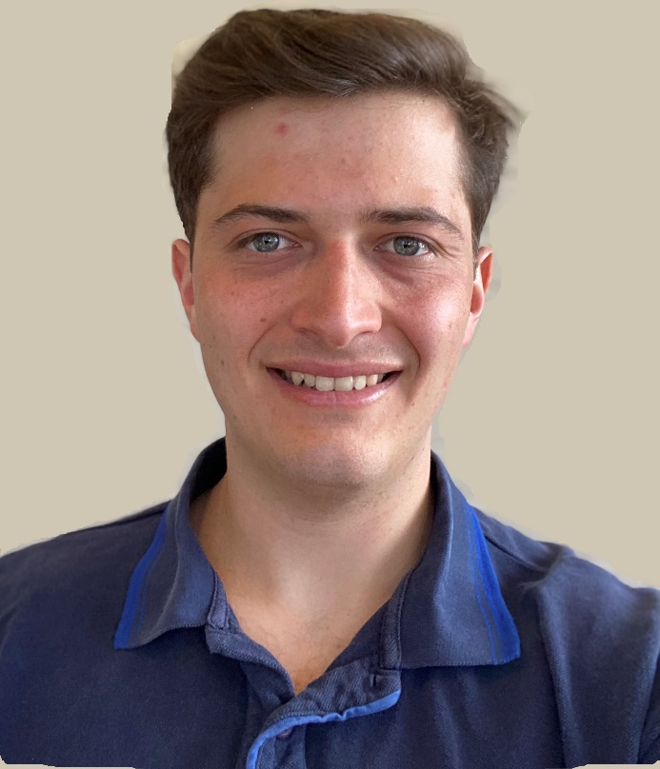

Offered Services:

* Website creation and hosting
* Computer / Mobile Support
* Router/Internet Support
* IOT Device setup and troubleshooting



Name: Scott Wilder

Cell: (301) 339-3976

Email: bethesdait21@gmail.com

Website: www.bethesdait.com

About Me:

I graduated from LSU with a Computer Science Degree and now live and work in the area. I currently work at a local software company in Rockville, Maryland. In my free time, I want to provide IT services for my community.