# Team pursuit excel model v8 usage, calculation procedure

*John Pitman AusCycling 8/08/2022*

## Overview

This document describes the inputs, calculations and outputs of v8 of the AusCycling team pursuit modelling tool.

This tool is a ‘what-if’ event time prediction tool, developed by John Pitman as Aerodynamics and Performance engineer at AusCycling. It does not include any kind of optimisation and is provided primarily as an introduction to the modelling concepts.

Extensive research into the supply and demand elements of the team pursuit along with a recent validation exercise has lead to the conclusion that the model in the presented state is on the whole useful in enabling support staff to make informed decisions about the relative impact of the elements that go into a 4km team pursuit on a velodrome. Known simplifying assumptions on both the supply and demand side mean it is not expected to predict an accurate time in all scenarios.

## **Inputs**

### Rider attributes

A team pursuit squad at a competition is typically comprised of 5 riders, where 4 will ride the event.

A rider attribute table is required, including their mass, seated solo CDA, standing CDA and centre-of-mass height (we use seat height as surrogate).

The model has fields for power input for each turn (up to 5, although typically riders only do 1-3 turns), rather than defining these via a supply model.



### Constants



* Dt = forward integration time step.
* V0 = initial velocity. Non-zero is necessary to initiate but is also physical as riders practice to throw out of the gate as the start signal is sounded.
* Hl length = half-lap length i.e. 250m /2
* Rho = air density
* Bike length = distance from front of front tyre to rear of rear tyre
* Spacing = distance between rear tyre of lead rider and front tyre of following rider
* Weight distribution frt-rr = as described
* Crr front, rear = Tyre rolling resistance coefficient
* Mu-scrub = empirical tyre scrubbing coefficient (to account for when tyre is not @ 90 degrees to the track surface)
* Efficiency = % input power lost to mechanical friction (chain, bearings etc)
* MoI frt/rr = Moment of Inertia of front, rear wheels
* Wheel radius = Distance from axle to tyre contact point with the track
* Time standing = How long after leaving the start does the lead rider remain in the standing position. Determines which CDA value (seated/standing) is used.
* Track geo = Legacy field enabling selection of different track geometries. For simplification only Brisbane ‘BRI’ is used in this model.
* Distance from black line = How far from the black line the rider is in the middle of the bend. Drives a calculation that scales lap distance travelled using perimeter of ellipse. Missing apex of the bend (further from black) is assumed to be slower.
* Lap 1 profile = Male or Female. Selects one of two VBA poly functions that define the lap 1 power profile.
* Reaction time = Time delay between start signal and movement out of the gate.
* 2nd team = True/False. Selects one of two empirical relative wind speed profiles. TP competitions are 2 or 3 rounds. Qualifying is always one team only. Round 1 and/or the Final have two teams on the track. Relative wind speed due to greater air swirl in the velodrome is greater with two teams. Assumes teams remain equi-distant.
* P1 CDA scaling = empirical value. Scales the lead rider’s CDA to account for favourable aerodynamic interaction from following rider

### Lap 1 power profiles (VBA fns)

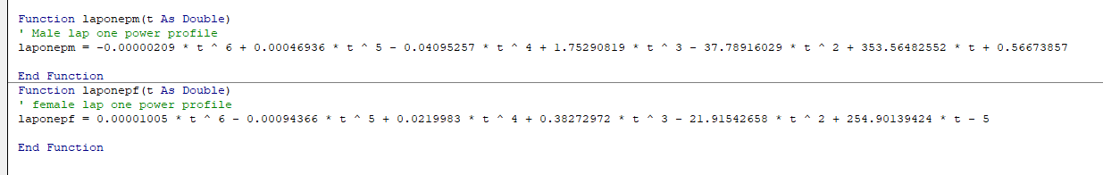

### Team start order

Define which 4 out of the 5 riders are used and in what order. Assume the start order defines the rotation order through the event.

### Turn strategy

Note that change-overs are assumed to always occur in the bends. As such, turn durations are specified in half-lap increments. With the start/finish line being in the middle of the straights, the first and last turns always include an additional ¼ lap.



## **Calculations**

### Initialise row

Calculations are given initial values at first time step where appropriate – highlighted in grey

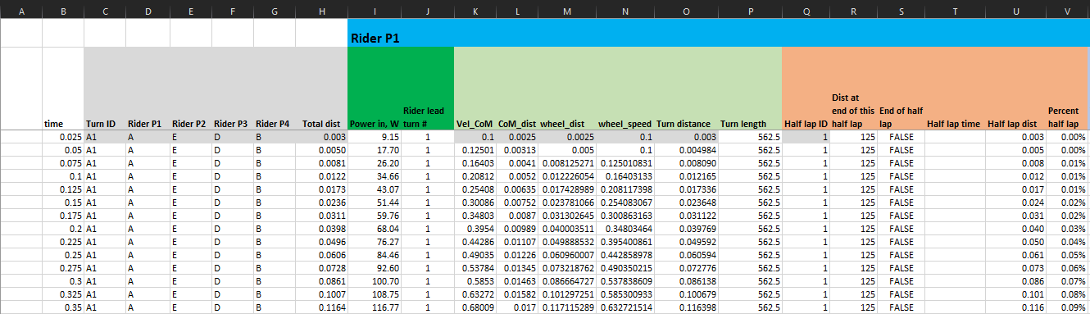

### Procedure

1. Define rider on the front, based on distance travelled
2. Lookup rider attributes (mass, CDA (distance dependent), CoM height)
3. Define power input (at the wheel)
4. Define location on the track (% of lap) based on distance travelled. Interpolation used for accuracy.
5. Lookup track geometry based on % lap distance
6. Calculate lean angle using iterative calculation that takes initial value from look-up table. Look-up table is used to reduce number of loops and avoid any risk of divergence

1. Calculate ‘centre-of-mass’ (CoM) velocity using lean angle, CoM dist, wheel dist, Wheel speed, turn distance etc
   1. Expected behaviour is for the wheelspeed to sinusoidally increase in the bends and match the wheelspeed on the straights:

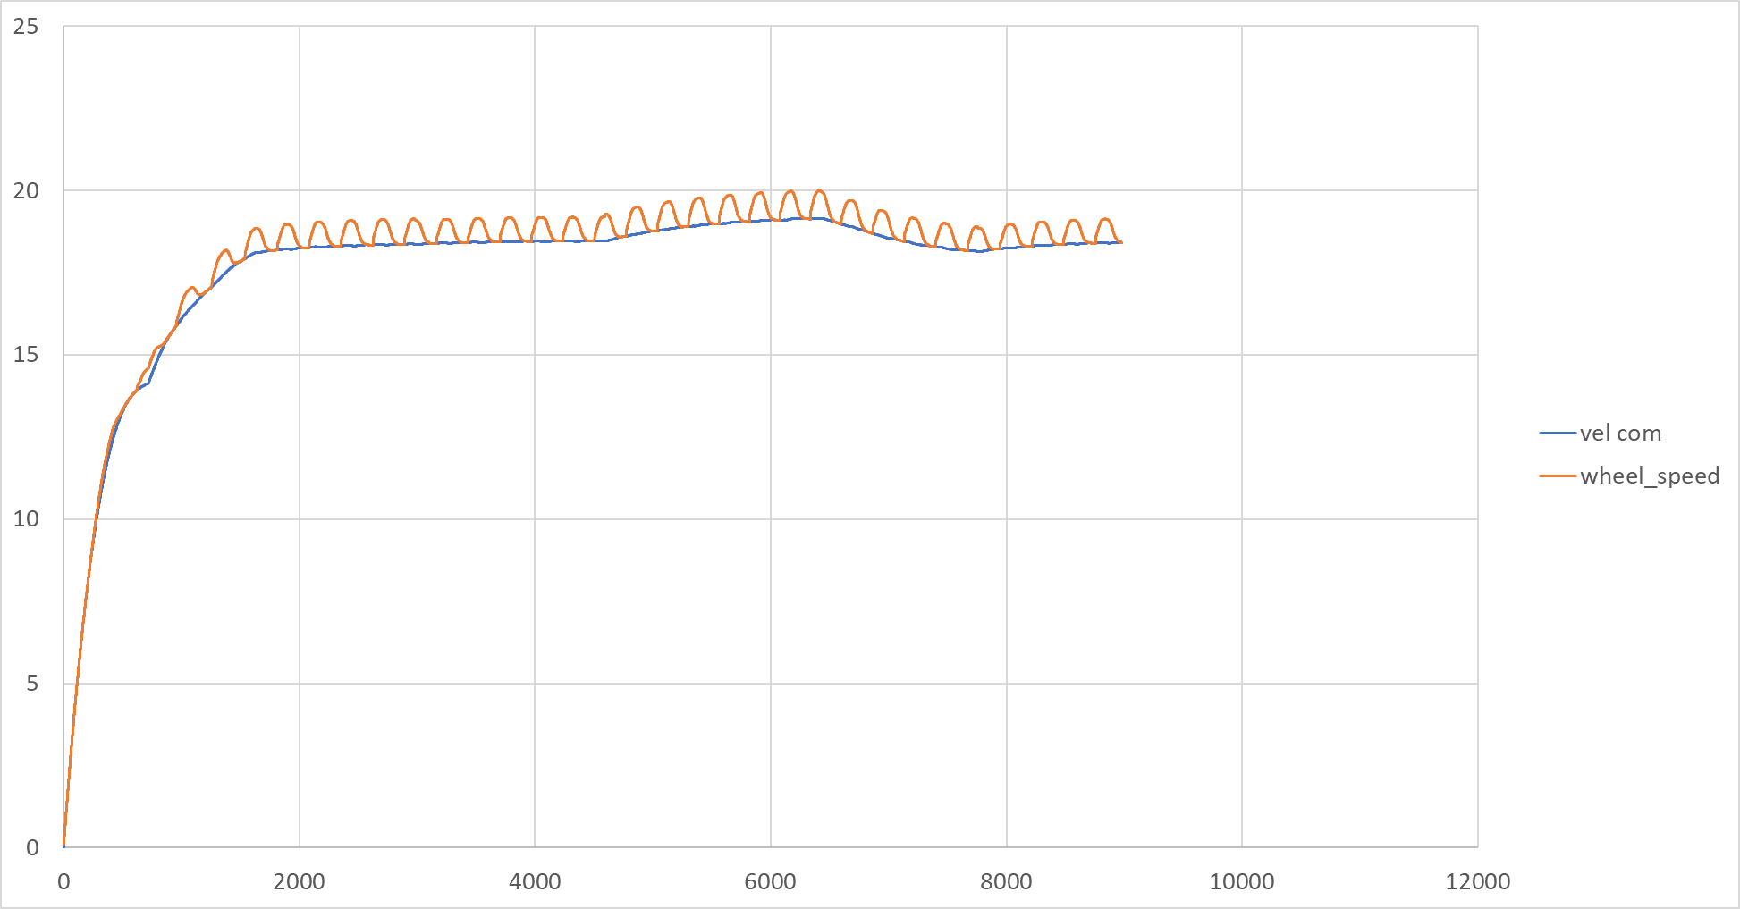

* 1. See calculations for inclusion of aspects including scaling for distance from the black line and addition of distance to account for bike-length loss when lead rider changes

1. Calculate instantaneous aerodynamic drag and rolling resistance (forces, in Newtons)
   1. Note scrubbing function requires lean angle in degrees
   2. Care with angle from vertical/horizontal
   3. Relative airspeed at that point of the event is looked up in table. This is then used in dynamic pressure part of aerodynamic drag equation



1. Calculate net acceleration, a = F/m
2. Note resistances ‘act upon’ the rider at the CoM speed except for the tyre RR which ‘acts at’ the wheel speed
3. Next row: calculate new CoM velocity using V = U+at

Lookup and comparison with prescribed turn distance is required to determine at what point the lead rider changes.

Calculations continue until total distance reaches 4000m.

## **Outputs**

* Primary output of interest in this case is total time:

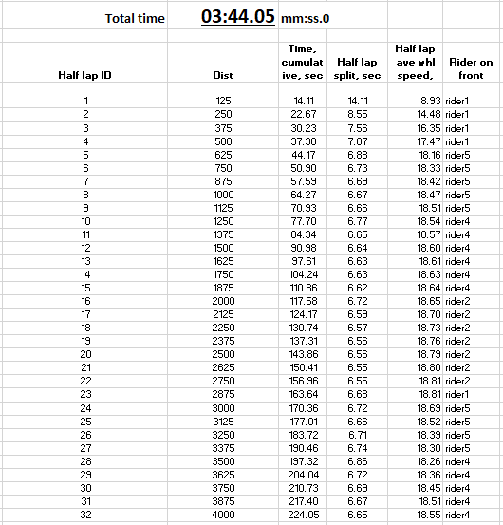

* Background calcs table used to pull out half lap splits and accumulated lead energy per rider:

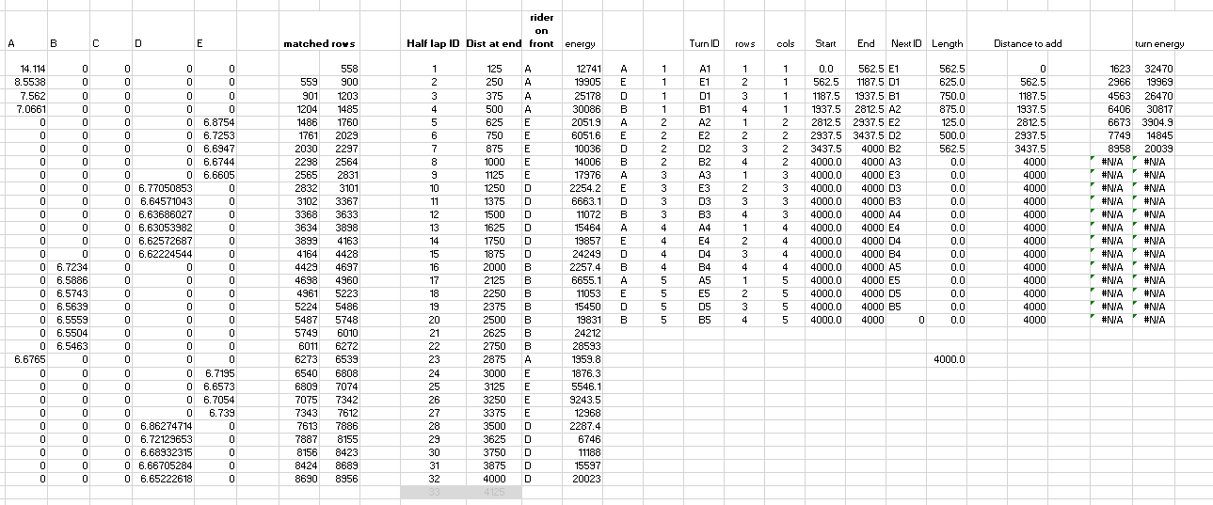

* Half lap split time chart. Note loss of time at beginning of each turn that results from loss of bike length when riders swing off the front

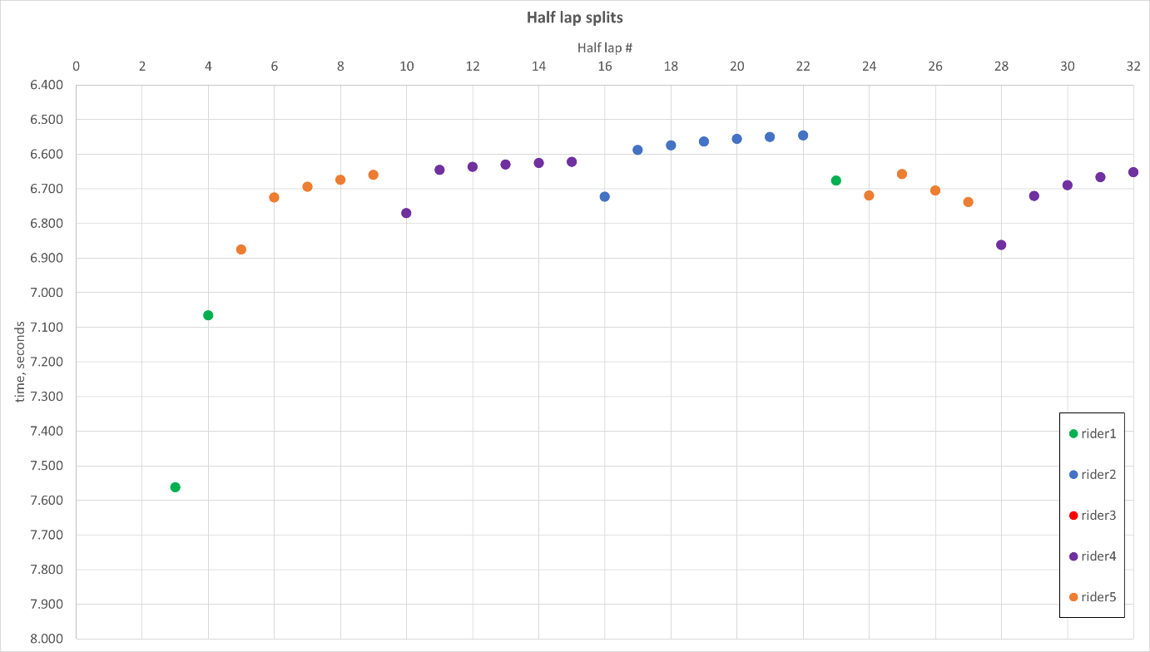

* Secondary outputs: energy usage

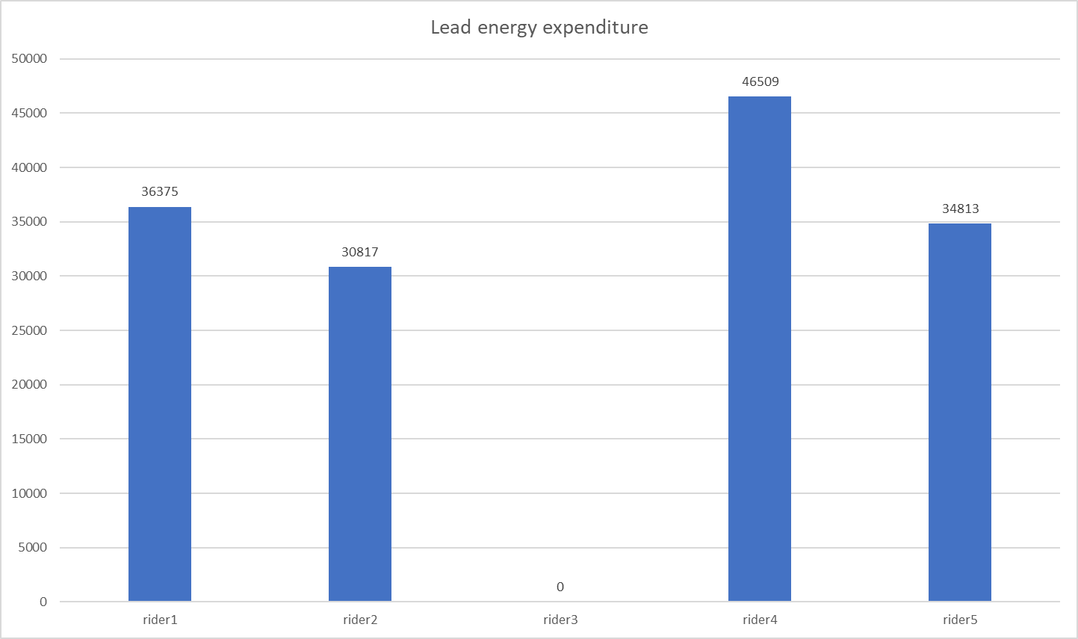

* ‘Quick / what-if’ increments – values in orange drive changes in the calculations to quickly see the effect of changing common parameters
* This table changes for all riders:



* This table adds power onto the turns of a given rider. The total lead energy they then output can be compared to known values from previous rides

