**Snapshot Week 3 of Group CYCIN11PG**

Project: **Team Pursuit Strategy Tool**

a1784310 Yiming Chen

a1789691 Lanxiao Li

a1832192 Penghao Ren

a1819238 Wing Yee Tong

a1702078 Kaifeng Xie

a1767091 Yuting Xu

a1795409 Yu Zhang

**Project Backlog and Task Board**

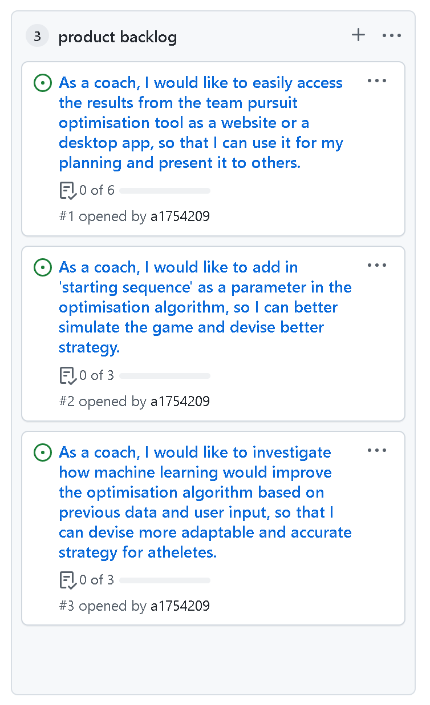

Figure 1. Project Backlog

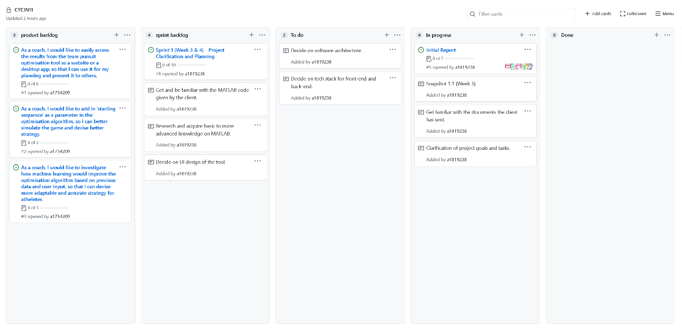Figure 2. Task Board

**Sprint Backlog and User Stories**

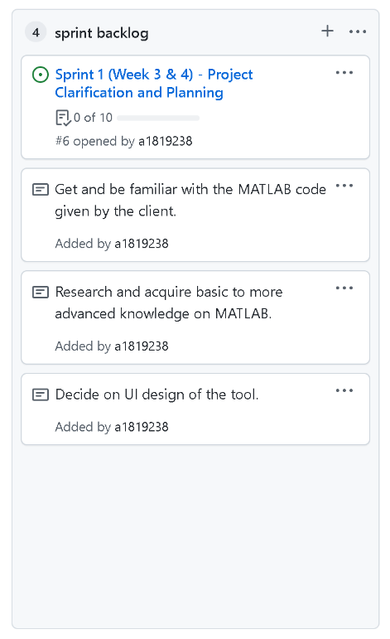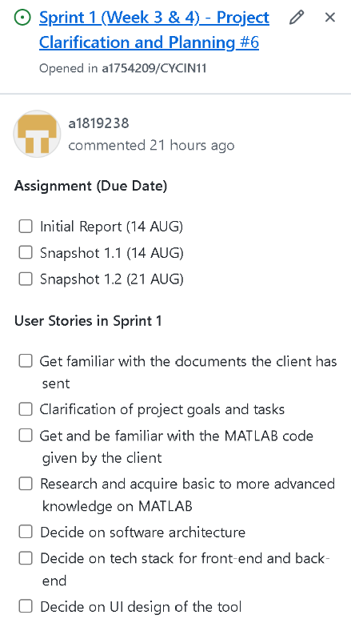

Figure 3. Sprint Backlog

* **Get familiar with the documents the client has sent**
  + After receiving the necessary documents from the client, team members are required to read these documents and understand basic project requirements. Additional team discussions or meetings will be arranged if any doubts or concerns arise.
  + ***Acceptance Criteria:***All team members should have read the documents to understand the project requirements and specifications.
* **Clarification of project goals and tasks**
  + Gain mutual understanding of project goals and tasks on a team basis. Additional Q&A sections or meetings with supervisor will be arranged if necessary.
  + ***Acceptance Criteria:*** All team members are informed of and have necessary knowledge of the project goals and tasks.
* **Get and be familiar with the MATLAB code given by the client**
  + After receiving the MATLAB code from the client, team members should have gained access to the code and understand the basic idea of what the code does.
  + ***Acceptance Criteria:*** All team members should have read the codes given and conduct their own research to have a mutual understanding of basic ideas of the client’s tool.
* **Research and acquire basic to more advanced knowledge on MATLAB**
  + Further research or advanced knowledge may be necessary for certain team members who are assigned MATLAB or machine learning related tasks. This user story is likely to continue through multiple sprints due to the code development nature of this project.
  + ***Acceptance Criteria:*** Responsible team members can acquire enough and necessary knowledge to work on the tasks assigned.
* **Decide on software architecture**
  + The team will research and decide on the best approach to complete the project in terms of software architecture. A flow chart or diagram to briefly describe said architecture is highly recommended.
  + ***Acceptance Criteria:*** The team has decided and finalized the tech stack for the project.
* **Decide on tech stack for front-end and back-end**
  + The team will research and decide on the best approach to complete the project in terms of tech stack (e.g., programming languages, IDE or other tools) front-end and back-end.
  + ***Acceptance Criteria:*** The team has decided and finalized the tech stack for the project.
* **Decide on UI design of the tool**
  + The team will design and decide on the best user interface design to fulfil the project requirements, including but not limited to aesthetics, user interactivity and tool functionality.
  + ***Acceptance Criteria:*** The team has designed a UI that is collectively reviewed and accepted by all team members.

**Definition of Done**

The following states the definition of done for the user stories applicable to Sprint 1:

* The sprint and related user stories were planned, notified, and accepted by all team members.
* Decision-type user stories are finalized and accepted by all team members.
* User stories listed in “To Do” or “In Progress” status that have met the acceptance criteria can be moved to the “Done” status.
* All user stories that have met the acceptance criteria are reviewed by at least 1 team member outside of the task-assigned team member or group.
* All user stories that have met the acceptance criteria are accepted by all team members.
* Any user story that hasn’t yet met the acceptance criteria in the current sprint is prolonged to the next or future sprint.

**Summary of Changes**

Not applicable. Being the first snapshot since the beginning of the project, we have added the user stories and related tasks necessary for the current sprint (i.e., Sprint 1 – Week 3 & 4).