**Snapshot Week 5 of Group CYCIN11PG**

Project: **Team Pursuit Strategy Tool**

a1784310 Yiming Chen

a1789691 Lanxiao Li

a1832192 Penghao Ren

a1819238 Wing Yee Tong

a1702078 Kaifeng Xie

a1767091 Yuting Xu

a1795409 Yu Zhang

**Project Backlog and Task Board**

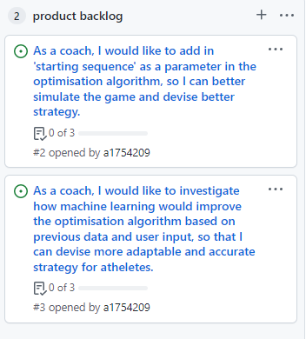

Figure 1. Project Backlog

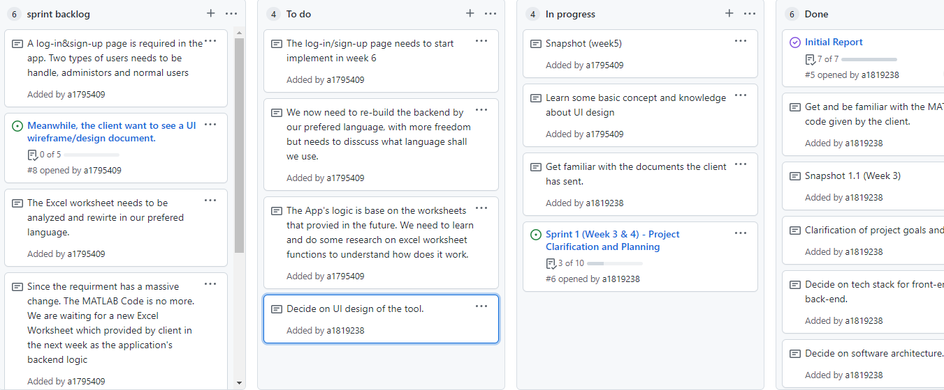

Figure 2. Task Board

**Sprint Backlog and User Stories**

Figure 3. Sprint Backlog

* **Analyze the Excel Worksheet the client provided**
  + Since the client change many requirements on week5 Friday. The MATLAB code is no more for now. The team is going to get a Excel worksheet as instead for back-end calculation’s logic. Thus, the analysis based on previous code needs to rework. Meanwhile, some knowledge of Excel Worksheet is also required. Due to the Worksheet might not be intuitive as programming languages, more discussion and research is needed.
  + ***Acceptance Criteria:*** As the preparation for back-end programming. All team members should have a clear vision of the worksheet workflow, including the input, output, and algorithm. After analyzing, some model like Behavioral Model and Data Model can be given.
* **Rewrite the Code in prefer language**
  + After finishing the analysis of Excel Worksheet. The team need to implement the worksheet’s logic into own program. There is no limitation of which language should be use, but the team will first consider about the convenience of data processing, visualization and the react with the data base.
  + ***Acceptance Criteria:*** The code needs to restore the functionality of the Worksheet by given the same output with same input, include the numerical or visual result
* **Finish a UI wireframe and design documents**
  + The client gives the clearly order that a UI design wireframe and a design document is needed before Week 6 Friday. The team needs to learn the UI drafting tool and structure in short time. The design needs to include:

1. Group name and clear headings for each design.
2. Descriptions & clarifications where you think is needed
3. Interface design to take user input
4. Interface design to display output
5. Interface design for sign-up & log-in page.
   * *Acceptance Criteria:* The appropriate UI documents need to be submitted before Week6 Friday on time.

* **Implement a Log-in page**
  + The Log-in page is a elective option before but now the client gives the clear requirments that a Log-in page and user-account is needed. The page needs include Log-in and Sign-up function for users. And there is also two types of users, administrator and regular user with different authority, needs to be handle.
  + *Acceptance Criteria:* The page’s front end needs to allow users do basic operations like register and log-in, also deny the incorrect access request. Meanwhile, the back-end database can store users’ account information and allow administrators to manage other users.

**Definition of Done**

The following states the definition of done for the user stories applicable to Sprint 1:

* The sprint and related user stories were planned, notified, and accepted by all team members.
* Decision-type user stories are finalized and accepted by all team members.
* User stories listed in “To Do” or “In Progress” status that have met the acceptance criteria can be moved to the “Done” status.
* All user stories that have met the acceptance criteria are reviewed by at least 1 team member outside of the task-assigned team member or group.
* All user stories that have met the acceptance criteria are accepted by all team members.
* Any user story that hasn’t yet met the acceptance criteria in the current sprint is prolonged to the next or future sprint.

**Summary of Changes**

At the end of Week 5, the team has received radical change of requirements from the client. It causes some shock on current plan. The UI design and Log-in page has intercept and add into the new plan. Meanwhile, the analysis and research of MATLAB reaction can stop, but also gives new challenge of re-build the program based on the Excel worksheet. The Team’s working focus will be turning into UI and Worksheet analyze in next week. The log-in page’s functionality implementation is also underway.