**Snapshot Week 6 of Group CYCIN11PG**

Project: **Team Pursuit Strategy Tool**

a1784310 Yiming Chen

a1789691 Lanxiao Li

a1832192 Penghao Ren

a1819238 Wing Yee Tong

a1702078 Kaifeng Xie

a1767091 Yuting Xu

a1795409 Yu Zhang

**Project Backlog and Task Board**

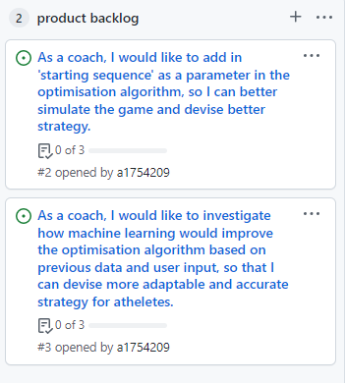

Figure 1. Project Backlog

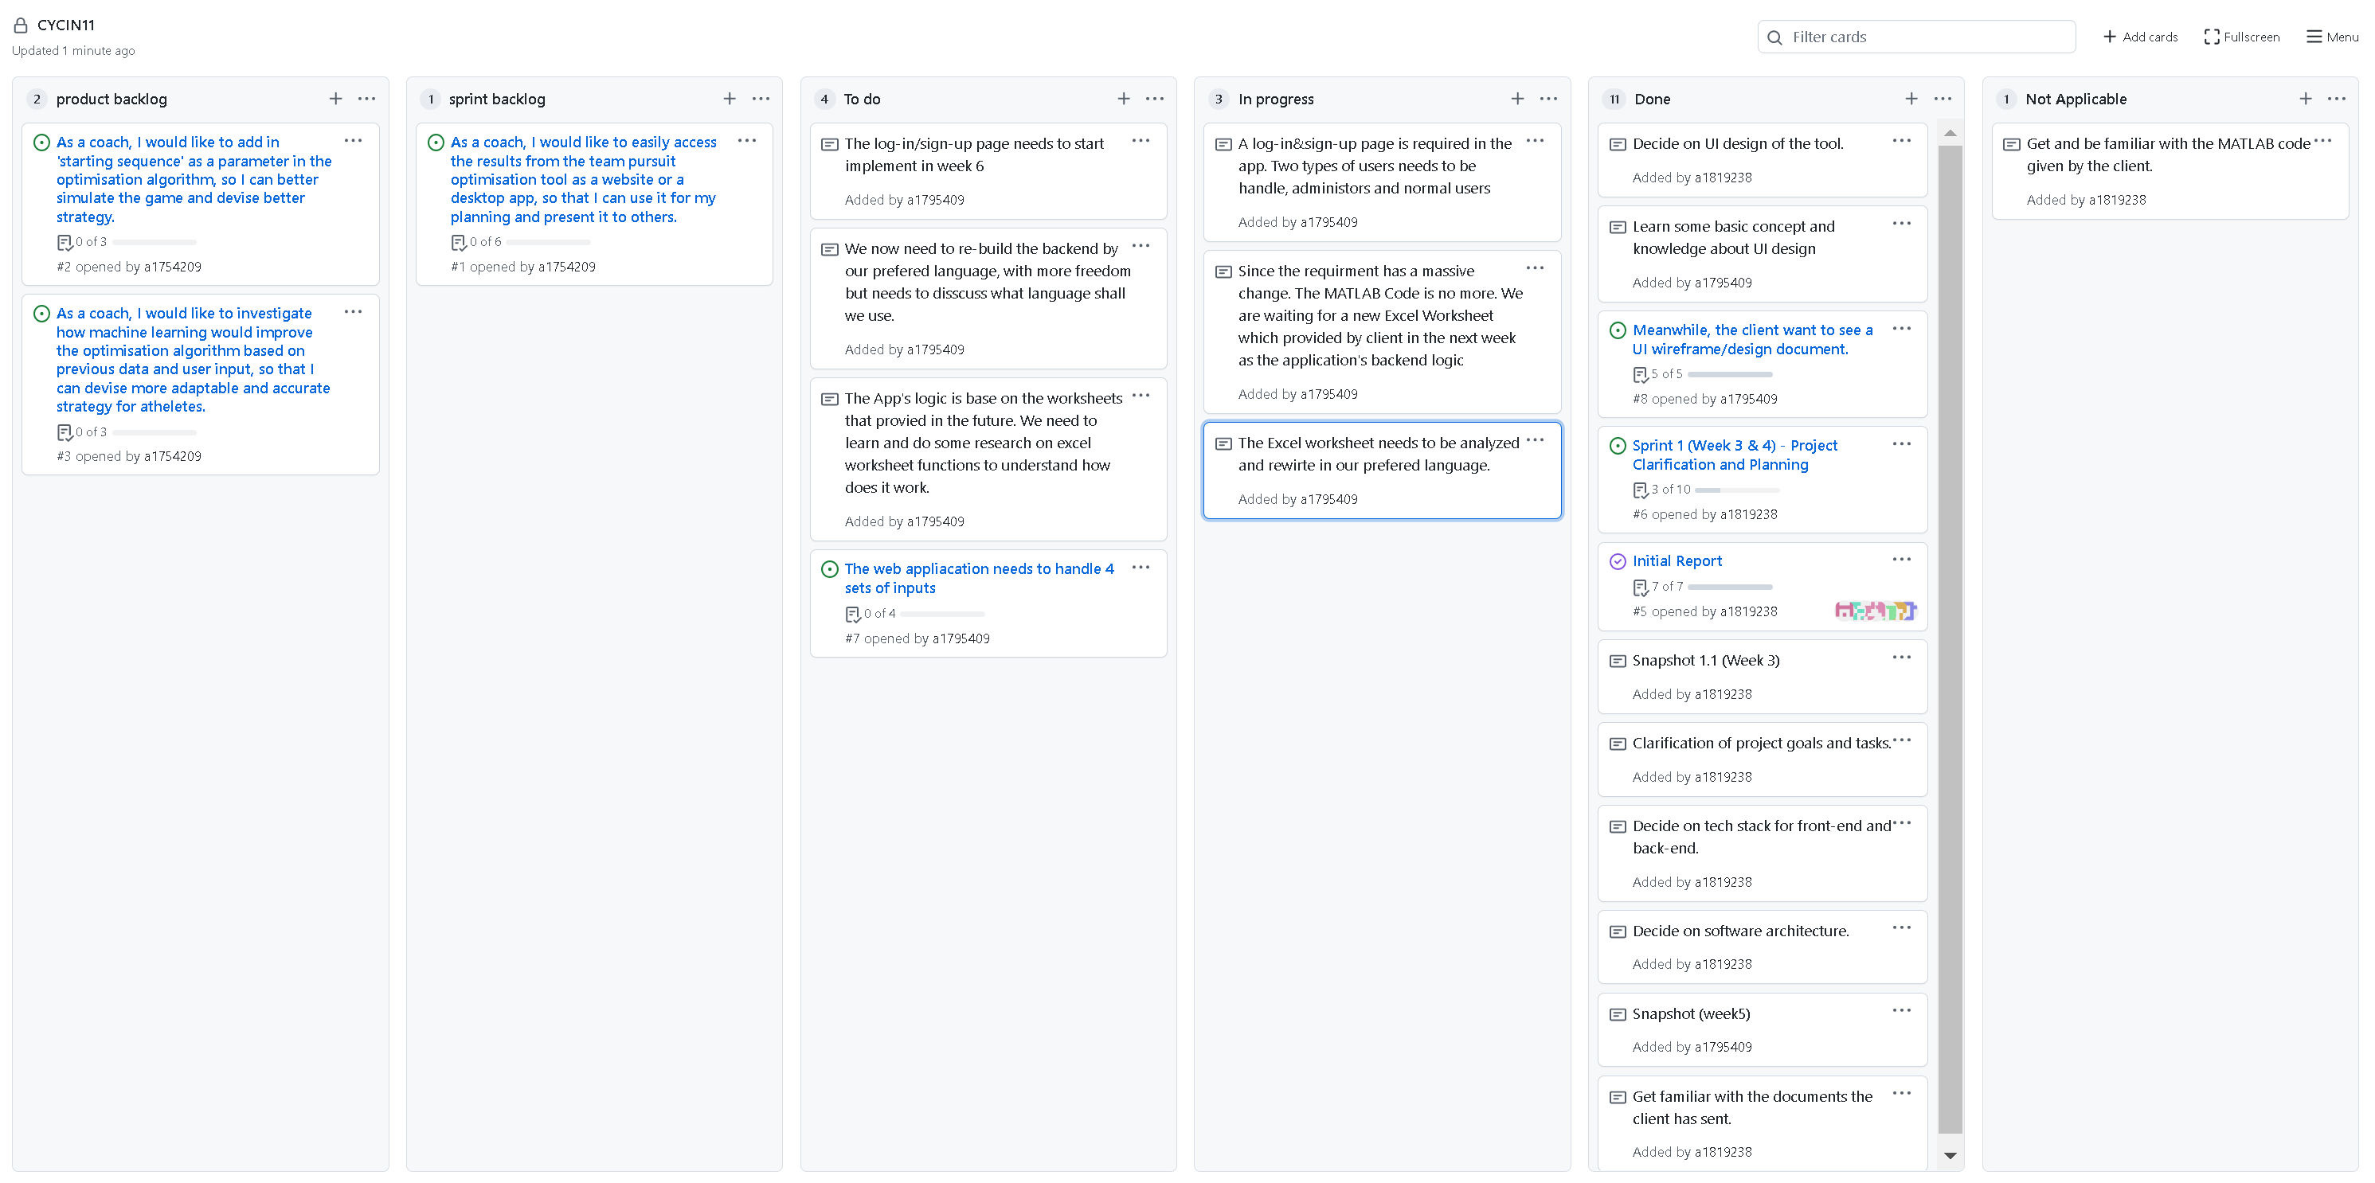

Figure 2. Task Board

**Sprint Backlog and User Stories**

Figure 3. Sprint Backlog

**Current User Story**

As a coach, I would like to easily access the results from the team pursuit optimisation tool as a website or a desktop app, so that I can use it for my planning and present it to others.

*Acceptable Criteria*

* user should be able to access the same result from the MATLAB code on a website / desktop app
* user should be able to load / upload data which the algorithm will use to calculate
* the website / app should give user a list of requirement for data input (e.g. type, column name, etc.)
* instead of hard-coding, user should be able to input variables to be optimised through html form / other means
* user should only be able to run optimisation algorithm once all requied fields are filled with valid input
* once all valid input have been received, the website / app should show the same result as the MATLAB code

**Task Description**

* **Rewrite the Code in prefer language**
  + After finishing the analysis of Excel Worksheet. The team need to implement the worksheet’s logic into own program. There is no limitation of which language should be use, but the team will first consider about the convenience of data processing, visualization and the react with the data base.
* **Implement a Log-in page**
  + The Log-in page is a elective option before but now the client gives the clear requirments that a Log-in page and user-account is needed. The page needs include Log-in and Sign-up function for users. And there is also two types of users, administrator and regular user with different authority, needs to be handle.

**Definition of Done**

The following states the definition of done for the user stories applicable to Sprint 1:

* The sprint and related user stories were planned, notified, and accepted by all team members.
* User stories that have met the acceptance criteria can be moved to the “Done” status.
* Any user story that hasn’t yet met the acceptance criteria in the current sprint is prolonged to the next or future sprint.
* All code has no syntax error and function as expected.
* All code should be commented and formatted in a readable fashion.
* All code should be reviewed by at least 1 team member.
* All code should pass all unit testing (at least 3 tests with edge cases).

**Summary of Changes**

At the end of Week 6, the team has completed and handed in the wireframe and UI designs document according to the changes made in Week 5. While we are still waiting for the client’s feedback to proceed with the implementation of front-end development, our team still keep on learning the necessary knowledge to complete this project.