**Snapshot Week 7 of Group CYCIN11PG**

Project: **Team Pursuit Strategy Tool**

a1784310 Yiming Chen

a1789691 Lanxiao Li

a1832192 Penghao Ren

a1819238 Wing Yee Tong

a1702078 Kaifeng Xie

a1767091 Yuting Xu

a1795409 Yu Zhang

**Project Backlog and Task Board**

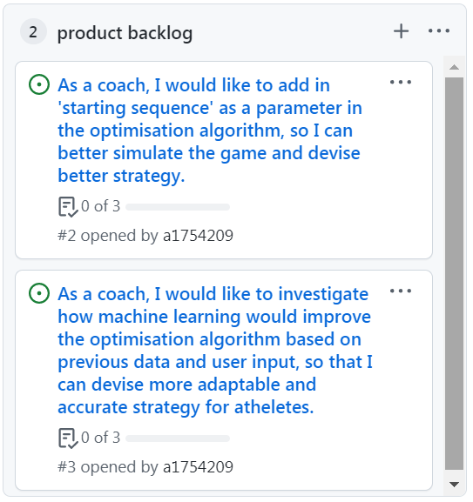

Figure 1. Project Backlog

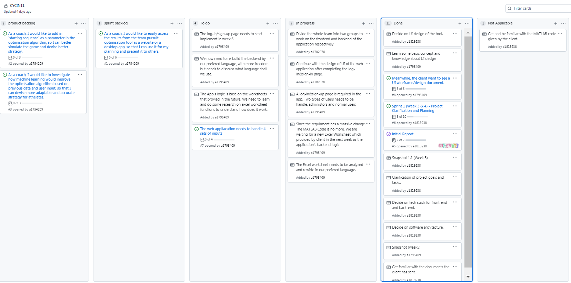

Figure 2. Task Board

**Sprint Backlog and User Stories**

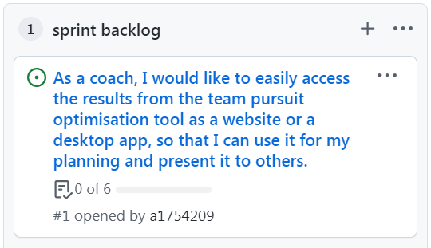

Figure 3. Sprint Backlog

**Current User Story**

As a coach, I would like to easily access the results from the team pursuit optimisation tool as a website or a desktop app, so that I can use it for my planning and present it to others.

*Acceptable Criteria*

* user should be able to access the same result from the MATLAB code on a website / desktop app
* user should be able to load / upload data which the algorithm will use to calculate
* the website / app should give user a list of requirement for data input (e.g. type, column name, etc.)
* instead of hard-coding, user should be able to input variables to be optimised through html form / other means
* user should only be able to run optimisation algorithm once all requied fields are filled with valid input
* once all valid input have been received, the website / app should show the same result as the MATLAB code

**Task Description**

* Build the backend of the application
* The backend of our web application needs to be programmed according to the information provided by the excel files. The program should contain all the functions included in the excel files, which produce the appropriate results with the given inputs. The use on the backend languages is not restricted, but we still need to consider the factors of data processing, visualization, and database to think of the most suitable programming language to be used in the backend.
* Construct the frontend of the application
* The team has created a general design of the UI of the web application, and the frontend needs to be created based on this design. Our team has already created the sign-in & log-in page of the UI, and we need to continue with the other parts of the UI and make sure the UI of the web application meets the requirements of client and is easy for users to use.

**Definition of Done**

The following states the definition of done for the user stories applicable to Sprint 1:

* The sprint and related user stories were planned, notified, and accepted by all team members.
* User stories that have met the acceptance criteria can be moved to the “Done” status.
* Any user story that hasn’t yet met the acceptance criteria in the current sprint is prolonged to the next or future sprint.
* All code has no syntax error and function as expected.
* All code should be commented and formatted in a readable fashion.
* All code should be reviewed by at least 1 team member.
* All code should pass all unit testing (at least 3 tests with edge cases).

**Summary of Changes**

In week 7, the team has received the new excel files from the client, these files contain the information required for constructing the backend of our web application. Also, the team has created a sign-in & log-in page of the UI, and the client is satisfied with that. At this stage, the whole team will be divided into two parts, one part will continue to work on the UI, and the other part will do the programming on backend based on the new information provided by the excel files.