**Snapshot Week 9 of Group CYCIN11PG**

Project: **Team Pursuit Strategy Tool**

a1784310 Yiming Chen

a1789691 Lanxiao Li

a1832192 Penghao Ren

a1819238 Wing Yee Tong

a1702078 Kaifeng Xie

a1767091 Yuting Xu

a1795409 Yu Zhang

**Project Backlog and Task Board**

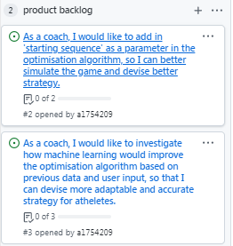

Figure 1. Project Backlog

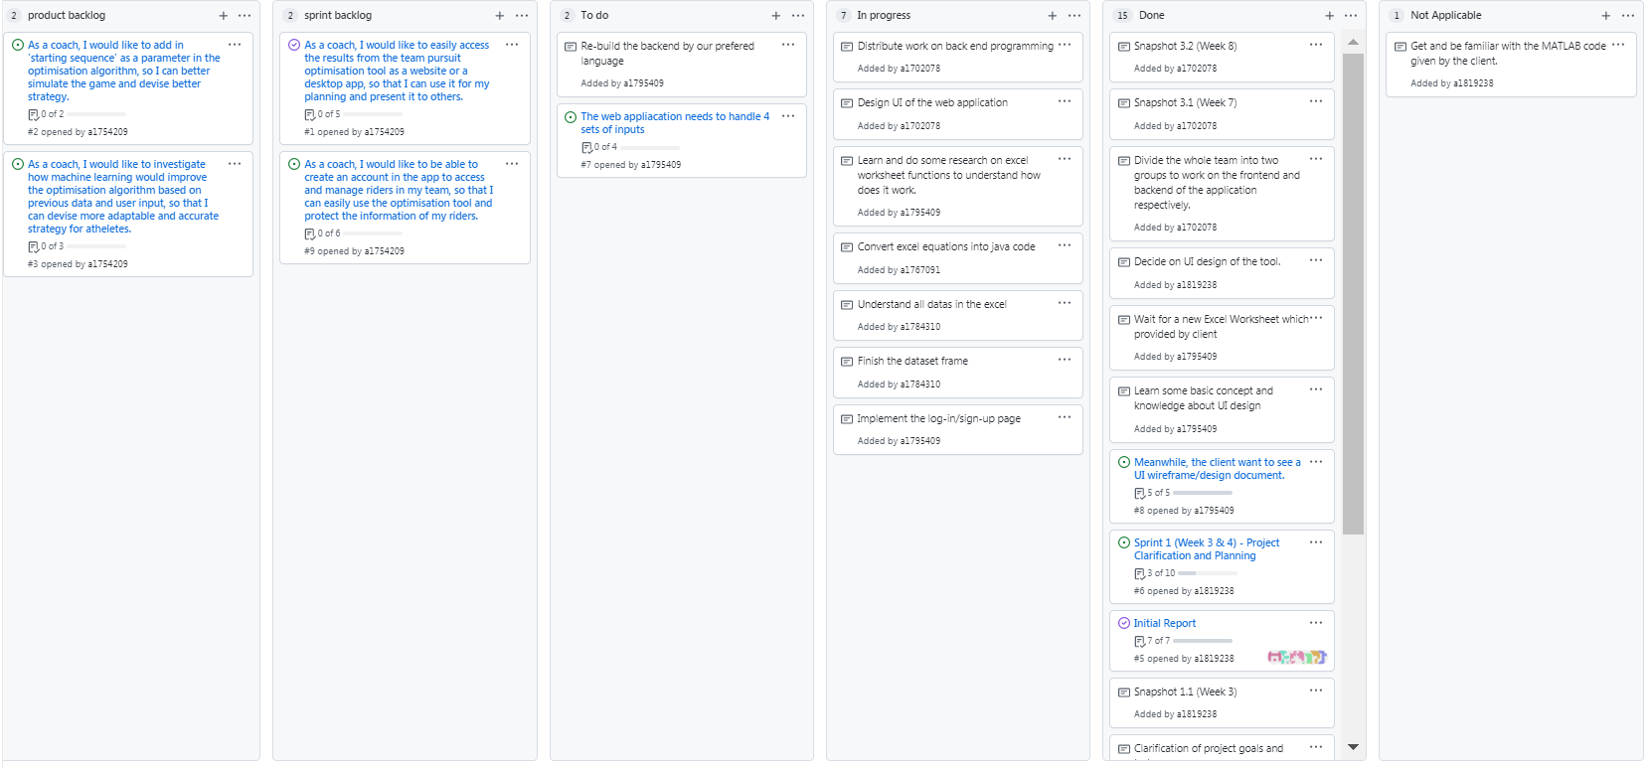

Figure 2. Task Board

**Sprint Backlog and User Stories**

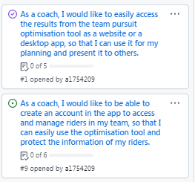

Figure 3. Sprint Backlog

**Current User Story**

As a coach, I would like to easily access the results from the team pursuit optimisation tool as a website or a desktop app, so that I can use it for my planning and present it to others.

As a coach, I would like to be able to create an account in the app to access and manage riders in my team, so that I can easily use the optimisation tool and protect the information of my riders.

*Acceptable Criteria*

* User should be presented with the same result from the excel sheet on a website / desktop app, which includes final time and graphs
* The website / app should present the user its purpose, the process of using the algorithm, and example use case upon opening the website / app
* User should be able to input / upload data which the algorithm will use to calculate
* The website / app should provide a list of rules for data input / upload, such as type of data required, name of columns (for data upload), etc.
* User should only be able to run the algorithm once all required fields are filled with valid input
* User of the app should be able to create an account (sign up) as coaches by providing some personal information (e.g. email or phone number)
* user of the app should be able to create, edit and access rider profiles they created when logged in
* user of the app should be able to edit and access constants when logged in
* rider profile and constant values that a user inputted before should still be available when they logged in again
* only user of the app should be able to run the optimisation algorithm
* user should be able to change their personal information (e.g. name) and login information (e.g. password)

**Task Description**

* Build the backend of the application
* The backend of our web application needs to be programmed according to the information provided by the excel files. The program should contain all the functions included in the excel files, which produce the appropriate results with the given inputs. The use on the backend languages is not restricted, but we still need to consider the factors of data processing, visualization, and database to think of the most suitable programming language to be used in the backend.
* Construct the frontend of the application
* The team has created a general design of the UI of the web application, and the frontend needs to be created based on this design. Our team has already created the sign-in & log-in page of the UI, and we need to continue with the other parts of the UI and make sure the UI of the web application meets the requirements of client and is easy for users to use.

**Definition of Done**

The following states the definition of done for the user stories applicable to Sprint 1:

* The sprint and related user stories were planned, notified, and accepted by all team members.
* User stories that have met the acceptance criteria can be moved to the “Done” status.
* Any user story that hasn’t yet met the acceptance criteria in the current sprint is prolonged to the next or future sprint.
* All code has no syntax error and function as expected.
* All code should be commented and formatted in a readable fashion.
* All code should be reviewed by at least 1 team member.
* All code should pass all unit testing (at least 3 tests with edge cases).

**Summary of Changes**

The team has already been divided into two groups, one group is responsible for the front end, while the other is responsible for back end. In members in back end group has conducted analysis through the excel files, and has started writing some of the programming codes based on the excel functions. At this stage, we also need to divide the back end programming work among the group members in the most suitable way.